Day 32

'is' vs '==' in Python:
What is == (Equality Operator)
== checks VALUE equality
“Do these two objects have the same value?”
What is is (Identity Operator)
is checks OBJECT identity
“Do these two variables point to the SAME object in memory?”
Key Difference (Simple Words)
Operator | Checks | Question Asked
== | Value | “Are the values equal?”
is | Memory | “Are they the same object?”

Example: of == and is
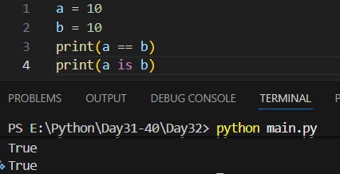

Example:
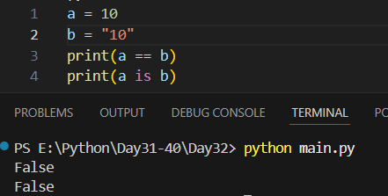
Example: as list is immutable.
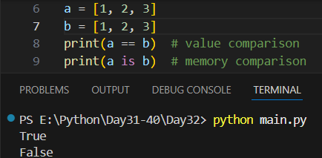
Example: when both are true.
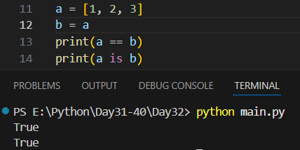

Example:
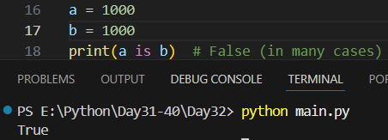
Example:
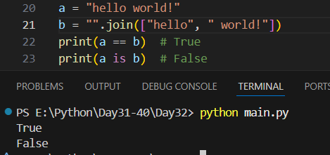

When SHOULD You Use is
✔ Comparing with None
if value is None:
print("No value")
✔ Singleton objects (None, True, False)
When SHOULD You Use ==
✔ Comparing values
- Numbers
- Strings
- Lists
- Tuples
- Dictionaries

One-Line Rule (Remember This!)
Use == to compare VALUES, use is to compare IDENTITIES.
Example: one tricky question.
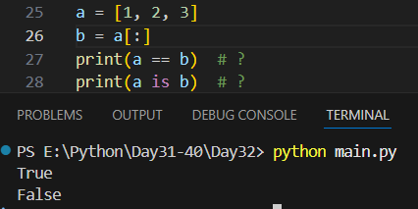

Scenario | Use
Compare numbers | ==
Compare strings | ==
Compare lists | ==
Check None | is
Same object check | is

--The End--

