Day 35

Decorators in Python:
Decorators in Python — From Basics
A decorator in Python is a function that modifies the behaviour of another function or method. Think of it as “wrapping” a function to add extra functionality without changing its original code.
Functions are first-class objects: In Python, functions are objects, which means:
- You can assign a function to a variable.
- You can pass a function as an argument to another function.
- You can return a function from another function.
Example:
def greet(name):
return f"Hello, {name}!"
# Assigning function to a variable
say_hello = greet
print(say_hello("Alice")) # Output: Hello, Alice!
Functions inside functions: You can define a function inside another function:
Example:
def outer():
def inner():
return "I'm inside!"
return inner

my_func = outer()
print(my_func()) # Output: I'm inside!
Notice outer() returns a function inner without calling it (no parentheses after inner when returning).
Passing functions as arguments: You can pass a function to another function:
def greet(name):
return f"Hello, {name}!"
def call_func(func, name):
return func(name)
print(call_func(greet, "Bob")) # Output: Hello, Bob!

What is a decorator?
A decorator is a function that takes another function and extends its behavior without explicitly modifying it. Think of it like wrapping a gift: the gift is the original function, and the wrapping is the decorator.
Example: decorating manually.
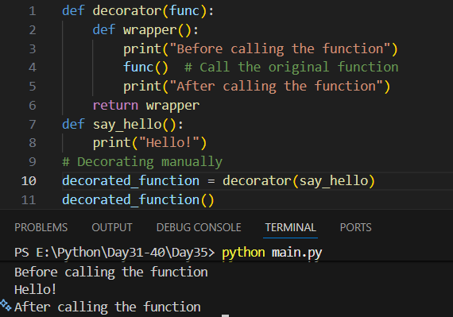
This code shows how a decorator works in Python. The decorator function takes another function (func) as input and wraps it inside a new function called wrapper. The wrapper adds extra behavior by printing a message before and after calling the original function. When say_hello is passed to decorator, it becomes decorated_function. So when decorated_function() is called, it first prints “Before calling the function”, then runs say_hello() (which prints “Hello!”), and finally prints “After calling the function”.
Example: Using the @ syntax. Python provides a shorthand for decorators using the @ symbol:
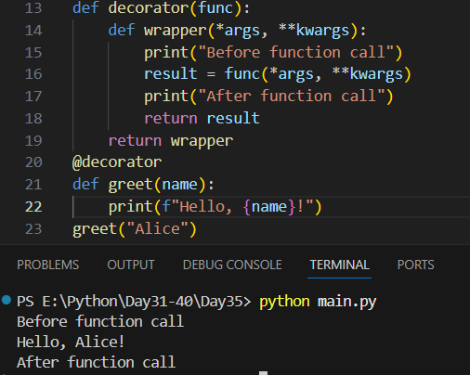

This code uses a decorator to add extra behavior to a function. The decorator takes a function and wraps it inside wrapper, which can accept any arguments using *args and **kwargs. When greet("Alice") is called, it actually runs the wrapper function: it prints “Before function call”, then calls the original greet function with the name "Alice" (which prints “Hello, Alice!”), and finally prints “After function call”. The @decorator line is just a shortcut for applying the decorator to greet.
Summary:
- Functions are first-class objects.
- You can define functions inside functions.
- Functions can be passed as arguments or returned from other functions.
- A decorator wraps a function to modify/extend its behavior.
- Use @decorator_name to apply a decorator in Python.
- Use *args and **kwargs in the wrapper to handle functions with parameters.

--The End--

