Day 13

List Methods in Python:
What are List Methods?
List methods are built-in functions that work only on lists to:
- add items
- remove items
- change order
- get information
They are used with dot (.) notation.
Syntax:
list_name.method()
Important Notes:
- List methods modify the original list
- Most methods return None
- Lists are mutable
Example: append()
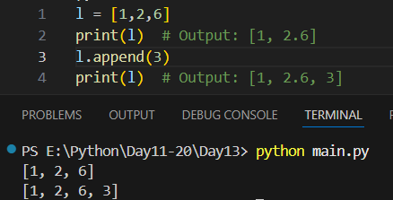

Example: sort()
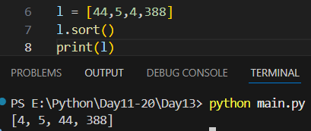
Example: sort(reverse=true)
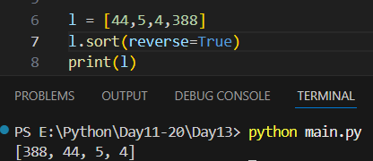
Example: reverse()
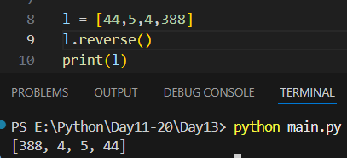

Example: index()
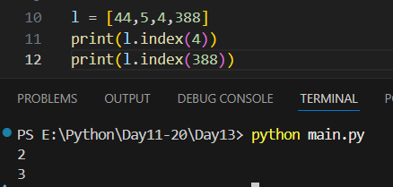
Example: count()
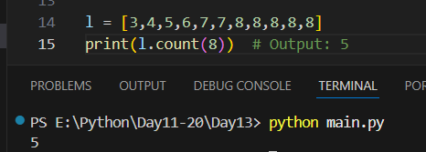
Example: keep in mind that if we store one list in another and then modify the later one then the original one get affected.
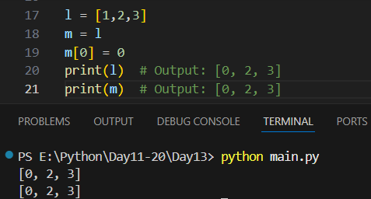
Example: alternative for above is copy(). It is much safer and good way.
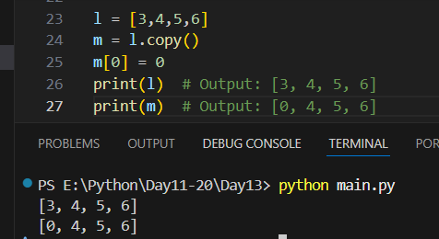
Example: insert(index,value)
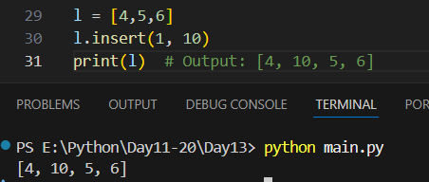
Example: extend()
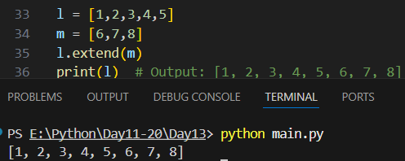

Example: another way to concatenate the list
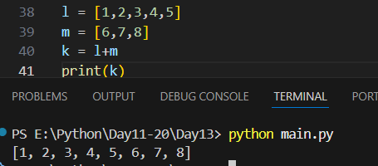
Summary:
- List methods help manage list data
- append, insert, extend → add items
- remove, pop, clear → remove items
- sort, reverse → arrange items
- index, count, copy → get info
--The End--

