Day 31

Lambda functions in Python:
What is a Lambda Function?
A lambda function is a small, anonymous function (a function without a name).
- It can take any number of arguments
- It can have only one expression
- The result of that expression is automatically returned
Think of it as a one-line function.
Normal Function vs Lambda Function
Normal function
def add(a, b):
return a + b
Lambda function
add = lambda a, b: a + b
Basic Syntax:
lambda arguments: expression

Example: a basic use case of lambda function.
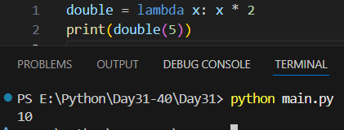

Example: multiple arguments in lambda.
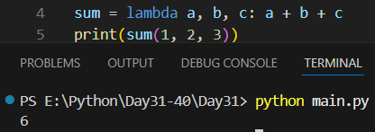
Example: Lambda Without Assigning to a Variable
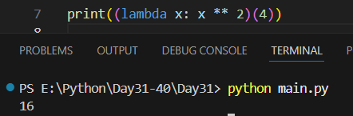

Map, Filter and Reduce in Python:
map() – Transform each item
map() applies a function to every element in an iterable (like a list).
Syntax:
map(function, iterable)
Example: without using them making cube of each of the list.
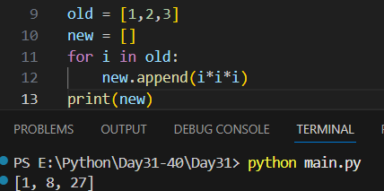

Example: doing the same as above using map().
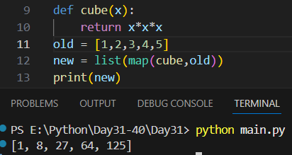
Example: another example of map.
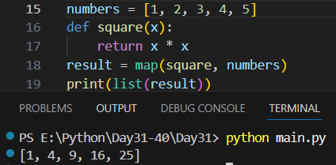
Example: map with lambda.
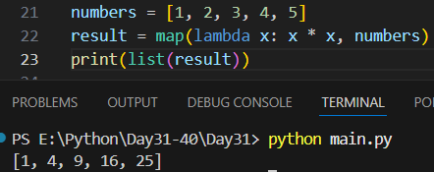
filter() – Select items that match a condition
filter() keeps only the elements that return True from a function.
Syntax
filter(function, iterable)

Example:
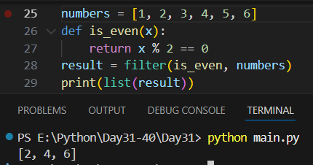
Example: filter() with lambda
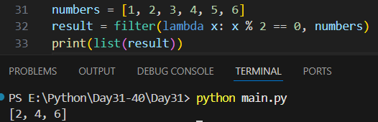
reduce() – Combine all items into one
reduce() reduces a list to a single value by applying a function cumulatively.
Note: reduce() is not built-in; you must import it.
Syntax
from functools import reduce
reduce(function, iterable)

Example:
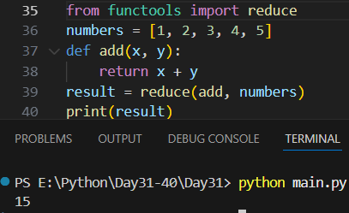
Example: reduce() and lambda.
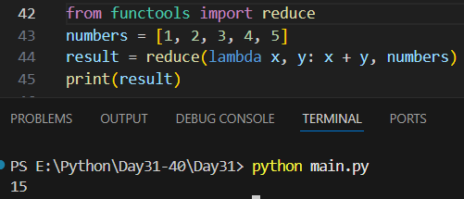

Map vs Filter vs Reduce (Simple Comparison)
Function | Purpose | Input | Output
map | Transform items | Iterable | New iterable
filter | Select items | Iterable | Fewer items
reduce | Combine items | Iterable | Single value

--The End--

