Day 14

Tuples in Python:
What is a Tuple?
A tuple is a collection of multiple values stored in one variable, just like a list, but it cannot be changed.
Tuple = immutable list
Why do we need Tuples?
- To store fixed data (data that should not change)
- Faster than lists
- Safer (no accidental changes)
- Used when data should remain constant
Creating a Tuple
t1 = (1, 2, 3)
t2 = ("Python", "Java", "C")
t3 = (1, "Hello", 3.5, True)

Important: Single-Element Tuple
Not a tuple: t = (5)
Correct tuple: t = (5,)
Comma , makes it a tuple.
Example: a basic example of tuple.
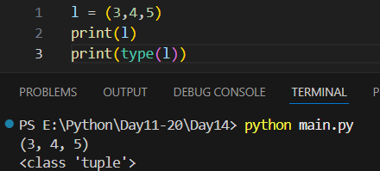

Example: accessing element by index.
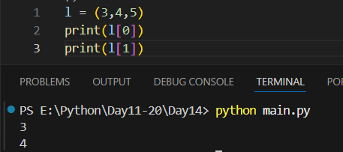
Example: tuples are immutable
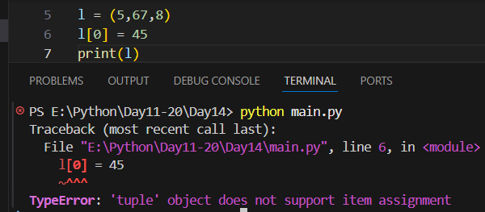
Example: tuples can have multiple data types.
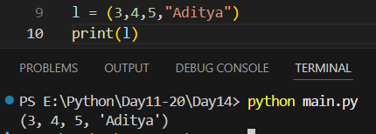

Example: negative indexing in the tuple
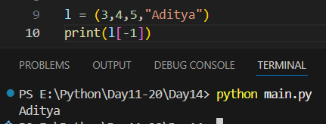
Example: to get the length of the tuple.
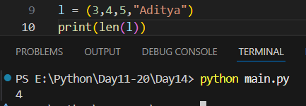
Example: looking for something in the tuple
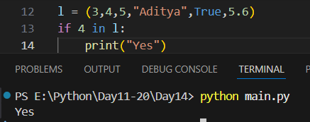

Example: we get new tuple when we do slicing.
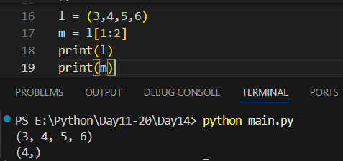
Tuple vs List (Quick)
Tuple | List
Immutable | Mutable
Uses () | Uses []
Faster | Slower
Safe | Flexible

Summary:
- Tuple stores multiple values
- Tuples are immutable
- Created using ()
- Supports indexing & slicing
- Faster and safer than lists

--The End--

