Day 49

Generators in Python:
What Is a Generator?
A generator is a special kind of function that:
- Produces values one at a time
- Remembers its state between values
- Uses yield instead of return
Think of a generator as a lazy factory: it creates values only when asked.
Problem with normal functions:
A normal function returns everything at once.
This:
- Uses more memory
- Computes all values immediately
Example:
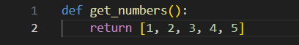
Example: using generator.
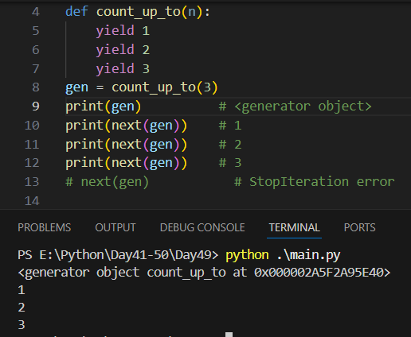
How yield Works
- yield pauses the function
- Saves all local variables
- Resumes from where it stopped
yield vs return
Feature | yield | return
Returns value | Yes | Yes
Pauses function | Yes | No
Remembers state | Yes | No
Multiple values | Yes | No

Summary:
- Generators use yield
- Produce values lazily
- Save memory
- Very Pythonic and powerful

Function Caching in Python:
What Is Function Caching?
Remembering the result of a function call so the next time the same inputs are used, Python can return the saved result instead of recomputing it.
This makes programs faster and more efficient.
Why Do We Need Caching?
Some functions:
- Are slow
- Do the same calculation repeatedly
- Return the same output for the same input
Example: manual caching.
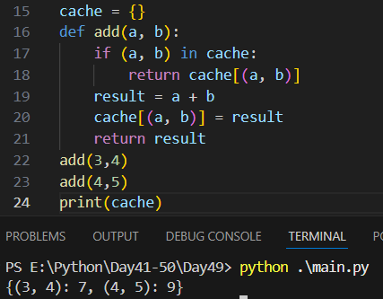
Example: python built-in solution for caching.
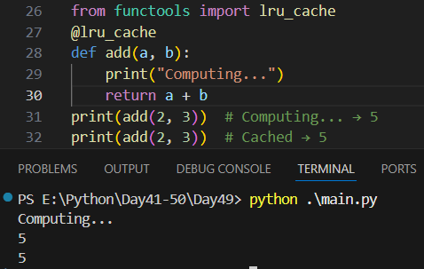

What Is lru_cache?
LRU = Least Recently Used
- Stores function results in memory
- Removes old values when cache is full
- Uses function arguments as cache keys
Caching vs Memoization
- Memoization: caching function results
- Caching: general term
In Python, they’re often used interchangeably.
Summary
- Function caching improves performance
- lru_cache is easy and powerful
- Use for deterministic, expensive functions
- Monitor cache size and memory

Regular Expressions in Python:
What Are Regular Expressions?
Regular Expressions (regex) are patterns used to search, match, and manipulate text.
Think of regex as: a powerful “find and replace” language for strings
Python’s Regex Module: re
import re
Example: regex search.
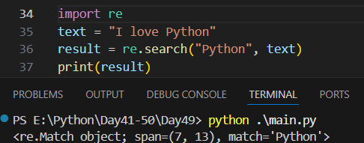
Example: returns None if not found.
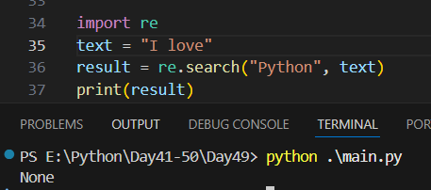
Common Regex Functions
Function | Purpose
re.search() | Find first match
re.match() | Match from start only
re.findall() | Find all matches
re.finditer() | Iterator of matches
re.sub() | Replace matches
re.split() | Split string

Example: re.search() vs re.match()
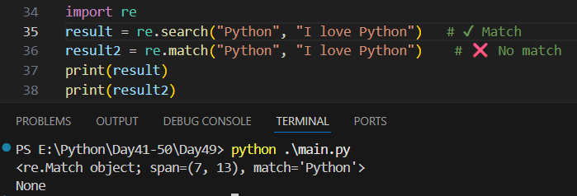
Example: finding all matches.
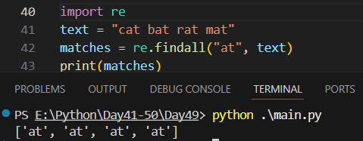
Character Classes
Pattern | Meaning
. | Any character
\d | Digit (0–9)
\w | Word (letters, digits, _)
\s | Whitespace
\D, \W, \S | Negations

Example:
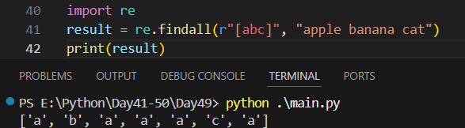
Quantifiers (How Many?)
Symbol | Meaning
* | 0 or more
+ | 1 or more
? | 0 or 1
{n} | Exactly n
{n,} | At least n
{n,m} | Between n and m
Example:
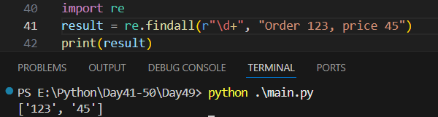
Anchors (Position Matters)
Symbol | Meaning
^ | Start of string
$ | End of string

Example:
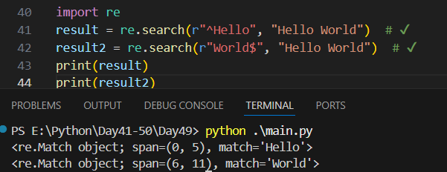
Example: splitting text
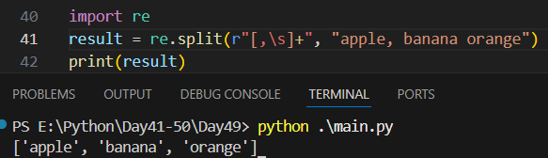
Summary
- Regex is powerful but needs practice
- Python’s re module is feature-rich
- Start small, test often
- Readability matters more than cleverness
--The End--

