Day 46

Time Module in Python:
What is the time Module?
The time module in Python provides functions to:
- Work with time
- Get current time
- Measure execution time
- Pause program execution (delay)
- Convert time formats
It deals mostly with system time (seconds since epoch).
What is Epoch Time?
Epoch is a fixed starting point in time.
- In Python: January 1, 1970, 00:00:00 (UTC)
- Time is measured in seconds since epoch
Importing the time module:
Import time
Example: time.time() – Current Time in Seconds. Returns the current time in seconds since epoch.
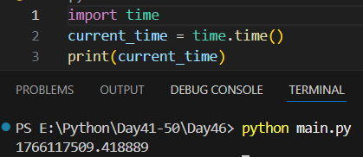

Example: time.ctime() – Readable Current Time. Converts seconds into a human-readable format.
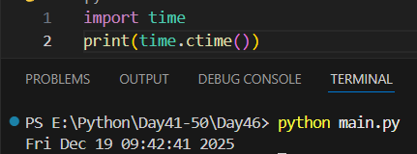

Example: time.sleep() – Pause Execution. Pauses the program for a given number of seconds.
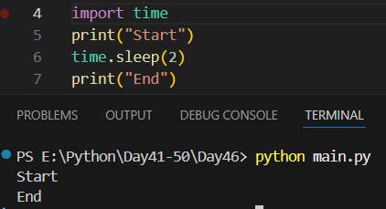
Example: time.localtime() – Local Time Structure. Returns current local time as a struct_time object.
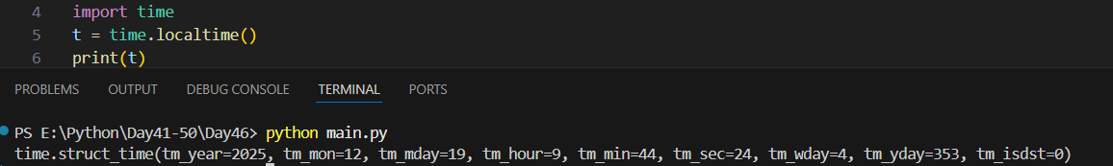
Example: time.strftime() – Formatting Time. Formats time into a readable string.
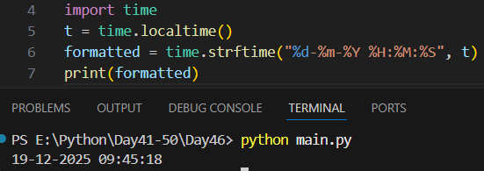

Example: measuring execution time.
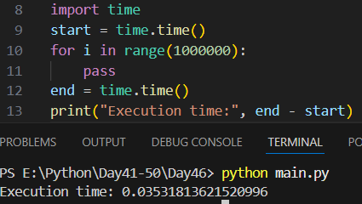
Summary
✔ time.time() → current timestamp
✔ time.sleep() → delay execution
✔ time.ctime() → readable time
✔ strftime() → formatting
✔ strptime() → parsing
✔ perf_counter() → benchmarking

Creating command line utility in python :
What is a Command-Line Utility?
A command-line utility is a Python program you run from a terminal, for example:
python greet.py Alice
or later, more professionally:
greet Alice --uppercase
First CLI Program (Very Basic):
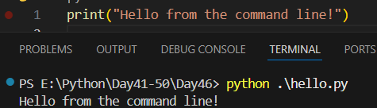
Reading Command-Line Arguments (sys.argv): Python stores command-line arguments in sys.argv.
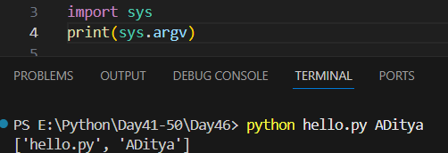
- sys.argv[0] → script name
- sys.argv[1] → first argument
Example: Simple CLI with arguments.
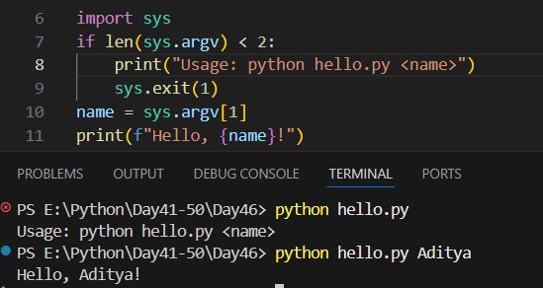

Why argparse?
Manually handling sys.argv gets messy. Python provides argparse, which gives:
- --help
- error messages
- named options
- type checking
Example: argparse CLI
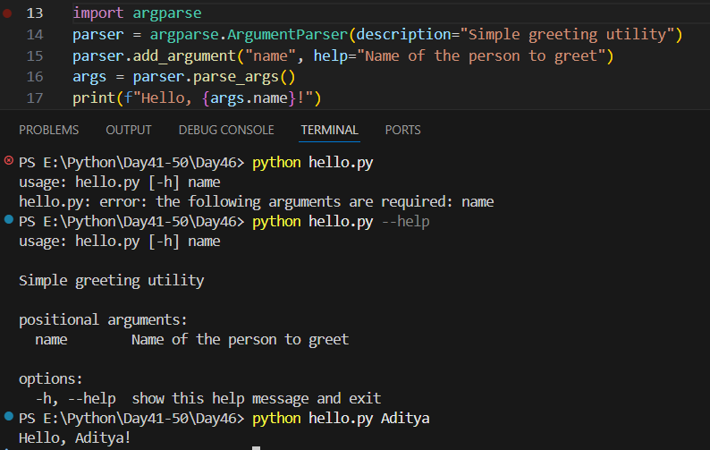
--The End--

