Day 42

Magic/Dunder Methods in Python:
What are Magic / Dunder Methods?
Magic methods (also called dunder methods) are special methods in Python:
- Start and end with double underscores: __method__
- Automatically called by Python
- Allow you to customize the behavior of objects
Example:
__init__, __str__, __add__, __len__
Why are Magic Methods Used?
They allow objects to:
- Be printed nicely
- Behave like numbers
- Support operators (+, -, ==)
- Act like containers (len(), indexing)
- Work with loops
- Support comparisons
Categories of Magic Methods
Category | Examples
Object creation | __new__, __init__
String representation | __str__, __repr__
Operators | __add__, __sub__, __mul__
Comparison | __eq__, __lt__, __gt__
Container | __len__, __getitem__
Attribute access | __getattr__, __setattr__
Callable | __call__
Context manager | __enter__, __exit__

Example: __init__ – Object Initialization -> called automatically when an object is created.
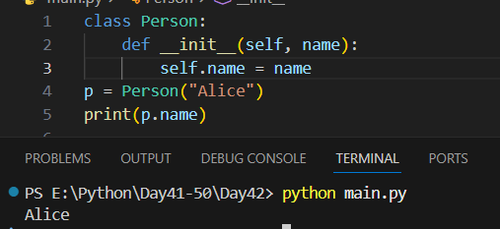
Example: __str__ – User-Friendly String Output
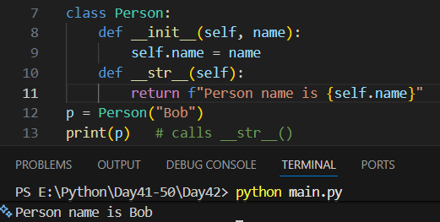
Example: __repr__ – Developer-Friendly Representation
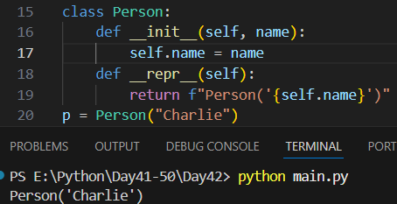
Example: __add__ – Addition Operator (+)
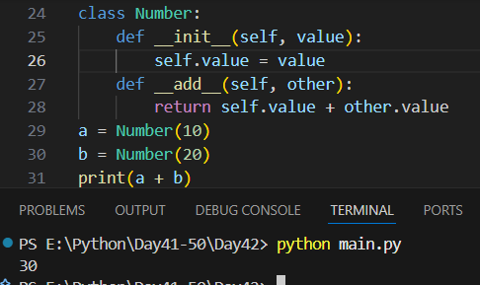
Example: __sub__ – Subtraction Operator (-)
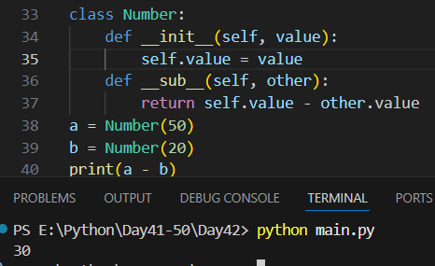
Example: __len__ – Length of Object
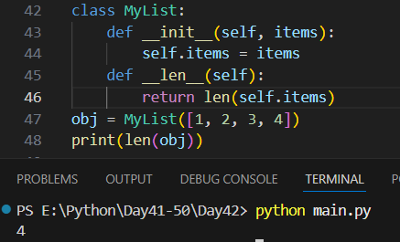

--The End--

