Day 11

Function Arguments in Python:
What are Function Arguments?
Arguments are the values we pass to a function when we call it. They help the function work with different data.
Parameters vs Arguments (Important)
def add(a, b): # a, b → PARAMETERS
return a + b
add(10, 20) # 10, 20 → ARGUMENTS
- Parameters → variables in function definition
- Arguments → actual values passed to function
Types of Function Arguments in Python:
Python mainly supports 5 types of arguments:
- Positional Arguments
- Keyword Arguments
- Default Arguments
- Variable-length Arguments (*args)
- Keyword Variable-length Arguments (**kwargs)
Default Arguments: A parameter that has a default value.
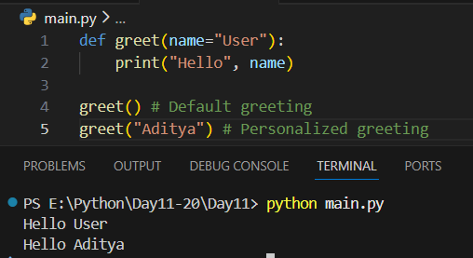

Example: default arguments another example.
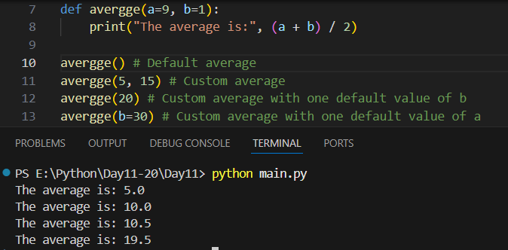
Keyword Arguments: Arguments are passed using parameter names.
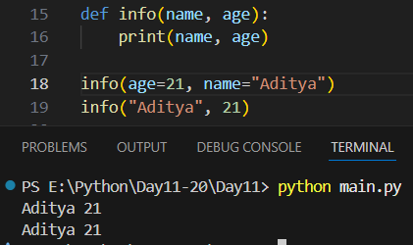
Required Arguments: Required arguments must always be passed when calling the function.
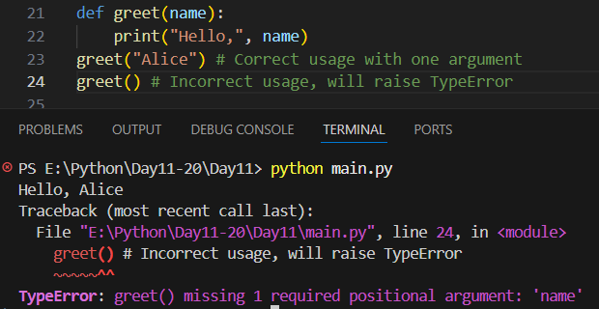
Variable-length Arguments (*args): Used when we don’t know how many arguments will be passed.
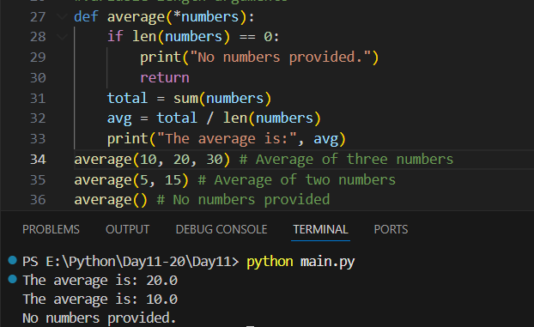
Keyword Variable-length Arguments (**kwargs): Used to pass many keyword arguments.
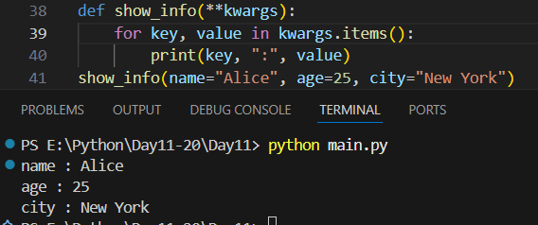
Example: basic example with ‘return’
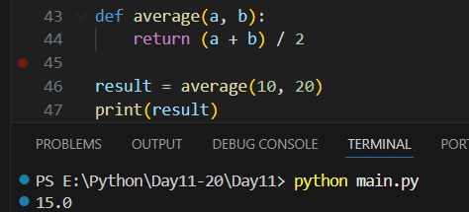
Example: above example without ‘return’
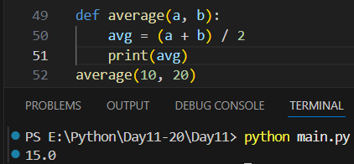
Summary:
- Arguments pass values to functions
- Positional → order matters
- Keyword → order doesn’t matter
- Default → fallback values
- *args → many positional arguments
- **kwargs → many keyword arguments
- Follow correct argument order

--The End--

