Day 9

Break and continue in Python:
What is break?
break is used to stop a loop immediately. When Python sees break, it comes out of the loop, even if the condition is still True.
What is continue?
continue is used to skip the current iteration and move to the next loop cycle. The loop does not stop, it only skips one step.
Example: basic example with “break” keyword.
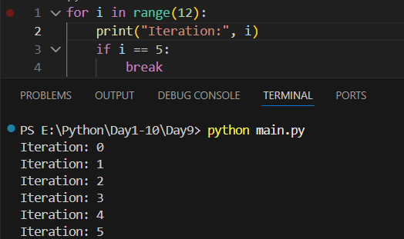
Example:
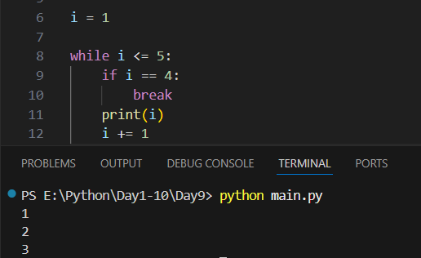
Example:
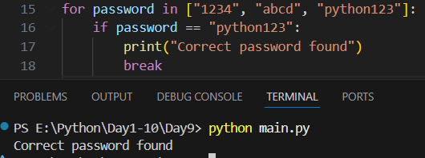
Example: using the ‘continue’ keyword
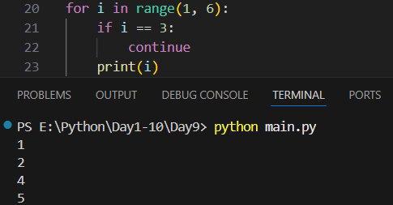
Example: while loop and continue keyword.
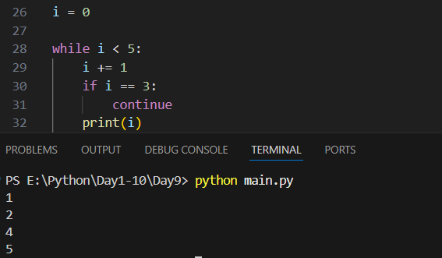

Important Difference:
break | continue
Stops the loop | Skips current iteration
Loop ends | Loop continues
Used to exit | Used to skip

Example: using both ‘break’ and ‘continue’ in the code.
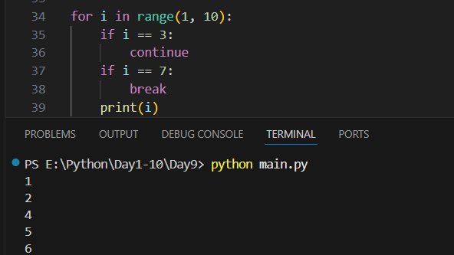
Summary:
- break stops the loop
- continue skips current iteration
- Both work in for and while
- Be careful using continue in while
- else does not execute if break is used
- Use wisely to control loops

--The End--

