Day 33

Introduction to OOPs in Python:
What is OOP?
OOP (Object-Oriented Programming) is a way of writing programs by grouping data and behaviour together.
Instead of thinking in terms of functions, we think in terms of objects.
Real-World Example
- Car
  - Data → color, model, speed
  - Behavior → drive(), brake(), stop()
Key OOP Concepts:
Python OOP is based on 4 pillars:
- Class
- Object
- Encapsulation
- Inheritance
- Polymorphism
- Abstraction

Classes and Objects in Python:
What is a Class?
A class is a blueprint or template to create objects.
class Car:
pass
This defines a class named Car
What is an Object?
An object is an instance of a class.
car1 = Car()
car2 = Car()
car1 and car2 are objects of class Car
Example: creating a class, an object, and printing one of its attributes.
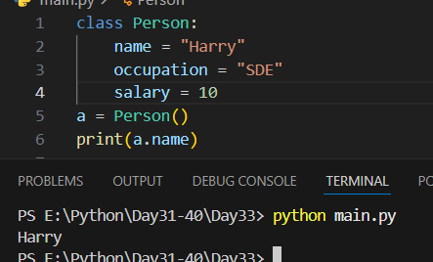

Example: updating the attributes.
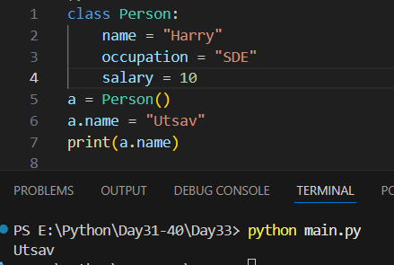
Example: Methods (Functions inside a Class)
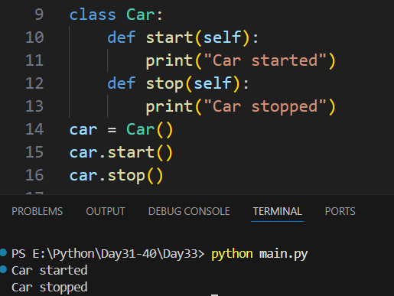

self Keyword (VERY IMPORTANT)
- Represents the current object
- Allows access to object variables and methods
Example: self is missing.
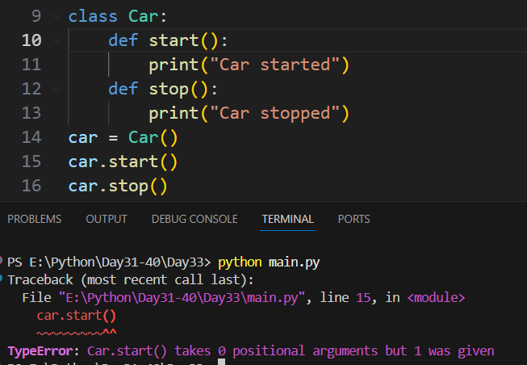
--The End--

