Day 38

Static Methods in Python:
What is a Static Method?
A static method is a method that:
- Belongs to a class, not to any specific object (instance)
- Does not use:
  - self (instance data)
  - cls (class data)
- Behaves like a regular function, but lives inside a class for logical grouping
Think of it as:
“A utility function related to a class”
Why Do We Need Static Methods?
Static methods are used when:
- The logic conceptually belongs to a class
- But it doesn’t need object data or class data
Example idea: A class MathUtils that groups math-related functions.
Normal Method vs Static Method
Normal (Instance) Method:
class Example:
def instance_method(self):
print("Needs an object")
- Requires an object
- Uses self
Static Method:
class Example:
@staticmethod
def static_method():
print("Does NOT need an object")
- No self
- No cls
- Can be called without creating an object
Example: normal (instance) method.
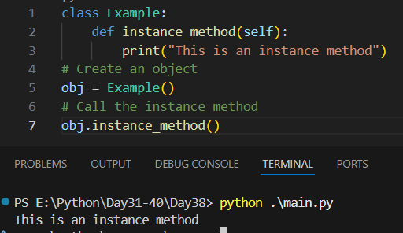
Example: static method.
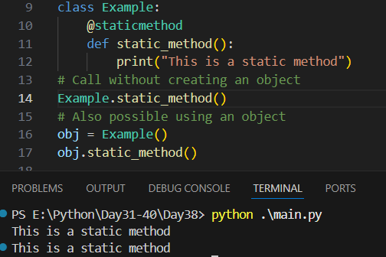
Summary:
- Are defined using @staticmethod
- Do not use self or cls
- Are called using the class name
- Help organize related functions

Instance variables vs Class variables in Python:
What Are Variables in a Class?
In Python, variables inside a class are of two types:
- Instance Variables → Belong to an object
- Class Variables → Belong to the class itself
Instance Variables (Object Variables)
Instance variables:
- Are unique to each object
- Are created using self
- Store data that differs from object to object
Class Variables (Static Variables)
Class variables:
- Are shared by all objects
- Are declared inside the class but outside methods
- Store data common to all objects
Example: a very important example before anything. Clearly, both “emp1.showDetails()” and “Employee.showDetails(emp1)” are equivalent to each other, as the output for both is same.
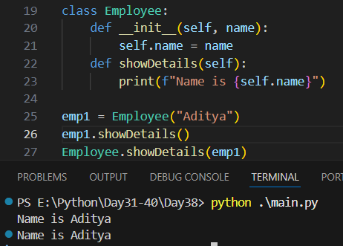

Example:
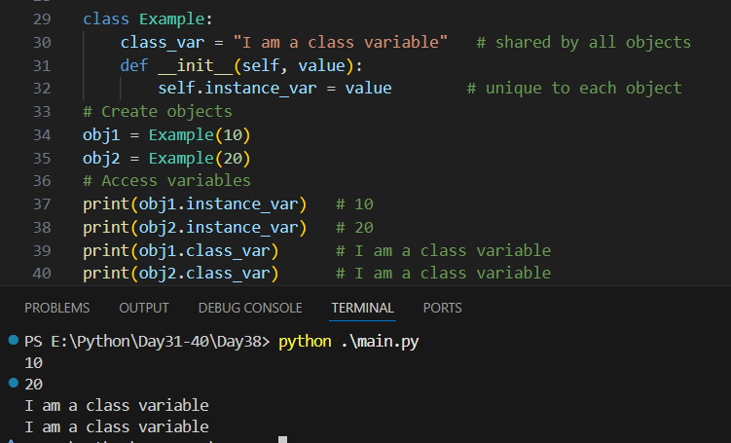
Summary:
- Instance Variables
- Belong to an object
- Created using self.variable
- Defined inside methods (usually __init__)
- Separate copy for each object
- Change affects only that object
- Used for object-specific data
- Class Variables
- Belong to the class
- Defined inside the class, outside methods
- Single shared copy for all objects
- Change affects all objects
- Used for common/shared data
- Key Point
- Changing a class variable using an object name creates an instance variable

--The End--

