Day 19

Sets in Python:
What is a Set?
A set is a collection of unique values.
This means:
- No duplicate elements
- Unordered (no fixed index)
- Written using { }
Why Do We Use Sets?
- To remove duplicates
- To perform mathematical set operations
- Fast checking of values (in)
Creating a Set:
numbers = {1, 2, 3, 4}
print(numbers)

Example: a basic example of set.
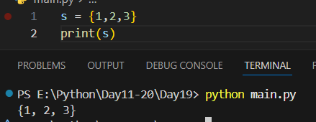

Example: when there be duplicate items in the set, they automatically get removed.
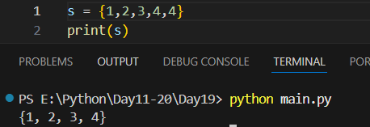
Example: they are unordered.
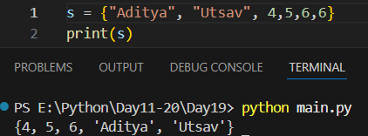
Example: type(set)
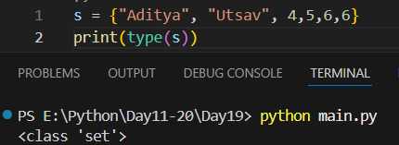
Example: what be the type of the set which has no element? Dictionary.
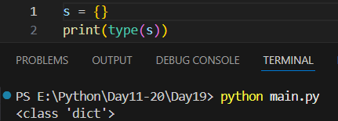

Example: thus to create an empty set we uses set()
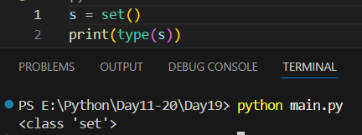
Example: accessing the elements of the set.
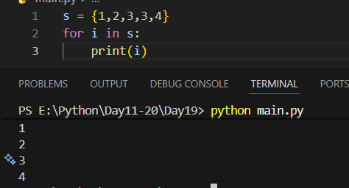
Summary:
- Set stores unique values
- No order, no index
- Very fast operations
- Used to remove duplicates
- Supports union, intersection, difference

Set Methods in Python:
Example: union() -> it will not change the original set.
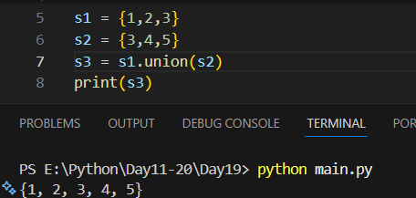
Example: update() -> it will change the original set.
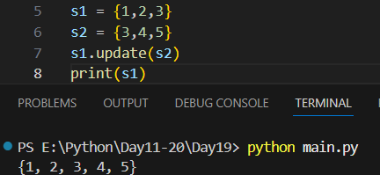
Example: intersect()
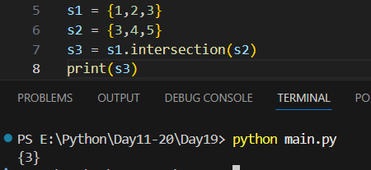
Example: intersection_update()
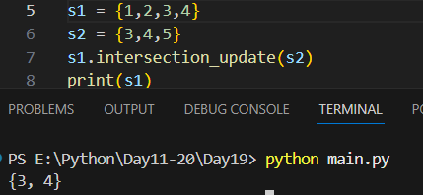
Example: what if there are no common elements for intersection? Then an empty set will be returned.
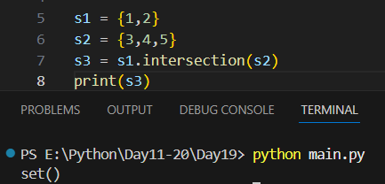
Example: symmetric difference
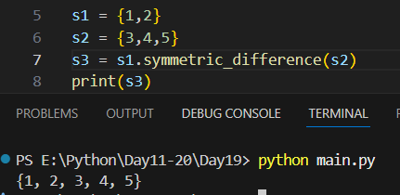
Example: symmetric difference update.
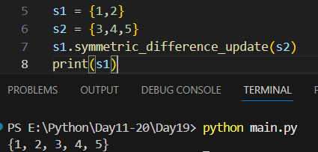
Example: difference()
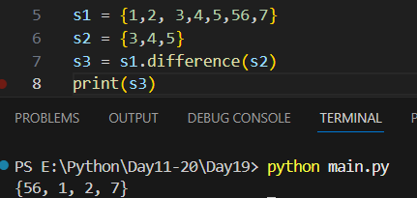
Example: difference_update()
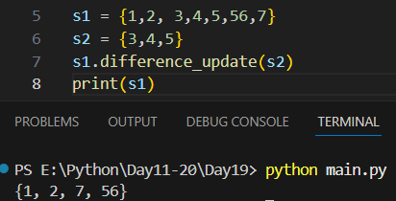
Example: isdisjoint()
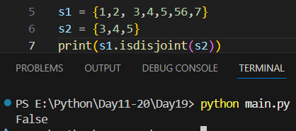
Example: issuperset()
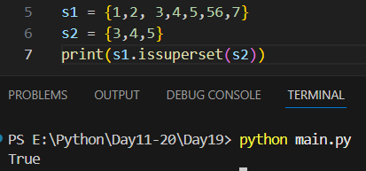
Example: issubset()
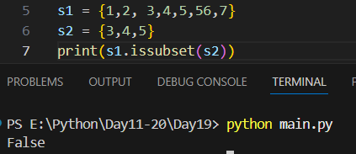
Example: add()
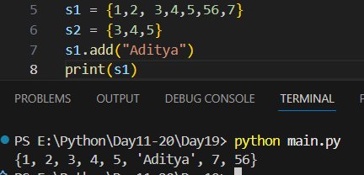
Example: remove()
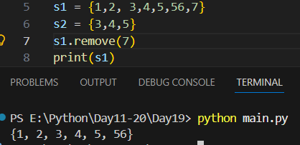
Example: discard()
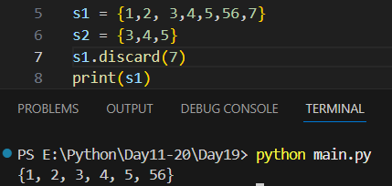

Example: pop()
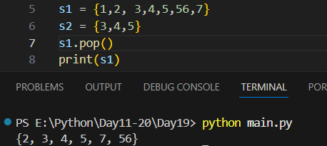
Example: del -> delete entire set.
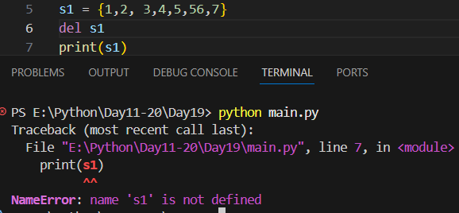
Example: clear()
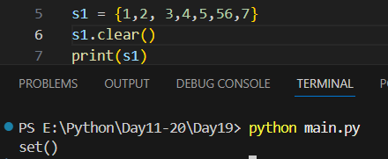

Example: check if item exists.
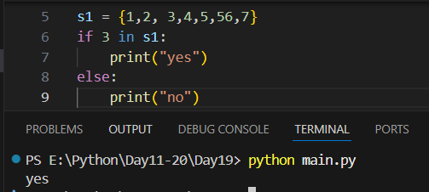
Summary:
- Set methods modify or compare sets
- add, update → add elements
- remove, discard, pop, clear → remove elements
- union, intersection, difference → set operations
- issubset, issuperset, isdisjoint → relationships

--The End--

