Day 17

Docstrings in Python:
What is a Docstring?
A docstring (documentation string) is a string written inside a function, class, or module to explain what it does.
It helps:
- Other programmers
- Future you
- Tools & IDEs
understand the code easily.
Why do we use Docstrings?
- To document code
- To explain purpose, parameters, and return value
- To make code professional & readable
- Used by help() function
How to Write a Docstring?
- Written using triple quotes (""" """ or ''' ''')
- Placed just below the function/class definition
Example: square of a number, without any docstring.
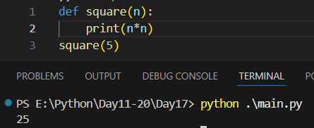

Example: we had added docstring.
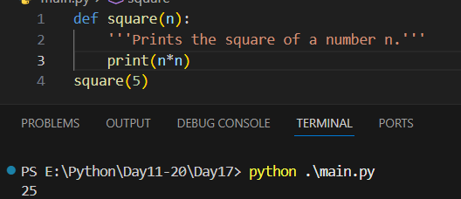
Example: printing the content of docstring. Using “__doc__”.
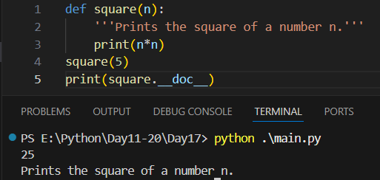
Example: we can also use Help() to print the content of the docstring.
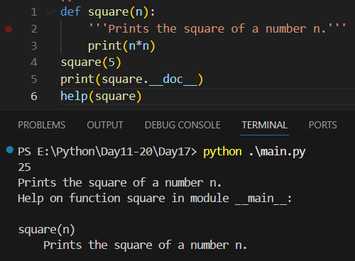
Example: invalid docstring, as we write the code of the function before the docstring.
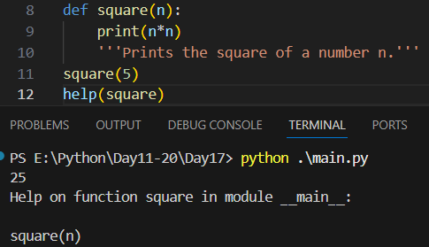
Docstring vs Comment:
Docstring | Comment
Used for documentation | Used for explanation
Written with triple quotes | Written with #
Accessible using help() | Not accessible
Stored in __doc__ | Ignored at runtime

Summary:
- Written using triple quotes
- Placed just below definition
- Accessible using __doc__ and help()
- Better than comments for documentation
--The End--

