Day 10

Functions in Python:
What is a Function?
A function is a block of reusable code that performs a specific task. Instead of writing the same code again and again, we put it inside a function and reuse it.
Why do we need Functions?
- To avoid repetition
- To make code clean and organized
- To reuse code
- To make programs easy to understand
Types of Functions:
- Built-in functions: Examples: print(), len(), input()
- User-defined functions: Functions created by the programmer
Example: Geometric mean without using the functions.
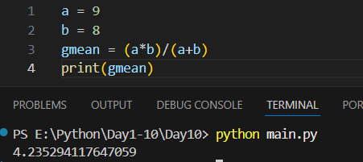
Creating a Function (def): Syntax
def function_name():
# code

Example: calculating the geometric mean using the functions in python.
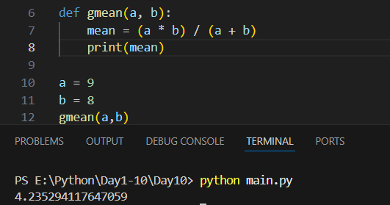
Example: code to compare the two numbers without using functions.
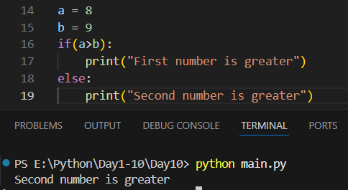
Example: code to compare the numbers using functions.
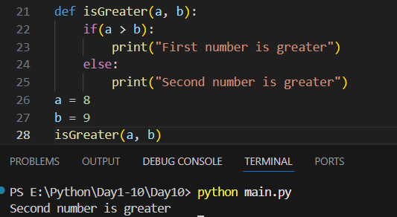
Example:
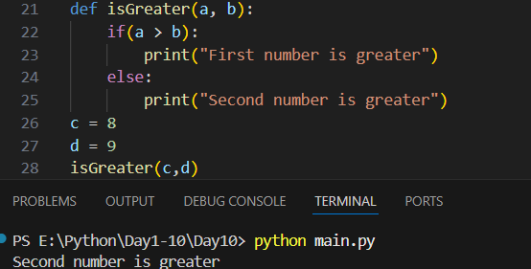
Example: we uses “pass” for things we don’t want to write as of now.
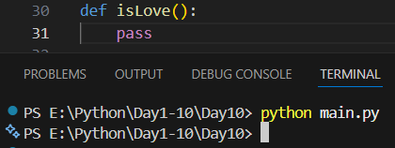
Example:
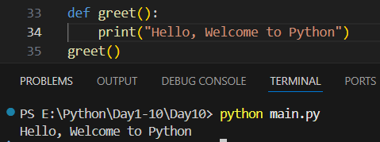
--The End--

