Day 41

super keyword in Python:
What is super()?
super() is used to call methods or access attributes from a parent (base) class inside a child (derived) class.
It helps with:
- Code reuse
- Method overriding
- Multiple inheritance
- Avoiding direct parent class names
Why do we need super()?
Without super():
- You must manually call the parent class
- Breaks easily if class names change
- Causes issues in multiple inheritance
With super():
- Python automatically finds the next class in the inheritance chain

Basic Syntax:
super().method_name()
or inside __init__:
super().__init__(arguments)

Example:
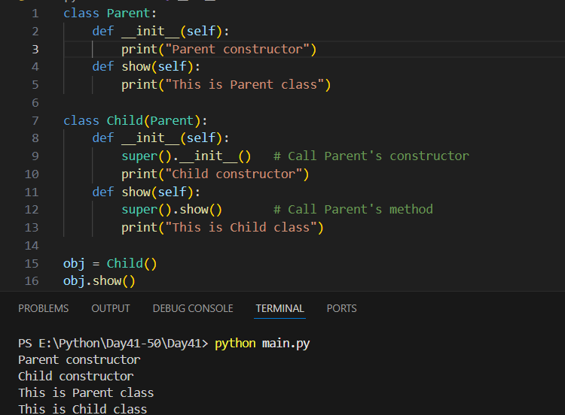
Example: super() with parameters
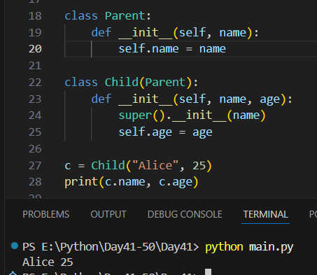

Example: super() in multiple inheritance
