Day 50

AsyncIO in Python:
What Is asyncio?
asyncio is Python’s library for asynchronous programming.
It lets your program:
- Do many things at once
- Without threads
- By waiting efficiently (non-blocking)
Best for I/O-bound tasks (network, disk, timers), not CPU-heavy work.
The Problem asyncio Solves: Synchronous (Blocking) Code. Asynchronous Idea: While one task is waiting, another task can run.
Key Async Concepts:
Term | Meaning
Event Loop | The scheduler that runs async tasks
Coroutine | A function that can pause & resume
await | Pause execution until result is ready
Task | A scheduled coroutine
Non-blocking | Doesn’t stop the whole program
Example:
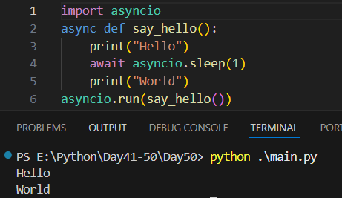
What Makes a Function Async?
async def my_function():
...
- async def → coroutine function
- Calling it does not run it immediately

await – The Heart of AsyncIO
await asyncio.sleep(2)
This means: “Pause this task, let others run, and resume later.”
Example: without asyncio
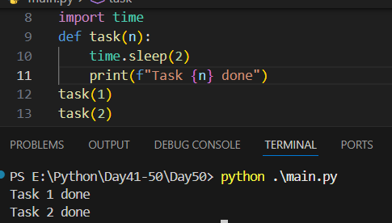
Example: with asyncio
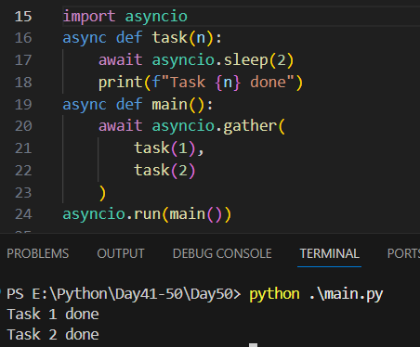

Async vs Threads vs Processes
Type | Best For
asyncio | I/O-bound tasks
Threads | Blocking I/O
Processes | CPU-bound tasks
Example:
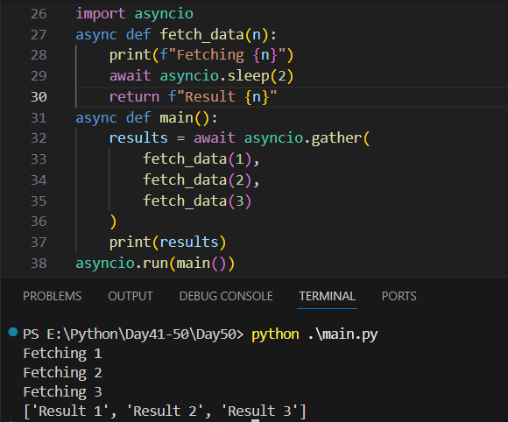
Summary
- asyncio enables efficient concurrency
- Uses coroutines (async / await)
- Perfect for I/O-bound tasks
- Event loop handles scheduling

Multithreading in Python:
What Is Multithreading?
Multithreading allows a program to run multiple threads (tasks) at the same time.
- A thread is the smallest unit of a program that can execute independently.
- Threads share the same memory space.
- Useful for I/O-bound tasks, like downloading files or waiting for network responses.
Why Use Multithreading?
Python threads can help you:
- Perform multiple tasks without waiting for each one to finish
- Improve performance for I/O-bound operations
- Keep a program responsive (e.g., GUI apps)
Note: For CPU-bound tasks, Python threads are limited by the GIL (Global Interpreter Lock). Use multiprocessing instead.
The threading Module
Python provides the threading module to create and manage threads:
Import threading
Example:
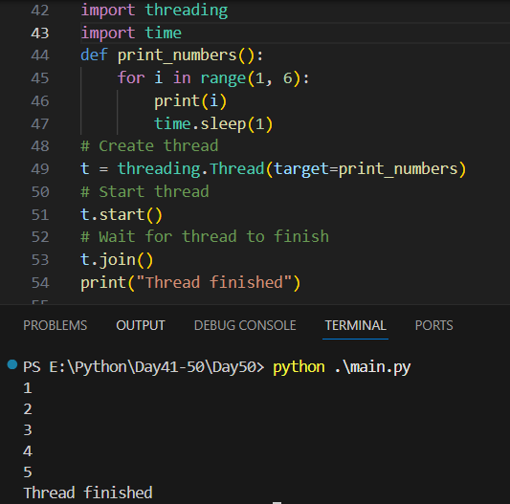

Key Methods in threading.Thread
Method | Purpose
start() | Starts the thread
run() | Thread’s code (called by start())
join() | Waits for thread to finish
is_alive() | Checks if thread is running

Example: running multiple threads.
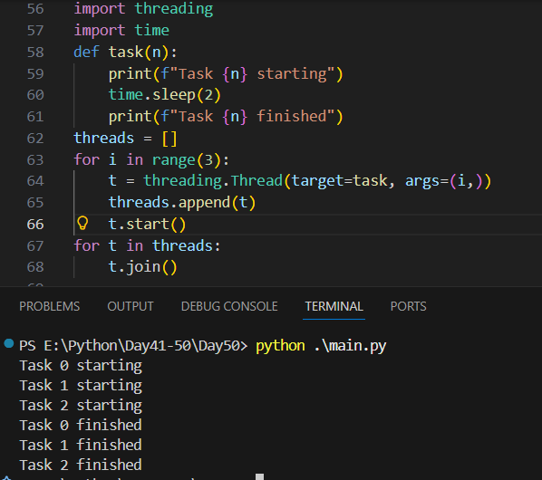
Thread vs Process
Feature | Thread | Process
Memory | Shared | Separate
GIL | Yes (limits CPU-bound) | No
I/O-bound | Good | Overkill
CPU-bound | Limited | Best

Summary
- threading enables concurrent execution of I/O tasks
- Use Thread, ThreadPoolExecutor, Lock, daemon wisely
- Not ideal for CPU-heavy work (use multiprocessing)
- Essential for responsive or I/O-heavy applications

Multiprocessing in Python:
What Is Multiprocessing?
Multiprocessing allows Python to run multiple processes at the same time, each with its own memory space.
- Each process is independent.
- Bypasses Python’s GIL (Global Interpreter Lock).
- Ideal for CPU-bound tasks like heavy calculations, data processing, or simulations.

The multiprocessing Module
Python provides the multiprocessing module to create and manage processes:
Import multiprocessing
Example:
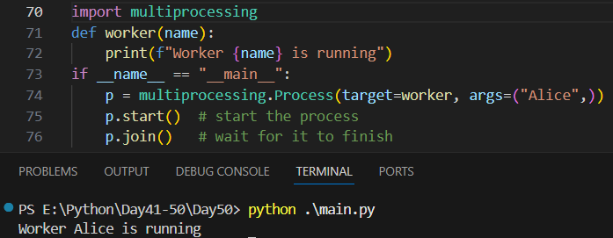
Note: Always protect the entry point with if __name__ == "__main__": when using multiprocessing on Windows.

Example: running multiple processes.
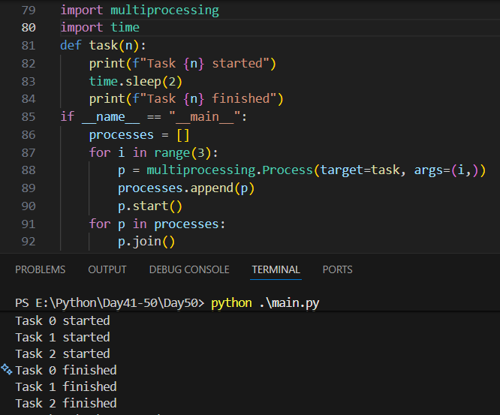
Process vs Thread
Feature | Thread | Process
Memory | Shared | Separate
GIL | Yes | No (true parallelism)
CPU-bound | Limited | Ideal
I/O-bound | Good | Works but overhead

Sharing Data Between Processes
Processes do not share memory by default. You need:
- multiprocessing.Queue
- multiprocessing.Pipe
- multiprocessing.Manager
Example: using queue.
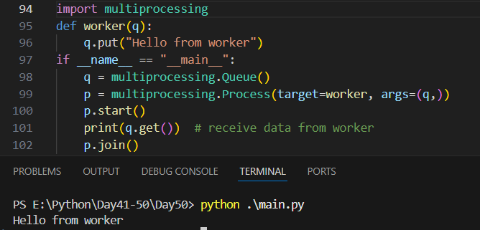
Example: using manager director.
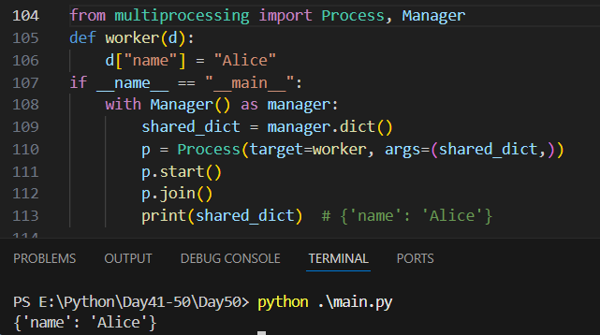
Summary
- Use multiprocessing for CPU-bound tasks
- Use Process, Queue, Pool, or Manager
- Threads are still better for I/O-bound tasks
- Always protect main entry point with if __name__ == "__main__"

--The End--

