ReactJS
Zustand:
What is Zustand?
Zustand is a small, lightweight state management library for React. Its purpose is to let multiple components share state without prop drilling or excessive Context providers.
Feature | Zustand | Redux Toolkit
Boilerplate | Very little | Moderate
Learning curve | Easy | Medium
Store setup | Simple | More setup
Reducers | Optional | Required via slices
Actions | Usually not needed | Required
DevTools | Yes | Excellent
Middleware | Basic | Powerful
Async support | Simple | Excellent
Performance | Excellent | Excellent
Ecosystem | Smaller | Huge

How to install Zustand?
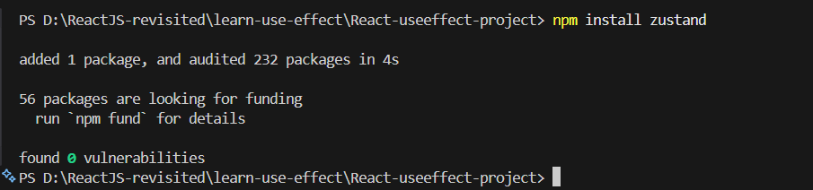

Let’s first create the store in zustand:
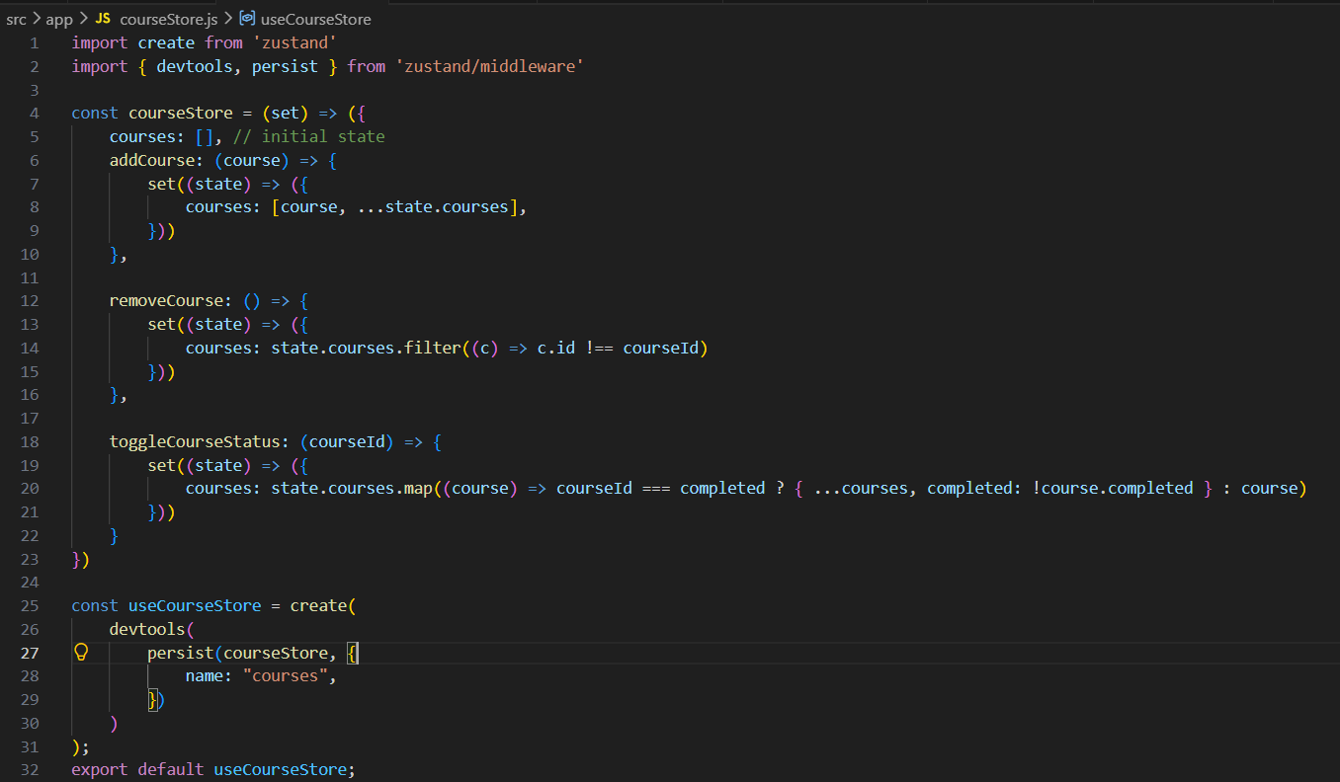
This code creates a global store using Zustand to manage a list of courses in a React app. It starts with an empty courses array and provides functions to add a course, remove a course, and toggle a course's completion status by updating the shared state with set(). The persist middleware saves the course data in the browser's local storage, so it remains available after a page refresh, while devtools lets you inspect and debug state changes using the Redux DevTools browser extension. Finally, the store is exported as useCourseStore, which any React component can use to access and update the shared course data.
Note: The removeCourse and toggleCourseStatus functions contain a few coding mistakes and would need small fixes to work correctly.
Now, we will create the form to take the input and store in the ‘store’.
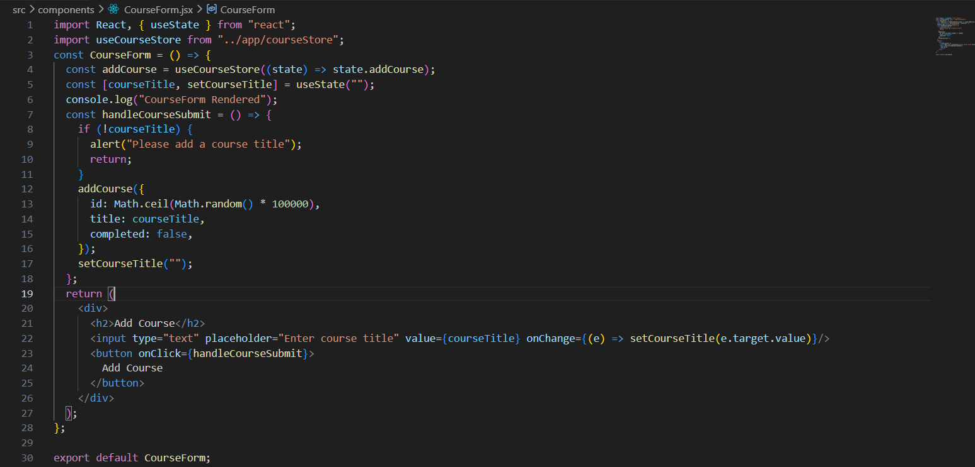
Updated courseStore.js:
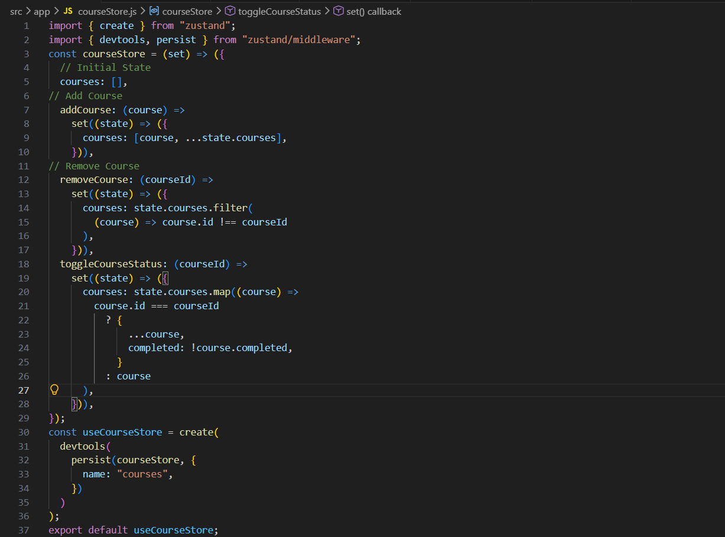
Output:
