ReactJS
Routing in ReactJS:
Routing is the mechanism that allows a web application to change what the user sees on the screen based on the URL in the browser's address bar.
What is a Route?
A Route is a specific URL path mapped to a specific component or view in your application.
Think of it as a set of instructions for your app:
- If the user visits /, show the Home component.
- If the user visits /dashboard, show the Dashboard component.
- If the user visits /settings, show the Settings component.
Why Do We Need It?
By default, React is a Single Page Application (SPA) framework. This means the browser loads exactly one HTML file (index.html) from the server. Without routing, if a user wanted to see their profile, you would have to manage that using state (e.g., if (showProfile) render Profile()). However, this introduces major issues:
- No Unique URLs: The URL would always just be www.myapp.com. Users couldn't bookmark their profile or share a specific page link with a friend.
- Broken Back/Forward Buttons: Clicking the browser's back button would take the user completely out of your website, rather than just taking them back to the previous view.
- Poor SEO: Search engines struggle to index different sections of your app if they all live under a single, unchanging URL.
Routing solves all of this by syncing your app's UI with the browser's URL bar.
Why You Should Prefer react-router-dom?
react-router-dom is the undisputed industry standard for React routing for several key reasons:
- Declarative Routing: It allows you to define your routes using standard React components and hooks, fitting perfectly into the React ecosystem.
- Dynamic Matching & Parameters: It easily handles complex URLs like /user/:id (where :id can be any user's ID).
- Nested Layouts: It lets you keep a persistent sidebar or navbar while only swapping out the center content of your page.
- Performance Optimization: It includes built-in features for code-splitting and lazy-loading, ensuring your app stays fast as it grows.

Command to install the react-router-dom:
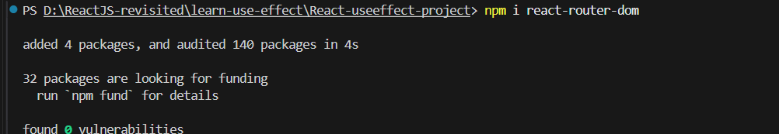
To import:
Now, let’s understand this with an example:
App.jsx:
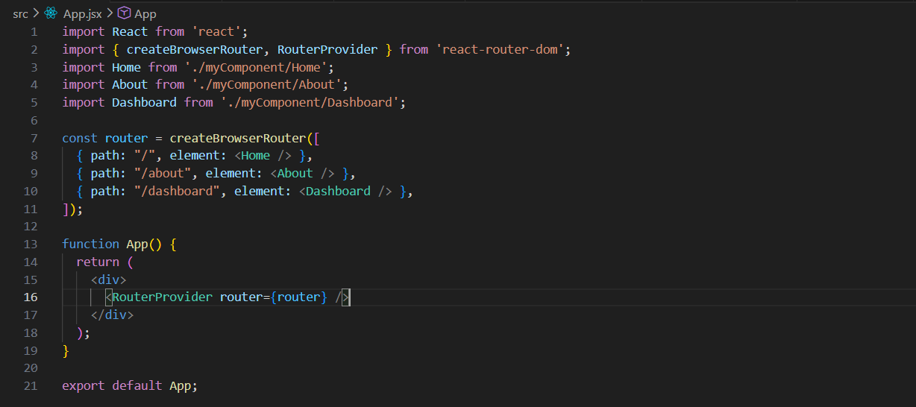
Home.jsx, About.jsx, Dashboard.jsx: has basic code inside it.
Output:
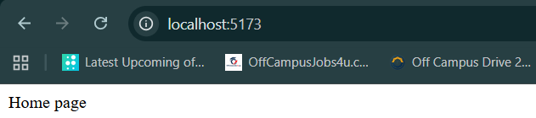
Output: when we hit the url /about
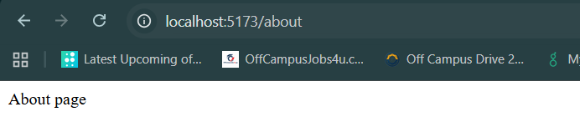

Output: when we hit the url /dashboard
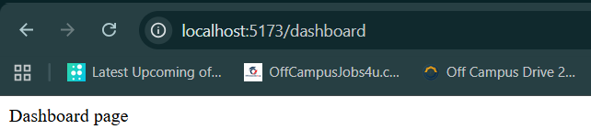
This function is used to declare all your application paths and their corresponding components in a clean, nested structure.
Clearly, it worked as intended. Now, let’s understand the part of that code:
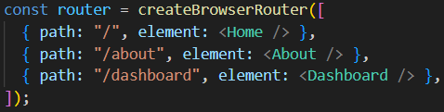
This code creates a routing configuration for your React app. createBrowserRouter() takes an array of route objects, where each object says: "If the URL matches this path, show this component." For example, if the URL is /, React renders <Home />; if it's /about, it renders <About />; and if it's /dashboard, it renders <Dashboard />. The resulting router object is then given to <RouterProvider> so React Router knows how to navigate between pages without reloading the browser.
This component is wrapped around your root application. It actually kicks off the routing functionality and injects the route configurations into React.
While, this code part:
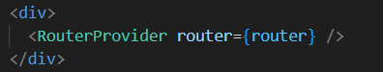
<RouterProvider router={router} /> is the component that activates the router in your app. It takes the router object you created with createBrowserRouter() and tells React, "Use these route rules to decide which component to display based on the current URL." Without RouterProvider, your routes exist as configuration, but React wouldn't know how to use them for navigation.
But, don’t you think we have to manually enter the address in the url? Yes, to make sure we don’t do this, we will use the Navbar. For which we created a Navbar.jsx:
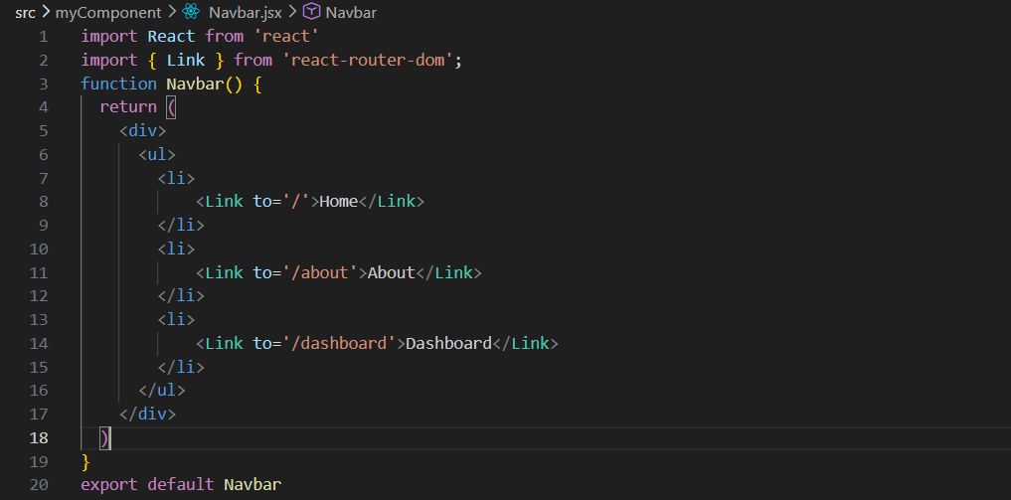
Now, we have to make sure that Navbar shall be present in each page, so we have to change the App.jsx, making sure that for each url, Navbar shall be present.
For, that the part will look like this:
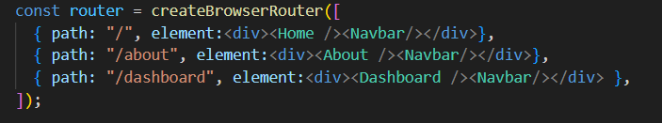
Now, the whole App.jsx:
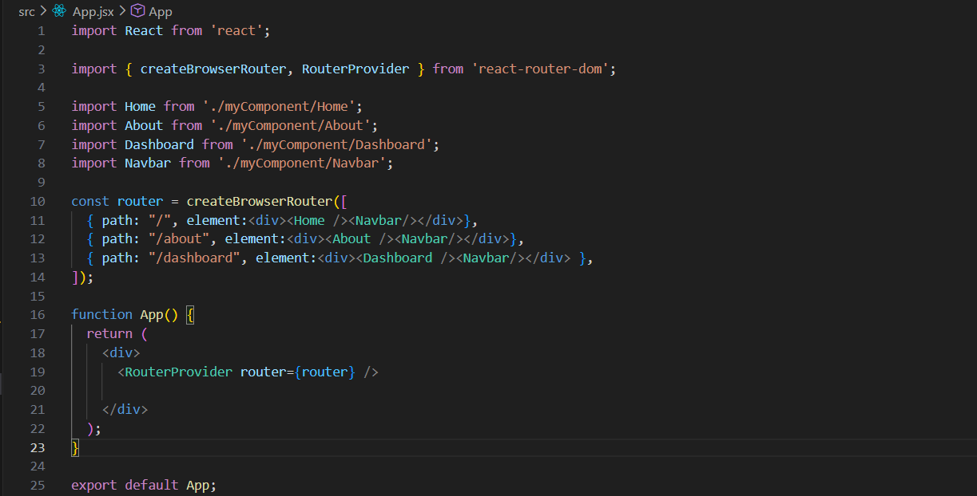
Output:
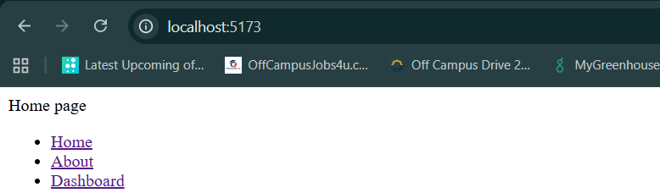
Output:
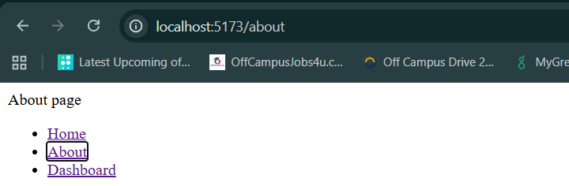

Output:
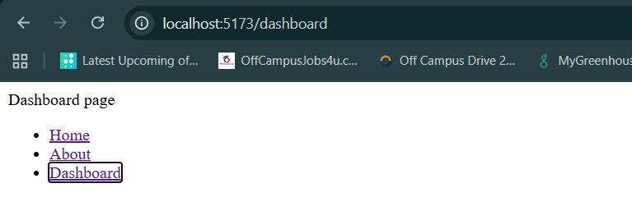
Observe that the page is not reloading. Fulfilling the goal of SPA of the react. But what actually happening in the background?
The browser does not reload the entire page. Instead:
- React Router changes the URL using the browser's History API.
- It checks which route matches the new URL.
- It unmounts the old route component (for example, <Home />).
- It mounts the new route component (for example, <About />).
- Components that are outside the changing area (like a Navbar) remain on the screen and are not recreated.

Now, you would have observed some kind of parameters passed in the URL when we visit a link? Right? Yes!
What are the parameters?
In routing, parameters (often called URL params or dynamic routes) are placeholders in a URL path that allow you to capture dynamic values. Instead of creating a unique route for every single user, product, or article (e.g., /user/1, /user/2, /user/3), you define one single route with a parameter placeholder.
How to Define a Route Parameter?
In react-router-dom, you define a parameter by placing a colon (:) in front of the parameter name inside your path string.
Example:

Now, the App.jsx:
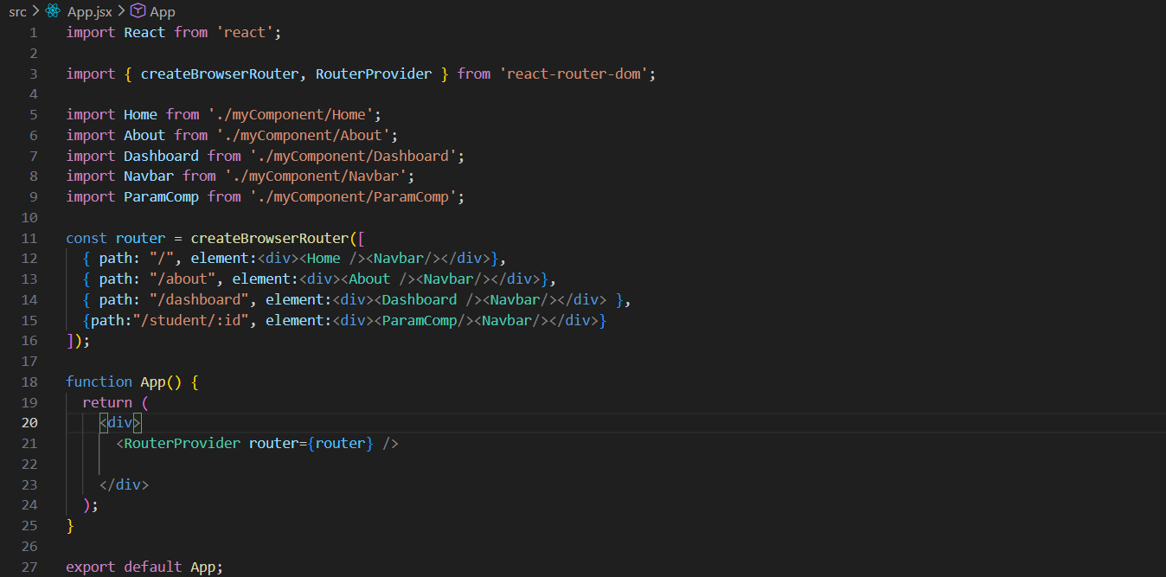
And the new component which we created, Paramcomp.jsx:
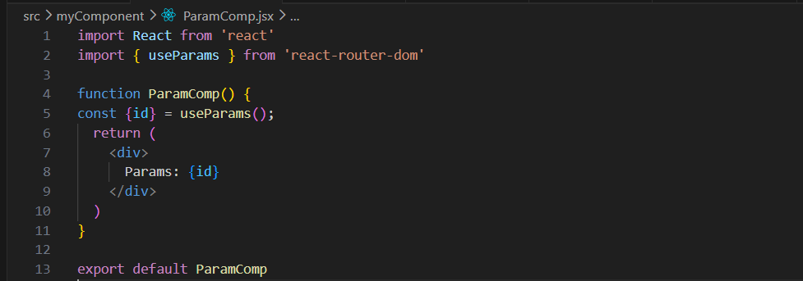
To access the actual value typed into the URL inside your component, React Router provides a built-in hook called useParams.
Output: the moment we type /student/abcd in the URL.
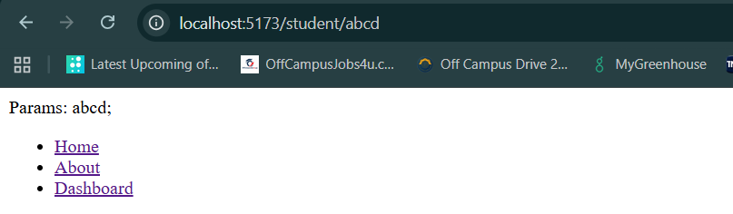

Now, there is something called as useNavigate hook.
What is useNavigate hook?
The useNavigate hook is used for programmatic navigation. It allows you to redirect users to different pages using code logic (e.g., inside functions, event handlers, or useEffect blocks) rather than relying on a direct user click on a <Link> component.
When to Use useNavigate vs. <Link>
- Use <Link> (Declarative): For static navigation where the user directly initiates the change by clicking (e.g., Navbars, Menus, Footers).
- Use useNavigate (Programmatic): For dynamic navigation triggered by background code or after an event finishes executing.

Example: suppose we add a button on the home page to navigate to the dashboard.
Home.jsx:
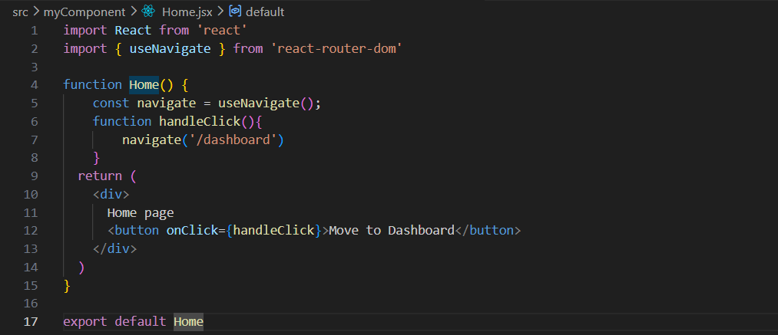
useNavigate() provides a navigate function that lets you change routes using JavaScript. In this code, when handleClick() is called (for example, by clicking a button), navigate('/dashboard') changes the URL to /dashboard and displays the Dashboard component without reloading the entire page.
Output:
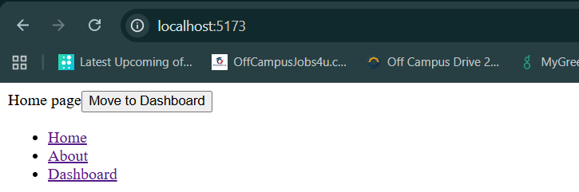

Output: when clicked on the button.
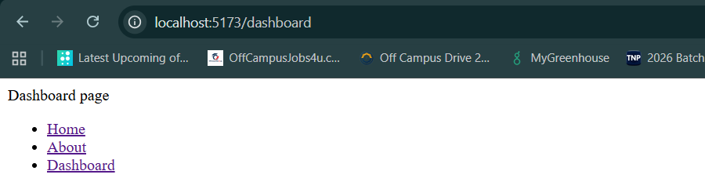
Done!
Now, we will study about the concept of Nested routing:
What is Nested Routing?
Nested Routing is the practice of rendering routes inside other routes. It allows you to build complex user interfaces where parts of the page stay exactly the same (like a sidebar, layout header, or dashboard menu) while other parts of the page dynamically swap content based on the sub-path.
Think of an application dashboard. The top navigation bar and left sidebar should stay on the screen at all times. When a user switches between "Analytics" and "Settings," only the center content panel changes.
- URL /dashboard -> Shows Dashboard Layout + General Stats
- URL /dashboard/analytics -> Shows Dashboard Layout + Live Graphs
- URL /dashboard/settings -> Shows Dashboard Layout + Settings Forms
How to set up Nested routing?
To set up nested routing using createBrowserRouter, you pass an array of routes to the children property of a parent route.
Example:
App.jsx:
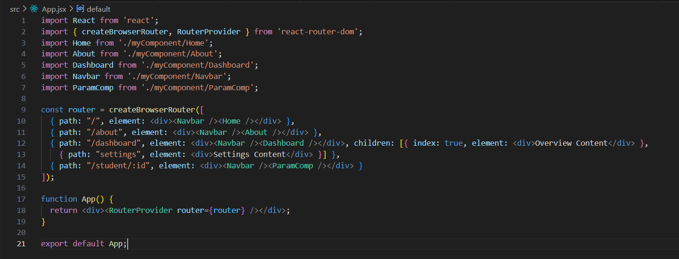
It defines /dashboard as a parent layout containing a navigation bar and the main dashboard view, which automatically loads "Overview Content" at the main URL or "Settings Content" when navigating to /dashboard/settings.

Dashboard.jsx:
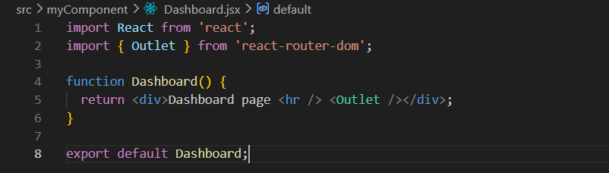
It acts as a dynamic placeholder inside a parent component where the matching child route's content will be automatically rendered.
Output:
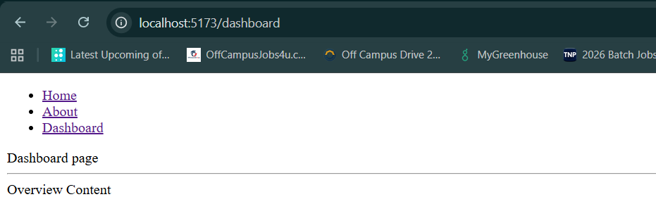
Output: for /setttings
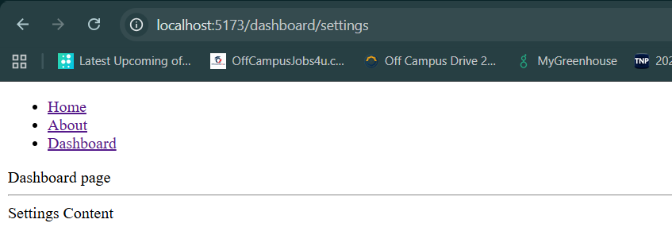

useRef Hook:
Routing is the mechanism
What is useRef?
The useRef Hook in React is used to store a value that persists between renders without causing a re-render when it changes.
When to use useRef?
It's commonly used for:
- Accessing DOM elements directly.
- Storing mutable values (timers, previous values, etc.).
- Preserving values between renders without triggering updates.
Syntax:
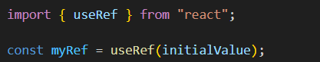
Example: without useRef.
App.jsx:
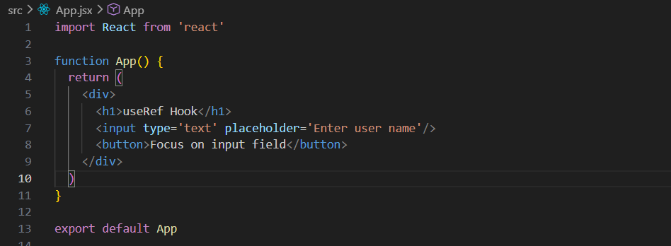
Output:
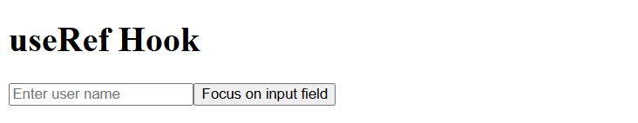

Example: now making the input field get focused when someone click on the button, using the useRef.
App.jsx:
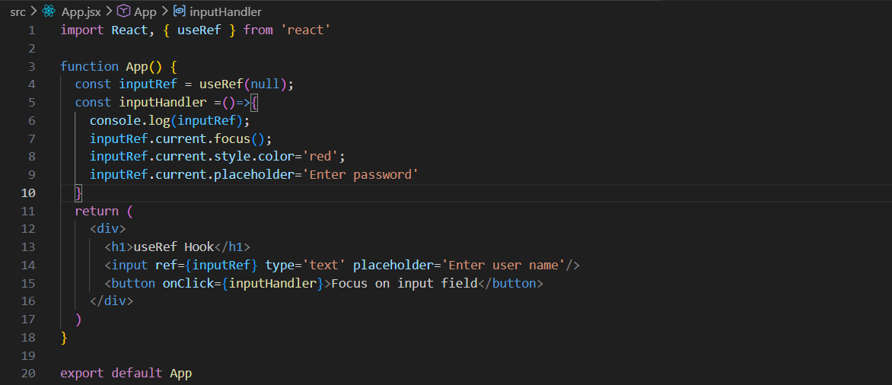
In this code, useRef(null) creates a reference called inputRef that is attached to the <input> element using ref={inputRef}. When the button is clicked, the inputHandler function runs and uses inputRef.current to directly access the actual input box in the DOM. It then focuses the input field (focus()), changes the text color to red (style.color = 'red'), and updates the placeholder text to "Enter password". In simple terms, useRef lets you directly work with a DOM element without re-rendering the component.
Output:
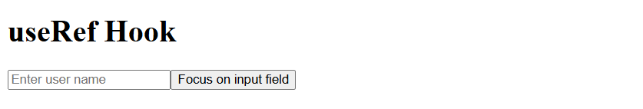
Output: when you clicked on the button, and started writing. We see that placeholder is changed, focus came on the input field, and the text colour also got changed to red.
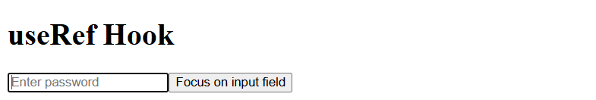
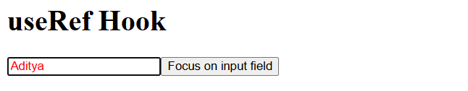

Also, we can use the useRef hook to hide and show, although it is not a good practice to do so.
App.jsx:
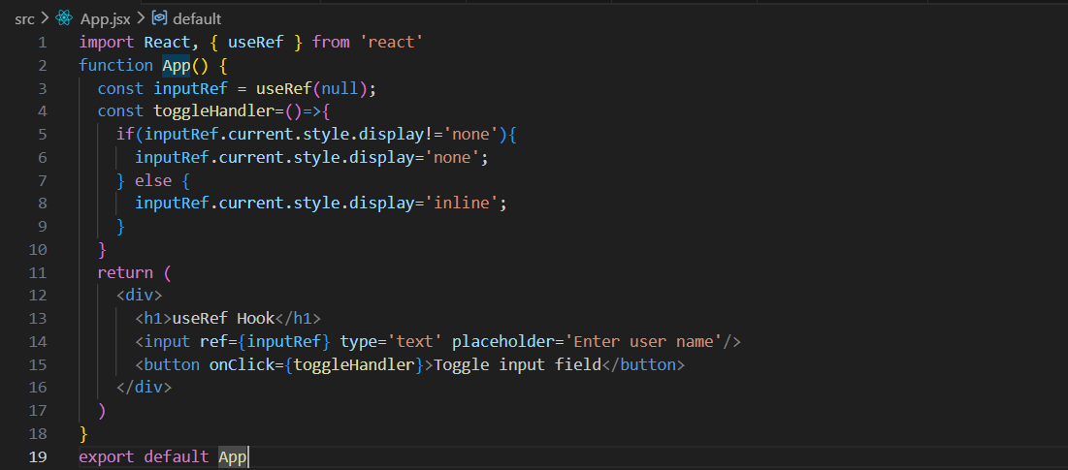
In this code, useRef(null) creates a reference to the <input> element and stores it in inputRef. When the Toggle input field button is clicked, the toggleHandler function checks the input's current display style. If the input is visible (display is not 'none'), it hides the input by setting display = 'none'. If the input is already hidden, it makes it visible again by setting display = 'inline'. In simple words, useRef is being used to directly access the input element and show or hide it without using React state.
Output:
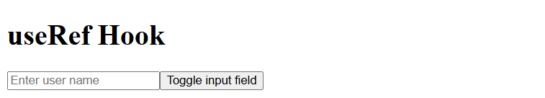
Using useRef for hiding works, but it skips React’s state system, so useState is preferred for UI visibility changes.
Output: when clicked on the button, input field hided.
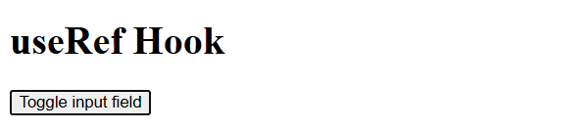

Use case 1: when a variable persists its value across every re-render.
Example: where the variable can’t manage to persists its value across re-render. No useRef hook is used here.
App.jsx:
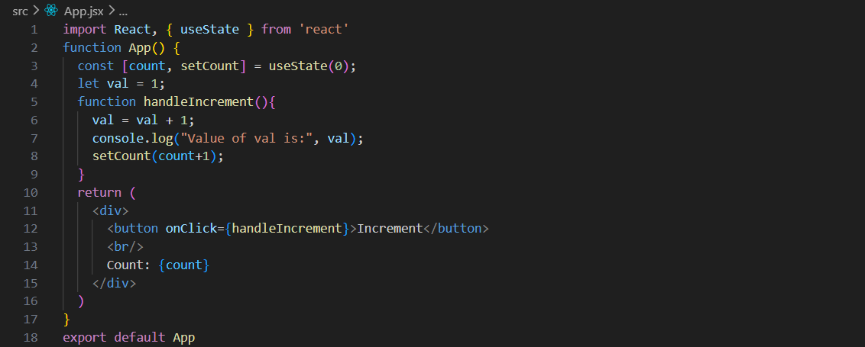
Output: when loaded.
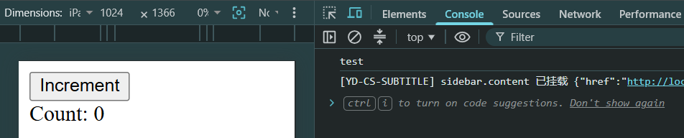
Output: when clicked on the button for few times, we expected that console shall show that value of val is also increased, but it didn’t. It mean val can’t manage to persist its value on re-render.
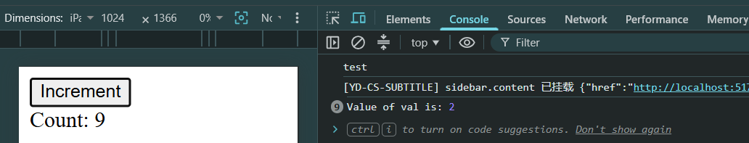
In this code, useState is used to manage count, so when the button is clicked, the UI updates correctly. But val is a normal variable, so every time the component re-renders, it resets back to 1, meaning its updated value is not preserved in React. Only count changes the UI because it is stored in state, while val only changes temporarily inside the function and is lost after re-render.

So, what’s the solution? Use useRef.
App.jsx:
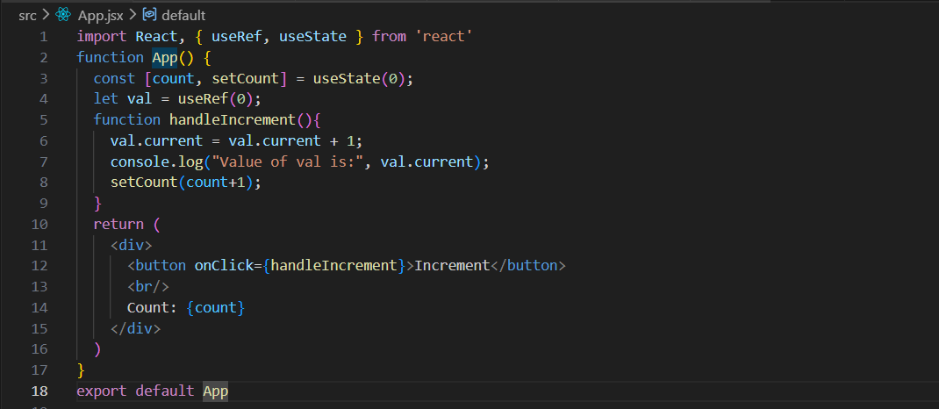
.current is the property inside a useRef object where the actual value is stored.
Output:
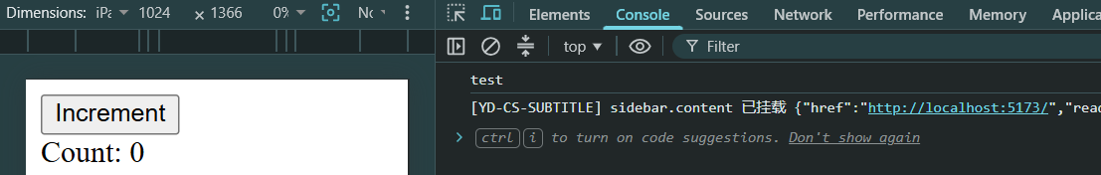
Output: when clicked for few times.
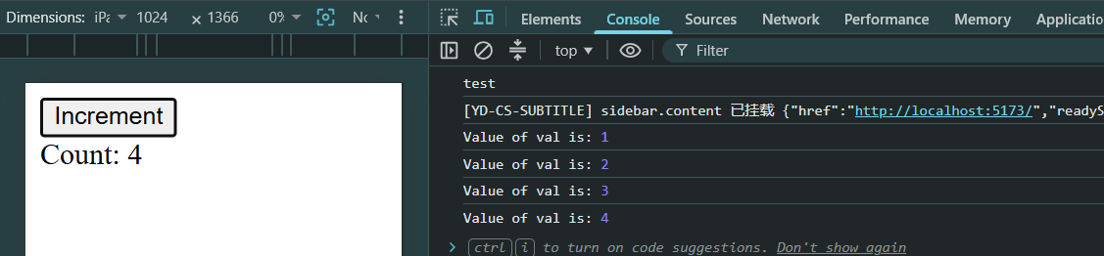
In this code, useState is used to manage count, so the UI updates every time the button is clicked. The variable val is created using useRef(0), which stores a value that persists across re-renders without resetting. When the button is clicked, val.current increases and keeps its updated value, and it is logged in the console, while setCount triggers a re-render to update the UI. In simple words, useRef is used here to remember a value between renders without affecting the UI.

Normal Variables vs Variables created using useRef:
Feature | Normal Variable | useRef
Persists after re-render | No | Yes
Causes re-render | No | No
Resets on render | Yes | No
Best use | Temporary logic | Storing stable values (counter, DOM, timers)

Use case 2: When we want to access a DOM element directly.
App.jsx:
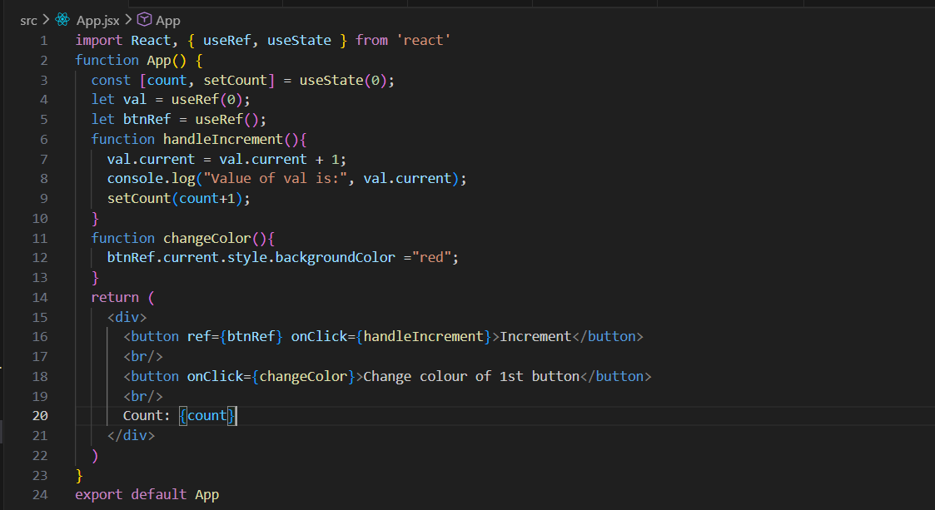
Output:
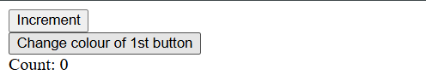
Output: when 2nd button was clicked.
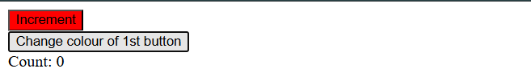

In this code, useState is used to manage the count value so the UI updates when the button is clicked, while useRef is used for two different purposes: val stores a value that persists across renders without affecting the UI, and btnRef is used to directly access the first button element in the DOM. When the first button is clicked, handleIncrement updates both the ref value and the state, and when the second button is clicked, changeColor directly changes the background color of the first button to red using btnRef.current, showing how useRef can be used for direct DOM manipulation.

uncontrolled component:
What is uncontrolled component?
In React, an uncontrolled component is a form element (like an input, textarea, or select) where the DOM itself manages the state, rather than React. Instead of storing the input value in React state and updating it on every change, you let the browser handle it, and you read the value only when needed (usually using a ref).
Key characteristics
- The DOM stores the form data
- React does not control the value in real time
- You typically use ref to access the value
- Less code for simple forms
Controlled vs Uncontrolled component:
Feature | Controlled Component | Uncontrolled Component
State location | React state | DOM
Updates | On every keystroke via onChange | No React updates during typing
Data access | Always in state | Access via ref
Complexity | More code | Simpler
Use case | Dynamic validation, live UI updates | Simple forms, quick input capture

When to use uncontrolled components?
Use them when:
- You don’t need instant validation or live updates
- You want simpler code
- You’re integrating with non-React libraries
- You only need values on submit

Example: a form controlled by DOM (basically uncontrolled component)
App.jsx:
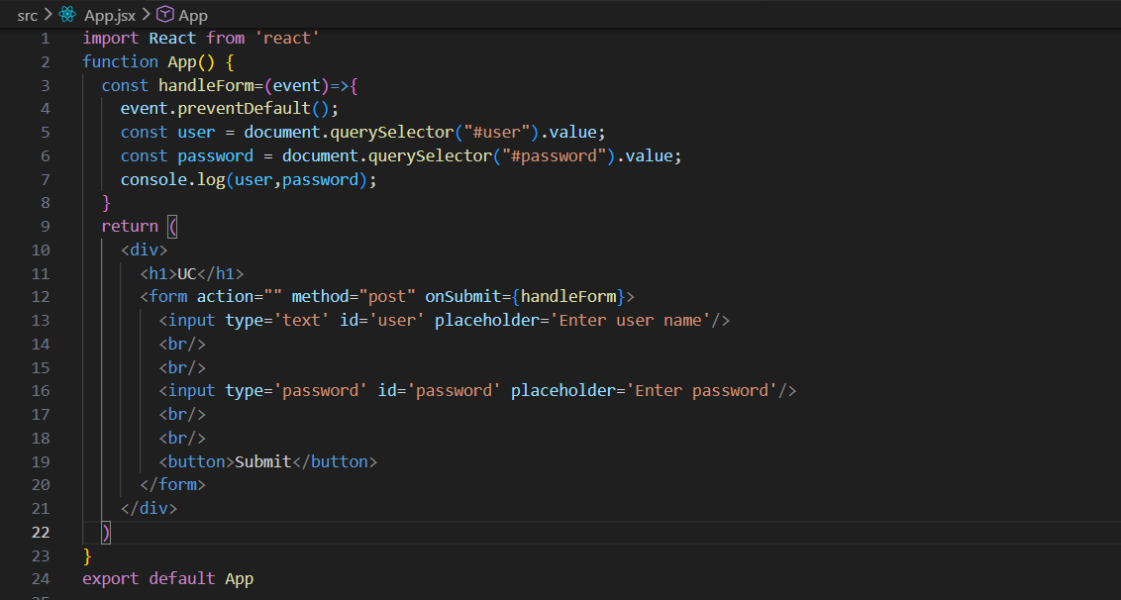
Why is it uncontrolled?
Because the values of the inputs are not stored in React state.

Output: ignore those errors, they are because of the extension I have.
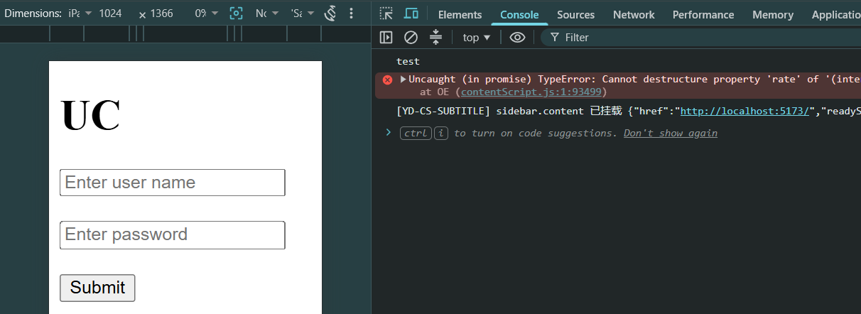
Output: fill it and then submit. We can see the entered value in the console.
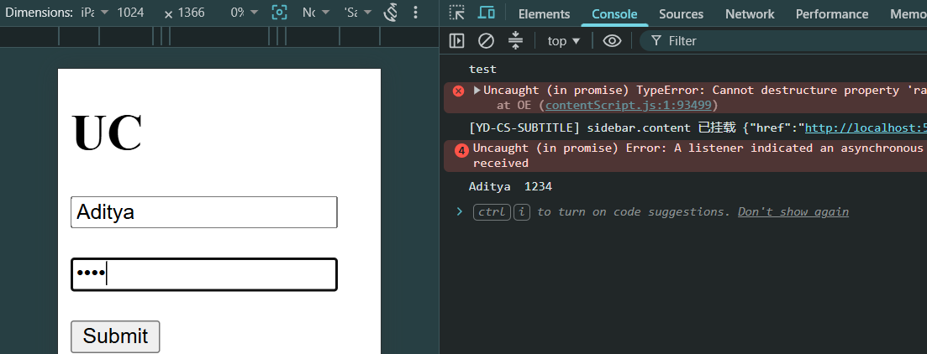
This component renders a username and password form. When the form is submitted, handleForm prevents the page refresh, gets the input values directly from the DOM using document.querySelector(), and prints them in the console. Since React does not store the input values in state, it is an uncontrolled component.
Now, handling the same thing using the useRef.
App.jsx:
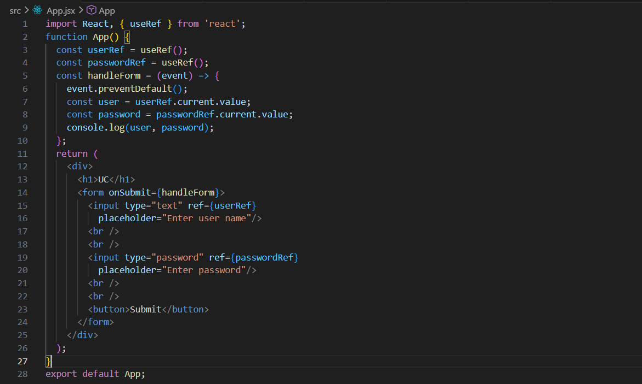
useRef creates references to the input elements, and userRef.current.value and passwordRef.current.value give you their current values when the form is submitted. This is still an uncontrolled component because React state is not managing the input values.
Output:
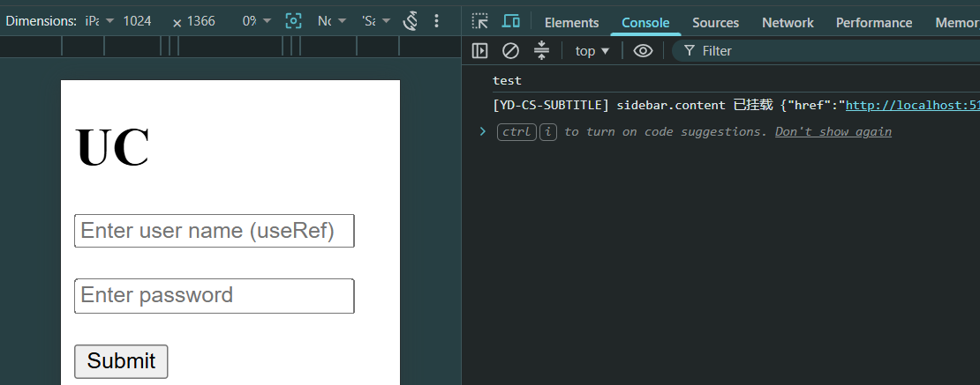

Output:
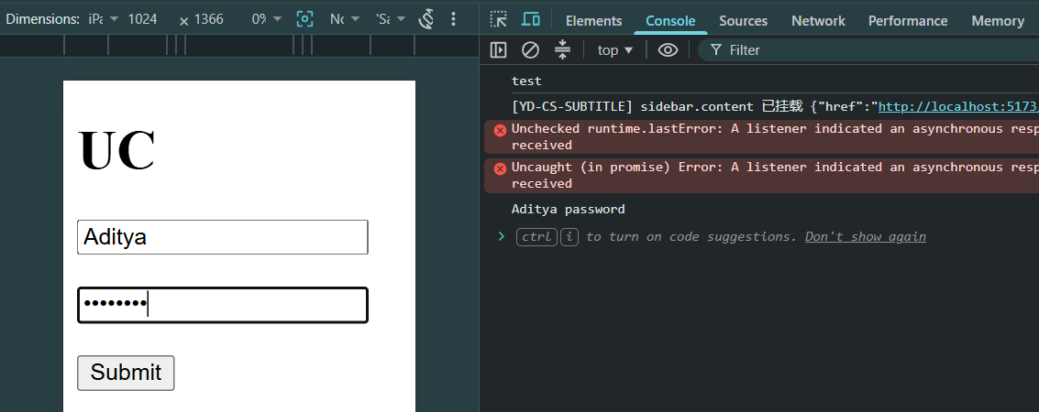
Now, some more examples of the useRef:
App.jsx:
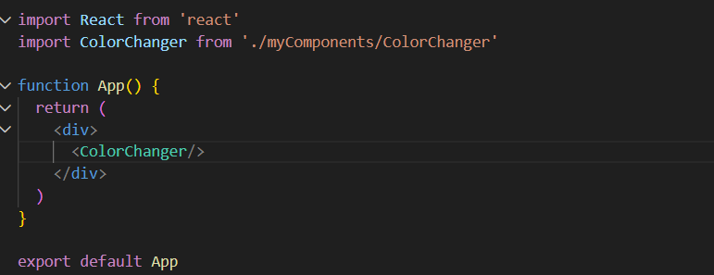

ColorChanger.jsx:
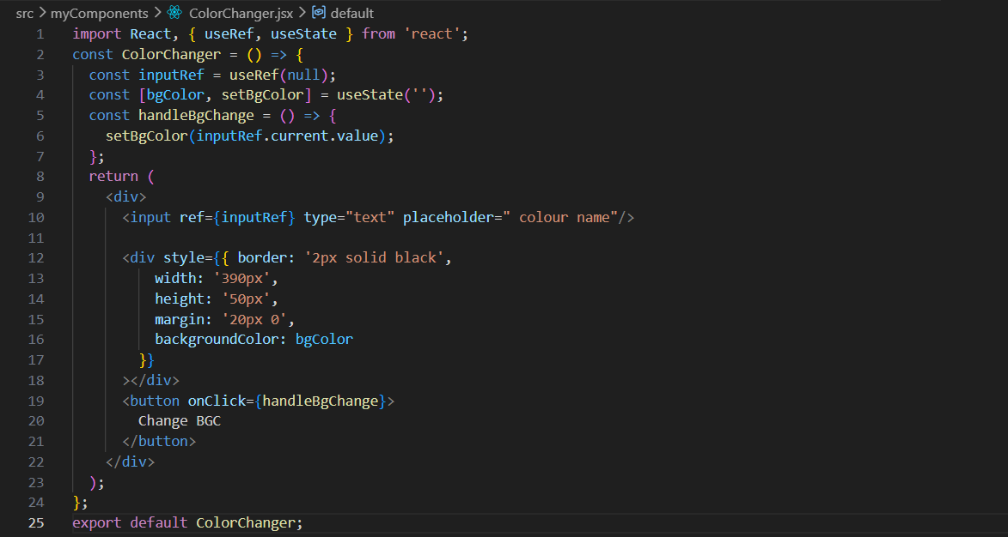
Output:
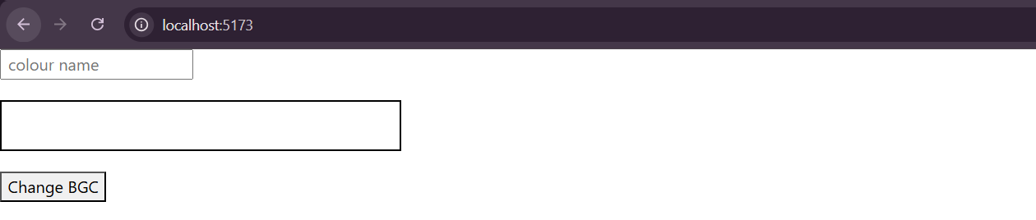
Output: when I wrote the colour name and clicked on the “Change BGC” button.
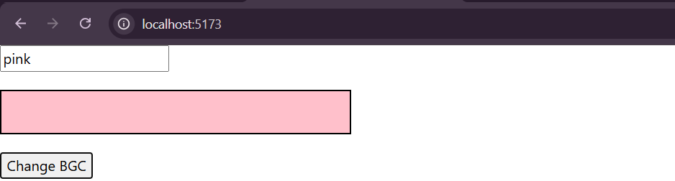

Pass Function in Component as Props:
Passing a function as a prop in React means sending a function from a parent component to a child component, so the child can execute some logic that belongs to the parent. This is one of the most important concepts in React because it allows child components to communicate with parent components.
Example: normally what we do?
App.jsx:
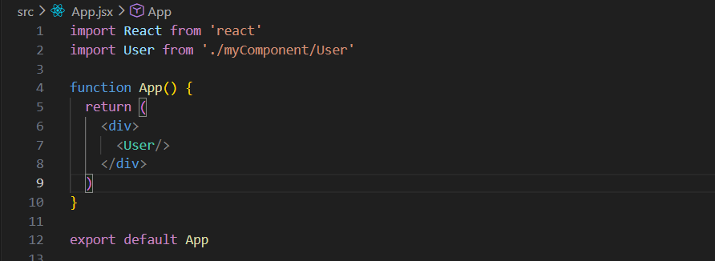
User.jsx:
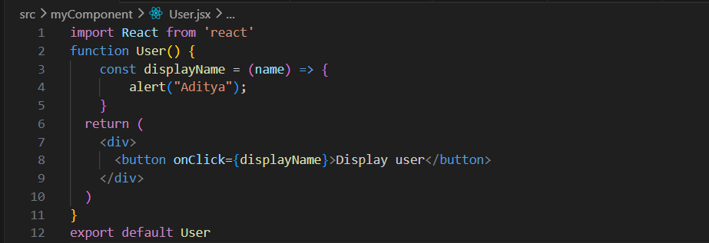
Output:
Output: 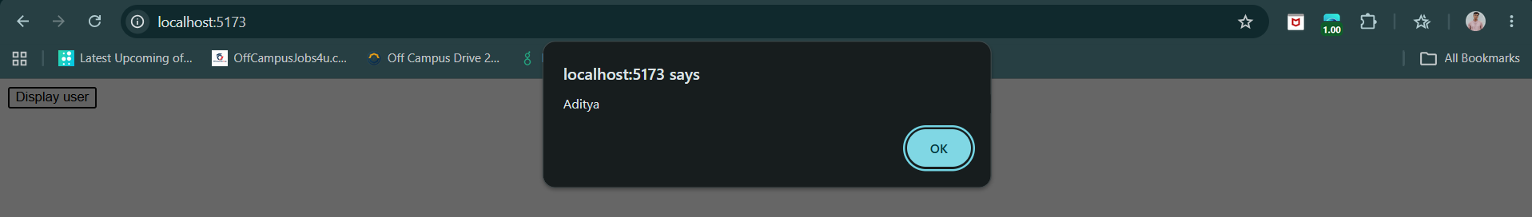
Observe, when we do one <User/> in the App.jsx, the whole code is rendered once, while if we do multiple <User/>, it will get rendered multiple times. This is long run is not a good idea. Instead we will use the function inside the App.jsx, as given below:
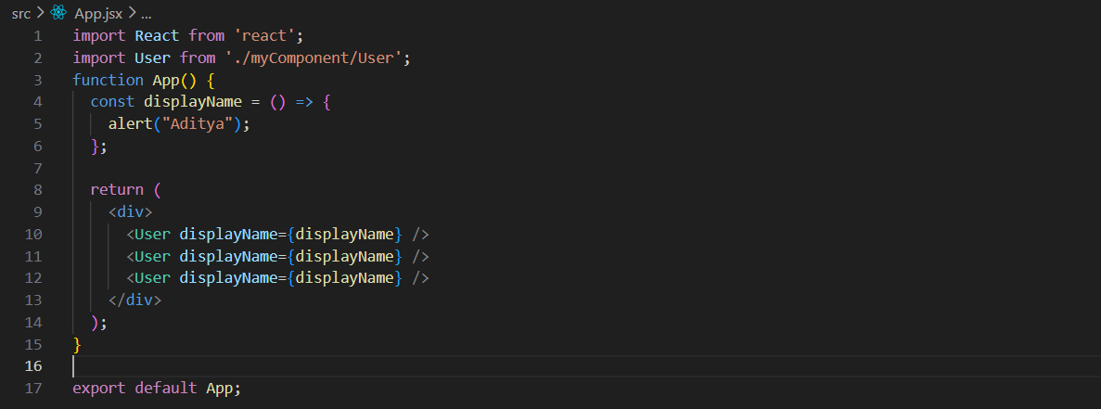
User.jsx:
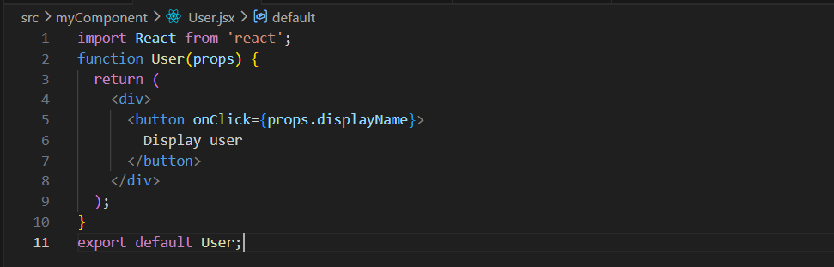Output:

Passing PROPS as Children and Functions:
What is Children?
The children prop is a special prop in React that contains everything you put between a component's opening and closing tags.
Example:
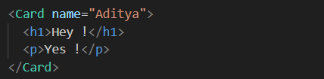
Children
Now, we can see this usage using a basic example.
App.jsx:
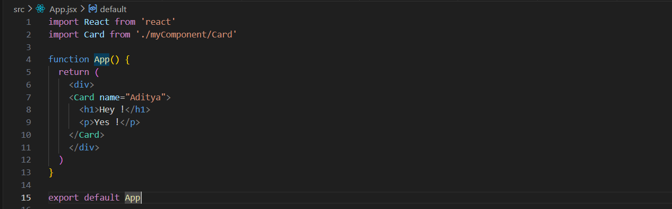
Card.jsx:
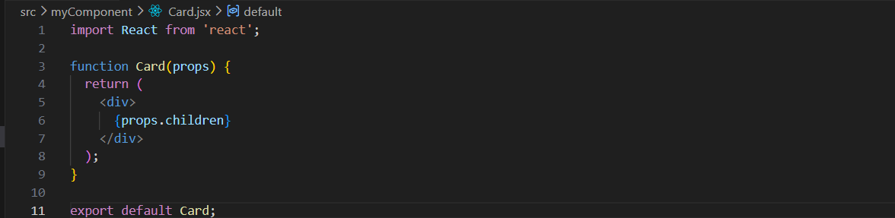
props.children gives you access to whatever is written inside a component's tags.
Output:

props.children is a special React prop that represents the content placed inside a component, and {props.children} renders that content at that location in the component's JSX.

Since, there is another way to create the children, using the “children=”.
App.jsx:
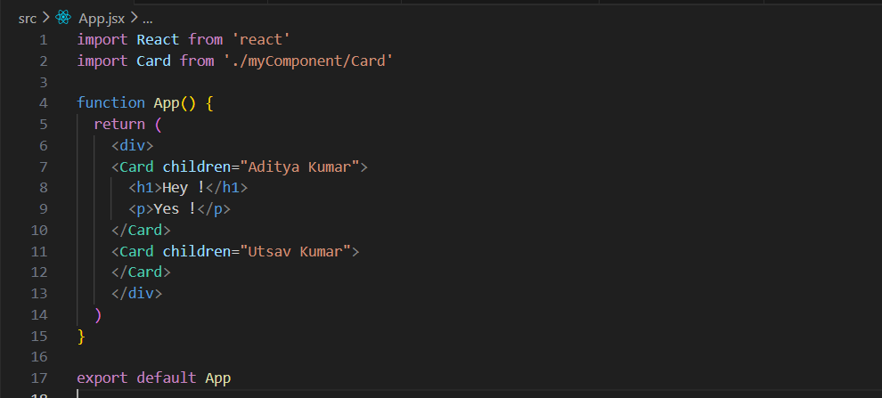
Card.jsx:
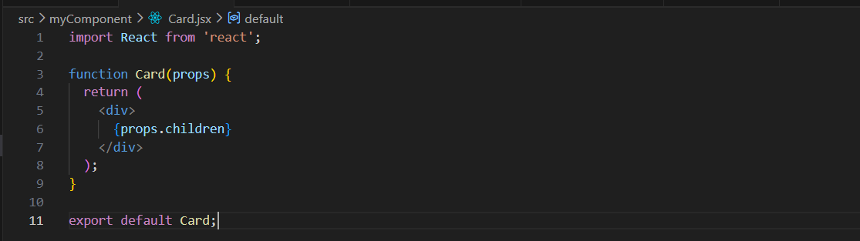
Output:


Now, we will learn how to pass a function from parent to child.
App.jsx:
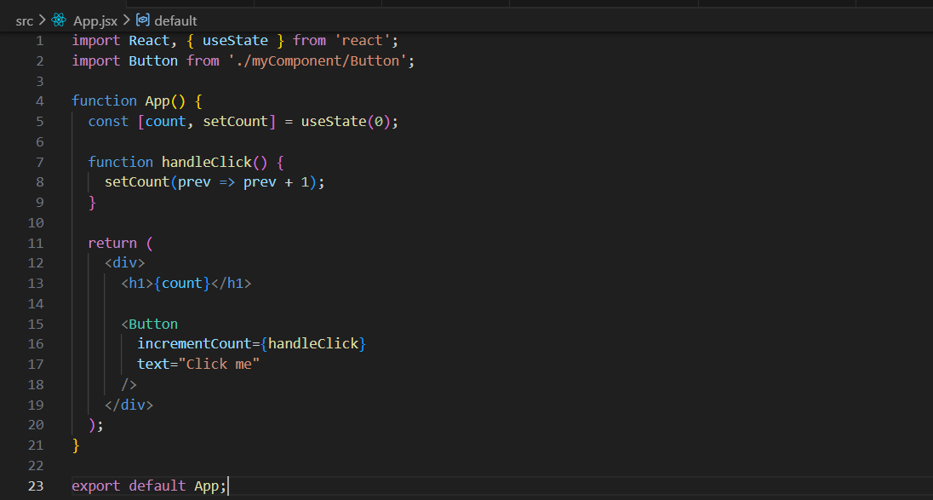
This code creates a React app that keeps track of a number using useState. The count variable starts at 0, and the handleClick function increases the count by 1 whenever it is called. The current count is displayed inside an <h1> tag. The Button component is then used and receives two props: incrementCount, which is the function that updates the count, and text, which sets the button's label to "Click me". When the button is clicked, the number on the screen increases by one.
Button.jsx:
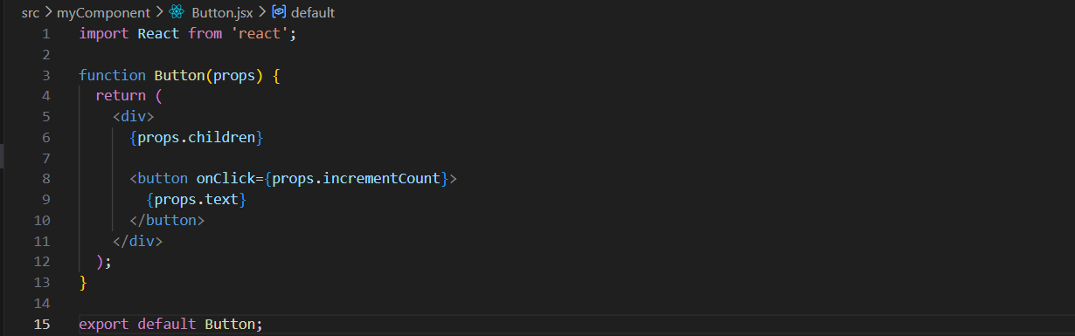
It receives information through props, such as the button text (props.text), a function to run when the button is clicked (props.incrementCount), and any content placed inside the component (props.children). The component displays the child content first and then shows a button. When the user clicks the button, the incrementCount function is executed, and the button displays the text passed through props.text. Finally, the component is exported so it can be used in other files.

Output:


forwardRef:
What is forwardRef?
In React, forwardRef is a method that allows a parent component to pass a ref to one of its child component's DOM elements. forwardRef is a React API that allows a parent component to pass its ref through a custom child component and access the child’s underlying DOM element or component instance.
forwardRef is a React utility that allows a parent component to pass a ref through a custom component to one of its child DOM elements.
Without forwardRef, refs work only on:
- HTML elements (input, div, button, etc.)
- Class components
They don't automatically work on function components.
Example: old way (for versions below React 19). Here, we are coding such that when we click on the button the input field should get the value 100 and it shall also get focused.
App.jsx:
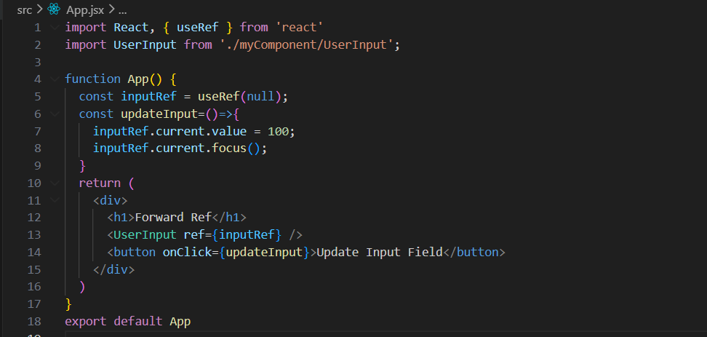
This code creates a ref called inputRef and passes it to the UserInput component. Because UserInput uses forwardRef, that ref points to the actual <input> element inside it. When the button is clicked, updateInput() uses inputRef.current to directly access that input, sets its value to 100, and then focuses it, placing the cursor inside the input box.

UserInput.jsx:
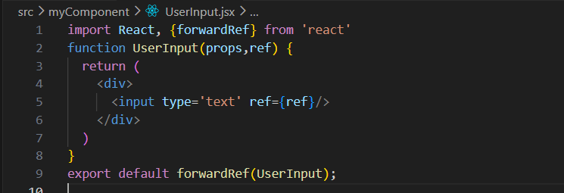
This code creates a custom UserInput component that forwards any ref it receives from its parent to the actual <input> element inside it. Normally, if a parent puts ref on a function component like <UserInput ref={myRef} />, React won't know which DOM element the ref should point to. By wrapping the component with forwardRef(UserInput), you're telling React: "If someone passes a ref to UserInput, attach it to this <input> instead." This lets the parent directly access the input DOM element and do things like focus(), change its value, or select its text.

Output:
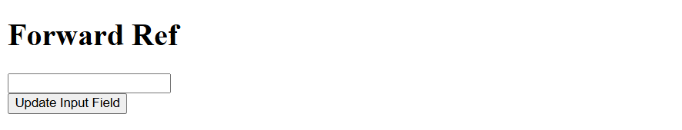
Output: when button was clicked.


Example: new way (for versions above and equal to React 19). Same thing we will try to do.
App.jsx: same as above.


UserInput.jsx:
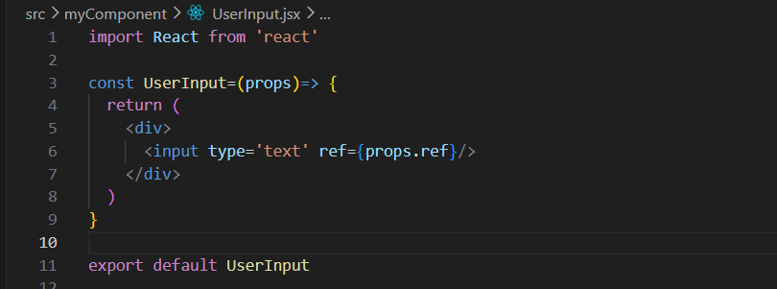

Output:

Output: when button was clicked.


