**Day 1**

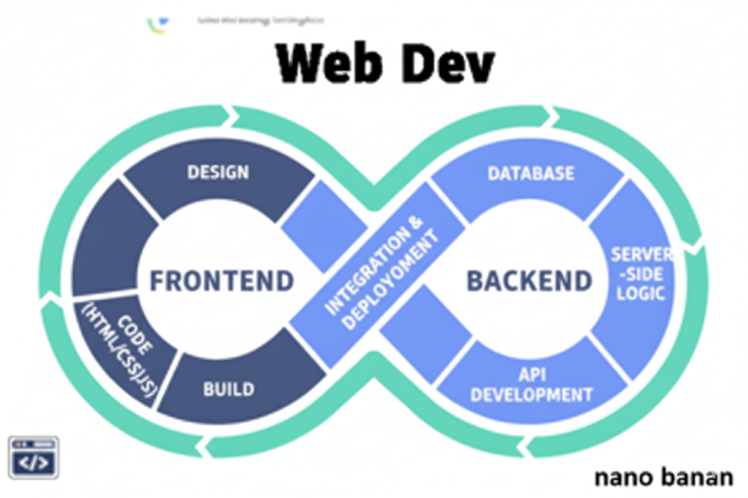

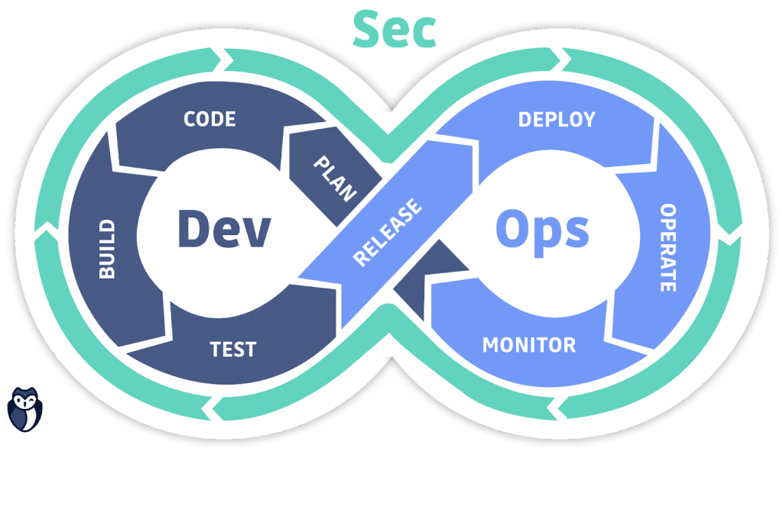

**“Web Development + Security”**

**Websites:**

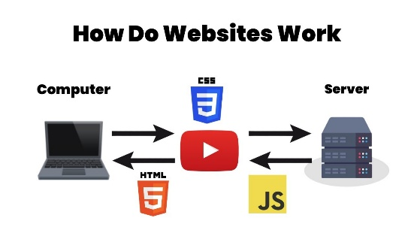

**How Websites work?**

1. **User Request (Browser → Server)**

* You type a web address (URL) into your browser or click a link.
* The browser sends a request to a web server using HTTP/HTTPS.

1. **DNS Resolution**

* The domain name (like google.com) is translated into an IP address using the Domain Name System (DNS) so your browser knows which server to contact.

1. **Server Response**

* The web server receives the request and sends back the website’s data (usually HTML, CSS, JavaScript, images, etc.).

1. **Browser Rendering**

* The browser reads the HTML and builds a DOM (Document Object Model).
* CSS styles are applied.
* JavaScript adds interactivity.
* Together, they render the page you see.

1. **User Interaction**

* When you click, type, or scroll, the browser may send more requests to the server (for new data, images, API calls, etc.).

**What is backend?**

The backend is the hidden part of a website that handles data, logic, and server communication. It connects the frontend (what users see) with the database and processes requests to deliver the right results.

**What is frontend?**

The frontend is the part of a website or app that users see and interact with directly. It includes the layout, design, buttons, text, images, and overall user experience, built mainly with HTML, CSS, and JavaScript.

**Note:** Frontend is easier to attack, but backend attacks are more dangerous because they can compromise the whole system.