**Day 10**

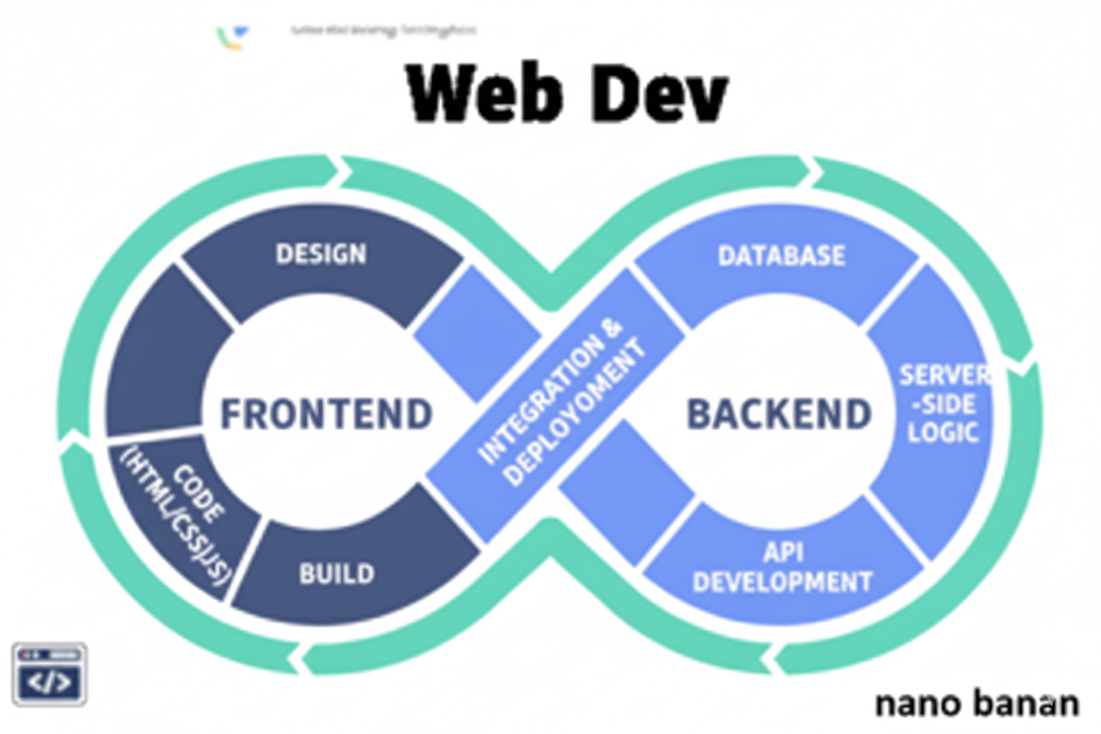



**“Web Development + Security”**

**Inline and Block Elements:**

**What are Inline elements in HTML?**

* Inline elements do not start on a new line.
* They only take up as much width as needed for their content.
* They are typically used inside text or within block elements.

Examples: <span>, <a>, <strong>, <em>, <img>.

**What are block elements in HTML?**

* Block elements start on a new line by default.
* They take up the full width available (unless styled otherwise).
* Usually used to create structure/layout of a page.

Examples: <div>, <p>, <h1>–<h6>, <section>, <ul>, <table>.

Example:

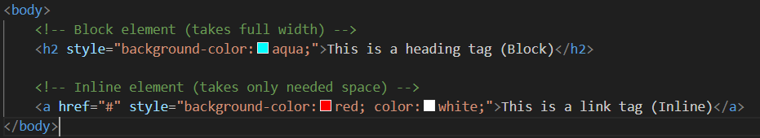

Output:

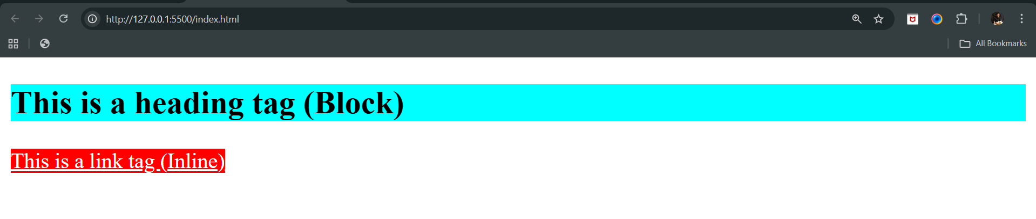

**Block Elements (Most Commonly Used First)**

<div>: A generic container for flow content.

<p>: Paragraph.

<h1>, <h2>, <h3>, <h4>, <h5>, <h6>: Headings.

<ul>: Unordered list.

<ol>: Ordered list.

<li>: List item.

<form>: A section containing form controls.

<table>: Table.

<section>: A standalone section of a document.

<header>: A container for introductory content or a set of navigational links.

<footer>: Footer of a section or page.

<nav>: A section of a page that contains navigation links.

<article>: A self-contained composition in a document.

<aside>: A section of a page that contains information indirectly related to the main content.

<main>: The main content of a document.

<fieldset>: A set of form controls grouped under a common name.

<blockquote>: A block of text that is a quotation from another source.

<pre>: Preformatted text.

<canvas>: A container used to draw graphics via JavaScript.

<dl>: Description list.

<dt>: Term in a description list.

<dd>: Description in a description list.

<figure>: Any content that is referenced from the main content.

<figcaption>: A caption for a <figure> element.

<address>: Contact information for the author or owner of the document.

<hr>: A thematic break or a horizontal rule.

<tfoot>: Footer of a table.

**Inline Elements (Most Commonly Used First)**

<a>: Anchor or hyperlink.

<img>: Image.

<span>: Generic inline container.

<input>: Input field.

<label>: Label for a form element.

<strong>: Strong emphasis.

<em>: Emphasized text.

<br>: Line break.

<code>: Code snippet.

<b>: Bold text.

<i>: Italic text.

<u>: Underlined text.

<small>: Smaller text.

<sub>: Subscript.

<sup>: Superscript.

<mark>: Marked or highlighted text.

<q>: Short inline quotation.

<cite>: Citation.

<kbd>: Keyboard input.

<samp>: Sample output.

<var>: Variable in a mathematical expression or programming context.

<time>: Time.

<abbr>: Abbreviation.

<data>: Machine-readable translation of content.

<acronym>: Acronym (Not supported in HTML5).

**Id & Classes in HTML:**

**What is an ID in HTML?**

* An ID is a unique identifier for an element.
* You can only use one ID per page for one element.
* Useful for targeting a single element with CSS or JavaScript, add # before it.

Example: Syntax for id creation

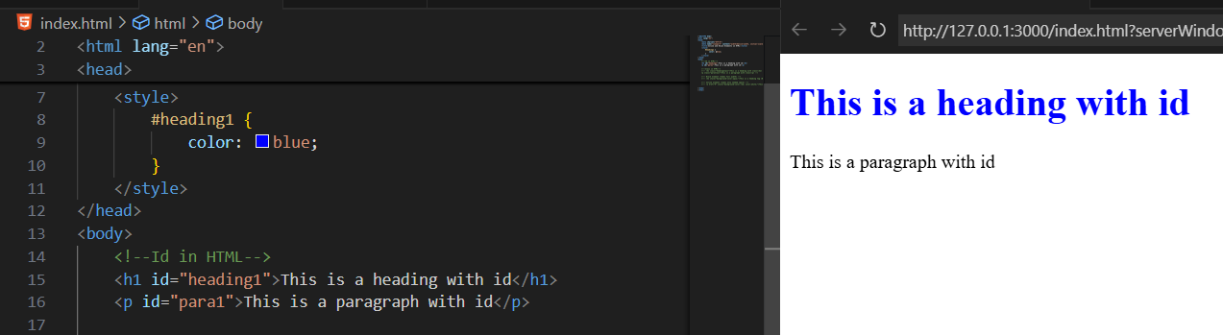

Example: If we redefine the id of an element then the last one will be assigned to the element

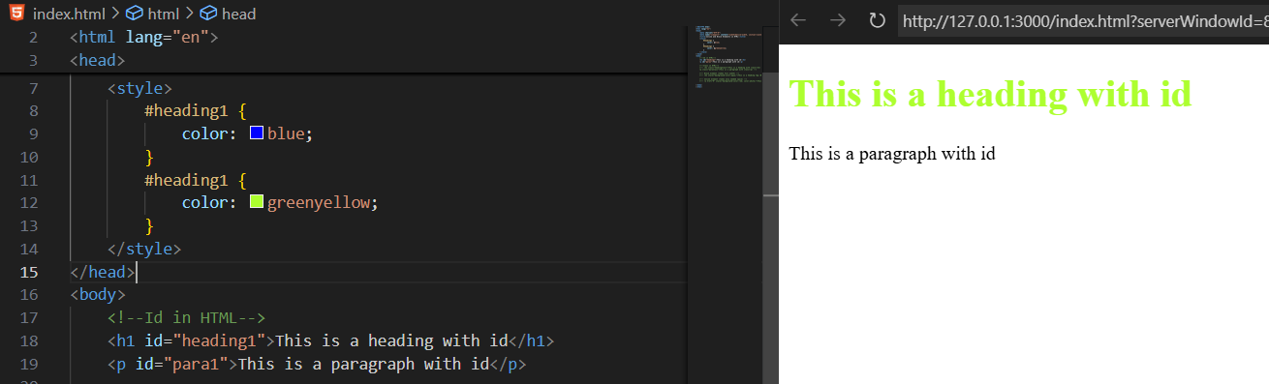

Example: we have given the same id name to different element, then also same properties will be applied to both

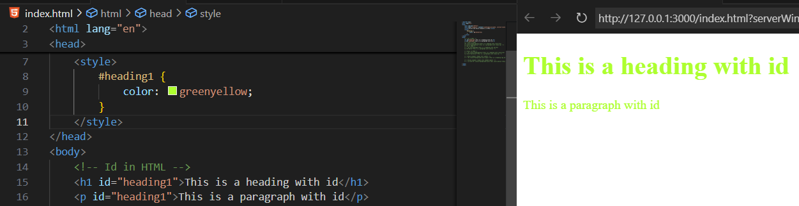

**What is a Class in HTML?**

* A class can be used for multiple elements.
* You can apply the same class to many elements.
* We can give more than one class to an element too, just separate the classes by space.
* Useful for styling groups of elements, just add . before it.

Example: simple use of class, we had given the same class to the different elements, but as they are of same class they got the same property.

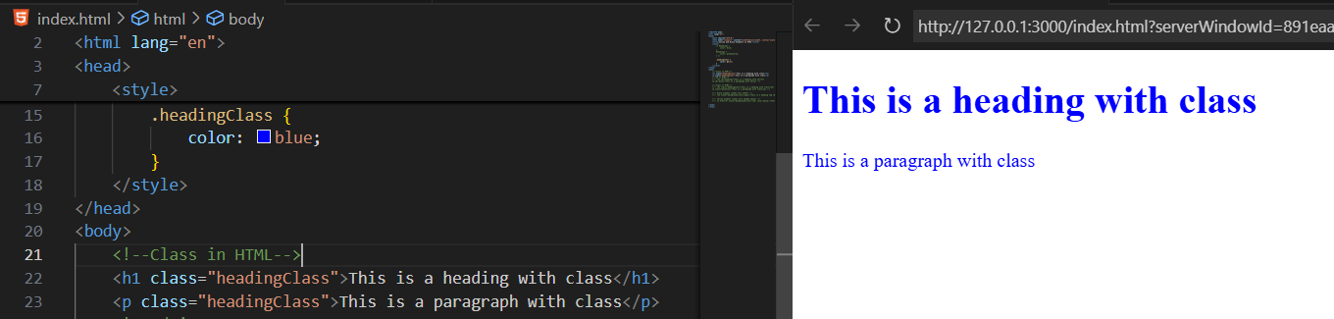

Example: giving two classes to an element, both properties will be applied.

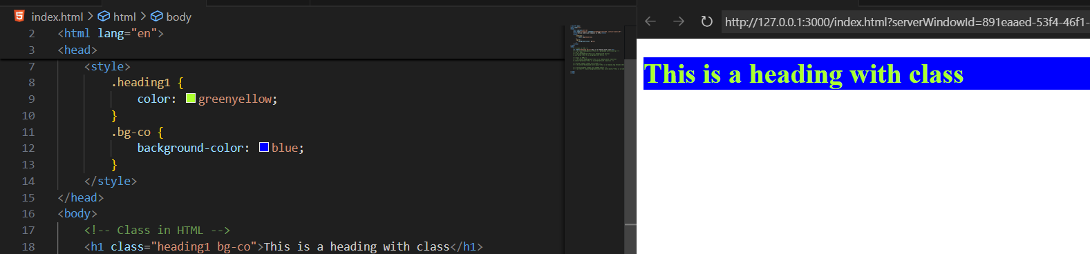

Example: assigning both id and class to an element, both properties will be applied.

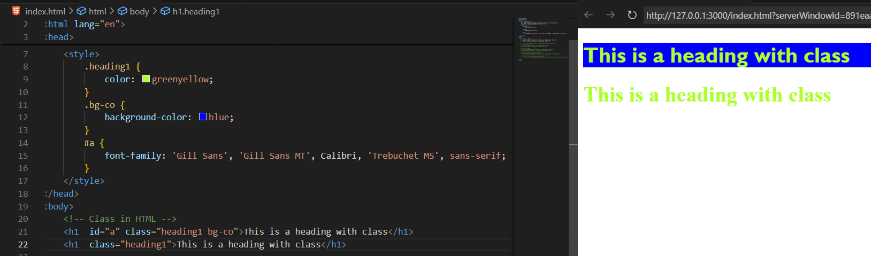

--The End--