**Day 2**

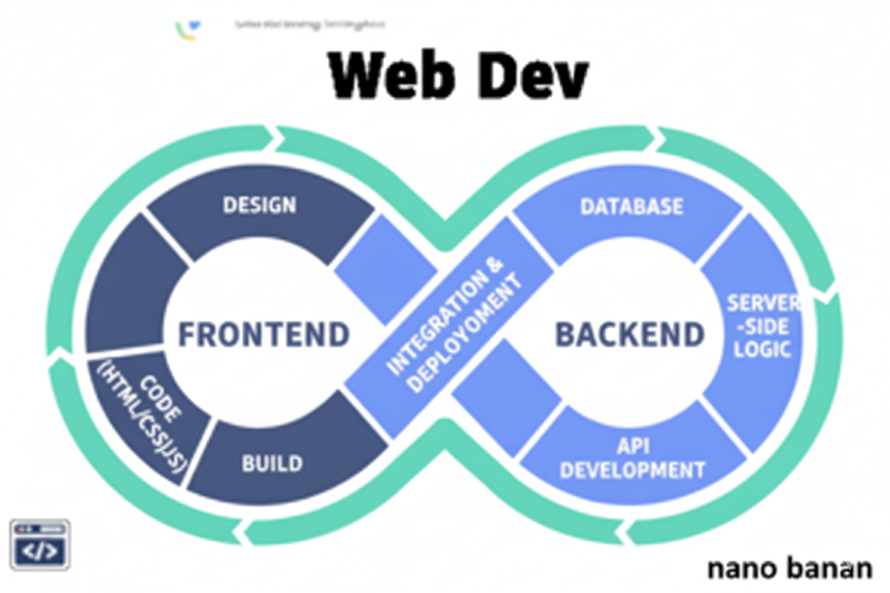



**“Web Development + Security”**

**My First HTML Website:**

A perfect and simple well-balanced website needs to be created using the HTML, CSS and JS:

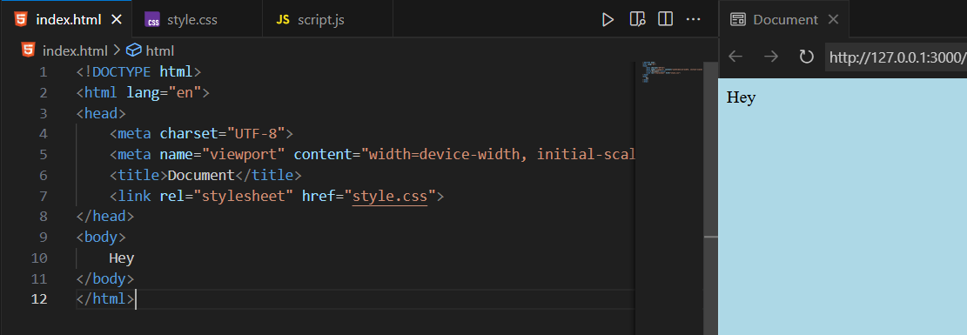

Here is the style.css:

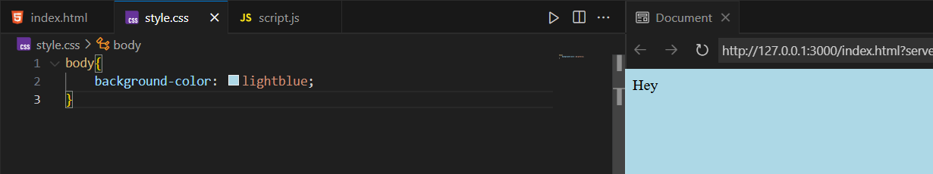

In case we want to include the script.js:

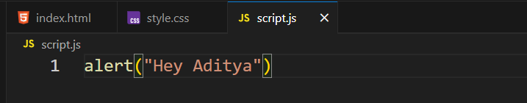

Including this script.js to index.html:

Just write this before the end of </body> tag

<script src="script.js"></script>

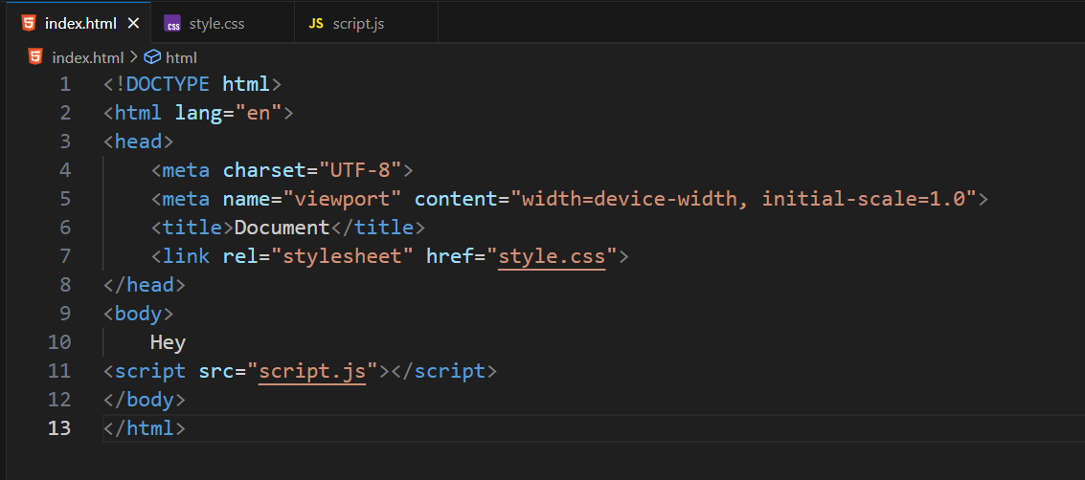

Output:

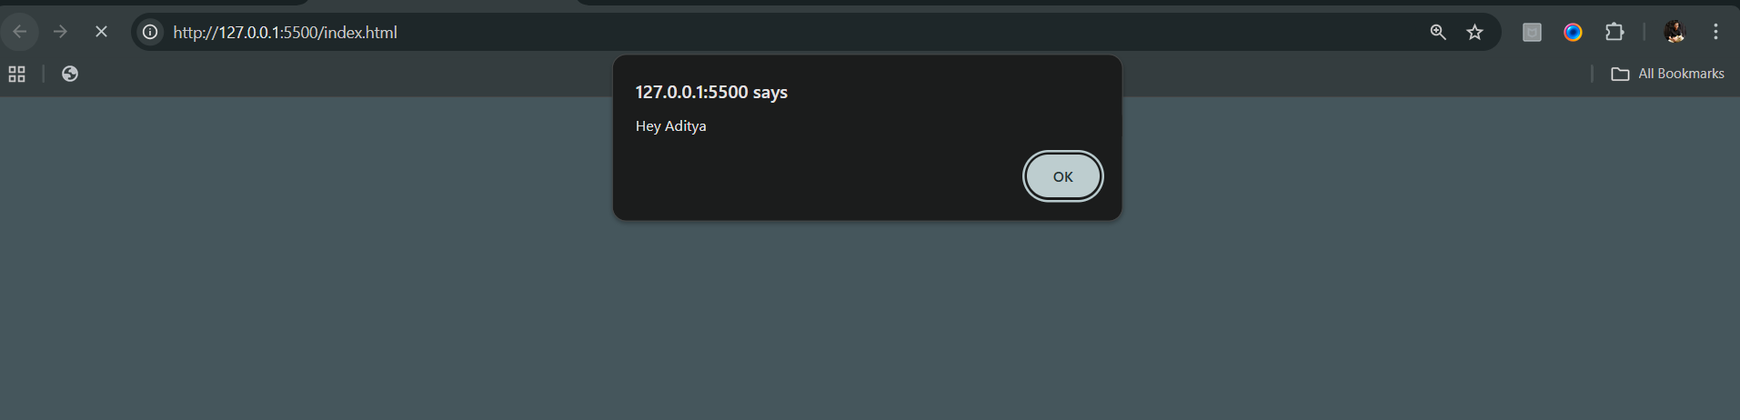

When we click “Ok” button of the pop up, following screen will open:  
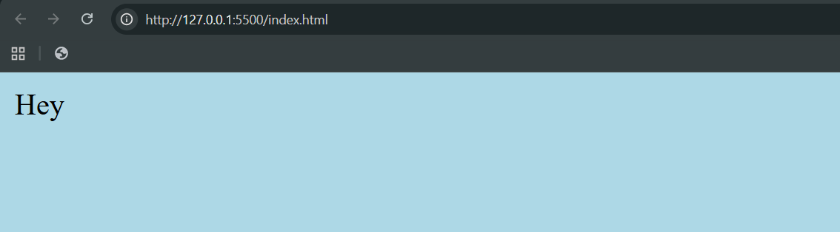

**Basic Structure of an HTML Website**

A basic html website will look like this:

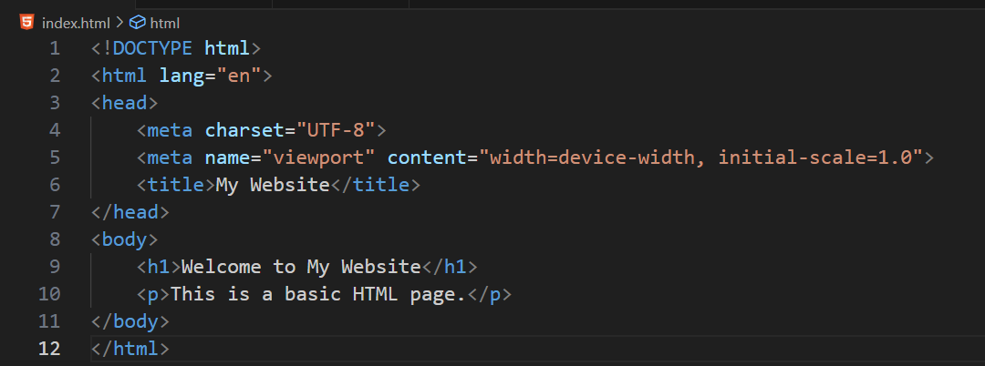

Explanation (in short):

* <!DOCTYPE html> → tells the browser it’s HTML5.
* <html> → root element.
* <head> → contains metadata (title, charset, links, etc.).
* <body> → contains visible content (text, images, links, etc.).

--The End--