**Day 3**

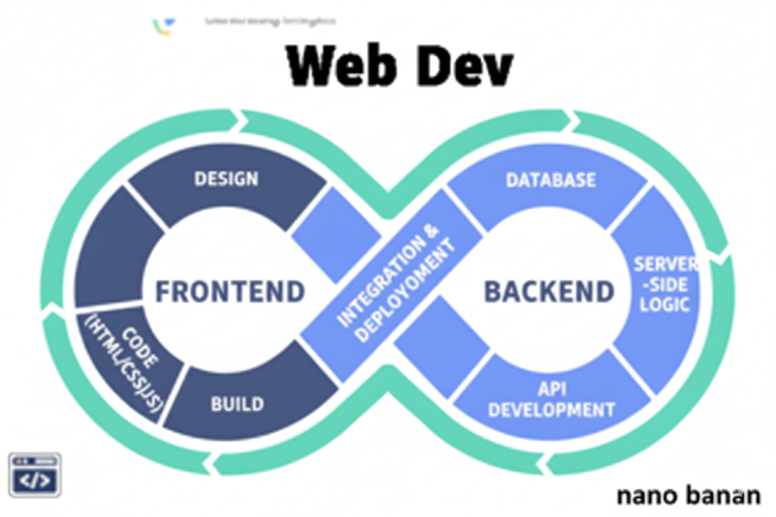

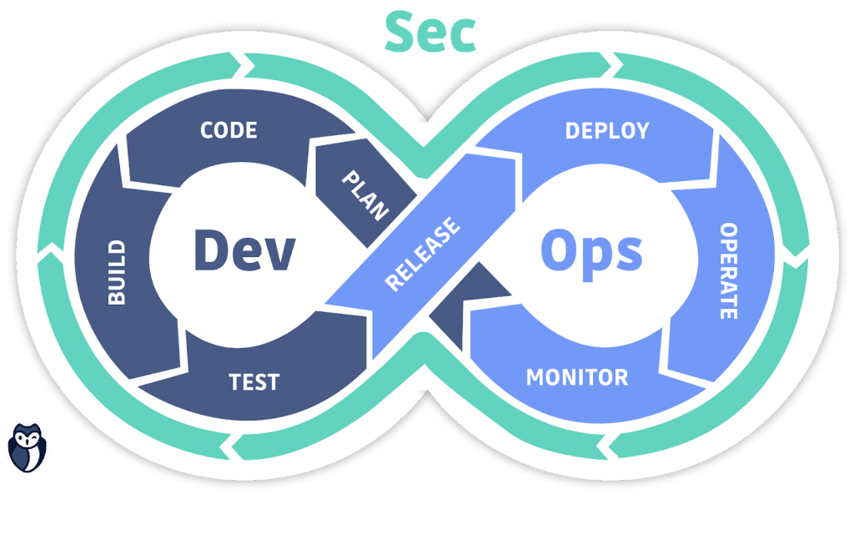

**“Web Development + Security”**

**Headings:**

**What are Headings in HTML?**

In HTML, a heading is a tag used to define titles or subtitles on a webpage. They range from <h1> (the most important, main heading) to <h6> (the least important, smallest heading).

Example:

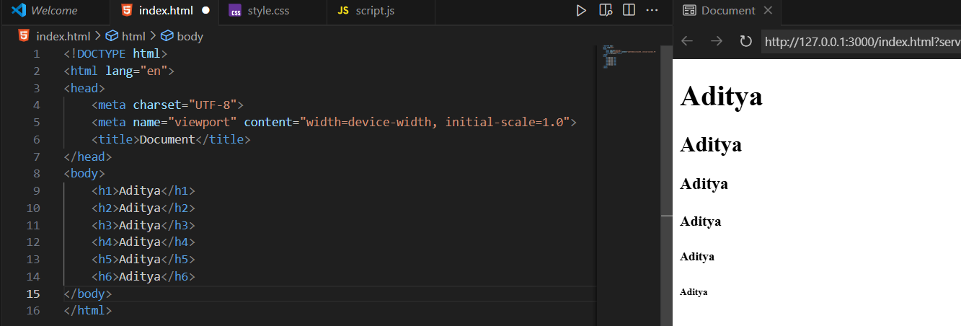

**Paragraphs:**

**What are Paragraphs in HTML?**

In HTML, a paragraph is defined using the <p> tag. It is used to display blocks of text as separate sections, making the content easier to read. Browsers automatically add some space (margin) before and after each paragraph.

Example:

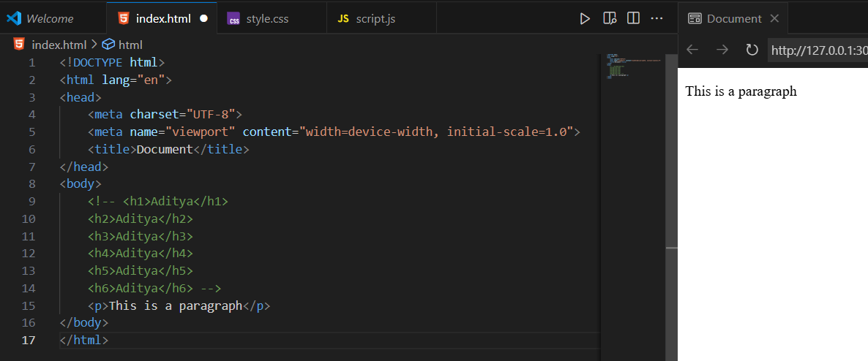

We can also use Lorem keyword to write some text, example:

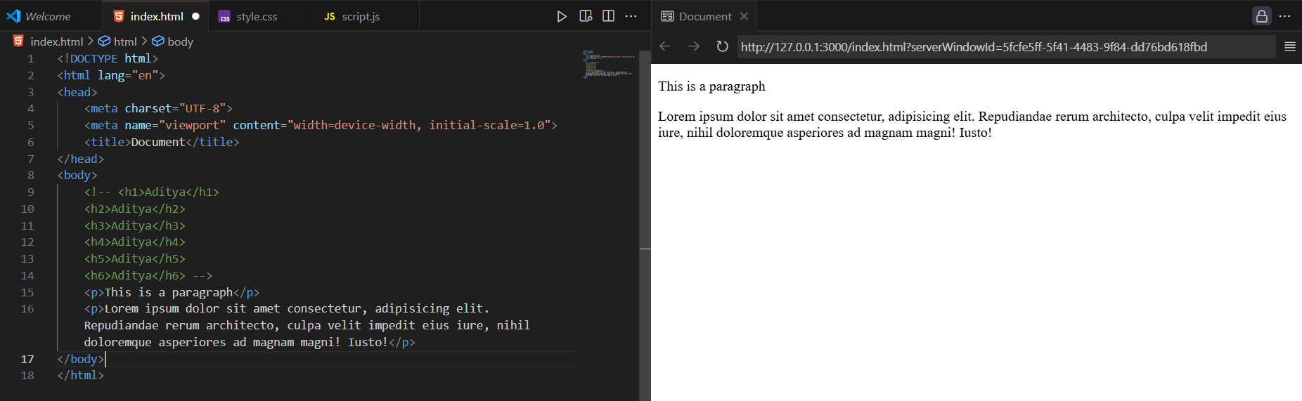

**Links:**

**What are links in HTML?**

In HTML, links are created using the <a> tag (called an anchor tag). They let you navigate from one page to another, open files, or jump to sections on the same page.

Example:

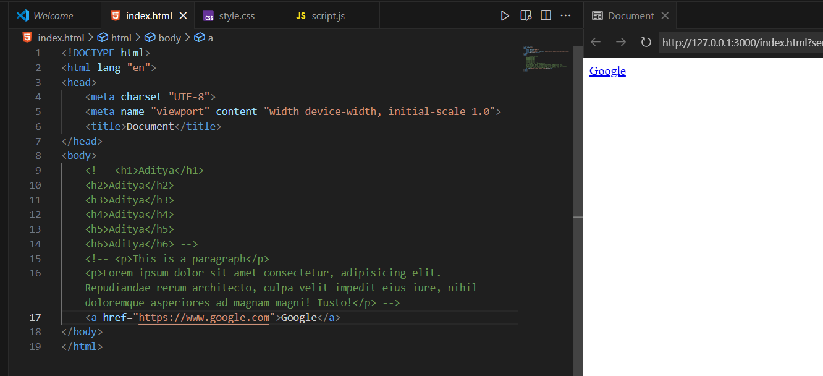

In above example if we click on the link, it will open the google.com in the same page. In case we wish that it should open in the new tab, we can use the attribute of <a> tag called ‘target’.

Example:

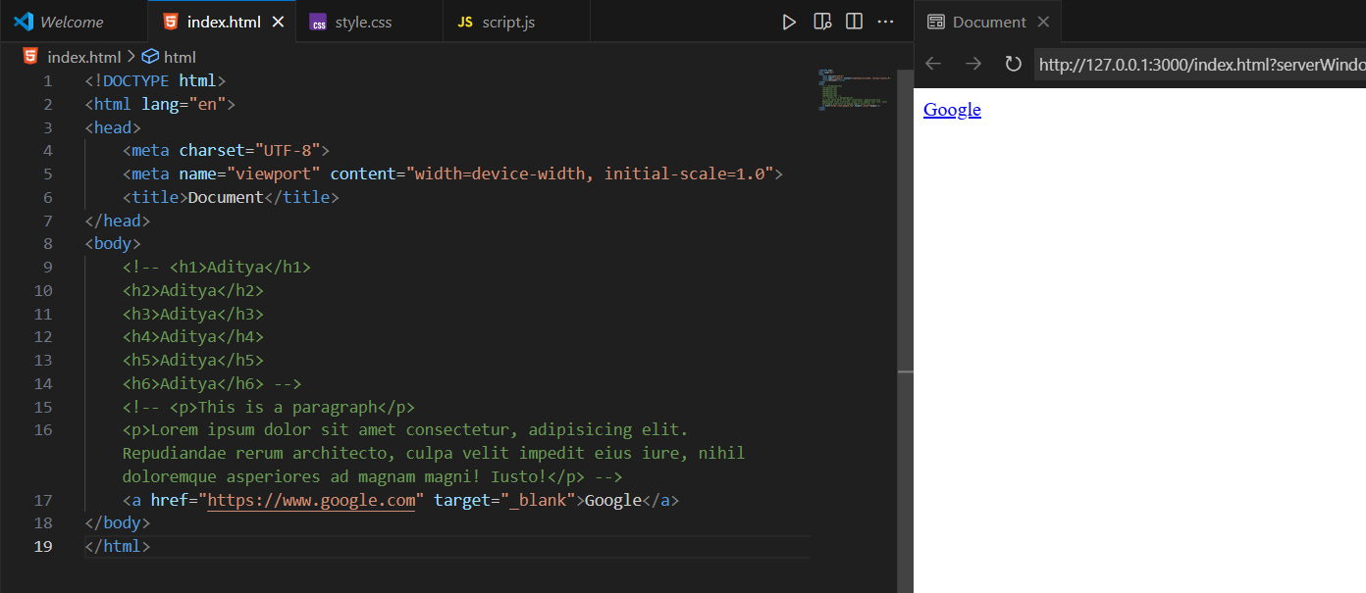

**Important attributes of <a> tag:**

| **Attribute** | **Use Case** | **Example** |
| --- | --- | --- |
| href | Defines the link destination (URL or file). | <a href="https://example.com">Visit Example</a> |
| target | Controls where the link opens. Common: _self (same tab), _blank (new tab). | <a href="page.html" target="_blank">Open in new tab</a> |
| rel | Adds relationship info; improves **security & SEO**. Common: noopener, noreferrer, nofollow. | <a href="https://example.com" target="_blank" rel="noopener noreferrer">Secure Link</a> |
| title | Shows a tooltip when hovering over the link. | <a href="about.html" title="More about us">About Us</a> |
| download | Makes the browser download the file instead of opening it. | <a href="file.pdf" download>Download PDF</a> |
| href="#" | Placeholder link (used with JavaScript or empty link). | <a href="#">Click Me</a> |

**Secure Practices for <a>:**

1. **Always use HTTPS links**

* Prevents man-in-the-middle attacks.

Example:

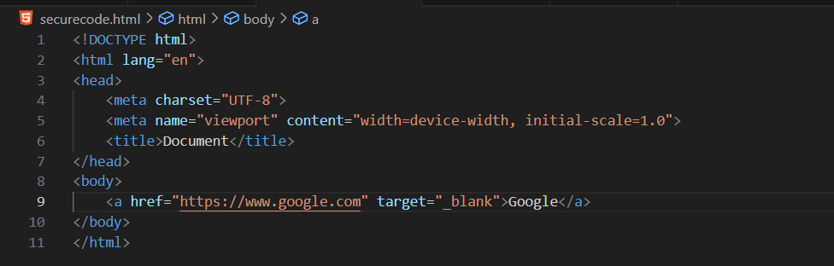

1. **When using target="_blank", add rel="noopener noreferrer"**

When you open a link in a new tab using target="_blank", the new page can access the original page with window.opener, which attackers can exploit to redirect you to a fake site (called reverse tabnabbing). Adding rel="noopener noreferrer" breaks that connection, making the new tab independent and keeping your original page safe.

Example:

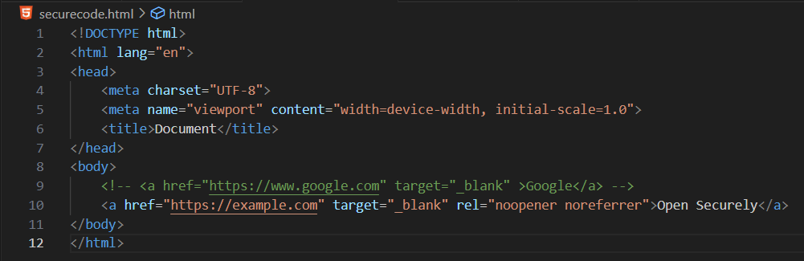

1. **Validate or sanitize dynamic links**

If a link comes from user input, attackers could insert javascript: or data: schemes to run malicious code. Always check that links start with trusted protocols like https://.

Example:

Unsafe:

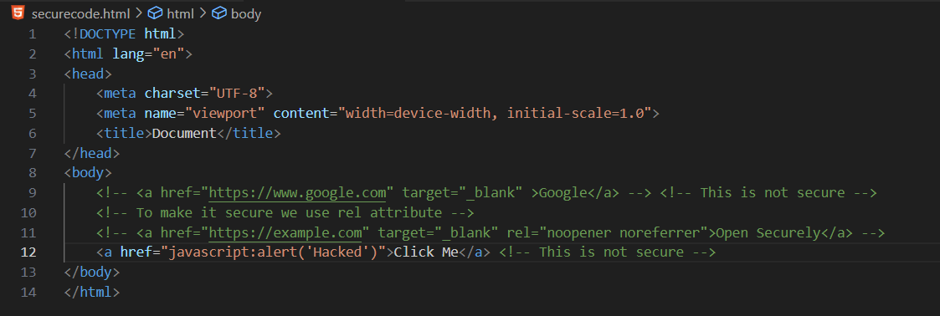

Output:

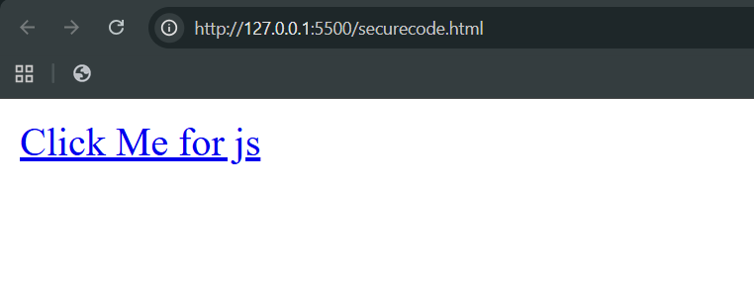

When clicked:

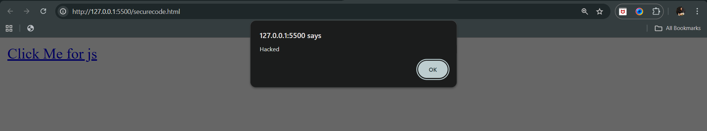

Safe:

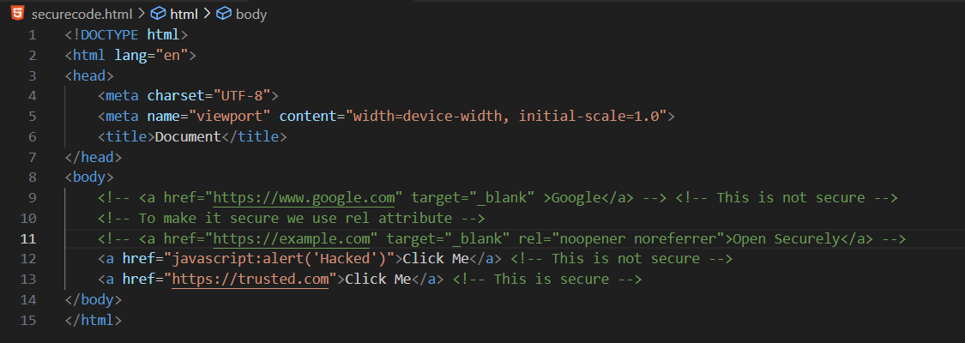

Output:

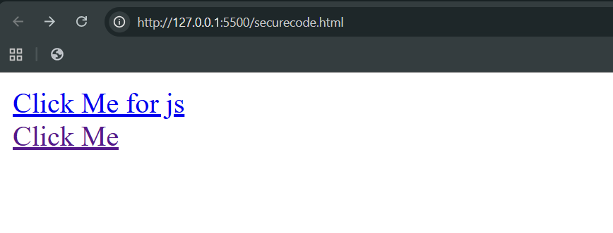

When clicked on 2nd link:

