**Day 5**

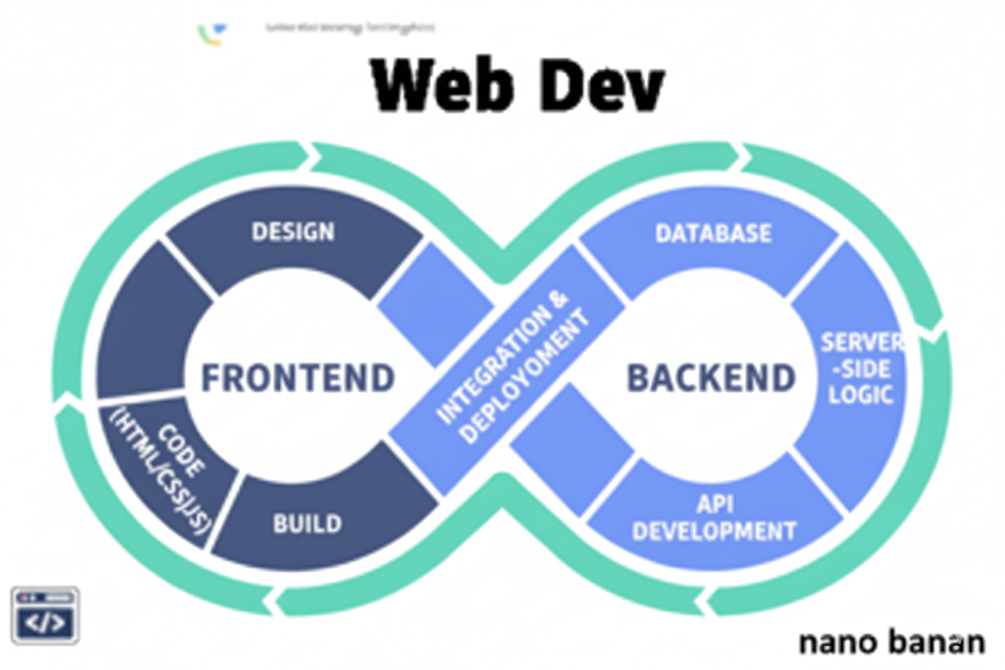

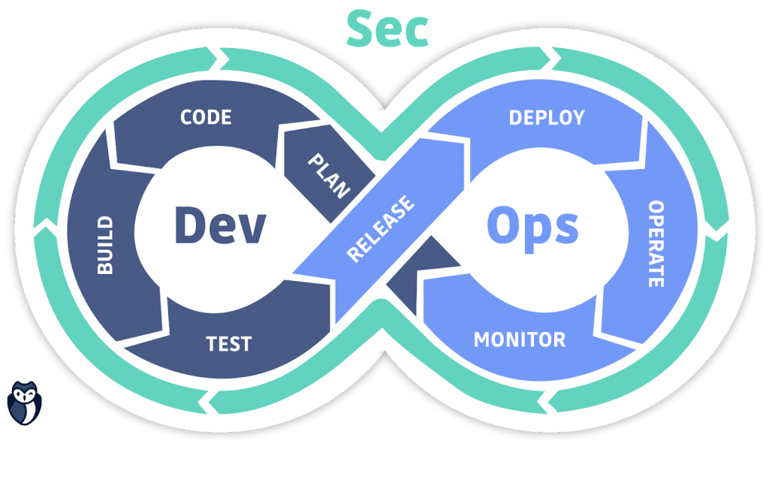

**“Web Development + Security”**

**Tables:**

**What is a table in HTML?**

In HTML, a table is used to organize data into rows and columns, like a grid. It’s created with the <table> tag and contains:

* <tr> → table row
* <td> → table data (cell)
* <th> → table header (for column titles, usually bold & centered)

Example:

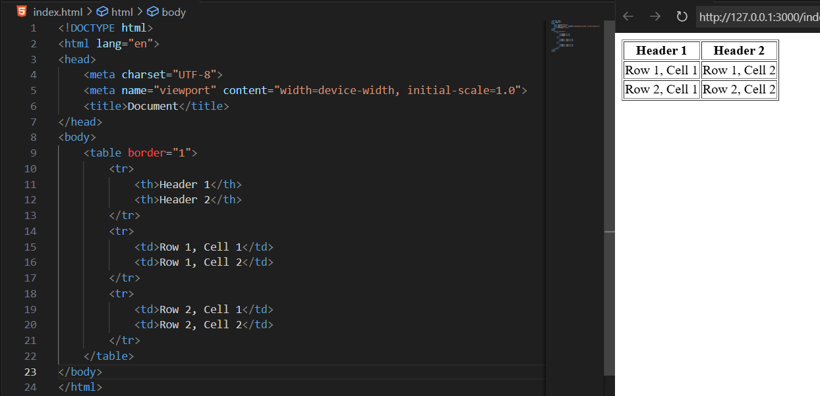

| **Attribute / Tag** | **Use Case** | **Example** |
| --- | --- | --- |
| <table> | Main container for the table | <table border="1"> |
| <tr> | Defines a row | <tr> ... </tr> |
| <th> | Table header cell (bold & centered by default) | <th>Name</th> |
| <td> | Table data cell | <td>Aditya</td> |
| border (HTML) / CSS border | Adds border around table/cells (prefer CSS in modern HTML) | <table border="1"> or table { border: 1px solid black; } |
| colspan | Cell spans multiple columns | <td colspan="2">Merged Cell</td> |
| rowspan | Cell spans multiple rows | <td rowspan="2">Merged Cell</td> |
| cellpadding | Space between cell content and border (use CSS: padding) | <table cellpadding="10"> |
| cellspacing | Space between table cells (use CSS: border-spacing) | <table cellspacing="5"> |
| <caption> | Adds a title/caption to the table | <caption>User Info</caption> |

Example: Showing use of rowspan and colspan

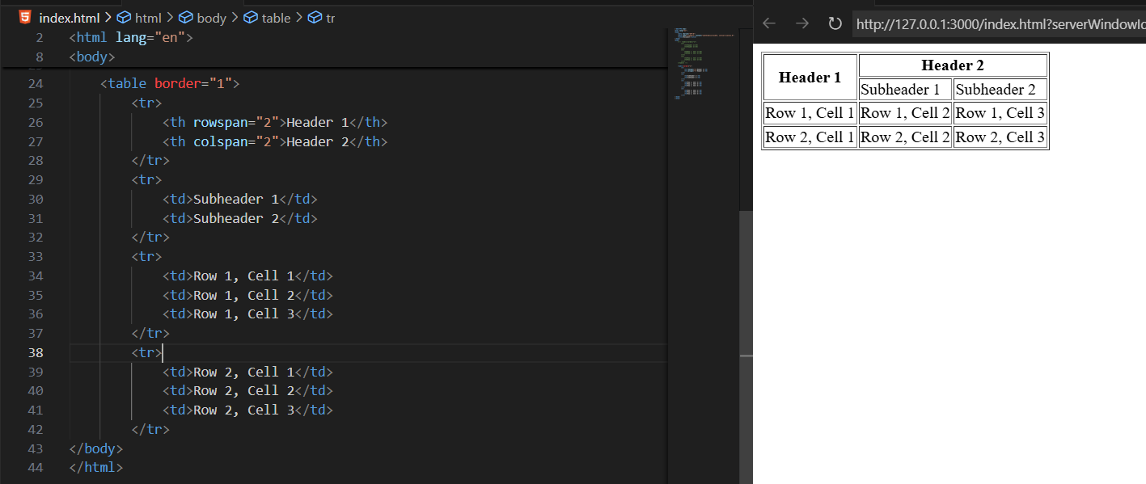

Example: Where one required cell is missing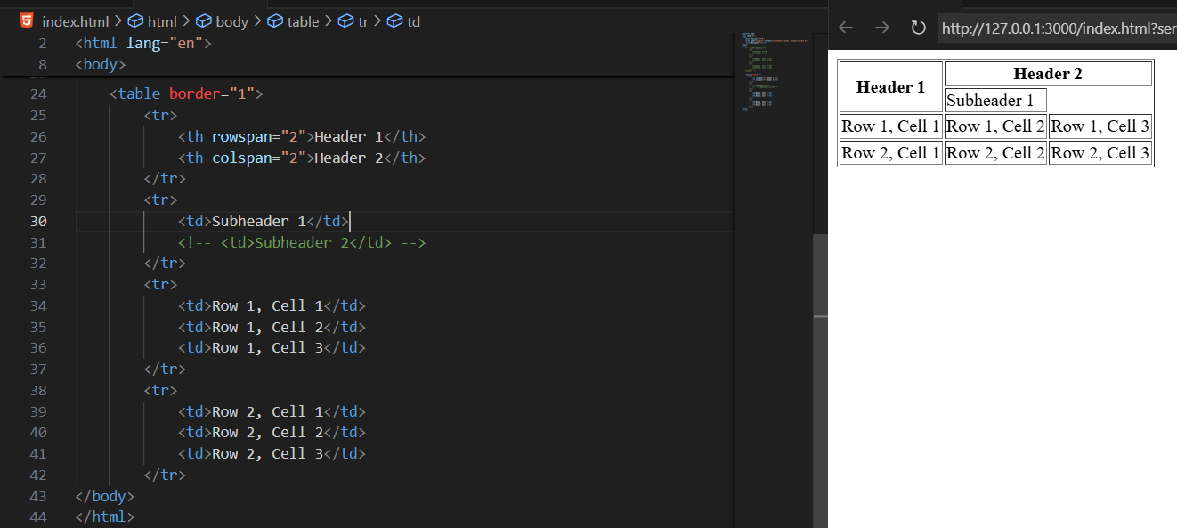

Example: showing use of caption

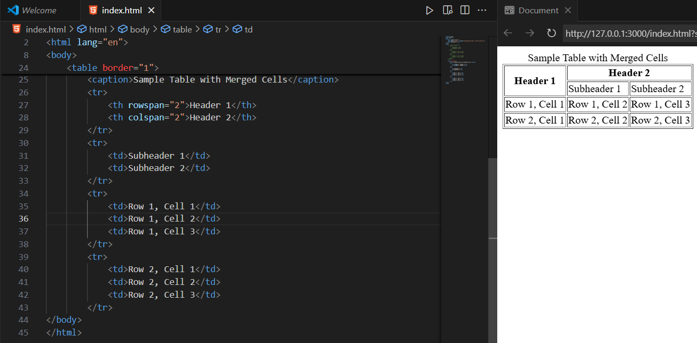

Example: showing use of <thead>, <tbody> and <tfoot>

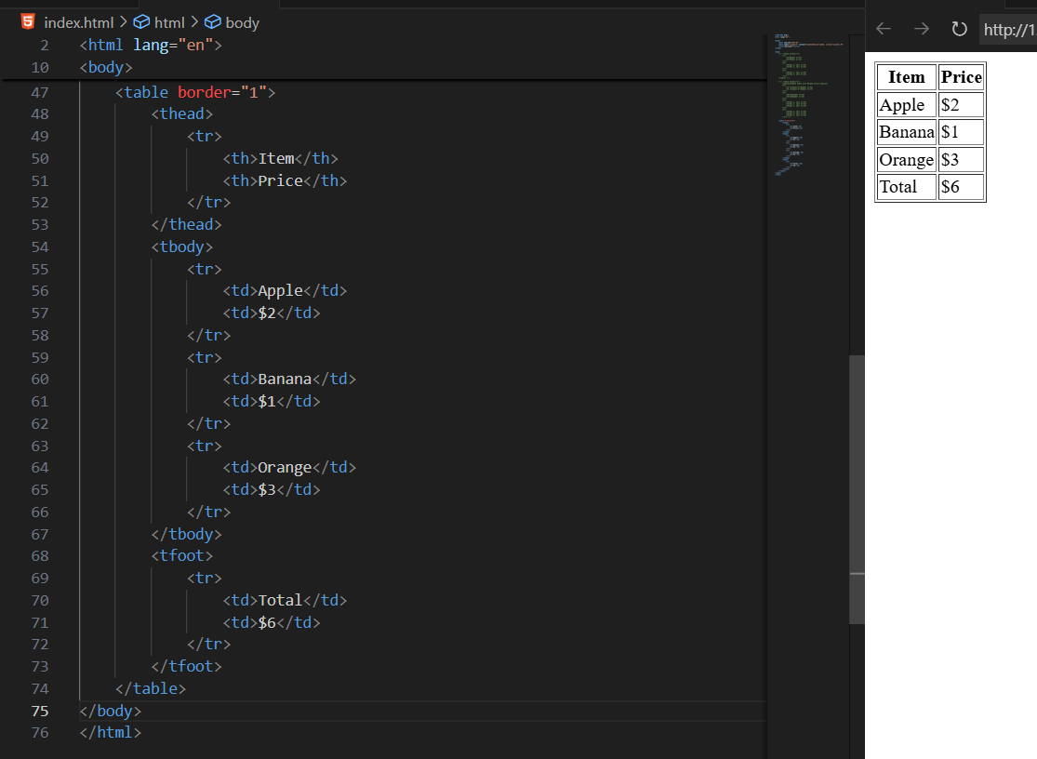

**Security Best Practices for Tables**

* Always sanitize user input before showing it in <td> or <th>.
* Use semantic tags (<thead>, <tbody>, <tfoot>) to keep data structured and prevent confusion.
* Don’t use tables for layout/design, only for data.
* Use HTTPS if table data is fetched from APIs (prevents tampering).
* Escape special characters (<, >, ", etc.) when inserting data into a table dynamically.

--The End--