**Day 6**

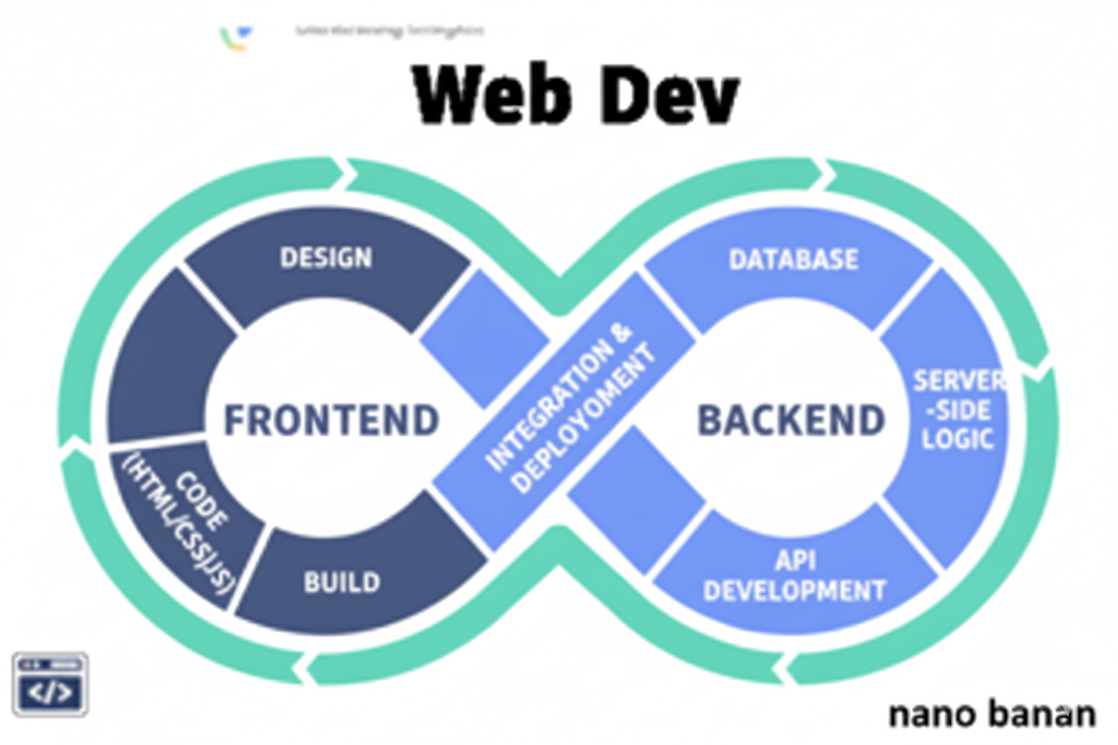



**“Web Development + Security”**

**Lists:**

**What is lists in HTML?**

In HTML, a list is a way to group related items together. There are three main types of lists:

1. Ordered list <ol>
2. Unordered list <ul>
3. Description list <dl>

Example:

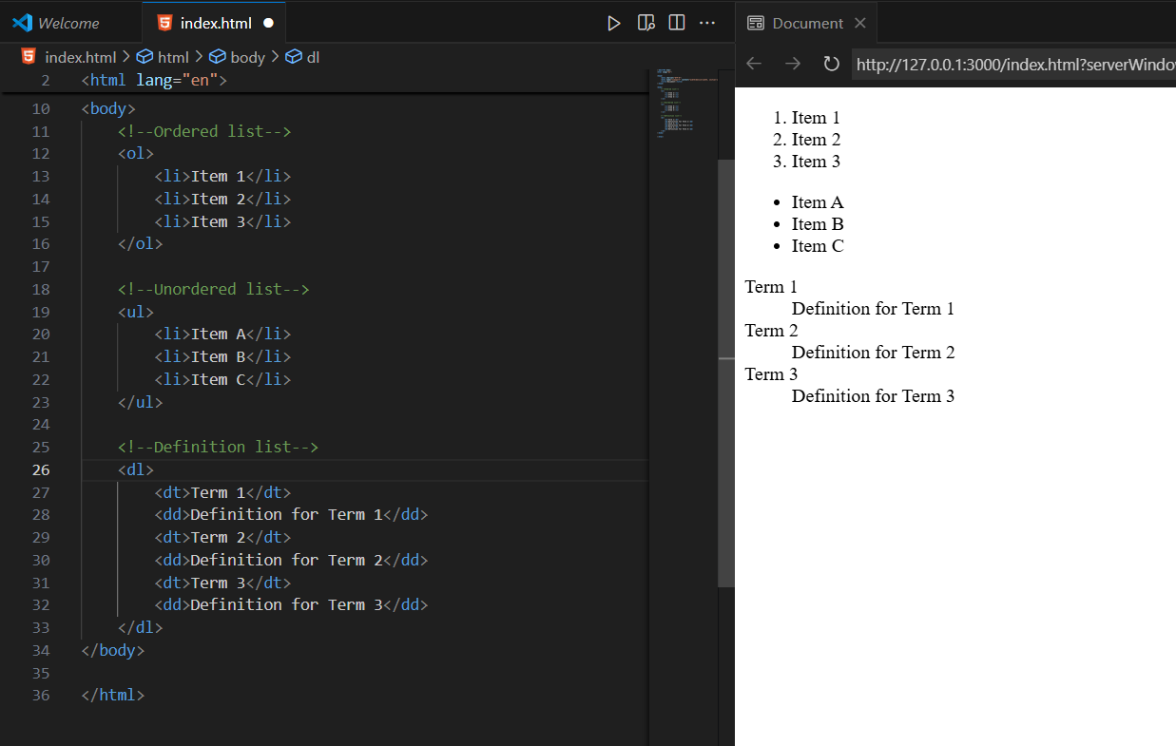

Important attributes:

| **List Type** | **Important Attribute** | **Use Case / Description** | **Example** |
| --- | --- | --- | --- |
| <ol> (Ordered List) | type | Controls numbering style (1, A, a, I, i) | <ol type="A"><li>Apple</li><li>Banana</li></ol> → A. Apple, B. Banana |
|  | start | Sets the starting number of the list | <ol start="5"><li>Item</li></ol> → starts numbering at 5 |
|  | reversed | Reverses the numbering order | <ol reversed><li>First</li><li>Second</li></ol> → 2. First, 1. Second |
| <ul> (Unordered List) | type (deprecated in HTML5) | Bullet style (disc, circle, square) – better via CSS | <ul type="square"><li>Apple</li></ul> |
| <dl> (Description List) | No specific attributes | Uses <dt> for term and <dd> for description | <dl><dt>HTML</dt><dd>Markup language</dd></dl> |
| All lists | class / id | Apply CSS styles or target with JS | <ul class="fruits">...</ul> |
|  | style | Inline CSS to control appearance (not recommended for maintainability) | <ol style="list-style-type: lower-roman;">...</ol> |

Example: showing some common attributes usage

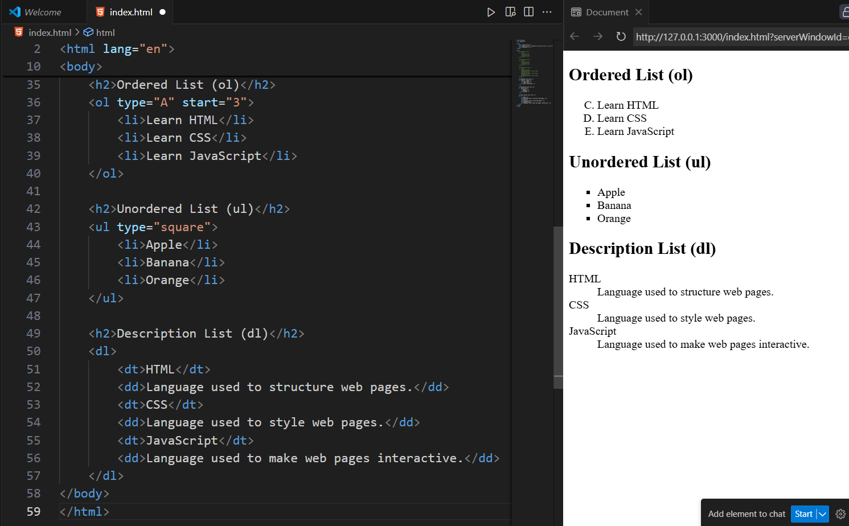

**Nested Lists:**

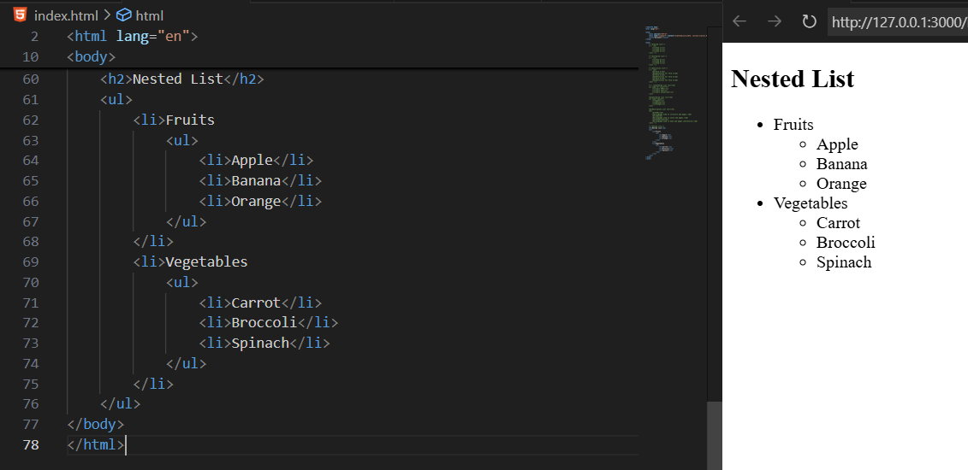

--The End--