**Day 7**

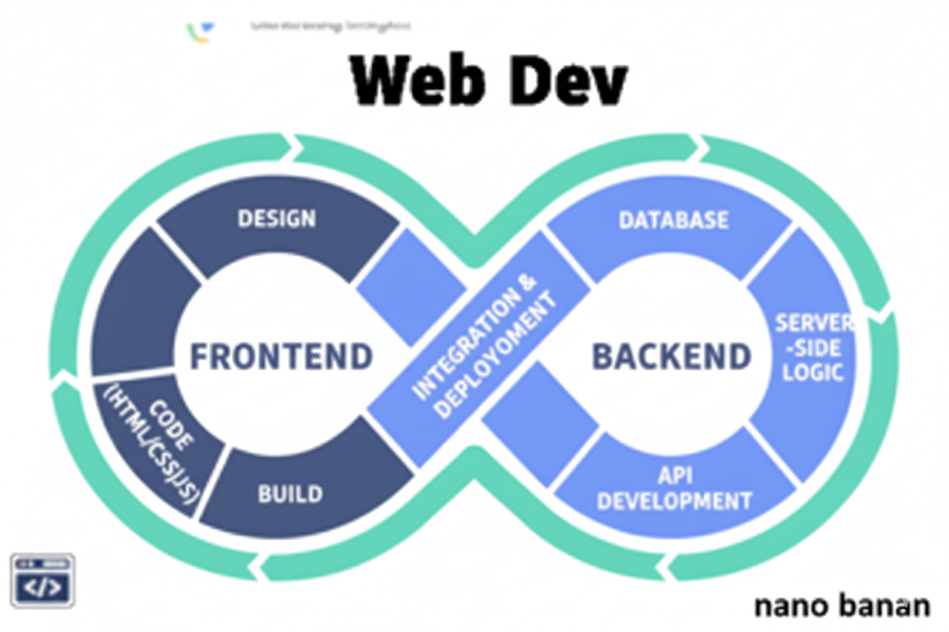

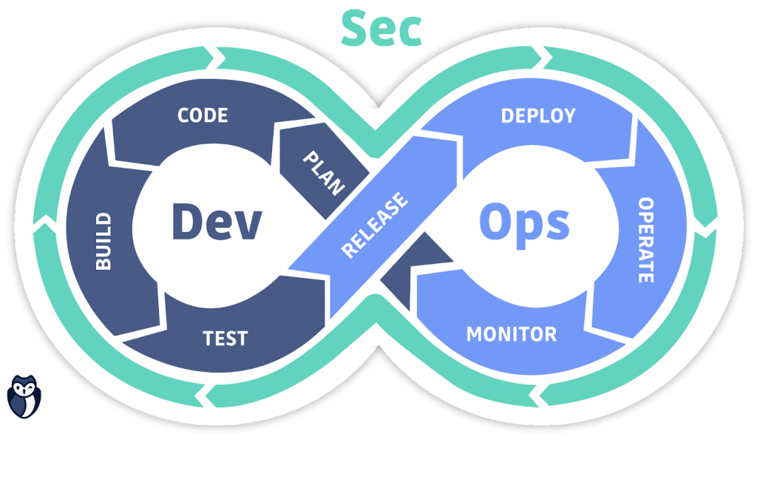

**“Web Development + Security”**

**SEO:**

**What is SEO in HTML?**

SEO (Search Engine Optimization) is the practice of improving a website so that it ranks higher in search engine results (like Google, Bing, etc.). The goal is to make the website more visible, trustworthy, and user-friendly, so more people can find it when searching for related topics.

It involves:

* On-page SEO → optimizing content, keywords, titles, headings, and meta descriptions.
* Technical SEO → improving site speed, mobile-friendliness, security (HTTPS), and clean code.
* Off-page SEO → building backlinks, social signals, and online reputation.

**What are Web Vitals?**

Web Vitals are Google’s key metrics to measure user experience on websites.

* LCP (Largest Contentful Paint): How fast main content loads (good ≤ 2.5s).
* FID/INP (First Input Delay / Interaction to Next Paint): How quickly the page responds to user actions (good ≤ 100ms).
* CLS (Cumulative Layout Shift): How stable the layout is without sudden shifts (good ≤ 0.1).

**Lighthouse:  
What is Lighthouse in browser?**

Lighthouse is a free, built-in tool in browsers like Google Chrome that helps you test and improve your website.

It analyzes a web page and gives a report on:

* Performance → how fast it loads.
* Accessibility → how usable it is for everyone.
* Best Practices → if the site follows security and coding standards.
* SEO → how well it can rank in search engines.
* Progressive Web App (PWA) → if it works like an app.

**Where can I find this?**

It can be found at “Inspect” section:

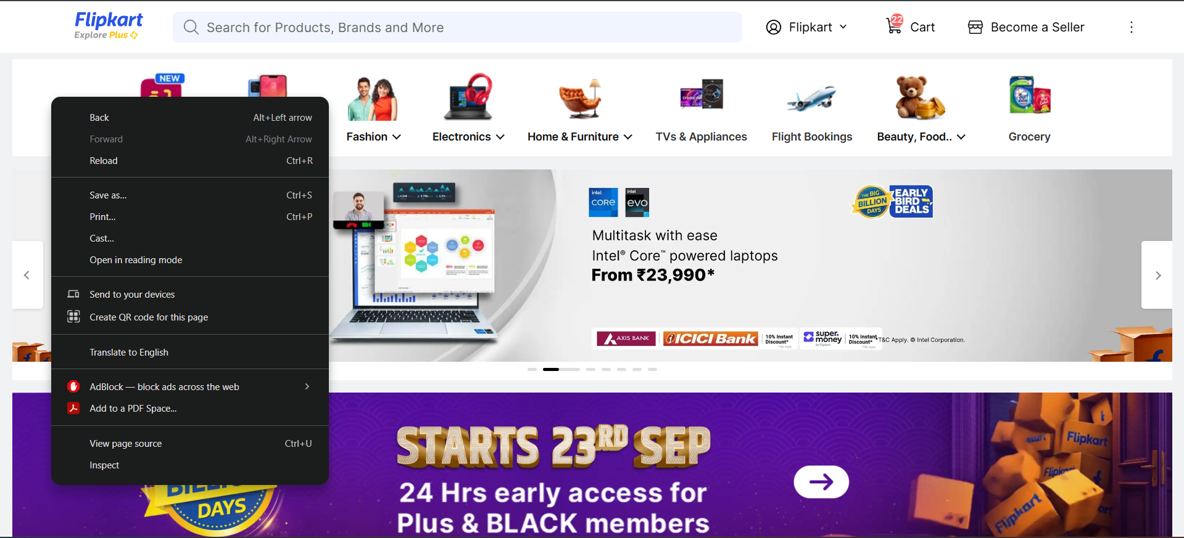

Scroll on right to see the “Lighthouse” option:

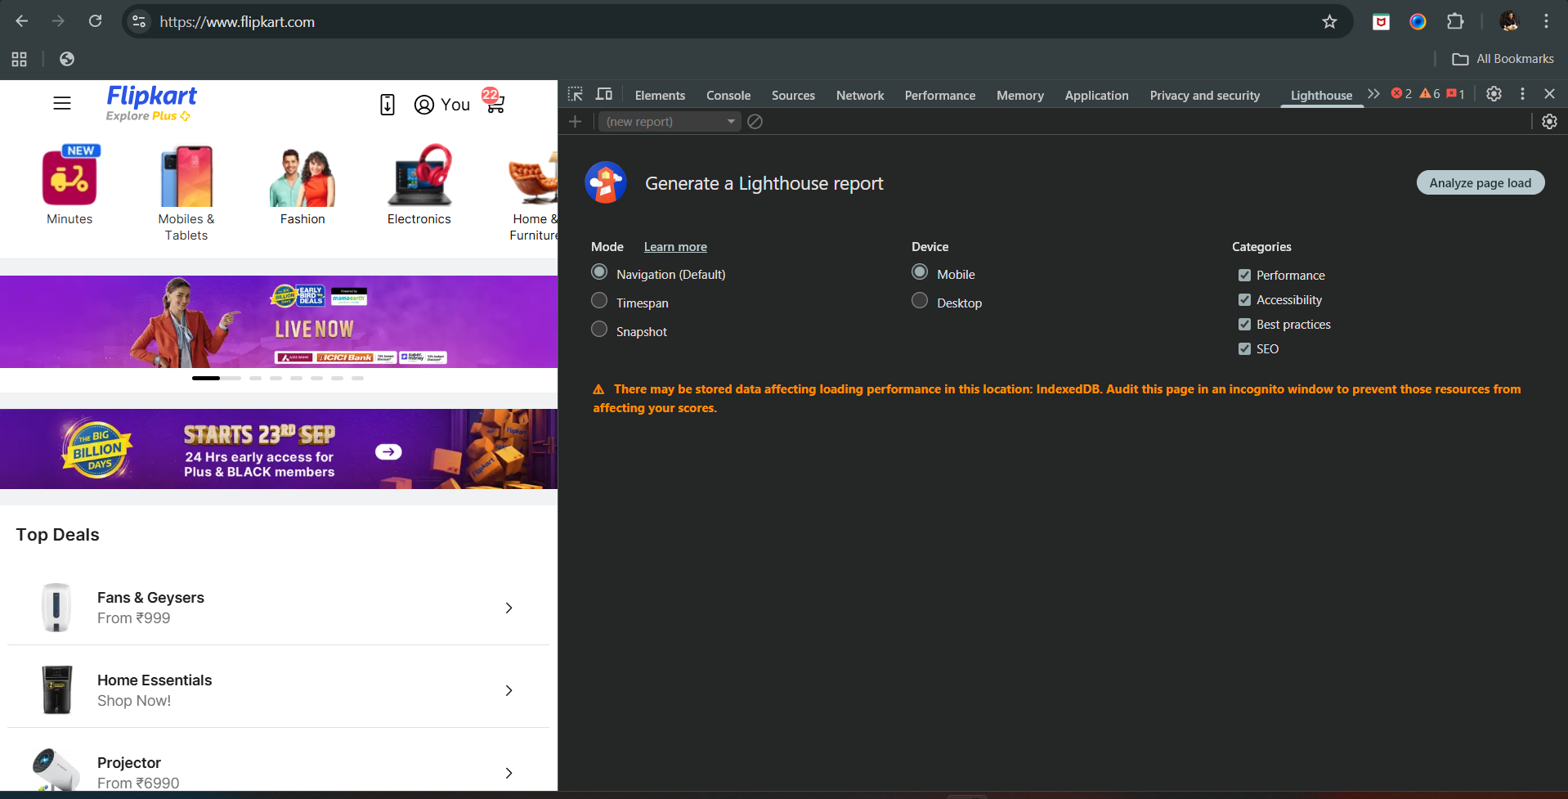

Click on “Analyse the page load” button to generate the report: report analysis is shown like this

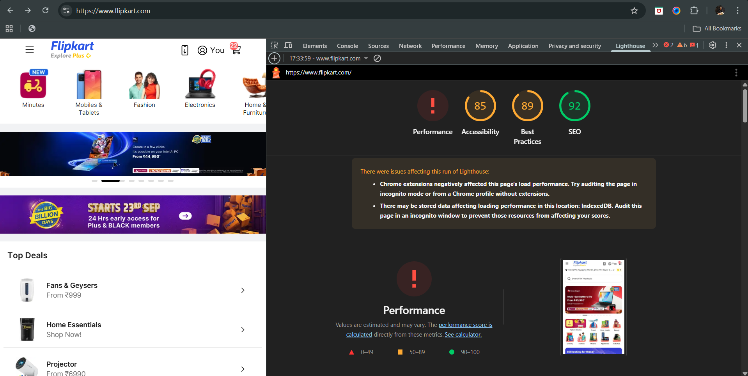

**Tags in HTML for SEO:**

| **HTML Element** | **Use / SEO Importance** | **Example** |
| --- | --- | --- |
| <title> | Sets the page title shown in search results | <title>Learn HTML Basics</title> |
| <meta name="description"> | Provides a summary for search engines | <meta name="description" content="A beginner's guide to HTML."> |
| <h1> – <h6> | Headings structure content; <h1> is most important | <h1>HTML Tutorial</h1> |
| <a> | Links to other pages; anchor text affects SEO | <a href="https://example.com">Learn CSS</a> |
| <img> + alt | Image SEO; alt describes image for accessibility | <img src="html.png" alt="HTML logo"> |
| <strong> / <em> | Emphasizes text; can help SEO contextually | <strong>Important</strong> |
| <meta name="robots"> | Controls crawling/indexing | <meta name="robots" content="noindex"> |
| <link rel="canonical"> | Avoids duplicate content issues | <link rel="canonical" href="https://example.com/page"> |
| <meta charset> | Ensures proper text rendering | <meta charset="UTF-8"> |