**Day 8**

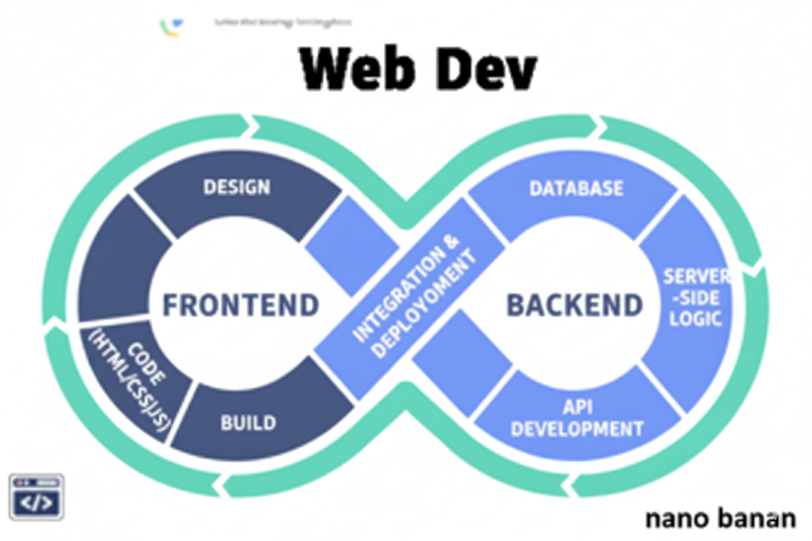



**“Web Development + Security”**

**Forms and Inputs:**

**What are Forms in HTML?**

In HTML, a form is a container that allows users to enter data and send it to a server for processing. Forms are used in almost every website for things like login, signup, search boxes, feedback, or payments.

A form is created using the <form> tag, and inside it, you can place input fields, checkboxes, radio buttons, dropdowns, and buttons.

**What are Input tags in HTML?**

In HTML, the <input> tag is used inside forms to create fields where users can enter data. It’s a self-closing tag and its behaviour changes depending on the type attribute.

**What is Label tag in HTML?**

The <label> tag in HTML is used to provide a text description for a form input element (like a text box, checkbox, or radio button). It improves usability (clicking on the label focuses/selects the input) and accessibility (screen readers read the label with the input, helping visually impaired users).

A very basic example to show the syntax:

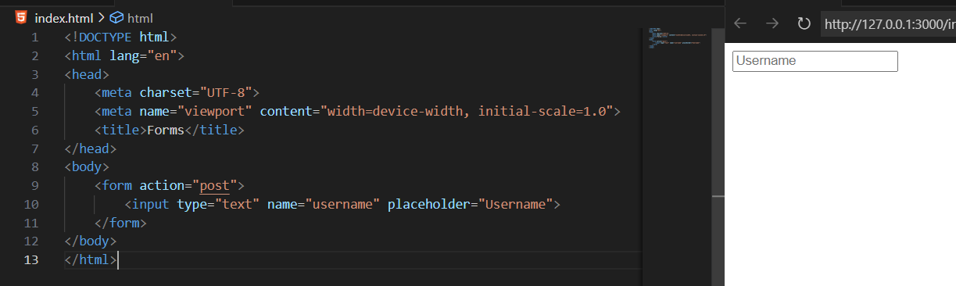

Example: <label> tag introduction

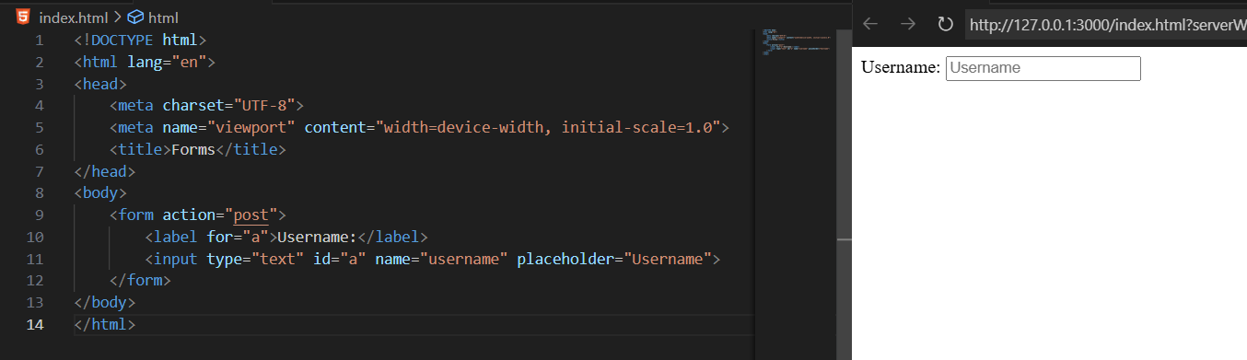

**Important <form> attributes:**

| Attribute | What it Does | Example |
| --- | --- | --- |
| action | URL where the form data is sent | <form action="/submit"> |
| method | HTTP method: GET (visible in URL) or POST (hidden in body) | <form method="post"> |
| enctype | Encoding type (important for file uploads). Common: application/x-www-form-urlencoded, multipart/form-data | <form enctype="multipart/form-data"> |
| target | Where to display the response (_self, _blank, _parent, _top) | <form target="_blank"> |
| autocomplete | Enables or disables autofill (on / off) | <form autocomplete="off"> |
| novalidate | Disables built-in HTML validation | <form novalidate> |
| name | Identifies the form (used in JavaScript) | <form name="loginForm"> |
| accept-charset | Character encoding (default is UTF-8) | <form accept-charset="UTF-8"> |

**Important <input> attributes:**

| Attribute | What it Does | Example |
| --- | --- | --- |
| type | Defines input type (text, email, password, etc.) | <input type="email"> |
| name | Key for sending data to server | <input name="username"> |
| id | Unique identifier, often used with <label> or JS | <input id="email"> |
| value | Default/pre-filled value | <input type="text" value="Aditya"> |
| placeholder | Hint text shown inside the field | <input type="text" placeholder="Enter name"> |
| required | Makes input mandatory | <input type="password" required> |
| readonly | Field cannot be edited, but is sent with form | <input type="text" value="123" readonly> |
| disabled | Field is inactive and not submitted | <input type="text" disabled> |
| maxlength / minlength | Restrict number of characters | <input type="text" maxlength="10"> |
| pattern | Regex pattern for validation | <input type="text" pattern="[A-Za-z]{3,}"> |
| autocomplete | Suggests saved values (on/off) | <input autocomplete="off"> |
| accept | Restricts file types (for type="file") | <input type="file" accept=".jpg,.png"> |
| step, min, max | For numbers/date inputs | <input type="number" min="1" max="100"> |

**Important <label> attributes:**

| **Attribute** | **What it Does** | **Example** |
| --- | --- | --- |
| for | Connects the label to an input field using the input’s id. Clicking the label will focus/activate the input. | <label for="email">Email:</label><input id="email" type="email"> |
| form | Associates the label with a form (useful if the input is outside the <form>). | <label for="username" form="signupForm">Username:</label> |
| *Global attributes* | Since <label> is a normal HTML element, it also supports global attributes like class, id, style, title. | <label for="password" class="bold">Password:</label> |

**What is textarea tag in HTML?**

The <textarea> tag in HTML is used when you want users to enter multi-line text, like comments, feedback, or messages. Unlike <input type="text">, which is for single-line input, <textarea> lets users type paragraphs.

**Key Attributes of <textarea>**

* name → the field’s name (sent to server).
* rows → visible height (number of text lines).
* cols → visible width (number of characters per line).
* placeholder → hint text inside the box.
* maxlength / minlength → limit character length.
* readonly → user can’t edit but value is sent.
* disabled → user can’t edit, and value is not sent.
* required → must be filled before submitting.

Example:

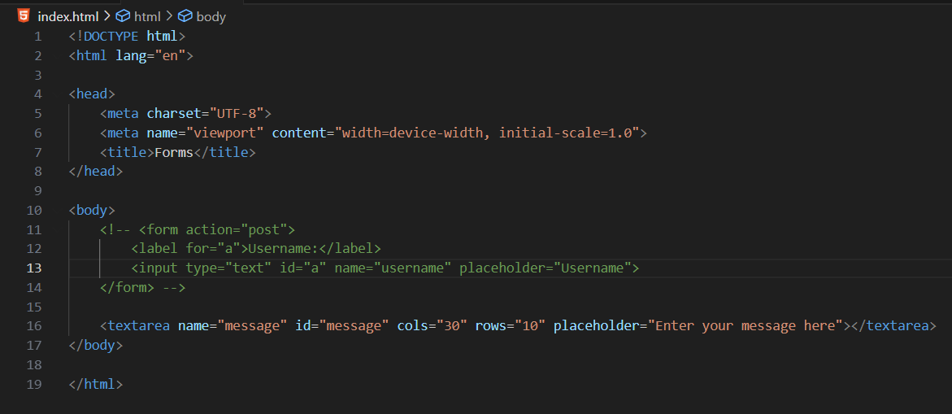

Output:

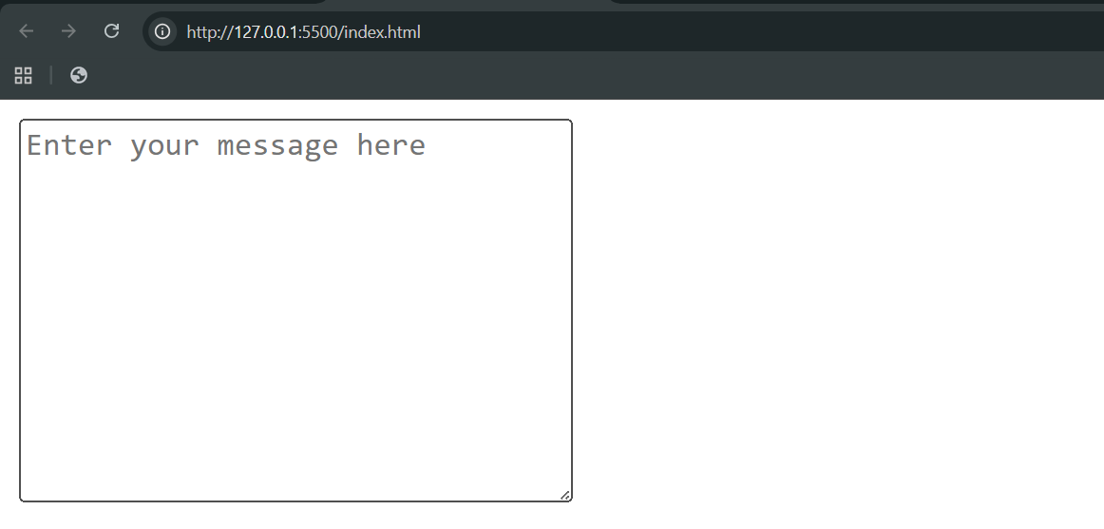

**What is <select> tag in HTML**

The <select> tag in HTML is used to create a dropdown list where users can pick one (or sometimes multiple) options. It works with <option> tags inside it.

**Key Attributes of <select>**

* **name** → the field’s name (sent to server).
* **id** → unique identifier (used with <label> or JS).
* **multiple** → allows selecting more than one option.
* **size** → number of options visible at once.
* **required** → makes selection mandatory.
* **disabled** → disables the dropdown.
* **autofocus** → focuses dropdown when page loads.

Example:

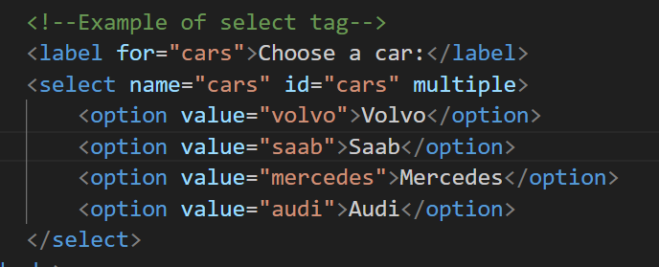

Output:

