**Day 11**

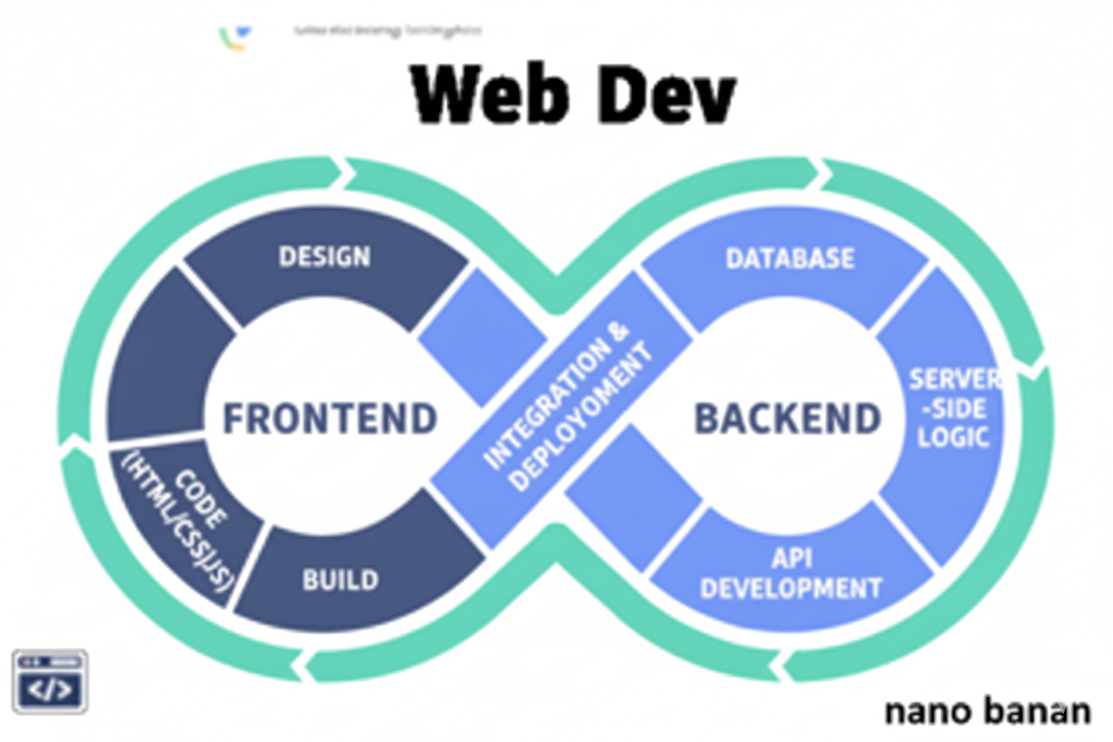

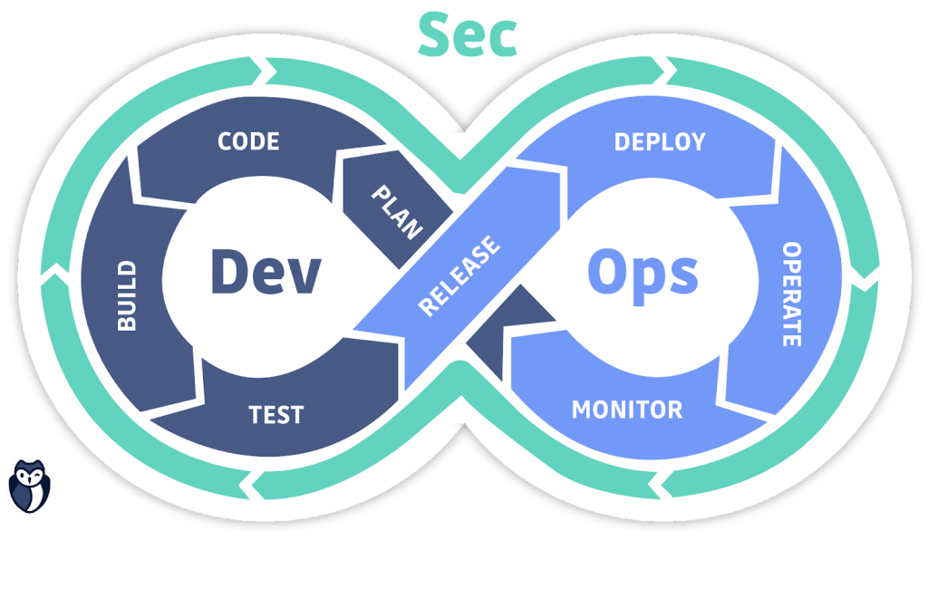

**“Web Development + Security”**

**Video, Audio & Media:**

**What is <video> tag in HTML?**

The <video> tag in HTML is used to show a video on a webpage.

* It works like the <img> tag, but for videos.
* You can play, pause, and control it with built-in buttons.
* It needs a video file (like .mp4, .webm, .ogg).

**Important attributes of <video>:**

| **Attribute** | **Meaning (Simple Words)** | **Example Code** |
| --- | --- | --- |
| **src** | Path of the video file | <video src="movie.mp4"></video> |
| **controls** | Adds play, pause, volume buttons | <video controls></video> |
| **autoplay** | Video starts playing automatically | <video autoplay></video> |
| **loop** | Video repeats after finishing | <video loop></video> |
| **muted** | Video starts with no sound | <video muted></video> |
| **poster** | Shows an image before the video starts (thumbnail) | <video poster="thumbnail.jpg"></video> |
| **width** | Sets the video’s width | <video width="400"></video> |
| **height** | Sets the video’s height | <video height="300"></video> |

Example:

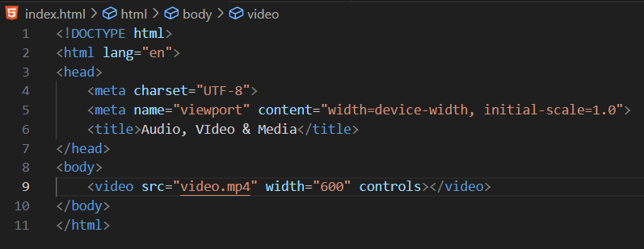

Output:

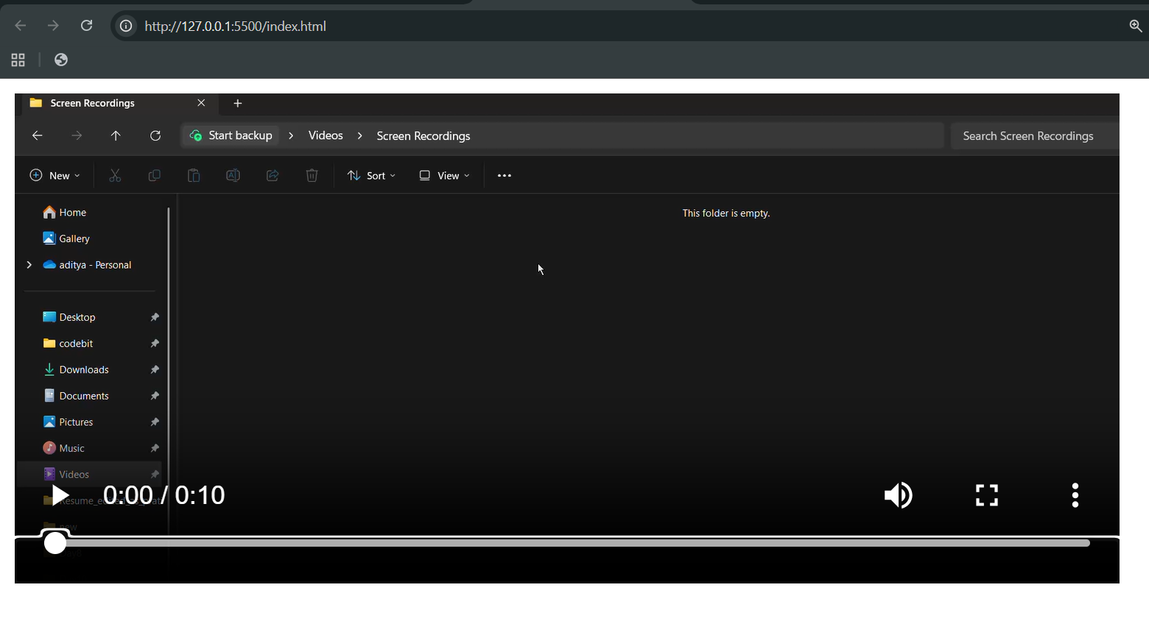

**What is <audio> tag in HTML?**

The <audio> tag in HTML is used to play sound/music on a webpage, just like <video> is used for videos.

**Important attributes of <audio>:**

| **Attribute** | **Meaning (Simple Words)** | **Example Code** |
| --- | --- | --- |
| **src** | Path of the audio file | <audio src="song.mp3"></audio> |
| **controls** | Adds play, pause, volume buttons | <audio controls></audio> |
| **autoplay** | Audio starts playing automatically | <audio autoplay></audio> |
| **loop** | Audio repeats again and again | <audio loop></audio> |
| **muted** | Audio starts with no sound | <audio muted></audio> |

Preload attribute:

| **Value** | **Meaning in Simple Words** |
| --- | --- |
| **none** | Don’t load the file until the user clicks play (saves data). |
| **metadata** | Only load info about the file (like duration, size), but not the whole media. |
| **auto** | Load the whole file in advance (useful if you expect the user will play it). |

Example:

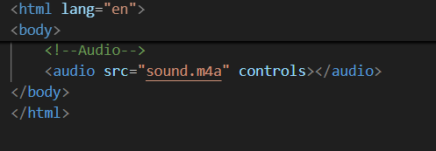

Output:

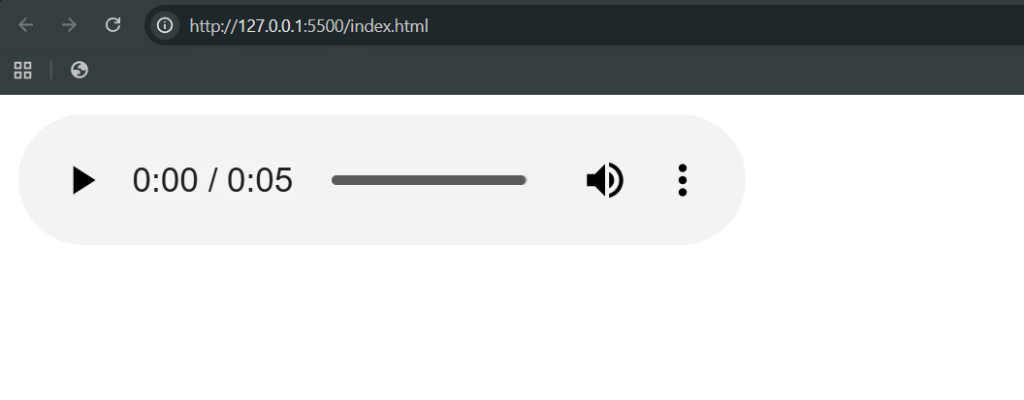

**What is <iframe> tag in HTJML?**

The <iframe> tag in HTML is used to embed another webpage inside your webpage.  
Think of it like a small window showing another site or page.

**Important attributes of <iframe>:**

| **Attribute** | **Meaning (Simple Words)** | **Example Code** |
| --- | --- | --- |
| **src** | The webpage link (URL) to display inside the iframe | <iframe src="page.html"></iframe> |
| **width** | Width of the iframe window | <iframe width="600"></iframe> |
| **height** | Height of the iframe window | <iframe height="400"></iframe> |
| **title** | A short description (for accessibility) | <iframe title="My site"></iframe> |
| **name** | Gives the iframe a name (can be used with links/targets) | <iframe name="myFrame"></iframe> |
| **allowfullscreen** | Allows the iframe to go full screen (useful for videos) | <iframe allowfullscreen></iframe> |
| **loading** | Controls when the iframe loads: lazy (load later) or eager (load immediately) | <iframe loading="lazy"></iframe> |
| **sandbox** | Adds security rules (restricts scripts, forms, etc.) | <iframe sandbox></iframe> |

Example:

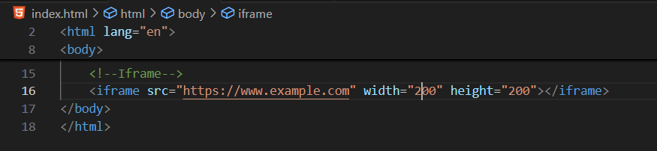

Output:

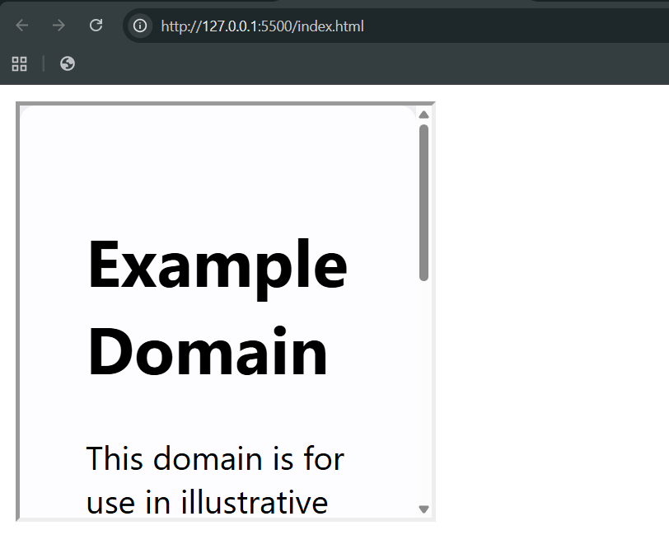

--The End--