**Day 13**

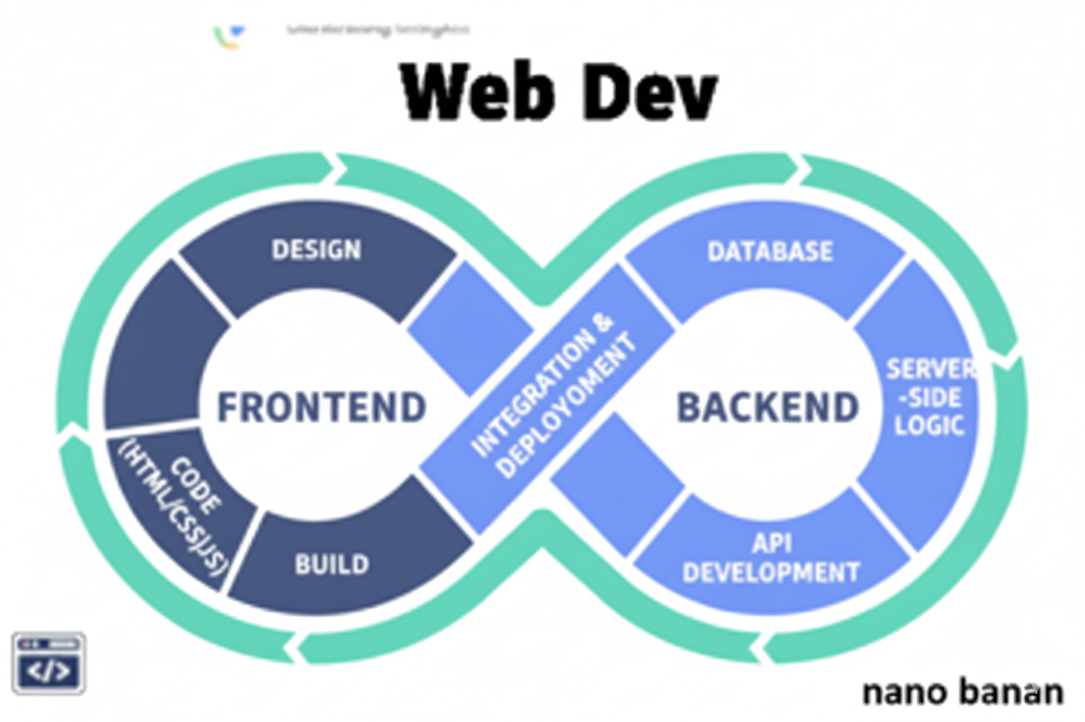

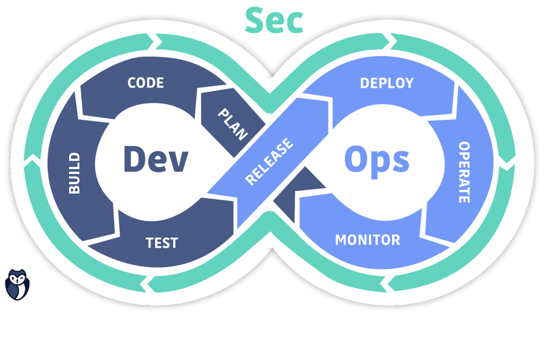

**“Web Development + Security”**

**Entities in HTML:**

**What are Entities in HTML?**

Entities in HTML are predefined codes that represent characters which have a special meaning in HTML (like <, >, &, etc.) or characters that are not easily available on the keyboard (like ©, ®, ₹, €, etc.).

Every HTML entity starts with an ampersand (&) and ends with a semicolon (;).  
There are two main types:

1. **Named Entity:** &lt; → <
2. **Numeric Entity:** &#60; → <

| **Entity Name** | **Displays As** | **Meaning** |
| --- | --- | --- |
| &lt; | < | Less-than sign |
| &gt; | > | Greater-than sign |
| &amp; | & | Ampersand |
| &quot; | " | Double quote |
| &apos; | ' | Single quote |
| &nbsp; | ( ) | Non-breaking space |
| &copy; | © | Copyright symbol |
| &reg; | ® | Registered trademark |
| &euro; | € | Euro sign |
| &#8377; | ₹ | Indian Rupee sign |

Example:

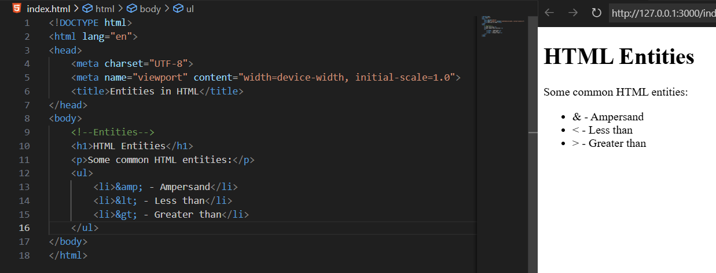

Example: writing <p> tag using entities

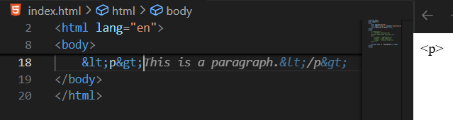

**<pre> Tag:**

**What is <pre> tag in HTML?**

The <pre> tag is used to display text exactly as it is written in the HTML code — including spaces, tabs, and line breaks.

Example:

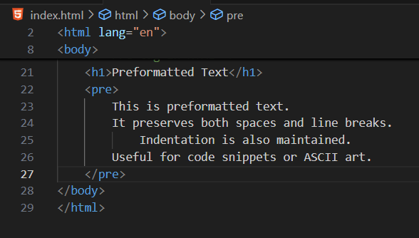

Output:

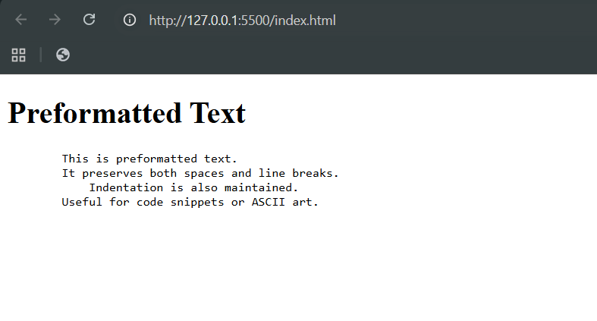

**Use cases:**

* Showing source code
* Displaying terminal output
* Writing ASCII art
* Keeping text alignment (like tables or poetry)

Features:

| **Feature** | **Description** |
| --- | --- |
| **Preserves formatting** | Keeps spaces, tabs, and line breaks as written. |
| **Uses monospace font** | By default, browsers display <pre> text in a fixed-width font (like code editors). |
| **Often used with <code>** | Ideal for showing code snippets, command output, or ASCII art. |

**<blockquote> tag:**

**What is <blockquote> tag?**

The <blockquote> tag defines a section that is quoted from another source and usually displays the text indented in browsers.

Features:

| **Feature** | **Description** |
| --- | --- |
| **Purpose** | To show long quotations or excerpts. |
| **Appearance** | Indented block of text (by default). |
| **Attribute** | cite → specifies the source of the quote. |
| **Can include** | Paragraphs, text, or inline tags inside. |

Example:

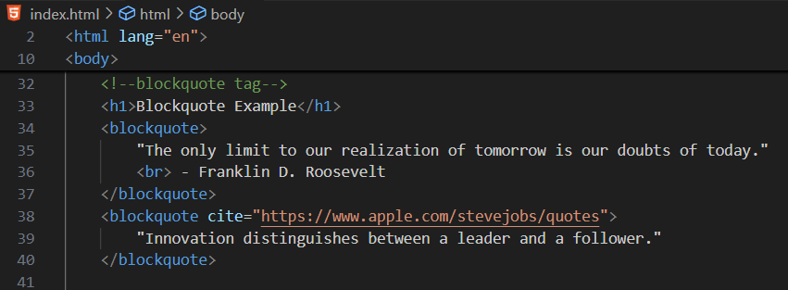

**<q> tag:**

**What is <q> tag?**

The <q> tag is used for short quotations that appear inside a paragraph.  
Browsers automatically add quotation marks (" ") around the text inside <q>.

Example:

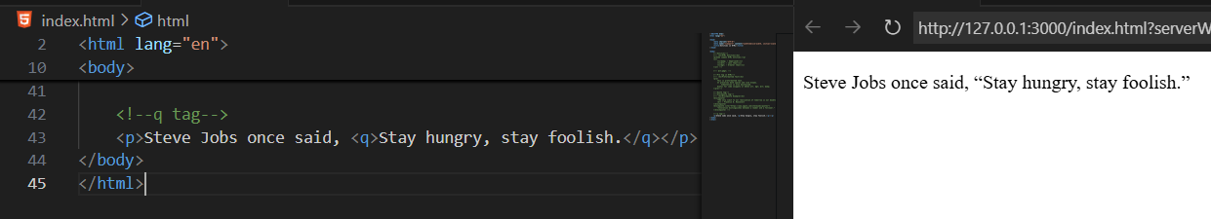

**Difference between <q> and <blockquote>:**

| **Tag** | **Used For** | **Display** |
| --- | --- | --- |
| <q> | Short, inline quotes | Adds quotation marks automatically |
| <blockquote> | Long, block-level quotes | Indents text as a block quote |

**Obsolete Tags:**

**What are obsolete tags?**

Obsolete (or deprecated) HTML tags are elements that were used in older versions of HTML (like HTML 3.2 or 4.01), but have been removed in HTML5 because they are either:

* Replaced by CSS for styling, or
* Considered non-semantic or redundant.

Some common obsolete tags:

| **Obsolete Tag** | **Purpose (Old)** | **Modern Alternative** |
| --- | --- | --- |
| <center> | Centered content | text-align: center; in CSS |
| <font> | Change font, color, size | Use CSS: font-family, color, font-size |
| <b> *(in some cases)* | Bold text | <strong> for importance, or CSS font-weight |
| <i> *(in some cases)* | Italic text | <em> for emphasis, or CSS font-style |
| <u> | Underline text | CSS: text-decoration: underline; |
| <marquee> | Scrolling text | Use CSS animations or JavaScript |
| <big> / <small> | Resize text | CSS font-size |
| <strike> | Strike-through text | <del> or CSS text-decoration: line-through; |
| <tt> | Teletype/monospace text | <code> or CSS font-family: monospace; |
| <frameset> / <frame> | Page frames | Use <iframe> or modern layouts with <div> and CSS Grid/Flexbox |
| <applet> | Embed Java applets | Use <object> or <embed> |
| <acronym> | Abbreviations | <abbr> tag |
| <dir> | Directory list | <ul> unordered list |
| <isindex> | Single-line input | <input> |

**Why They’re Avoided:**

* They break semantic meaning.
* Harder to maintain and style.
* Don’t work well on mobile or responsive designs.
* May not be supported by modern browsers.

**<code> tag:**

**What is a <code> tag?**

The <code> tag defines a fragment of code. It is usually displayed in a monospace (fixed-width) font to make it stand out from normal text.

| **Use Case** | **Example** |
| --- | --- |
| Inline code in sentences | <code>if (x > 0)</code> |
| Displaying snippets of HTML, CSS, JS, etc. | <code>&lt;div&gt;Hello&lt;/div&gt;</code> |
| With <pre> for multi-line blocks | For structured code formatting |

Example:

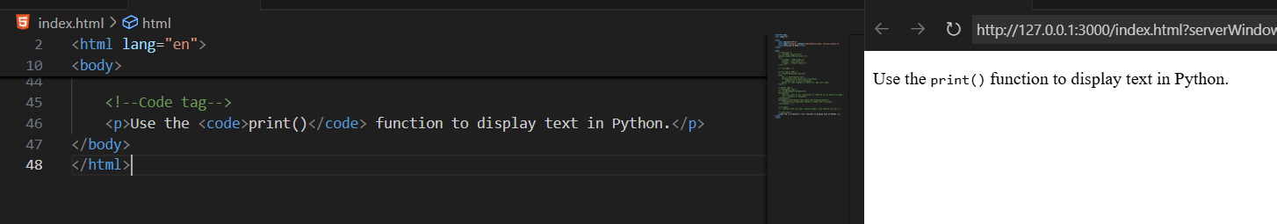

--The End--