**Day 14**

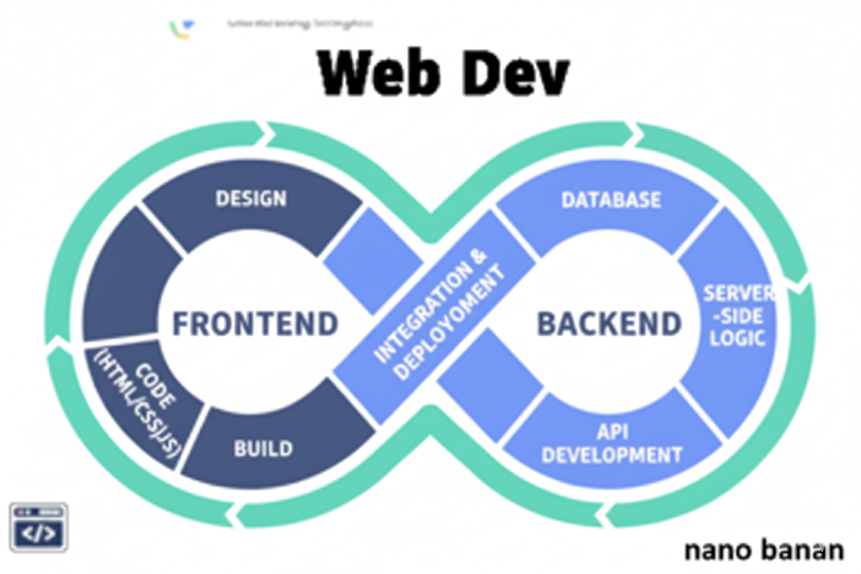



**“Web Development + Security”**

**CSS:**

**What is CSS?**

CSS stands for Cascading Style Sheets. It is the language used to style and design web pages — controlling how HTML elements look on screen, paper, or other media.

HTML builds the structure of a webpage, and CSS makes it look beautiful — by adding colors, layouts, fonts, spacing, animations, and more.

**CSS can control:**

| **Feature** | **Example** |
| --- | --- |
| **Colors** | Text, background, borders |
| **Fonts** | Family, size, weight |
| **Layout** | Positioning, spacing, flexbox, grid |
| **Animation** | Smooth transitions and effects |
| **Responsiveness** | Makes websites mobile-friendly |

A basic example adding CSS using <style> tag:

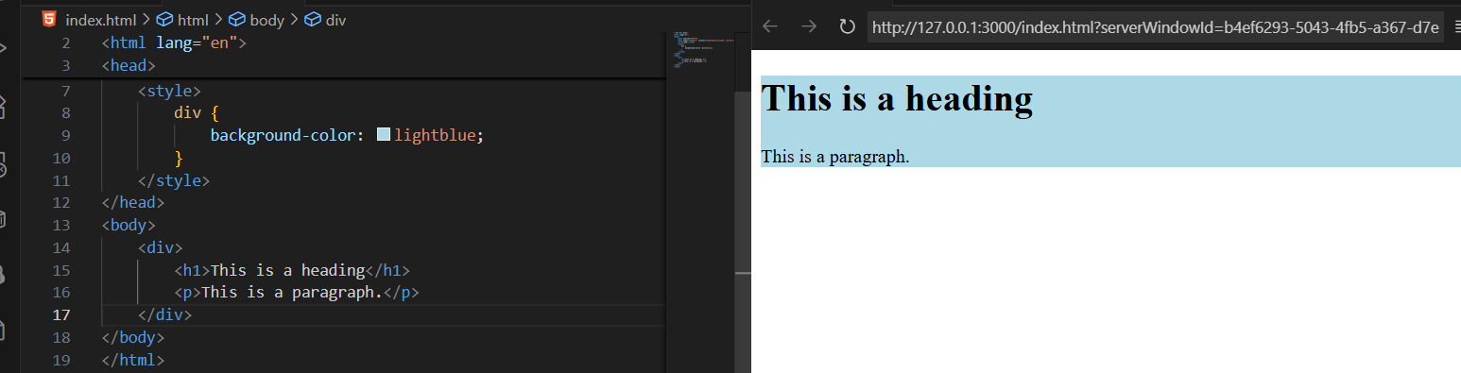

**What is a selector?**

A selector tells the browser *which HTML elements* you want to style. It’s the first part of a CSS rule, before the { ... }.

Syntax:

selector {

property: value;

}

Example:

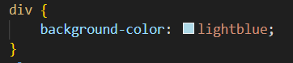

Here, div is the selector. While declaration says that background-color be blue.

| **Selector Type** | **Example** | **Selects** |
| --- | --- | --- |
| **Element Selector** | p {} | All <p> tags |
| **Class Selector** | .intro {} | Elements with class="intro" |
| **ID Selector** | #main {} | Element with id="main" |
| **Universal Selector** | * {} | All elements |
| **Group Selector** | h1, h2, p {} | Multiple types at once |
| **Descendant Selector** | div p {} | <p> inside <div> |
| **Attribute Selector** | input[type="text"] {} | <input> with type="text" |
| **Pseudo-class** | a:hover {} | <a> when hovered |
| **Pseudo-element** | p::first-letter {} | The first letter of each <p> |

Also, even if I write the <div> twice, properties defined for the first will also be possessed by the next.

Example: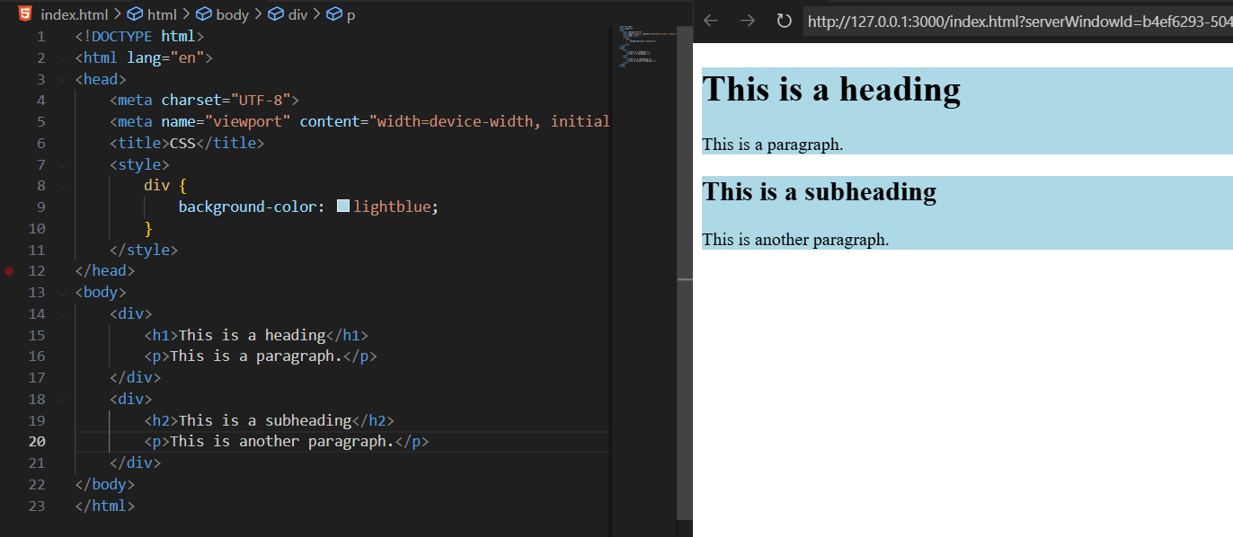

Example: assigning properties using the comma.

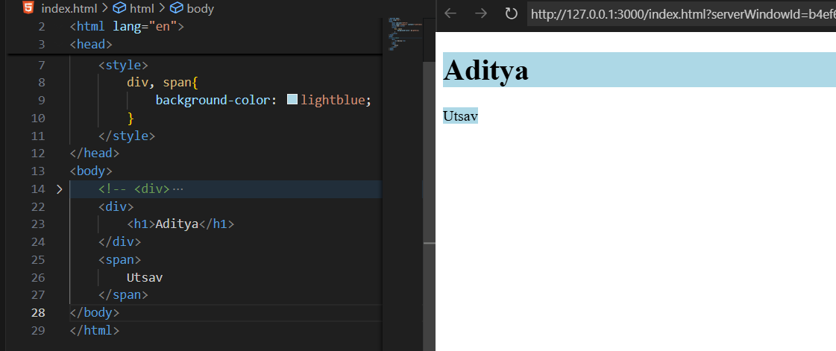

**3 ways to add CSS:**

| **Type** | **Description** | **Example** |
| --- | --- | --- |
| **Inline CSS** | Inside an HTML tag | <p style="color:blue;">Text</p> |
| **Internal CSS** | Inside <style> tag in <head> | As shown below |
| **External CSS** | In a separate .css file linked with <link> | <link rel="stylesheet" href="style.css"> |

**Example of Inline CSS**: We just write the ‘style=””’ and define what we want to change

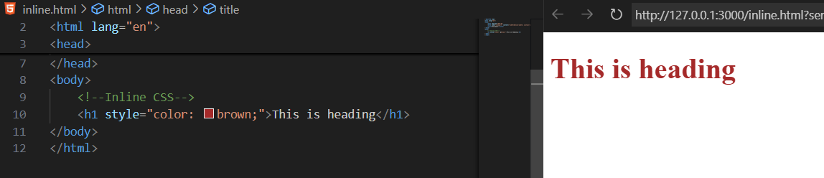

Example: adding more than one properties

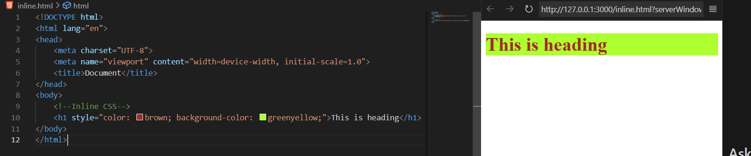

**Example of internal CSS**: we uses <style> tag (which is a closed tag) inside the <head> tag.

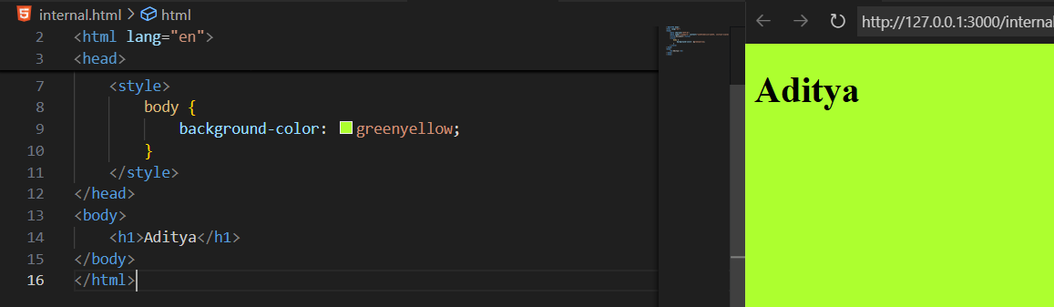

**Example of external CSS**: we just write the line <link rel="stylesheet" href="styles.css">

External.html:

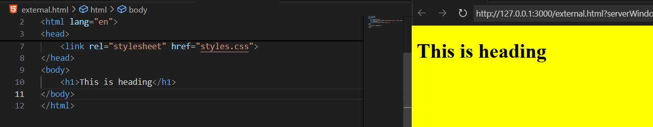

Style.css:

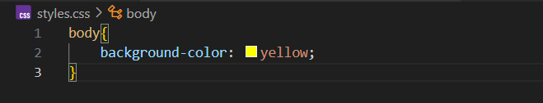

--The End--