**Day 15**

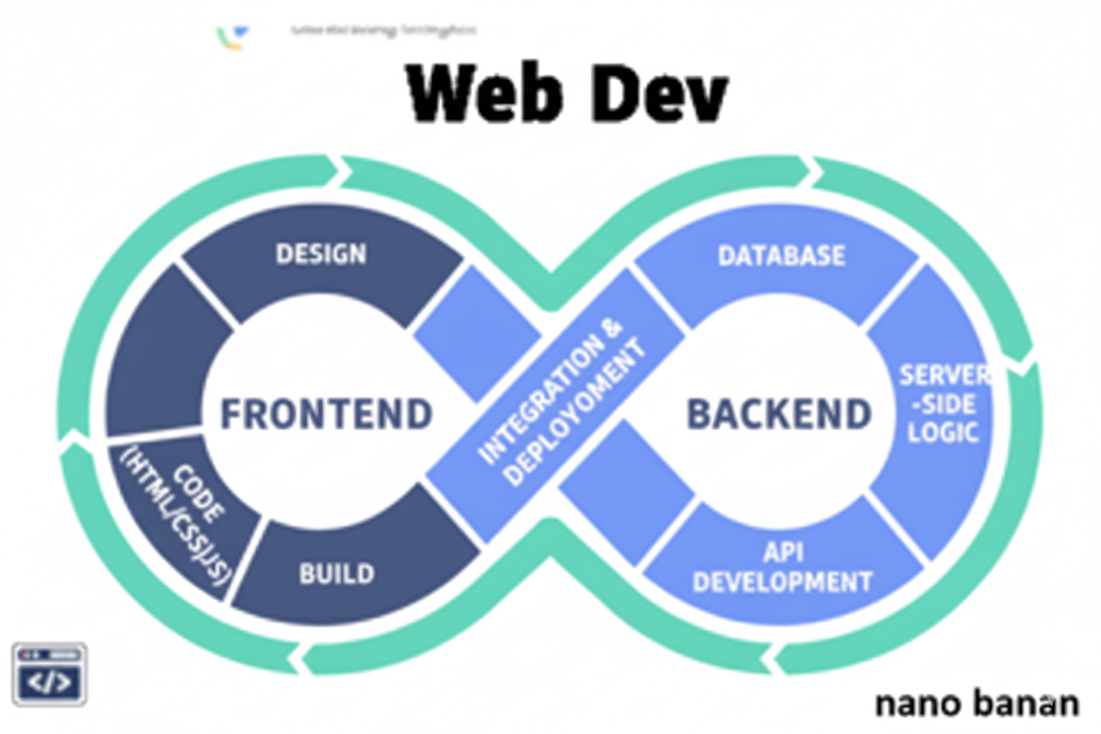



**“Web Development + Security”**

**Selectors:**

**What are Selectors in CSS?**

A selector tells the browser *which HTML elements* you want to style. It’s the first part of a CSS rule, before the { ... }.

Syntax:

selector {

property: value;

}

Example:

p {

color: blue;

font-size: 18px;

}

**Types of CSS Selectors:**

| **Selector Type** | **Example** | **Selects** |
| --- | --- | --- |
| **Element Selector** | p {} | All <p> tags |
| **Class Selector** | .intro {} | Elements with class="intro" |
| **ID Selector** | #main {} | Element with id="main" |
| **Universal Selector** | * {} | All elements |
| **Group Selector** | h1, h2, p {} | Multiple types at once |
| **Descendant Selector** | div p {} | <p> inside <div> |
| **Attribute Selector** | input[type="text"] {} | <input> with type="text" |
| **Pseudo-class** | a:hover {} | <a> when hovered |
| **Pseudo-element** | p::first-letter {} | The first letter of each <p> |

Example: a basic div tag use

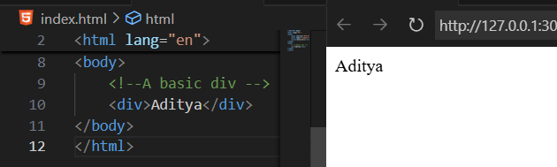

Example: element selector, we just use the element name in the style tag to style them.

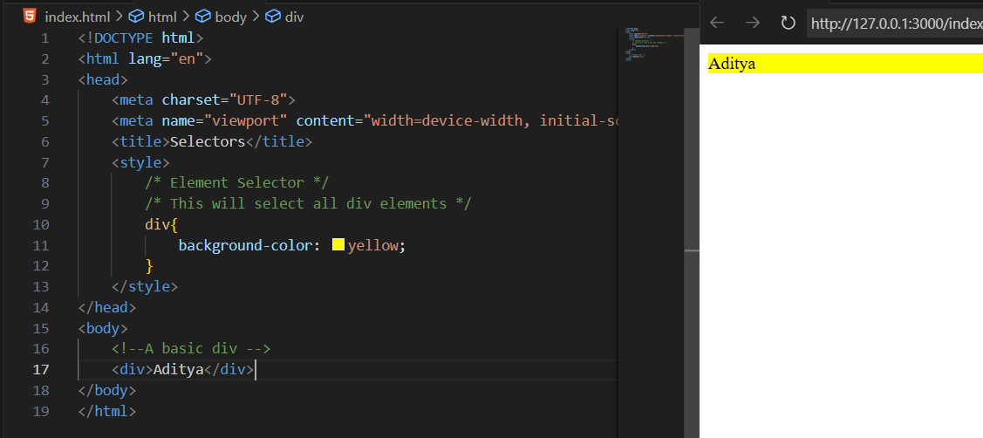

Example: adding another div tag, we can see that same properties get applied to both

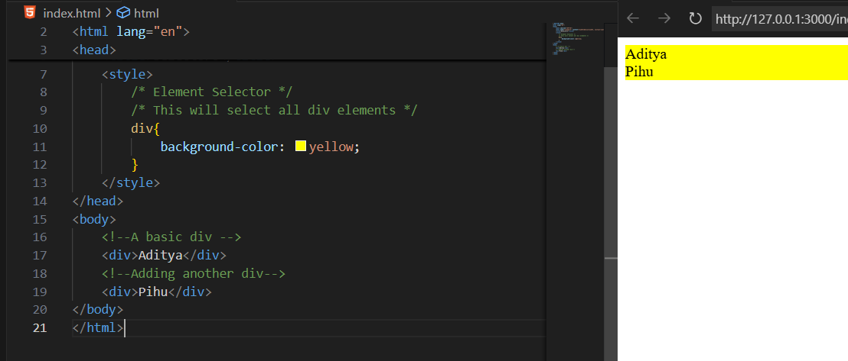

Example: targeting element using there class name, just write the name of class starting with “.”. It is an example of class selector.

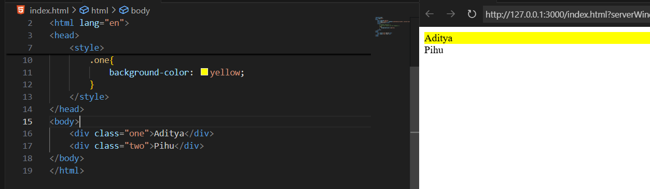

Example: id selector, we just name the id inside the style tag using the # and add the properties we want

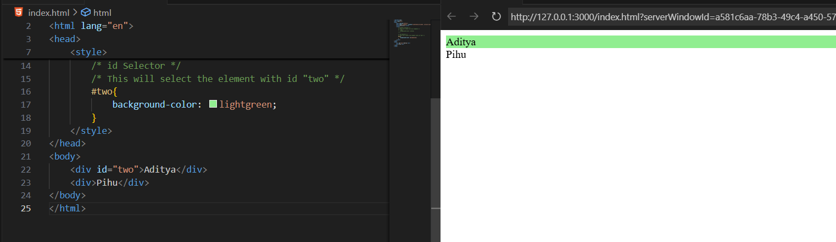

Example: child selector, This will select all div elements that are direct children of the body

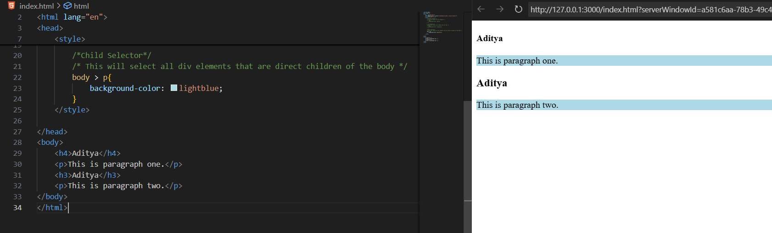

For above example, in case we have <p> inside some other element, then it don’t directly get applied.

Example: clearly <p> is inside the <div> and also inside the <article>, so inside the article one it don’t get applied.

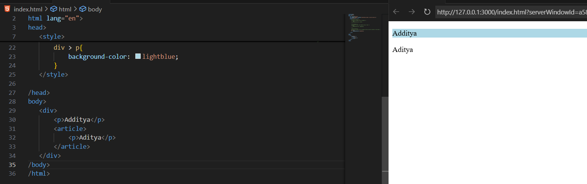

Example: Descendant selector, This will select all p elements that are descendants of div elements

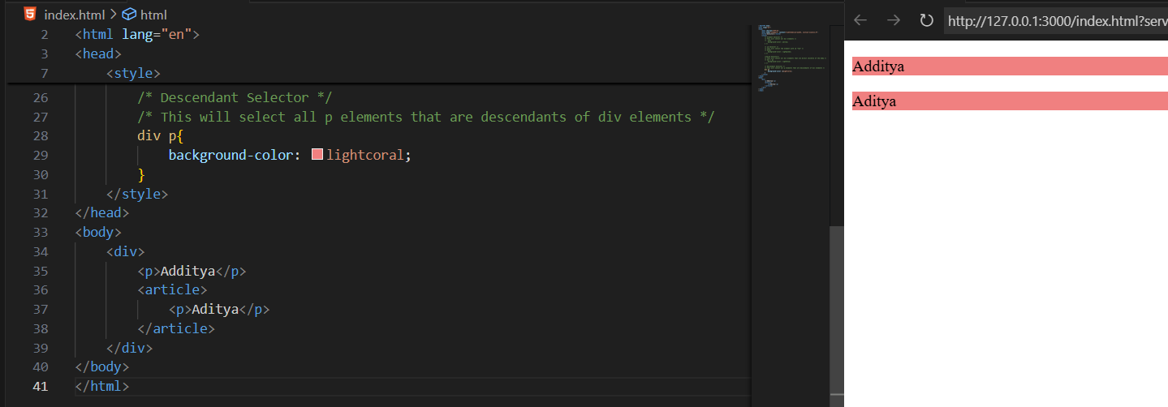

Example: universal selector, we just uses * in the <style> tag.

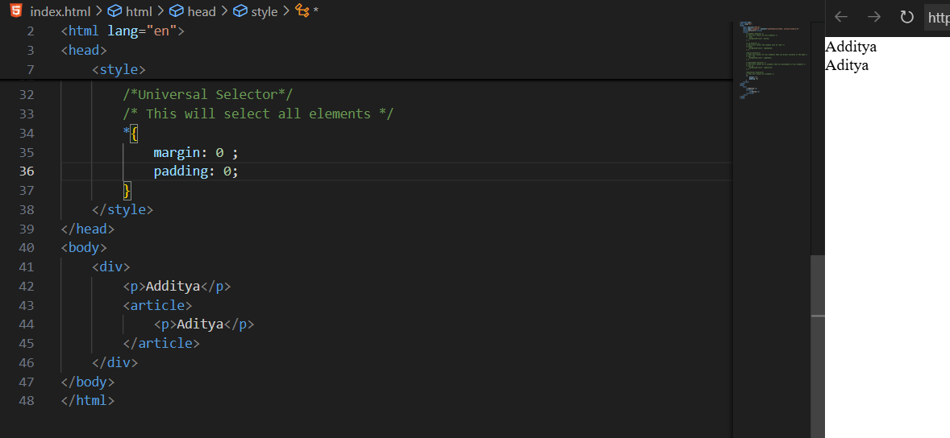

Example: pseudo selectors

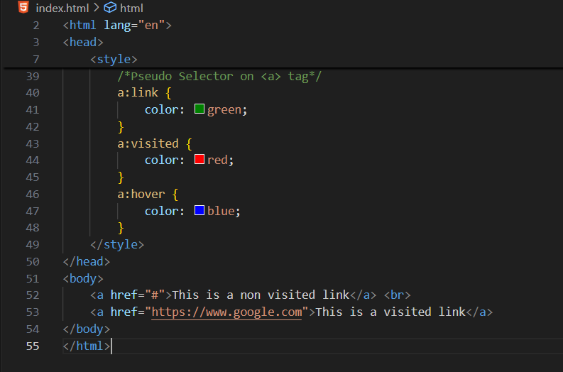

Output:

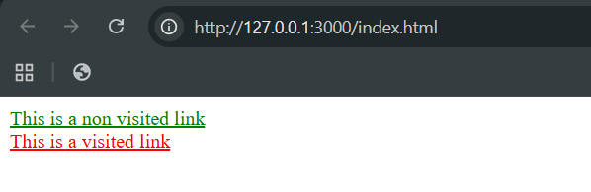

Example: pseudo selector usage in other tags, like <p> tag

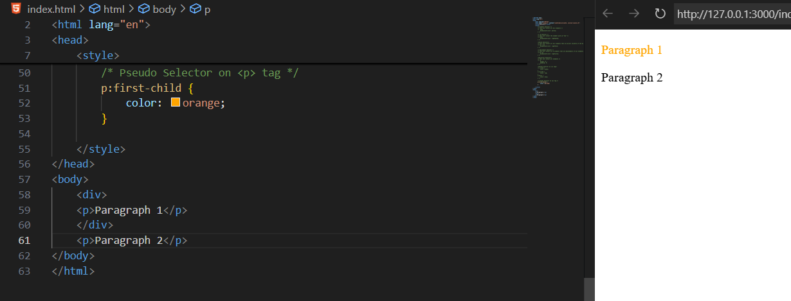

Example: trying one more <p> inside the <div>

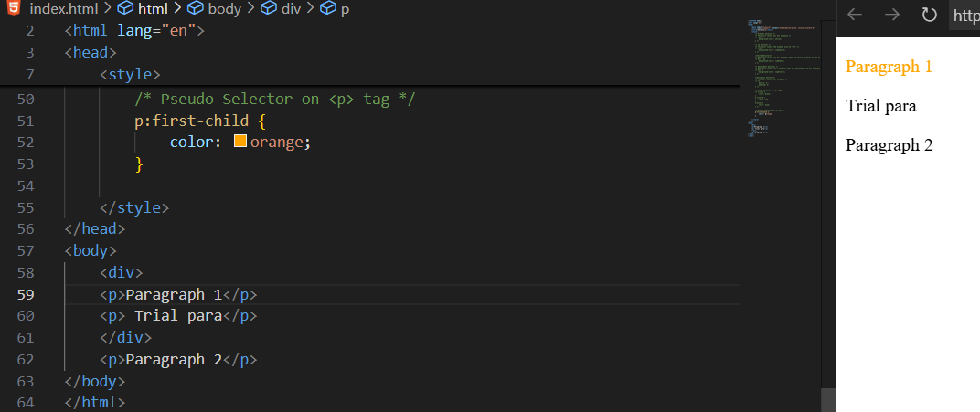

--The End--