**Day 16**

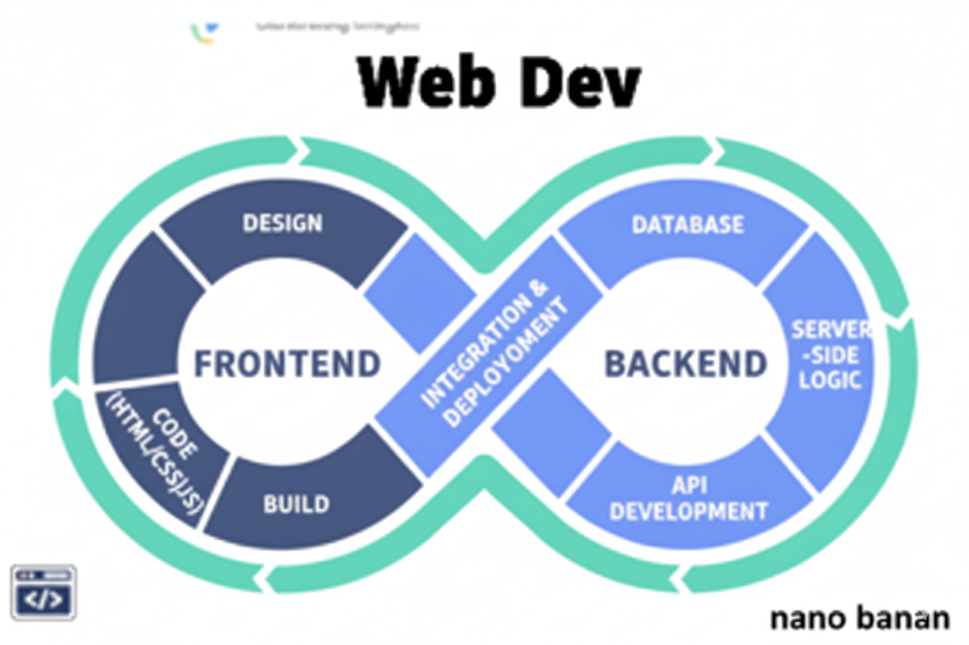

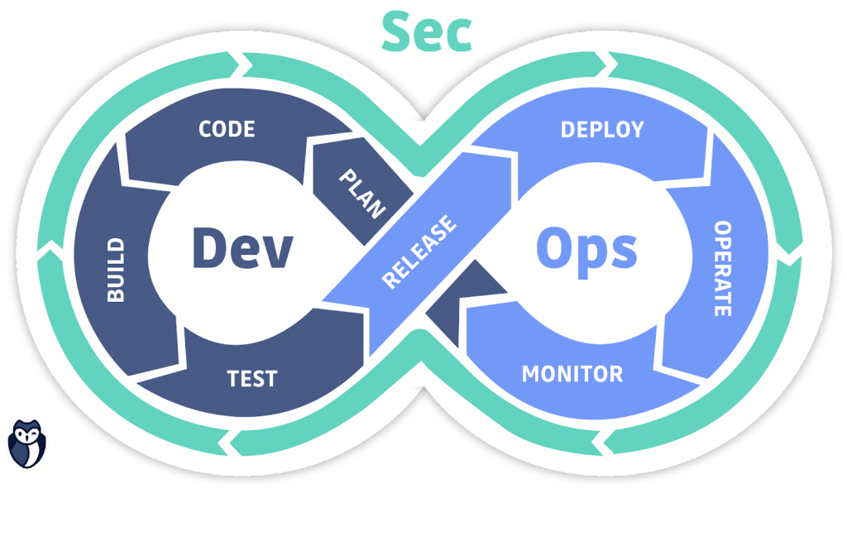

**“Web Development + Security”**

**CSS box model:**

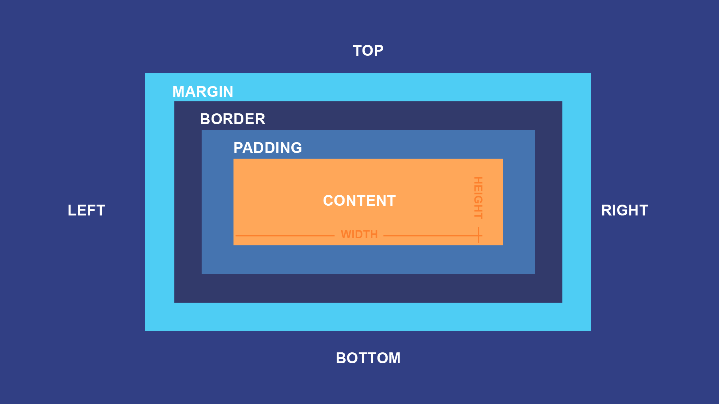

**What is CSS box model?**

The CSS Box Model describes how every HTML element is treated as a rectangular box in a webpage layout. It defines how space is distributed around each element — including its content, padding, border, and margin.

**Explanation of each part:**

| **Part** | **Description** | **Example CSS** |
| --- | --- | --- |
| **Content** | The actual text, image, or other data inside the box. | width, height |
| **Padding** | Space between content and border (inside the box). | padding: 10px; |
| **Border** | The line surrounding the padding and content. | border: 2px solid black; |
| **Margin** | Space *outside* the border — separates element from others. | margin: 20px; |

Example: a basic <div> without any <style> tag

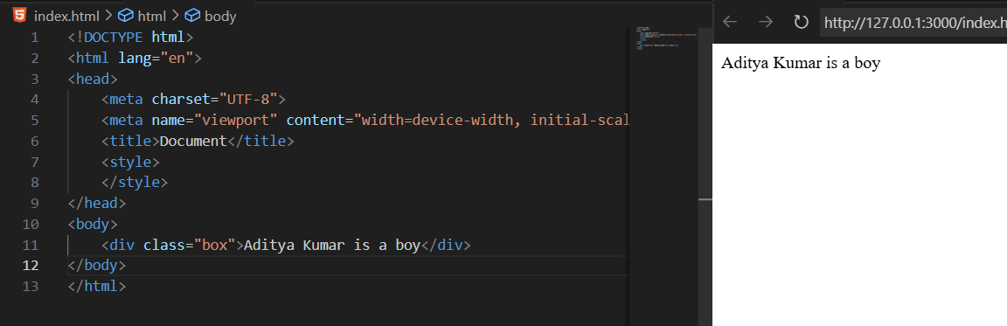

Example: adding a basic CSS to it

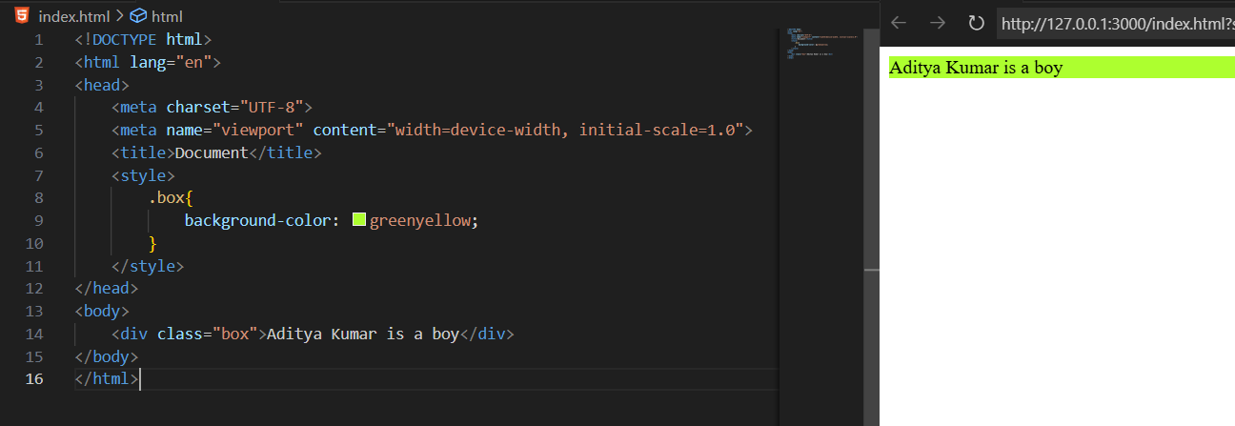

Clearly, in above example we can see that there is some space between the top and left corner of the screen and the coloured <div>. This means that there is some default margin and padding is added.

Example: removing that default margin and padding from that <div> and making sure that margin and padding be 0.

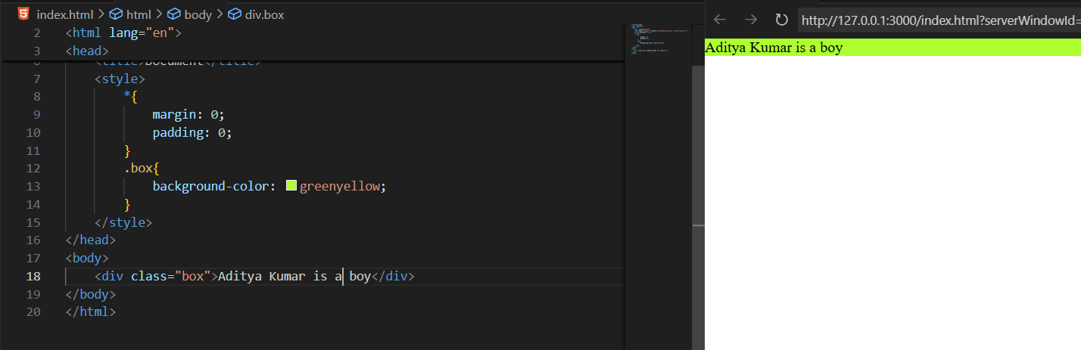

**Note**: padding means that space between content and border (inside the box).

We can also cross check the styles applied to the element via the “inspect” option on the browser:

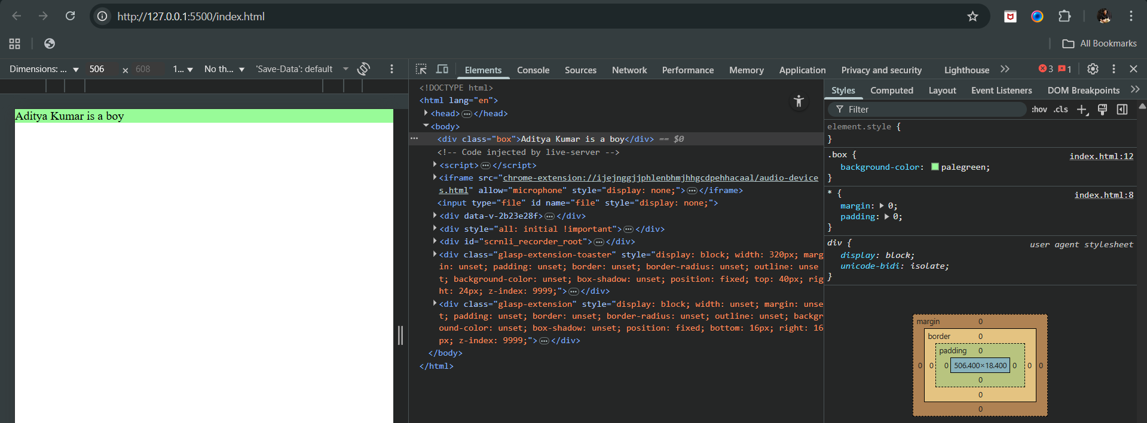

**Total Box Size Formula:**

**Total Width** = content width + left/right padding + left/right border + left/right margin  
**Total Height** = content height + top/bottom padding + top/bottom border + top/bottom margin

Example: now we have added one more <div> in above example, with different class name and

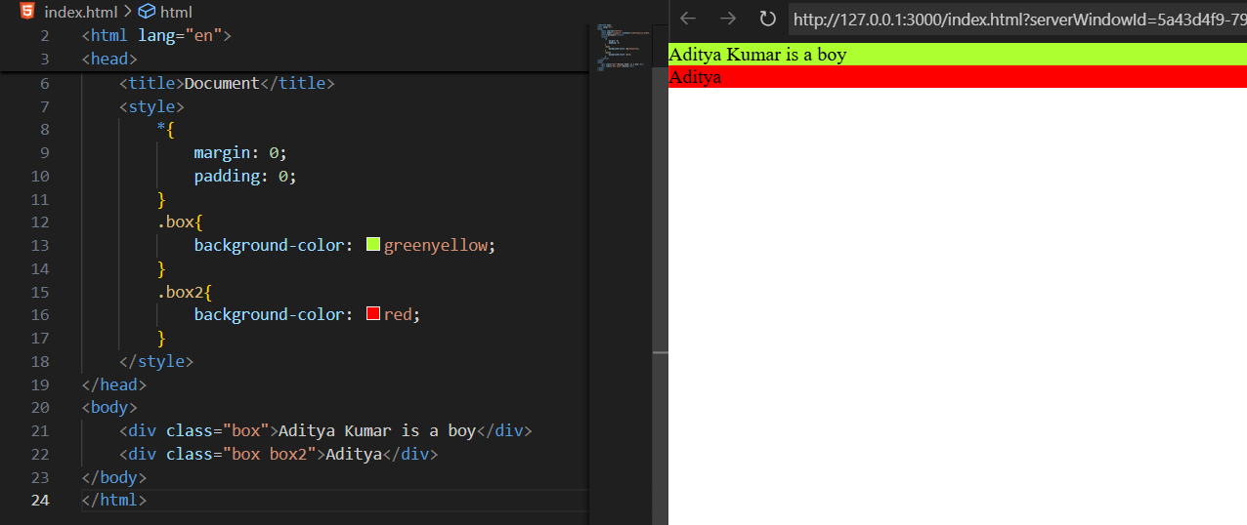

Example: showing how 0 margin and 0 padding looks if added to both <div>

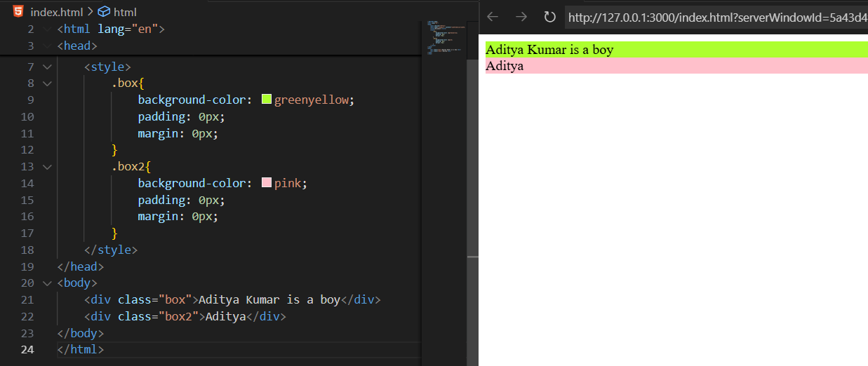

Now, we will make small changes in the padding and margin: changed padding from 0 to 10px. Clearly, padding adds space inside the element

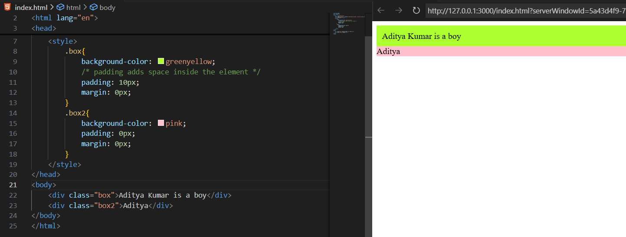

Now, adding margin to the above example from 0 to 10px: margin adds space outside the element

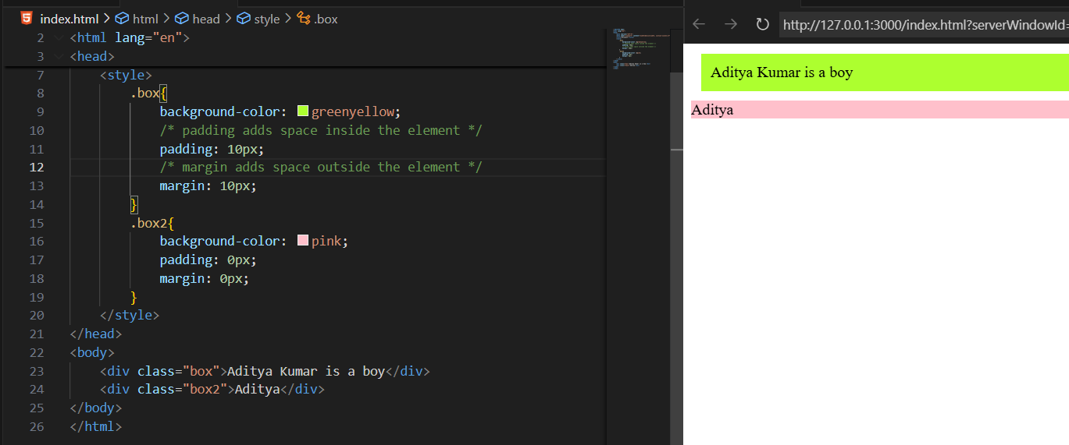

Example: adding border to the class box

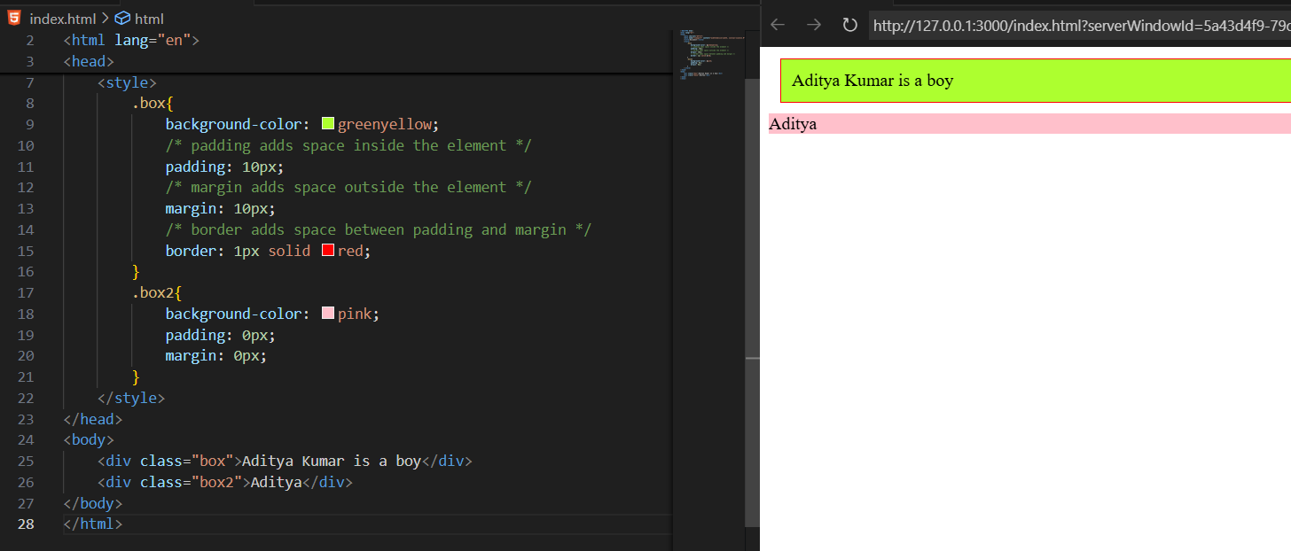

**Box-sizing:**

**What is box sizing?**

The box-sizing property controls how the total size of an element is calculated — whether the padding and border are included inside the width/height or added outside.

**By Default: box-sizing: content-box**

(Default behaviour of browsers)

The width and height only apply to the content area, and padding + border are added on top of that.

Example:

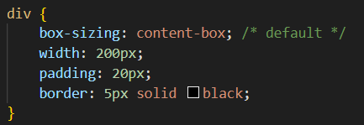

**Actual rendered width** = 200 (content) + 20 + 20 (padding) + 5 + 5 (border) = **250px**

The box becomes *bigger* than the width you set. This can cause layout issues when you expect exact sizes.

**Important: When Using** *box-sizing: border-box*

The width and height include content + padding + border.

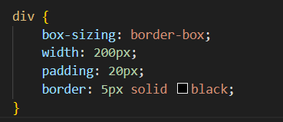

**Total rendered width** = 200px (everything included)

The content area automatically shrinks to make room for padding and border —  
so the *total box stays exactly 200px wide.*

**Margin collapse:**

**What is margin collapse?**

Margin collapse happens when two vertical margins meet (top and bottom) and combine into a single margin, instead of adding together.

It applies only to vertical margins (top/bottom), not horizontal ones (left/right).

When two blocks touch vertically — like one <div> stacked above another — the space between them isn’t the *sum* of both margins. It becomes the larger of the two margins.

**When Does It Happen?**

| **Situation** | **Description** | **Example** |
| --- | --- | --- |
| **Adjacent vertical margins** | Two block elements stacked vertically | .box1 and .box2 example above |
| **Parent and first/last child** | A child’s top margin or bottom margin collapses with parent’s margin | <div><p></p></div> |
| **Empty blocks** | An empty block with no padding/border/content collapses top & bottom margins together | <div style="margin:30px 0;"></div> |

Example:

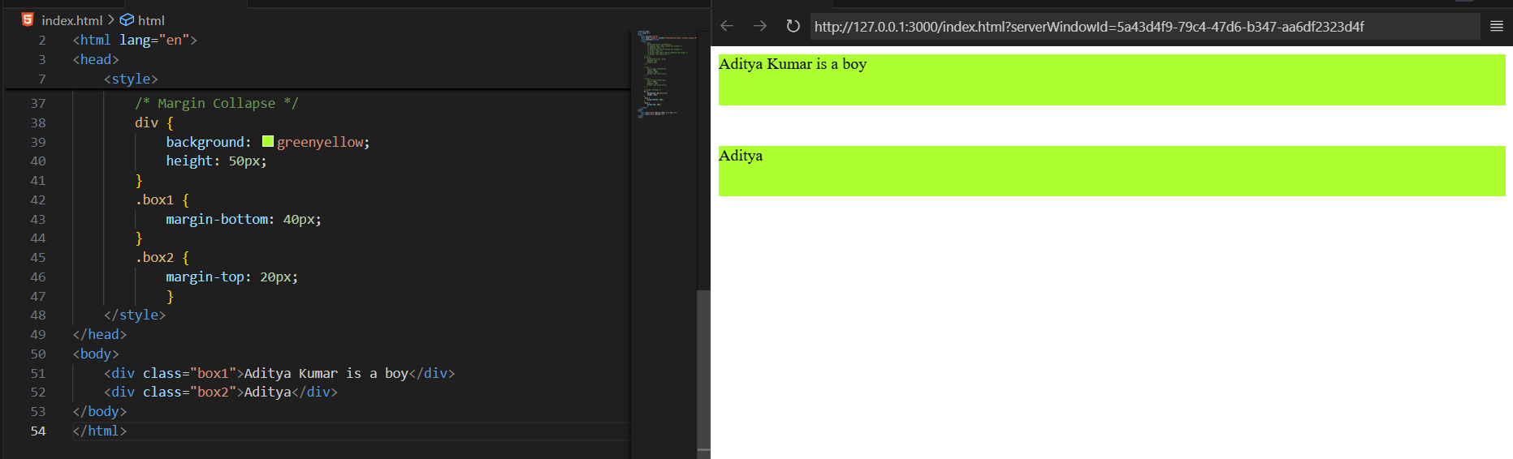

--The End--