**Day 17**





**“Web Development + Security”**

**CSS Fonts, Text and Color properties:**

Default font appearance: no <style> tag is there

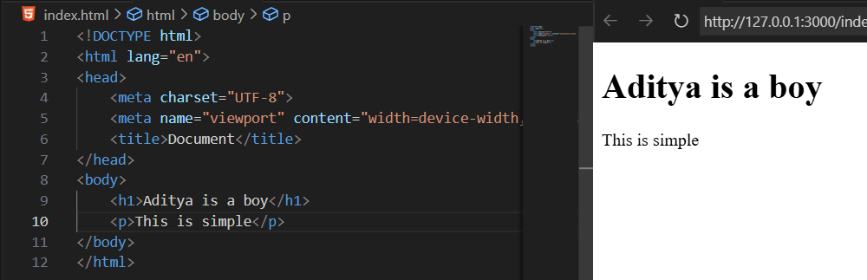

Adding some font type using the CSS inside the <style> tag: for which we will specify the font-family for that element.

Example:

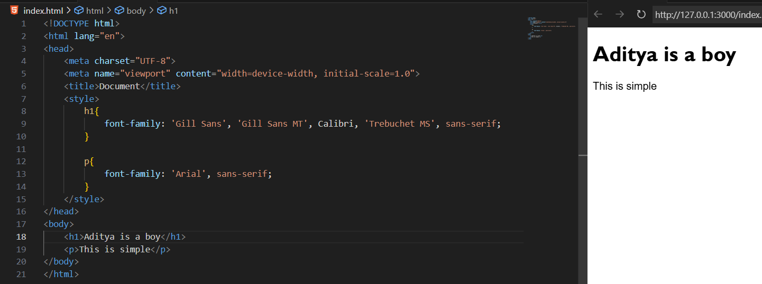

Now, an example showing the font-style value:

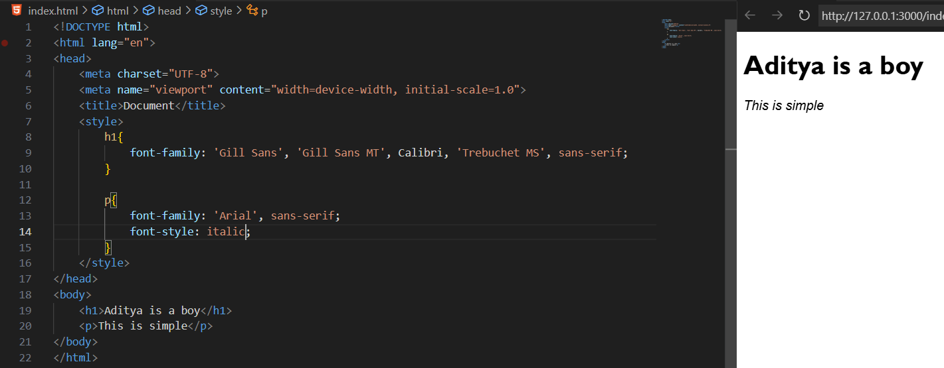

Example: use of font-weight in CSS

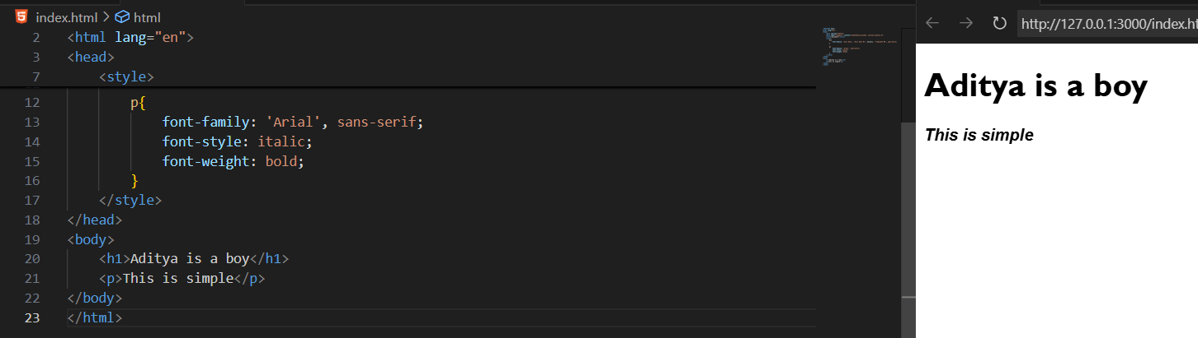

Example: use of text-decoration

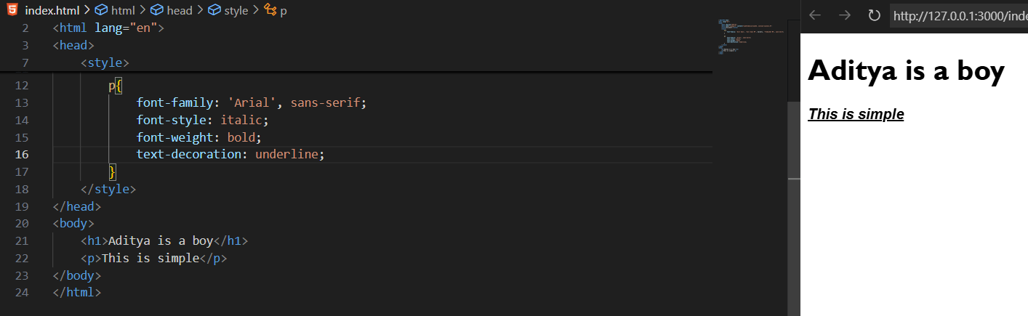

Example: use of line-height

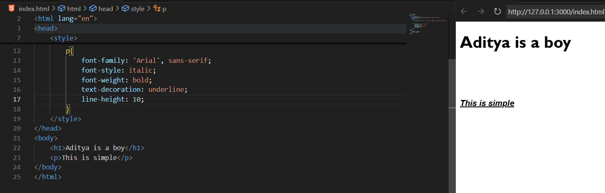

Example: use of letter-spacing

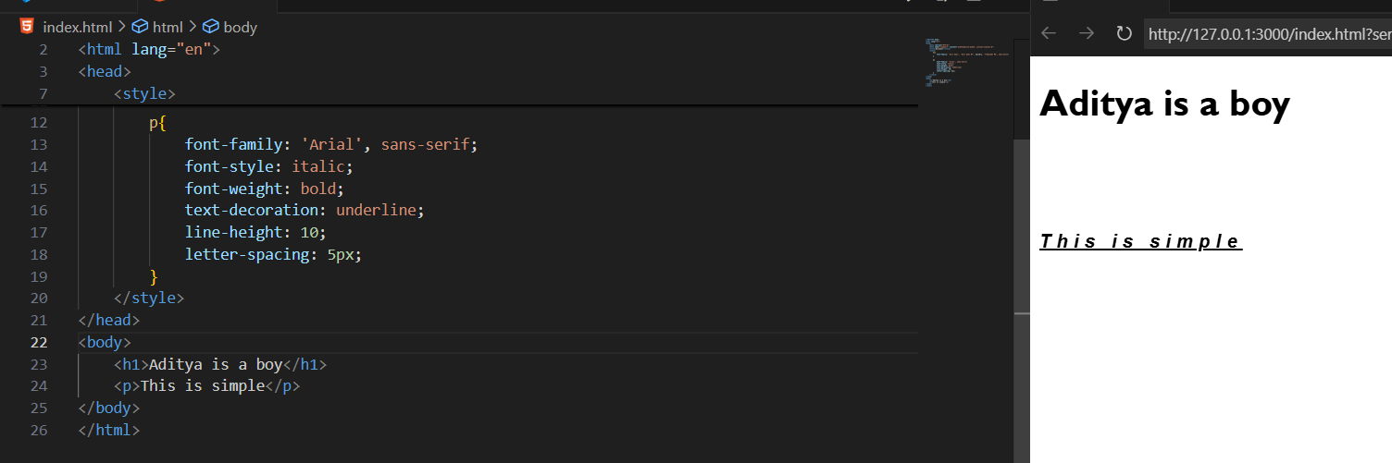

Example: use of word-spacing

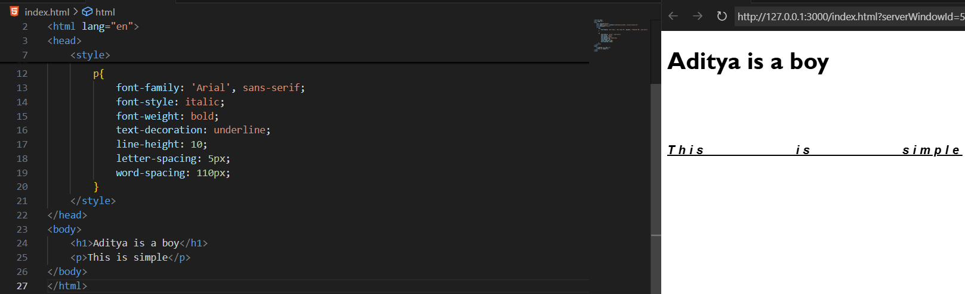

Example: use of text-transform

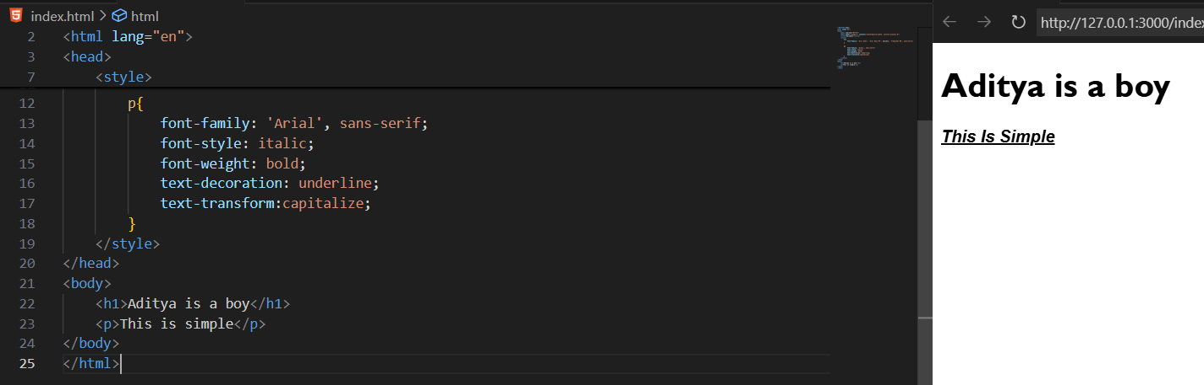

Example: use of text-decoration-color

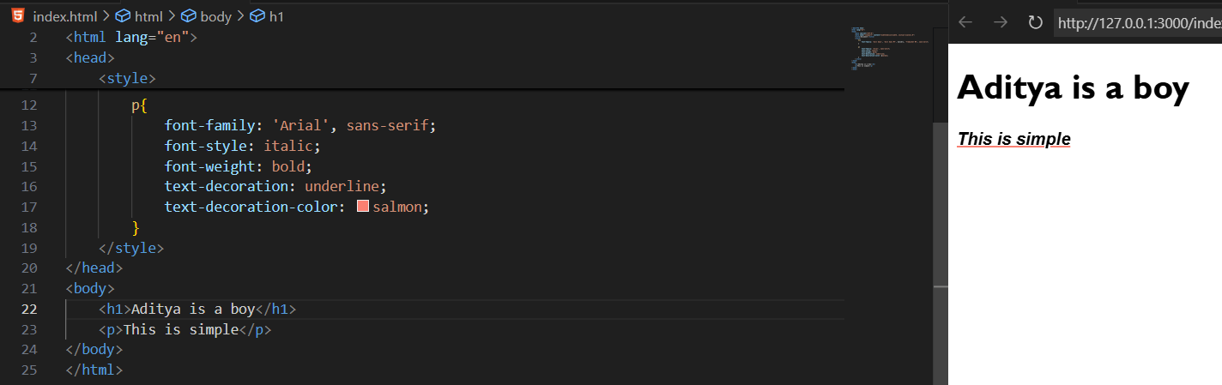

Example: use of text-decoration-style  
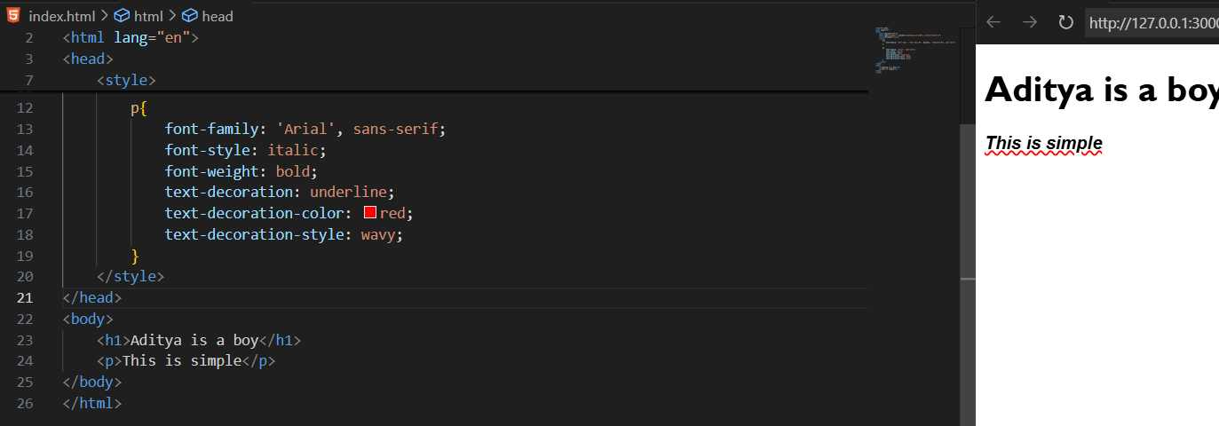

Example: use of text-indent

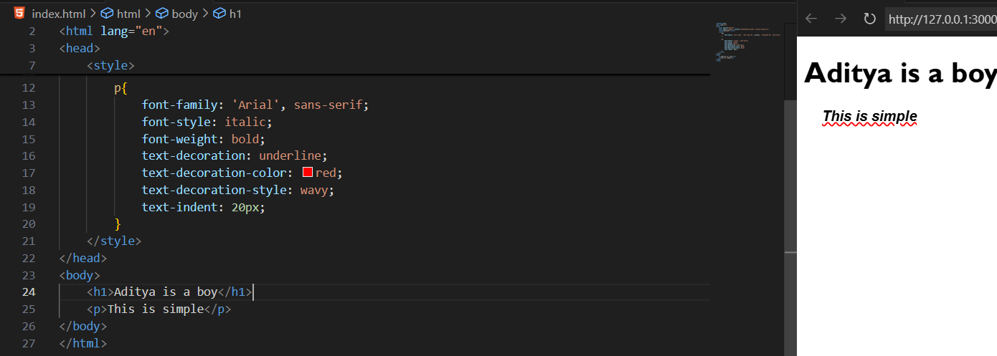

Example: use of text-align

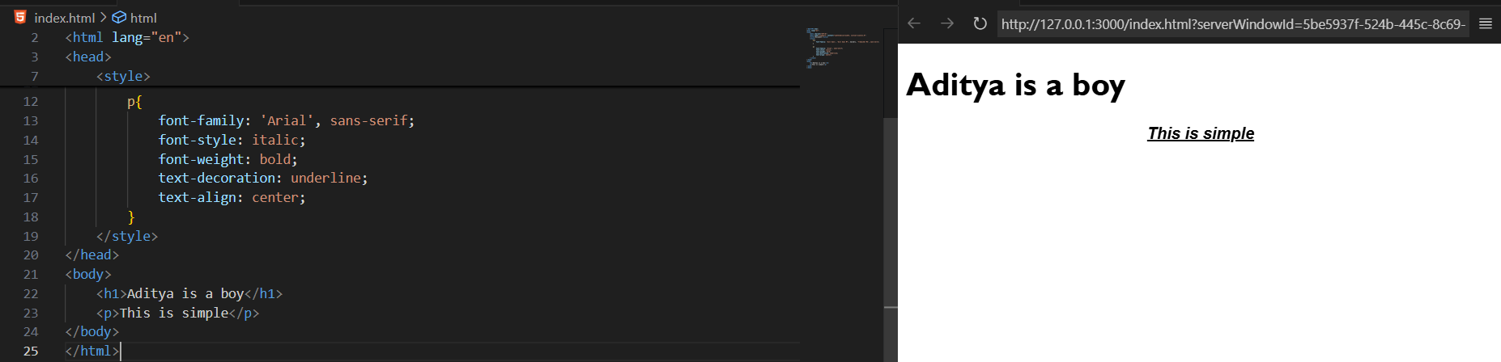

Example: use of colors

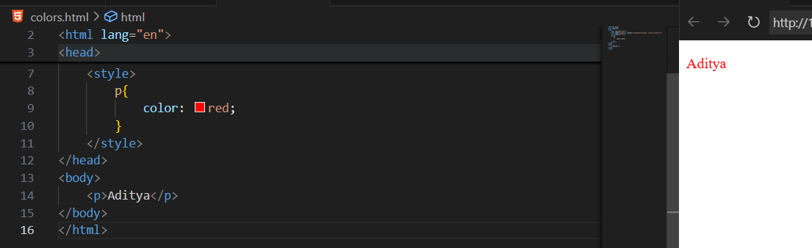

**Ways to represent color in CSS:**

| **Method** | **Example** | **Notes** |
| --- | --- | --- |
| **Named Colors** | color: red; | 140+ predefined names (e.g., blue, gray, tomato). |
| **HEX** | #ff0000 or #f00 | Hexadecimal RGB values (00–FF). |
| **RGB** | rgb(255,0,0) | Red, Green, Blue (0–255). |
| **RGBA** | rgba(255,0,0,0.5) | RGB + Alpha (opacity 0–1). |
| **HSL** | hsl(0,100%,50%) | Hue (0–360), Saturation %, Lightness %. |
| **HSLA** | hsla(0,100%,50%,0.5) | HSL + Alpha (transparency). |
| **color()** | color(srgb 1 0 0) | Advanced CSS4 method for modern displays. |

--The End--