**Day 20**





**“Web Development + Security”**

**CSS Shadows:**

**What are CSS Shadows?**

In CSS, shadows are visual effects used to add depth, realism, and emphasis to elements like boxes or text.  
There are two main types of shadows:

1. Box Shadow
2. Text Shadow

A simple <div> without any CSS properties:

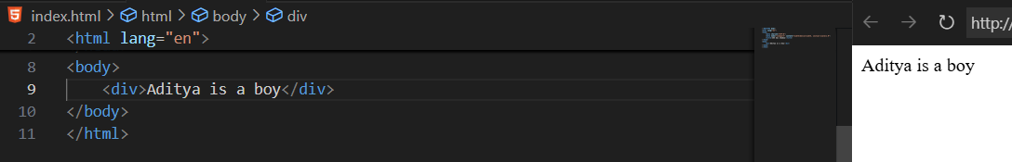

**What is Box shadow?**

Adds a shadow behind an element’s box (like a card, button, or div). Uses box-shadow

Syntax:

box-shadow: offset-x offset-y blur-radius spread-radius color;

Explanation:

* offset-x: Horizontal position of shadow
* offset-y: Vertical position
* blur-radius: How soft the shadow’s edges are
* spread-radius: How large or small the shadow is
* color: Shadow color (can use rgba for transparency)

Example:

Without box-shadow: simple <div> with borders

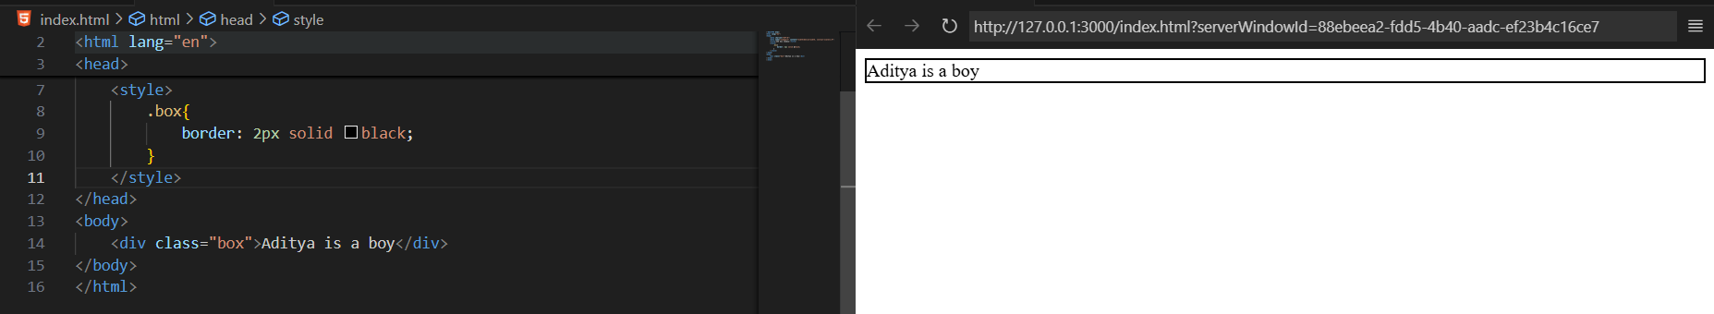

With box-shadow:

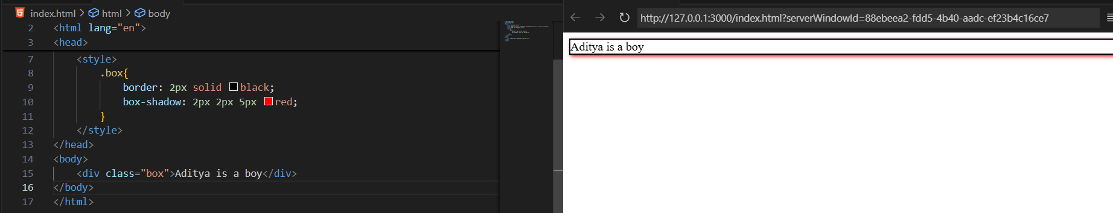

We can also get an idea about its alignment, if we do the inspect for this:

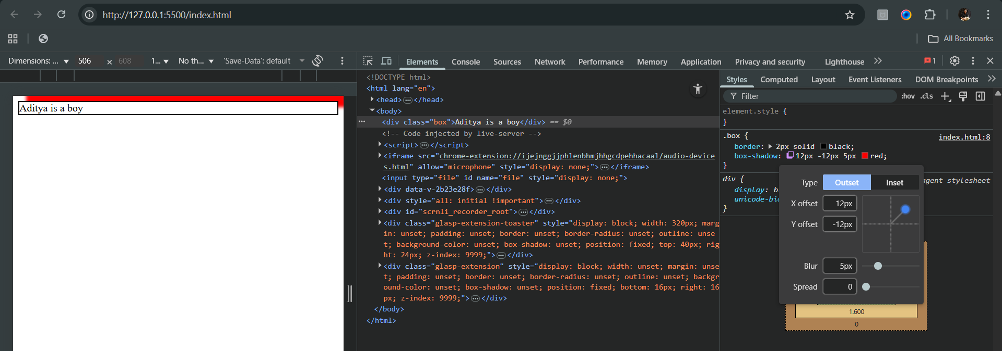

**What is Text shadow?**

Adds shadow behind text to make it pop or glow.

Syntax:

Adds shadow behind text to make it pop or glow.

Example: without any CSS on the text

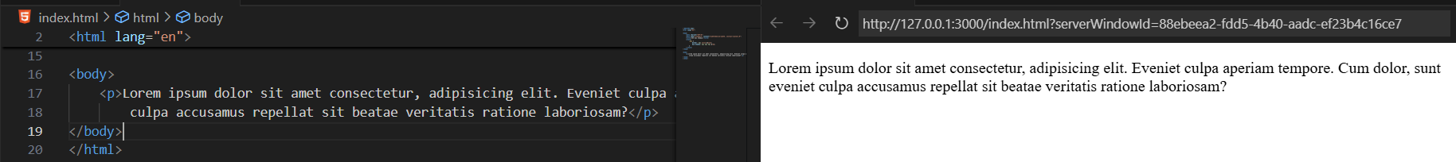

Example: with text-shadow

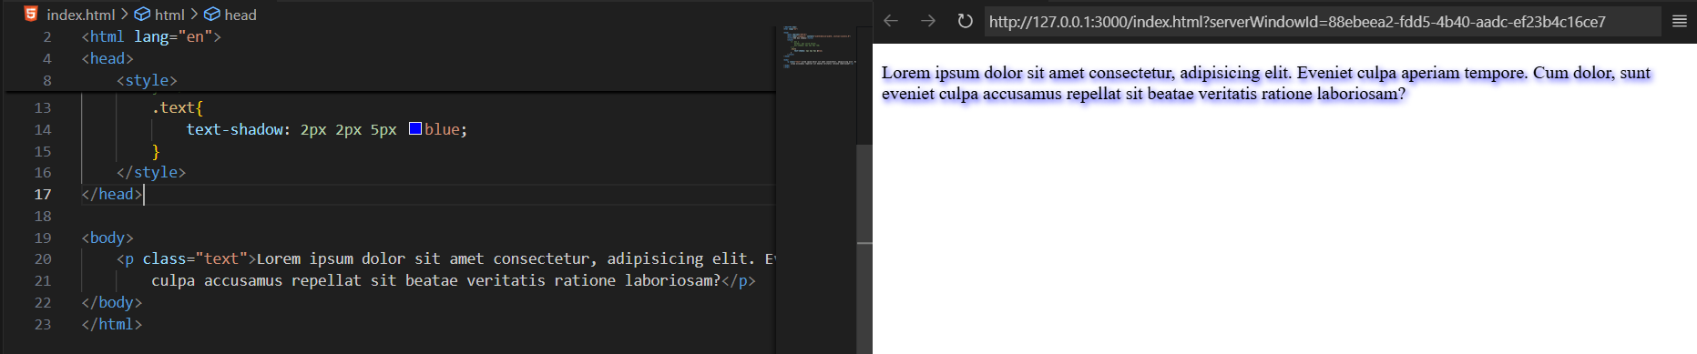

**CSS Outline:**

**What are CSS Outlines?**

A CSS outline is a line drawn outside an element’s border — often used for highlighting elements (like focus indicators in forms or buttons). It does not take up space or affect element size, unlike borders.

Syntax:

outline: width style color;

| **Property** | **Border** | **Outline** |
| --- | --- | --- |
| **Position** | Inside element box | Outside border |
| **Affects layout?** | Yes | No |
| **Can have radius?** | Yes (border-radius) | ❌ No |
| **Common use** | Design element boxes | Focus or debug highlights |

Common outline properties:

| **Property** | **Description** |
| --- | --- |
| outline-color | Sets color of outline |
| outline-style | Solid, dotted, dashed, double, etc. |
| outline-width | Thickness of outline |
| outline-offset | Space between border and outline |
| outline | Shorthand (width, style, color) |

A basic example: just with outline

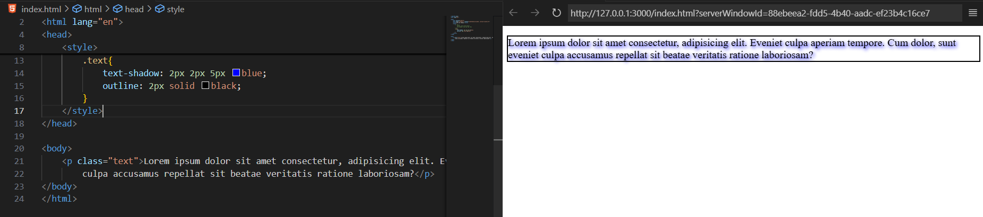

A basic example: with both border and outline

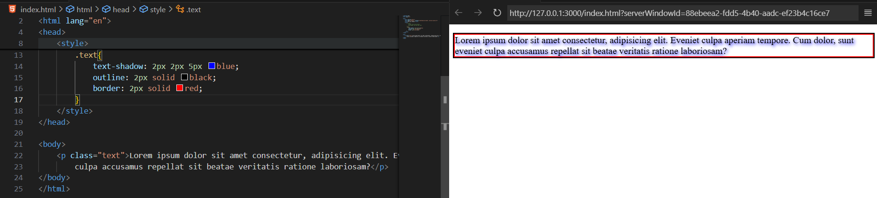

A basic example: here the border size is more than the outline size.

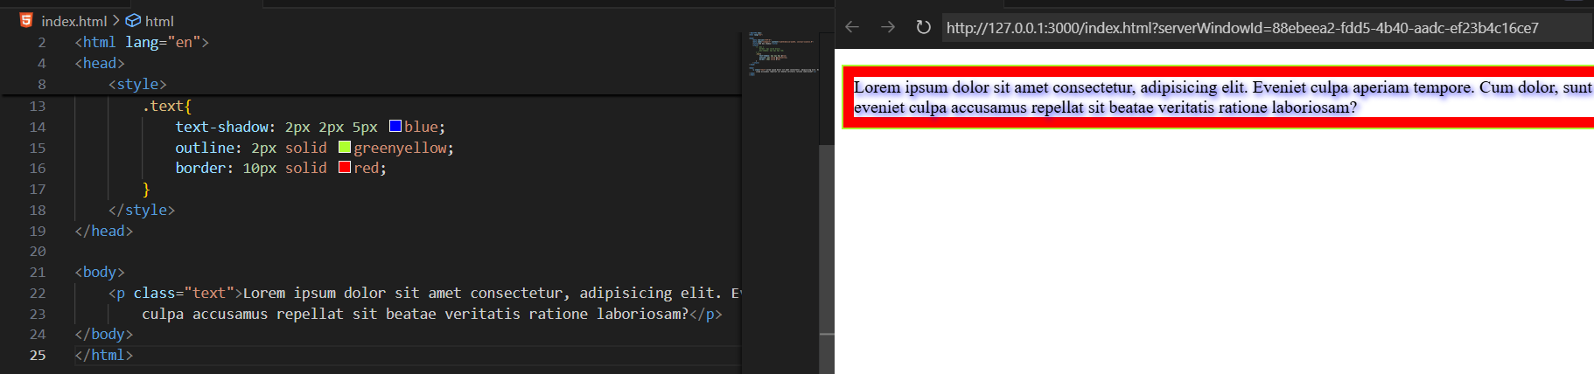

In case we specify both the outline, border, we can see that later on specifying the border-radius, outline follows it. Since, we can’t apply the border-radius to the outline.

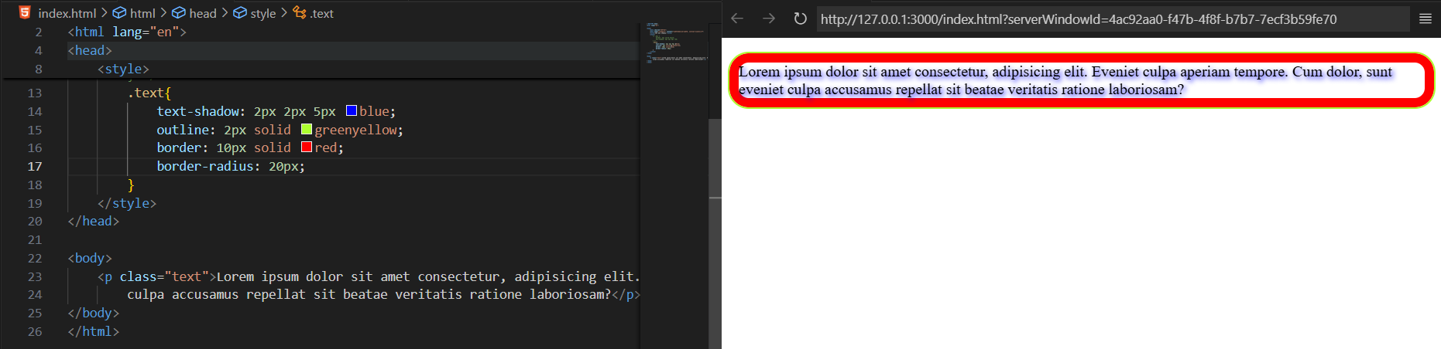

**Styling Lists using CSS**

A simple list without any CSS:

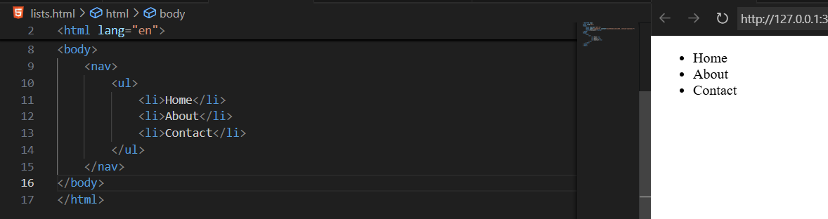

Example: removing the marker of the list, we will use the list-style-type:none

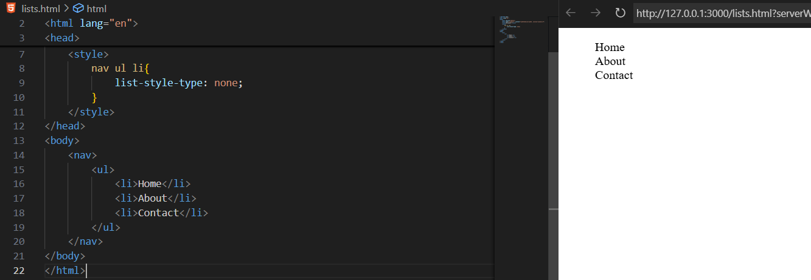

Example: adding background color to the list item

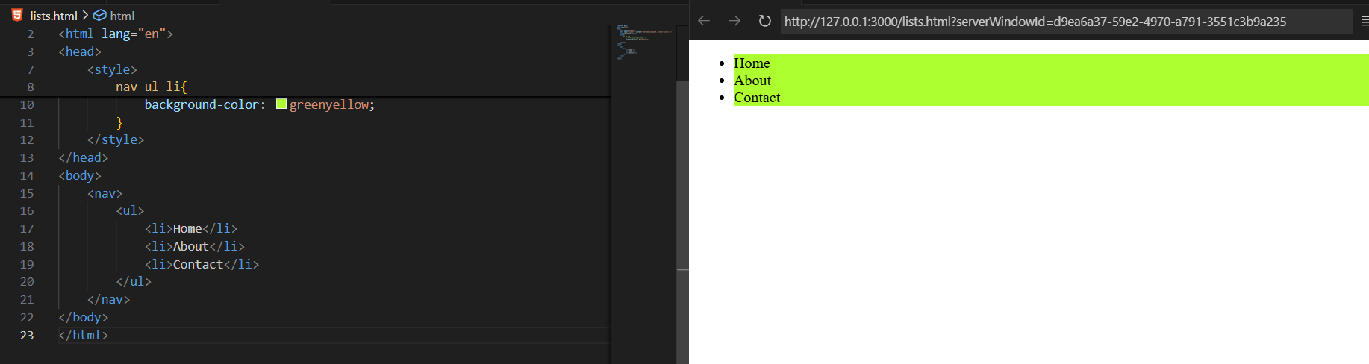

Clearly, above we can see that the marker is not in the background colour. But, in case we want it to be inside: we will use list-style-position: inside

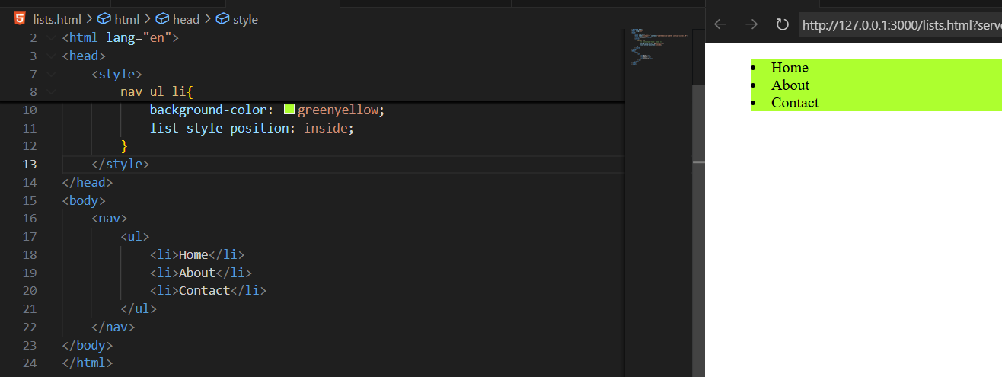

We can also add borders to the list items:

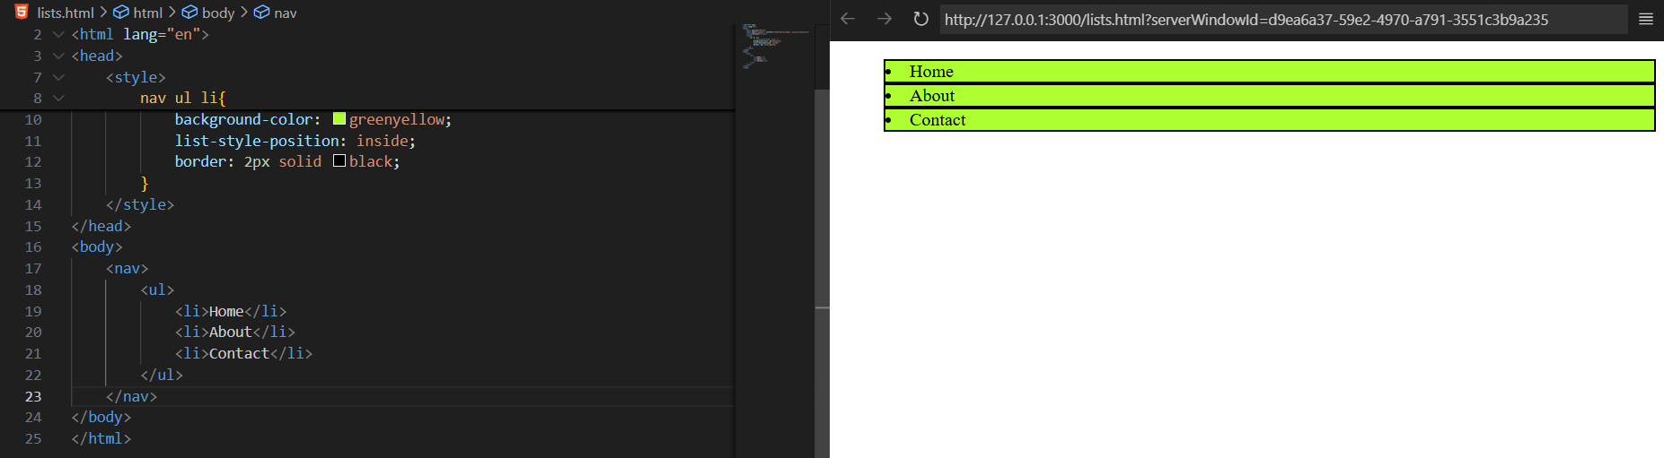

--The End--