**Day 21**





**“Web Development + Security”**

**CSS Overflow:**

**What is CSS overflow?**

The overflow property in CSS determines what happens when the content of an element is bigger than its container. If content doesn’t fit inside its box, you can control whether it spills out, scrolls, or is hidden.

A basic example without any overflow:

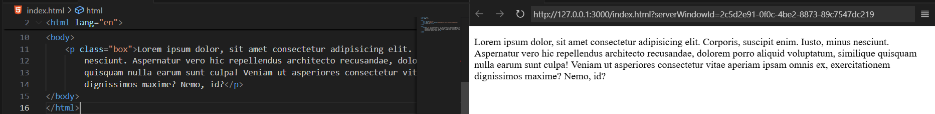

A basic example where we had just added the borders and no width and height specified:

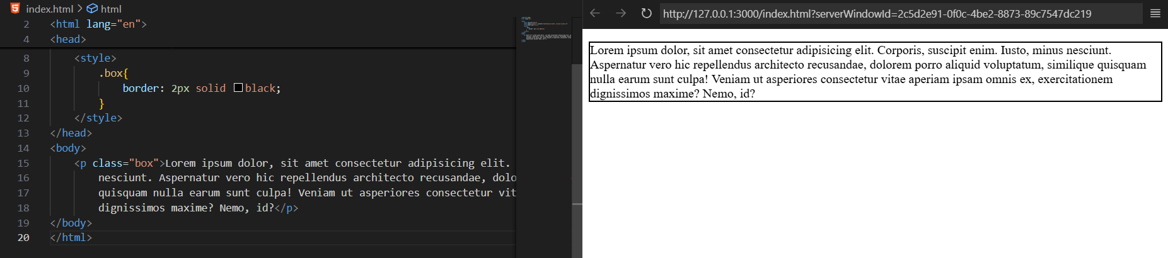

Example where we had shown the overflow property by using the width and height: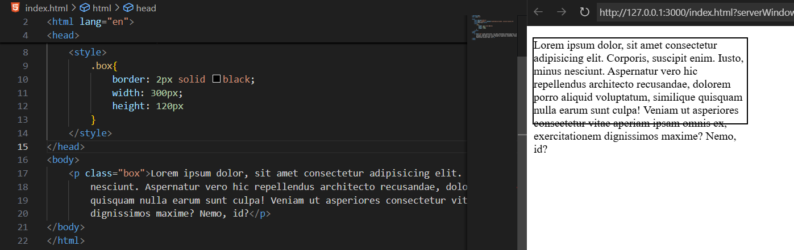

**How to fix this overflow?**

Syntax:

overflow: visible | hidden | scroll | auto;

Values:

| **Value** | **Description** | **Example Use** |
| --- | --- | --- |
| **visible** | Default. Content spills out of the box | Rarely used, default behavior |
| **hidden** | Extra content is clipped, not visible | For neat cards or cropped images |
| **scroll** | Adds scrollbars (even if not needed) | Force scrollable area |
| **auto** | Adds scrollbars only if needed | Most common responsive usage |

A basic example of handling the overflow adding the scroll bar:

