**Day 22**

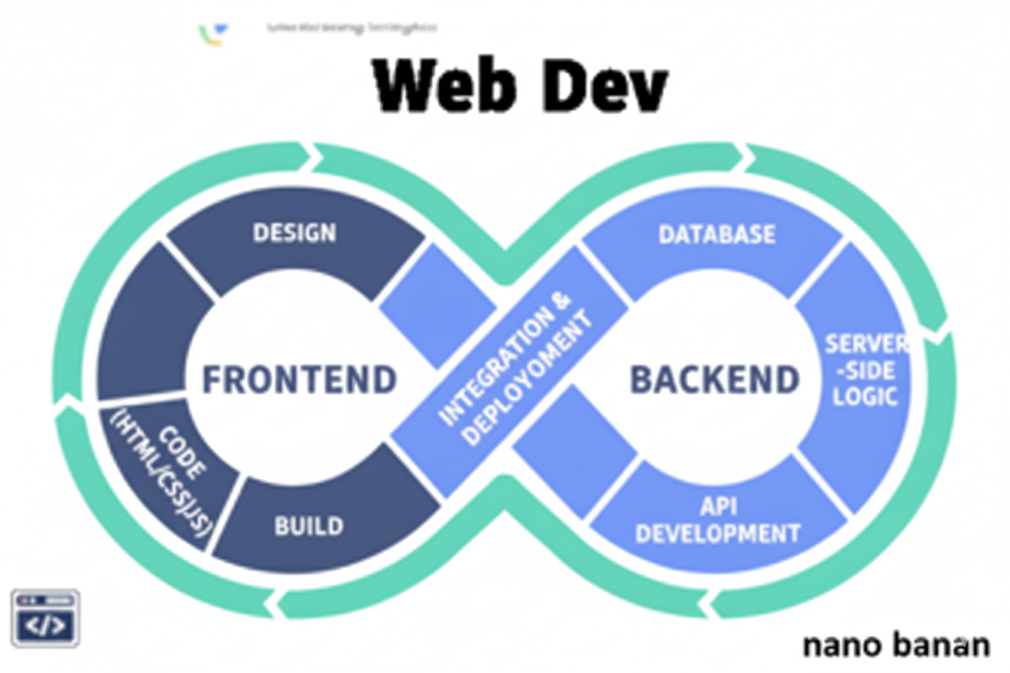

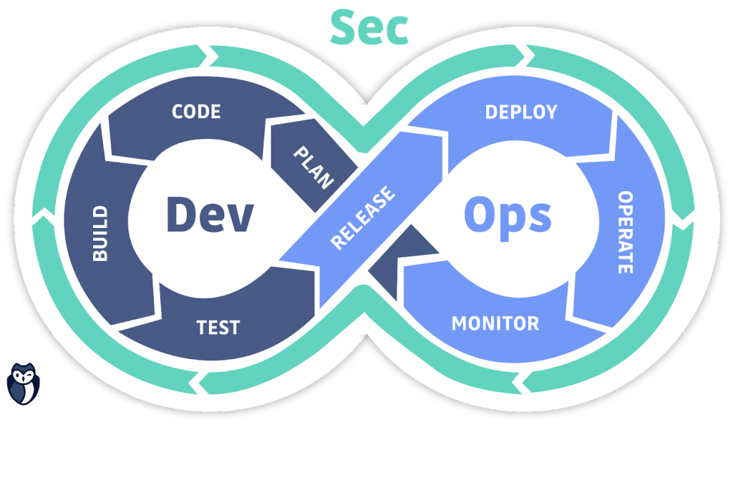

**“Web Development + Security”**

**CSS Position Property:**

**What is the position Property?**

The position property defines how an element is placed on a webpage — whether it follows the normal document flow or is positioned manually using top, left, right, and bottom.

**Syntax:**

position: static | relative | absolute | fixed | sticky;

**Types of positioning:**

| **Type** | **Description** | **Moves with Page Scroll?** | **Can Use top / left / right / bottom?** |
| --- | --- | --- | --- |
| **static** | Default, normal flow | Yes | No |
| **relative** | Moves relative to its normal position | Yes | Yes |
| **absolute** | Moves relative to nearest positioned ancestor | No | Yes |
| **fixed** | Fixed to viewport (screen) | No | Yes |
| **sticky** | Acts relative until a scroll threshold, then becomes fixed | Partial | Yes |

Example: a basic code, where we have four <div> and no CSS:

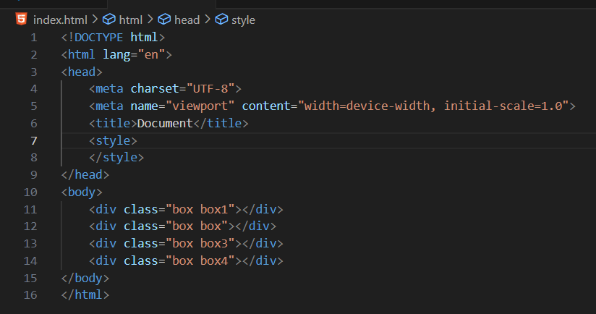

Now, we will give CSS to all of these <div>:

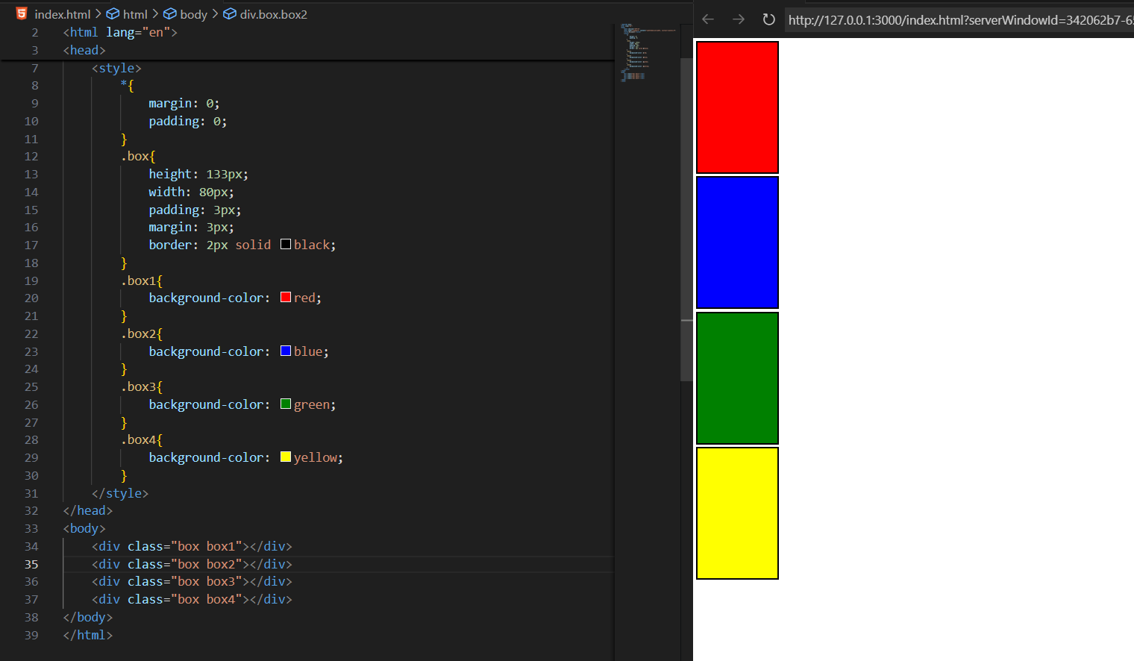

So, by default the position of them be static.

Example: showing the use of position: relative, say we are targeting box2:

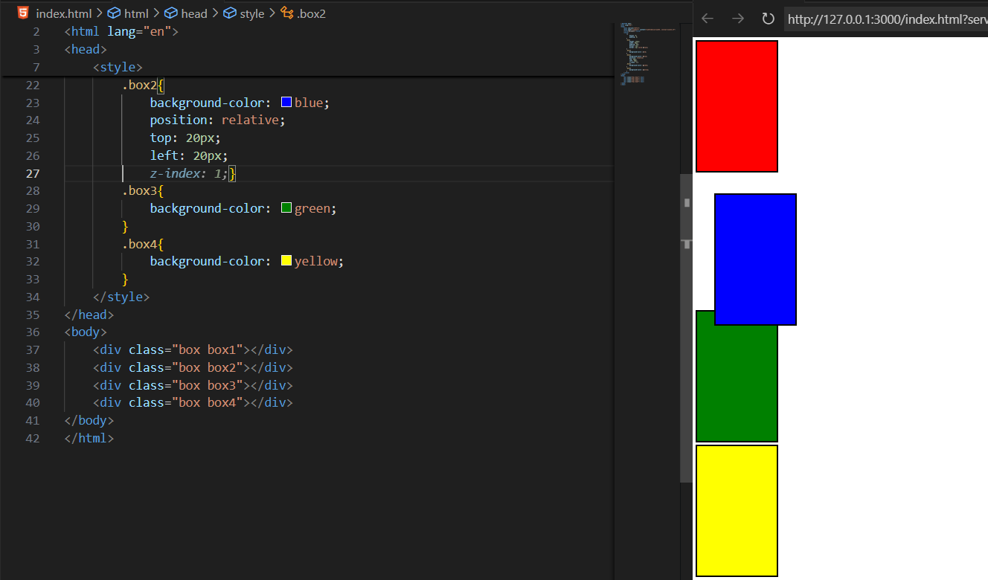

Clearly, we are allowed to change the position of that <div> from all the ends.

Example: adding the z-index to the element, -1 means not prior, 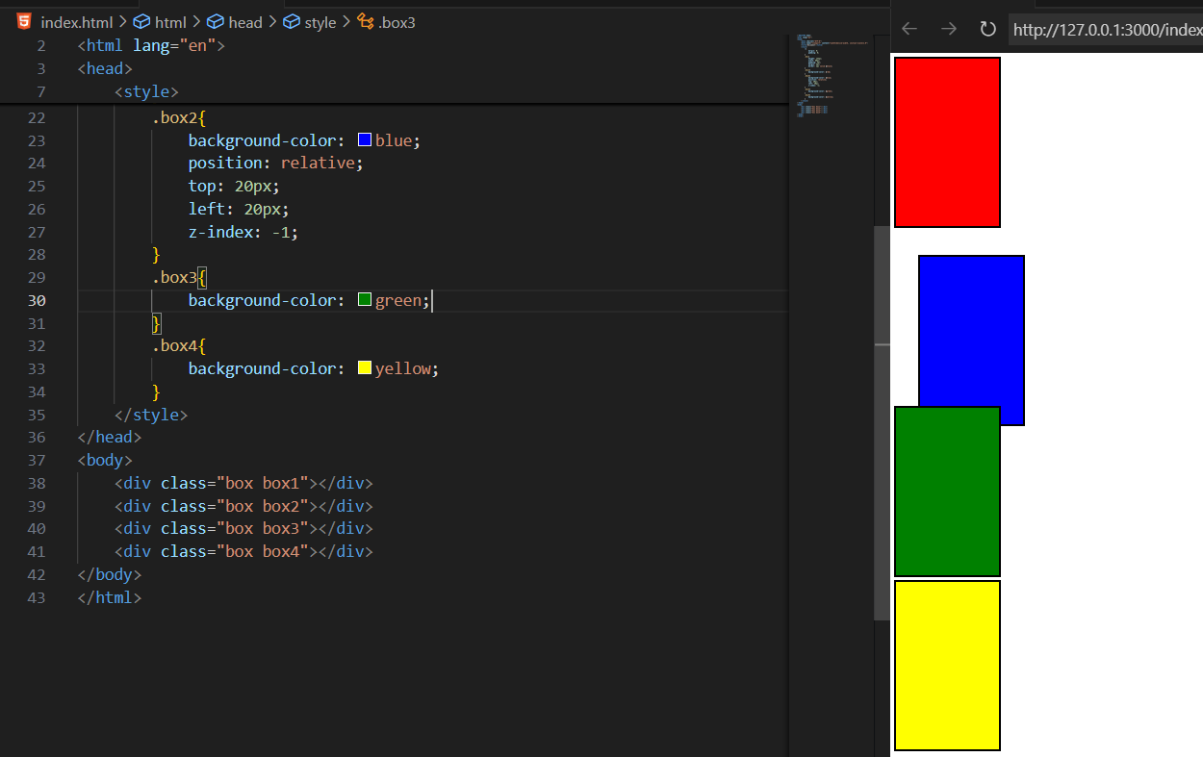

Another example of z-index:

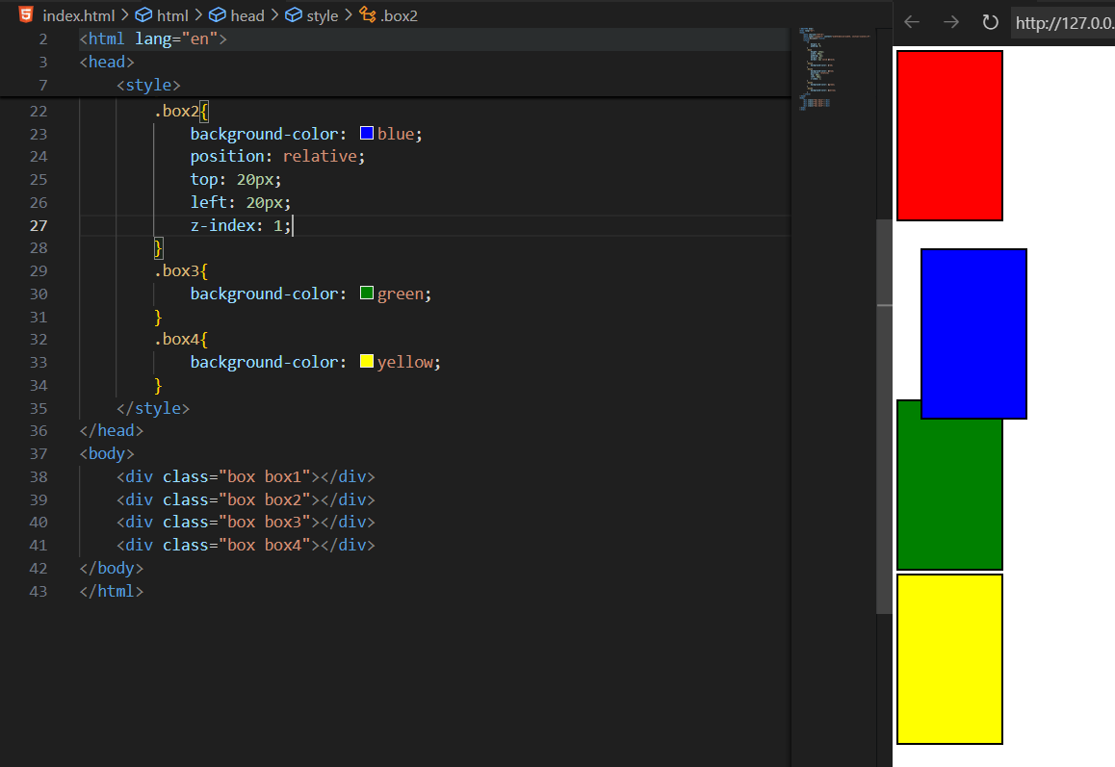

Example: when we write position:absolute, then we will see that it will look for positioning itself as per the Moves relative to nearest positioned ancestor.

For now, see that there is no defined position from us: so everything is inside the parent div

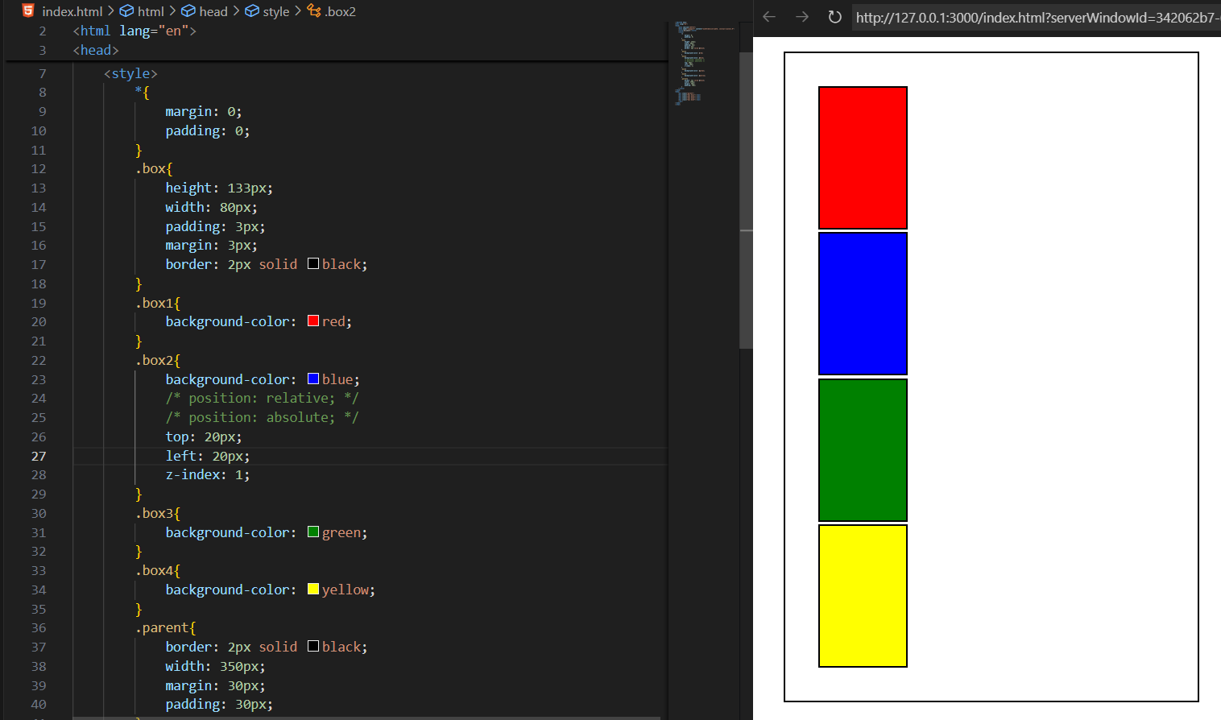

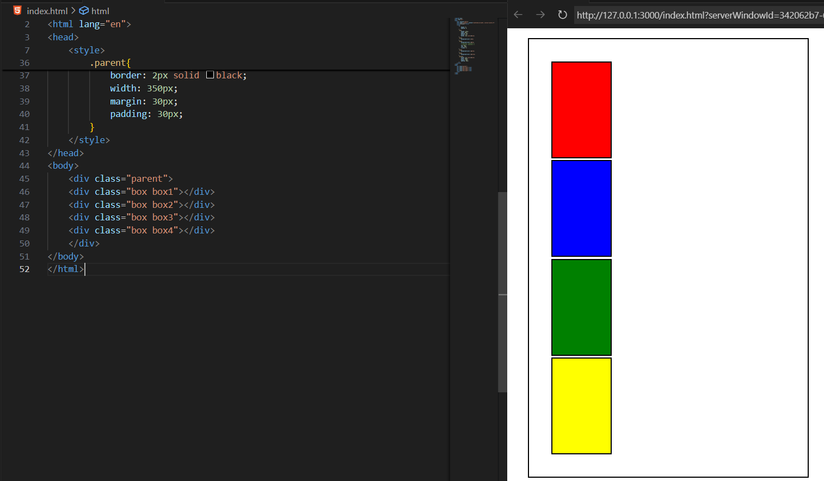

Now, the moment we will say that .box2 to have the position: absolute, the moment it will look for the nearest, but since .parent is also static, so it will go to the default page

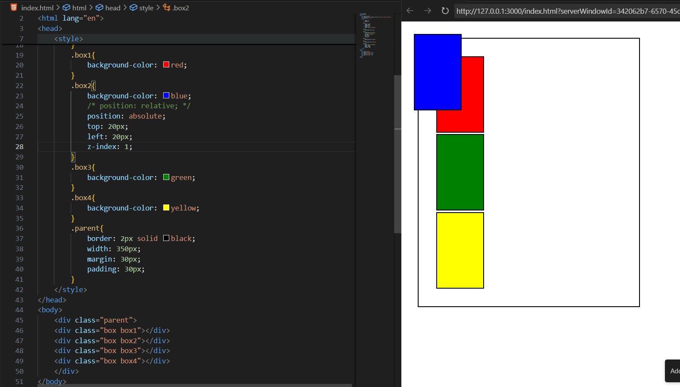

Now, the moment we changed the position of parent to relative, the box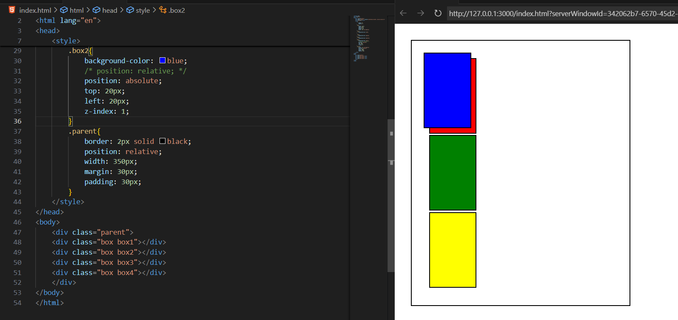

Example: position:fixed

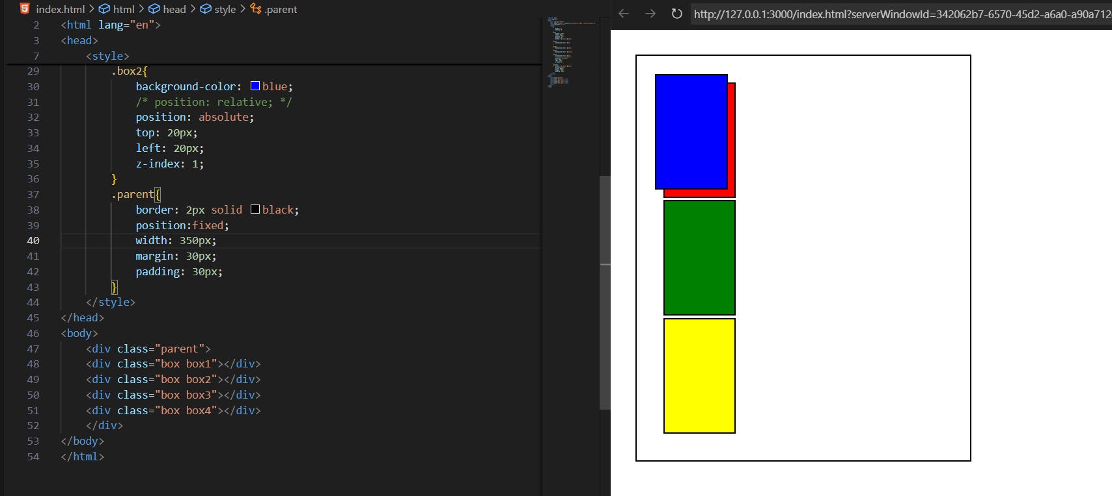

--The End--