**Day 23**





**“Web Development + Security”**

**CSS Variables:**

**What are CSS Variables?**

CSS Variables are reusable values defined in CSS that can be used throughout a stylesheet. They make your code more consistent, easier to maintain, and simpler to update.

Basic Syntax:

:root {

--main-color: blue;

--font-size: 18px;

}

Now, to understand, let’s do some coding!  
Example: basic code where we have just removed the marker of the <li>

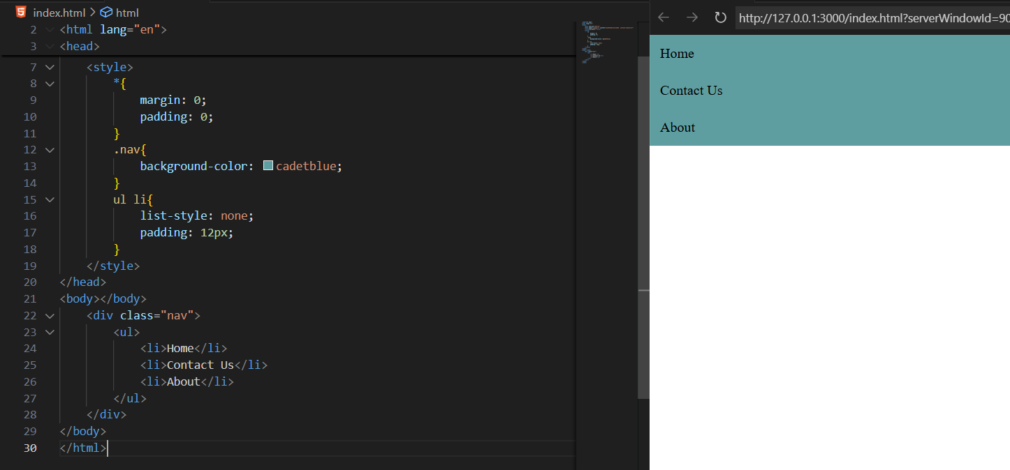

Now, we want to make the items of <ul> in the same line, we will use the display:flex in the ul selector: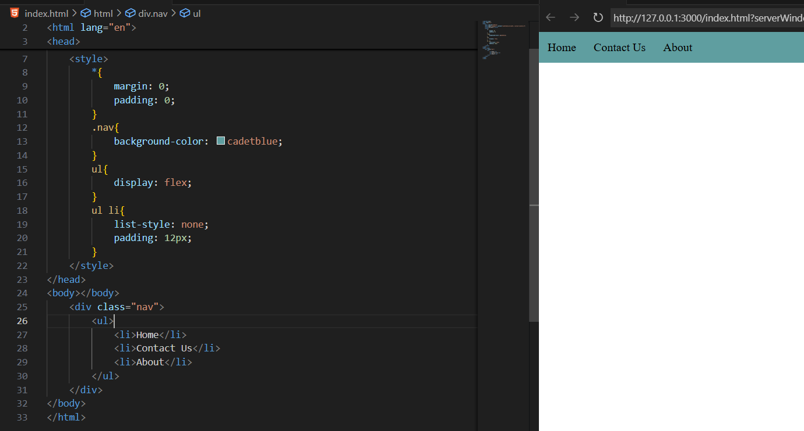

Now, we are introducing the variables: --primary-color & --secondary-color are the vraible screated by me. Also, we can see that in .nav var(--secondary-color) is written in order to provide the color of that variable to the nav class.

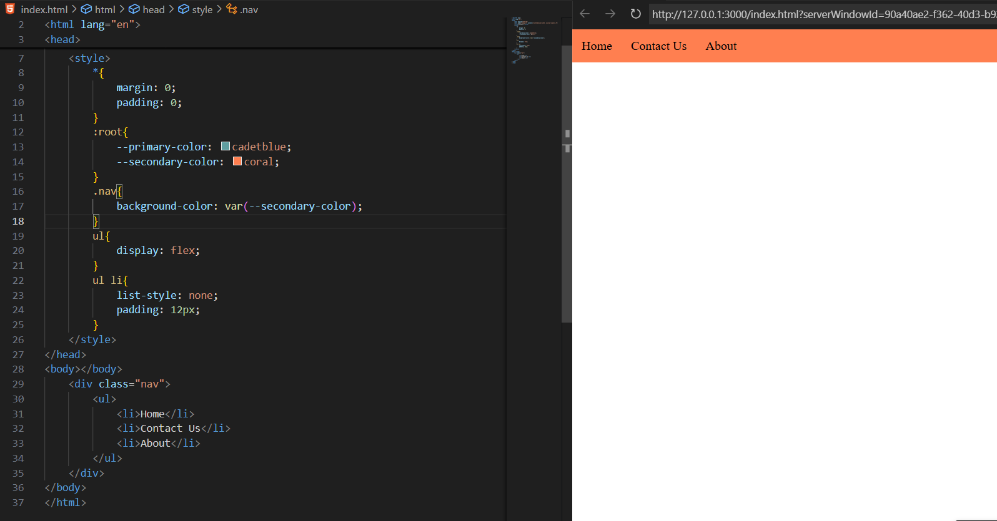

In case we change it to var(--primary-color) it will change its color as shown below:

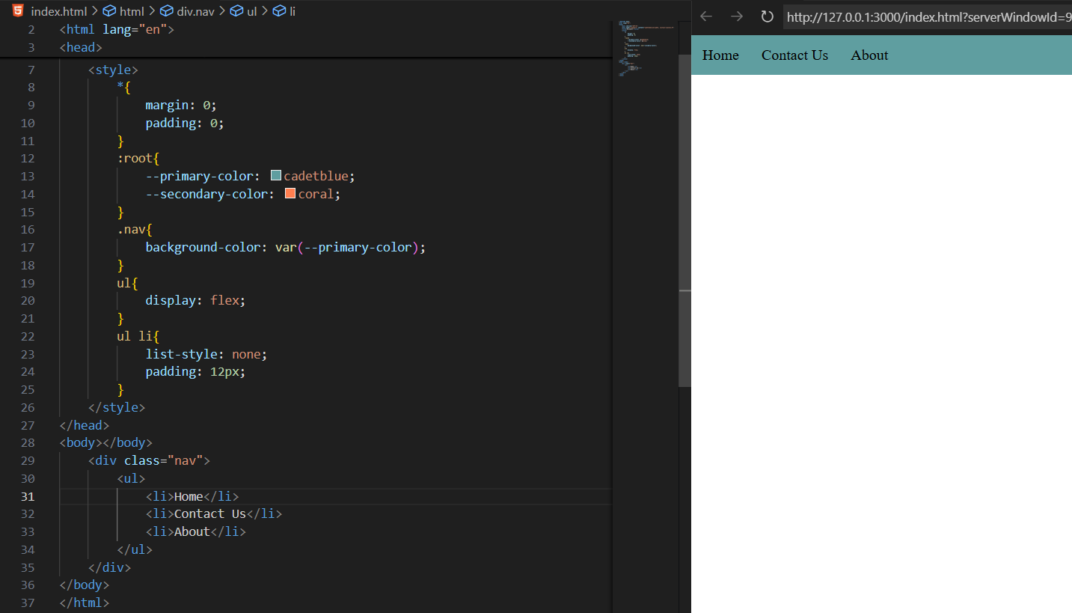

Now, we have the concept of local variable too, let’s see: clearly, we can see that we have overwrite the color we had in the :root in the ul li:first-child.

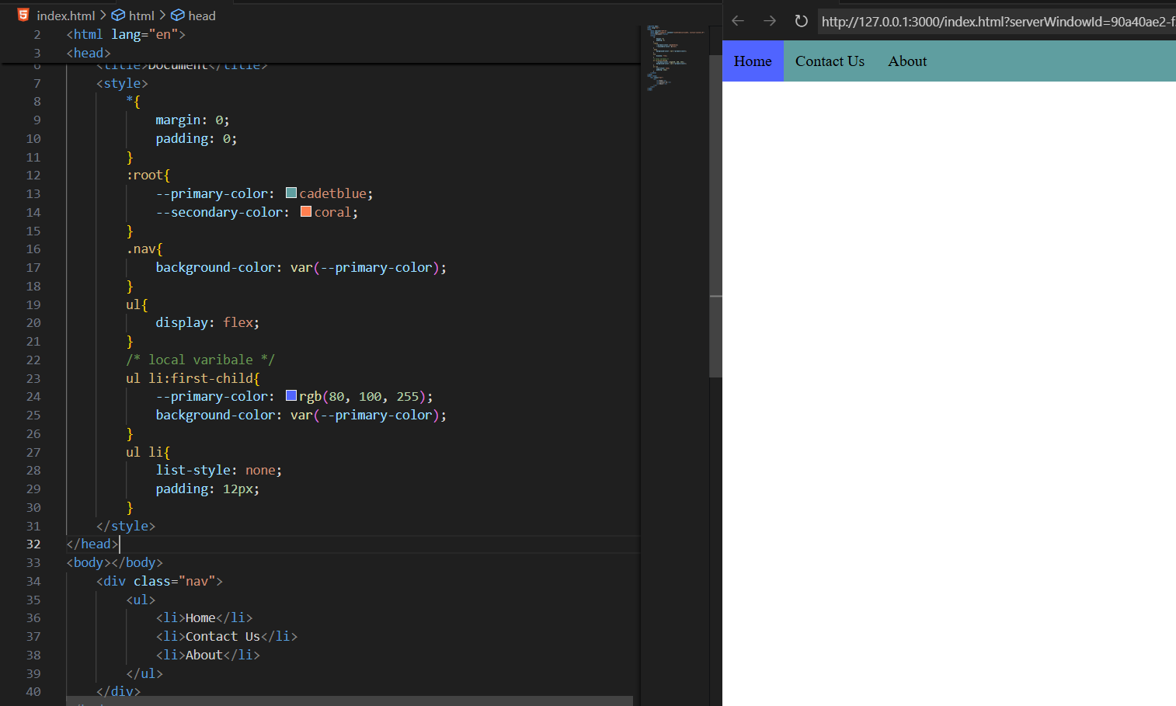

Suppose we don’t have that variable then? We can specify It as shown below:

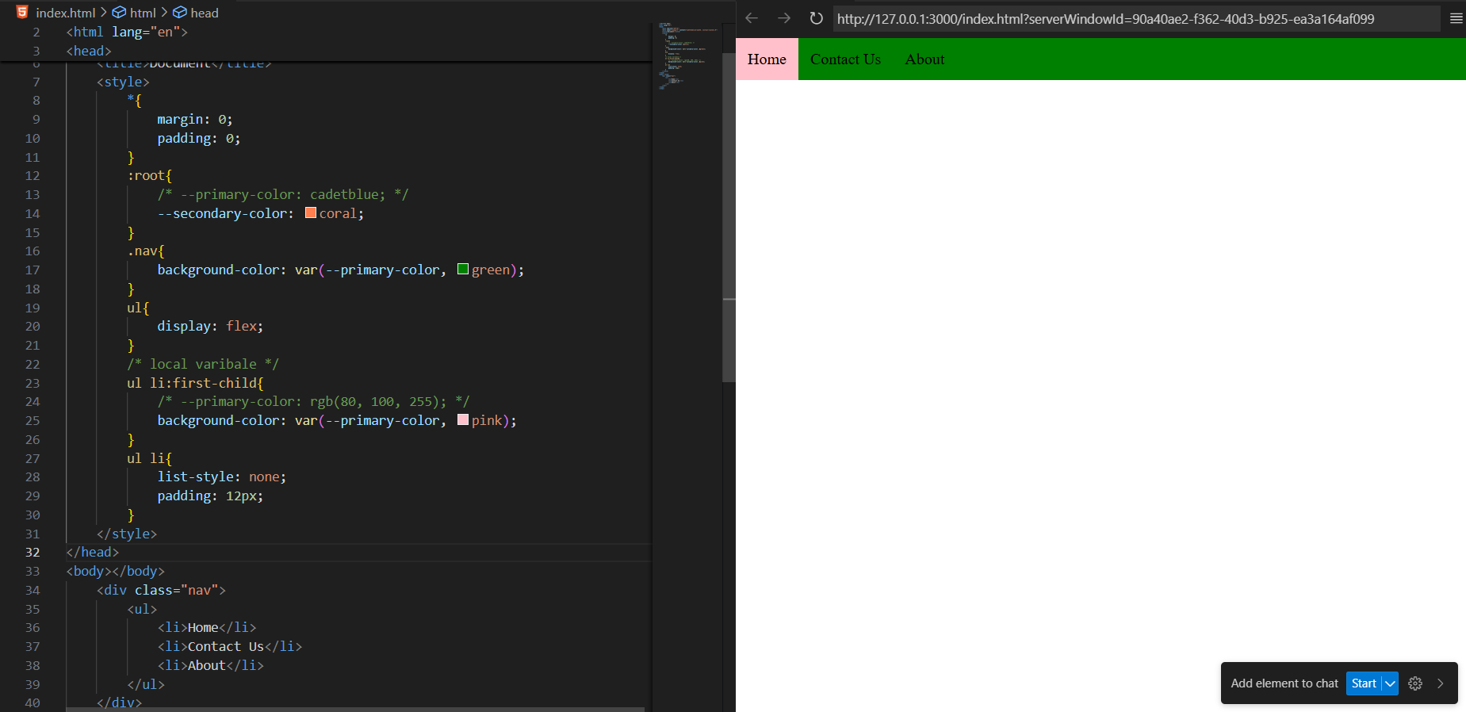

Also, it is not important that we are using the color properties for the colours only, we can use it for other properties too like padding:

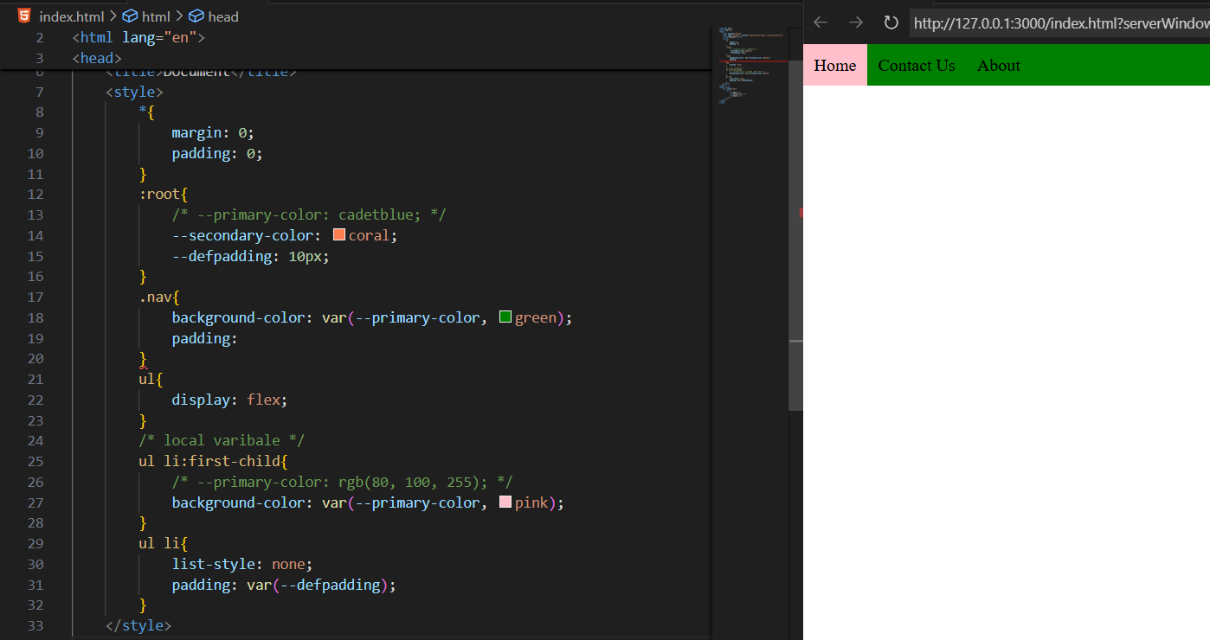

**CSS Media Queries:**

**What Are CSS Media Queries?**

Media Queries are used in CSS to make your website responsive — meaning it looks good on all devices (mobile, tablet, laptop, desktop). They apply different styles based on screen size or device type.

**Basic syntax:**

@media (condition) {

/* CSS rules go here */

}

**Conditions:**

| **Condition** | **Meaning** |
| --- | --- |
| max-width | Applies when the screen width is up to that value |
| min-width | Applies when the screen width is at least that value |
| orientation: portrait | Applies when the screen is taller than wide |
| orientation: landscape | Applies when the screen is wider than tall |

Example: a basic example of red background color

Code:

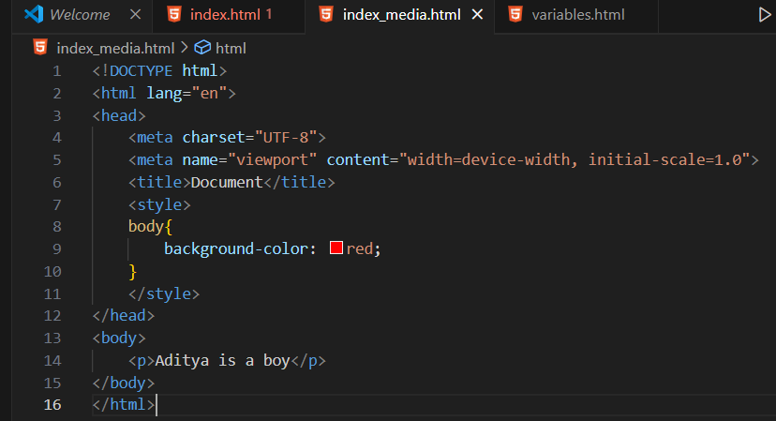

Output:

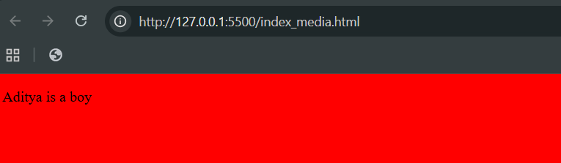

Now, we want that if the device max-width is a certain value then the background colour of the page changes to blue, then for that we will use the media query:

Code:

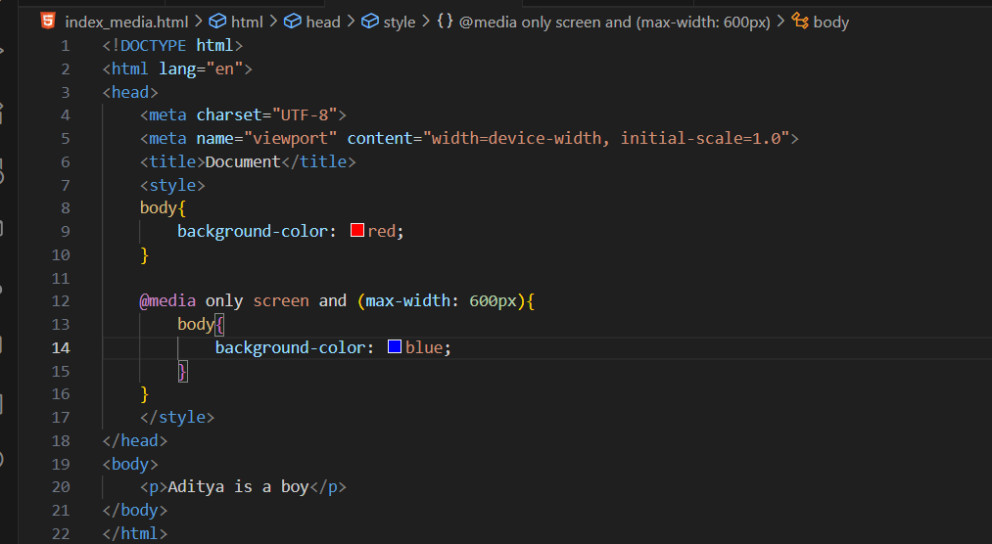

Output: in the inspect section

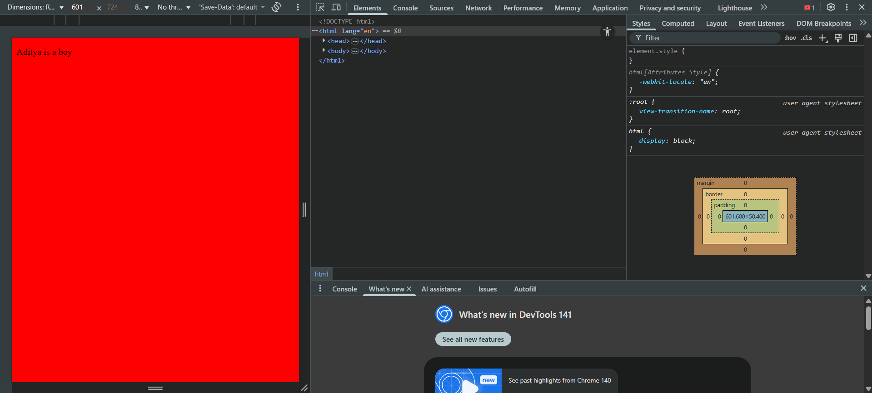

The moment we decrease the size to 600 from 601, the moment it changes its colour to blue:

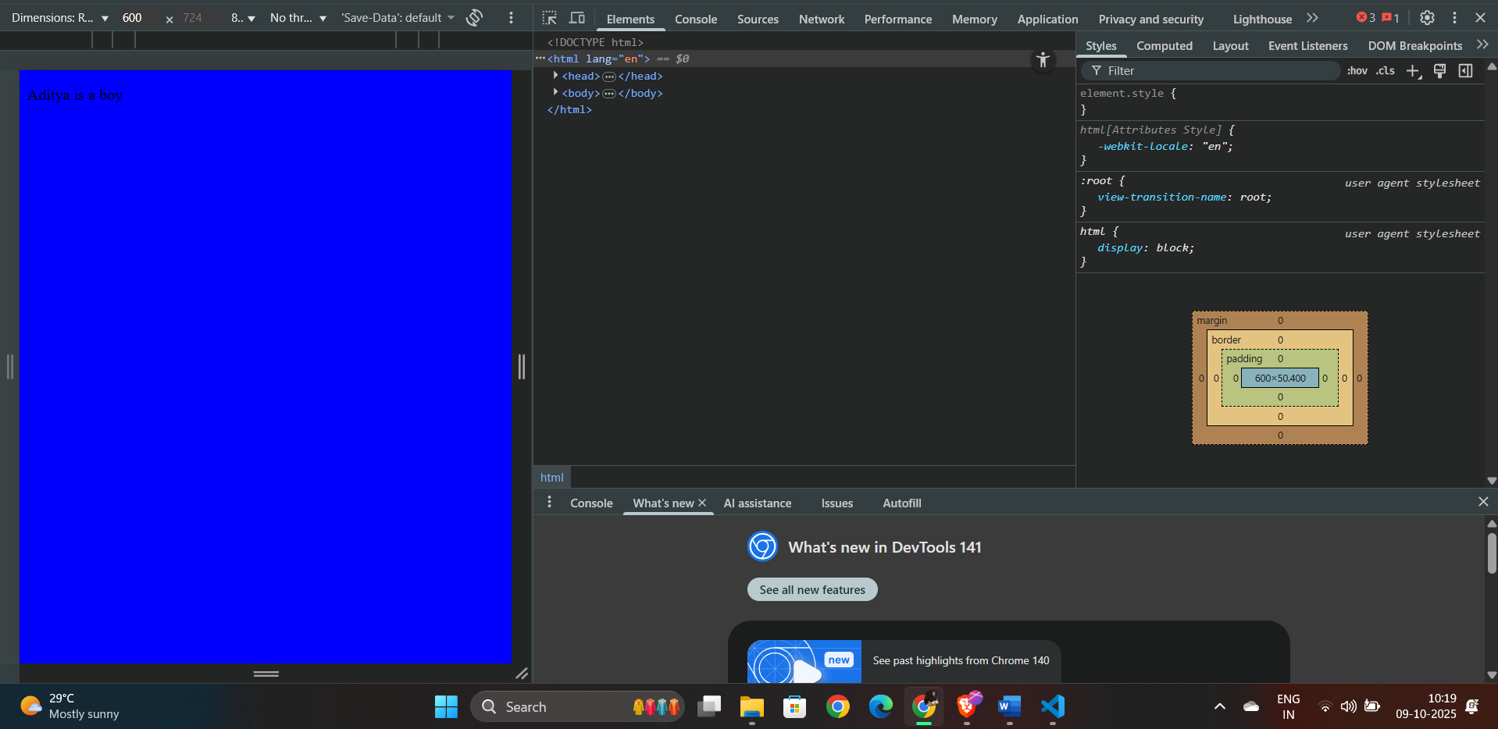

This means that the webpage will have background colour blue for the devices whose max-width of deice be 600px.

--The End--