**Day 29**

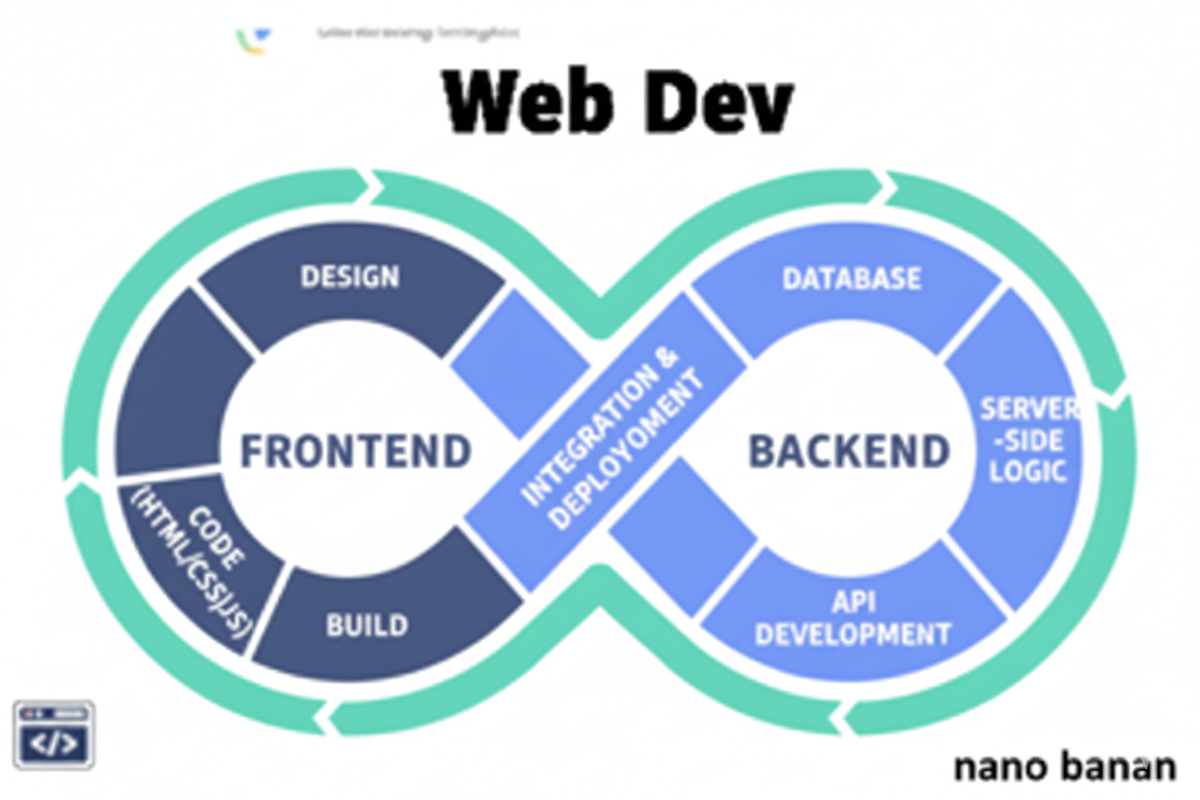

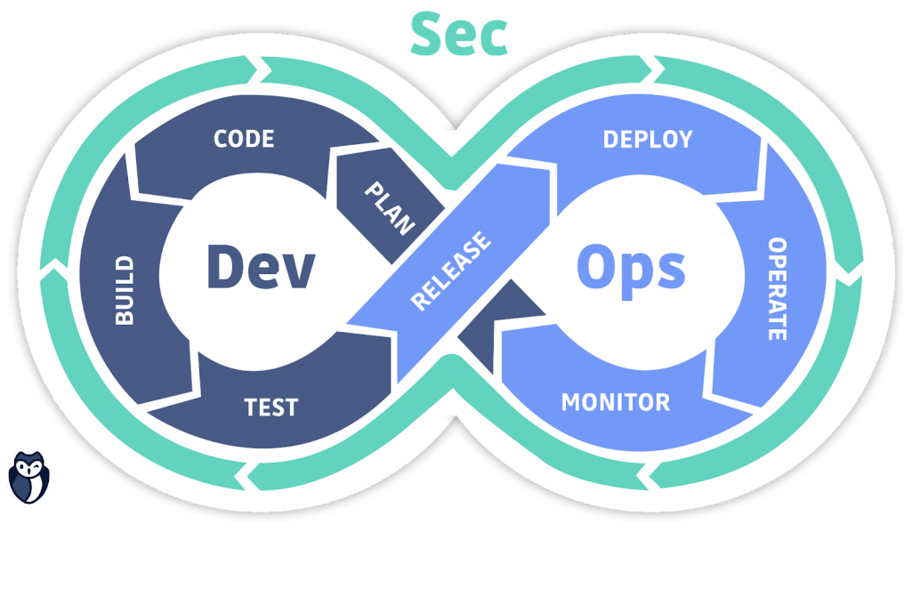

**“Web Development + Security”**

**Figma:**

**What is Figma?**

Figma is a browser-based design tool used for:

* UI/UX design
* Wireframing
* Prototyping
* Collaboration (multiple people can design on the same file in real-time)

It’s like a mix of Photoshop + Illustrator, but simpler and focused on interface design.

**How Figma Fits Into Web Development**

| **Stage** | **What You Do in Figma** | **What You Do in Code** |
| --- | --- | --- |
| Design | Draw buttons, layouts, navigation bars, cards, sections | HTML for structure, CSS for styling |
| Prototype | Link pages, simulate button clicks | Add real interactivity with JavaScript |
| Inspect | Copy CSS values, fonts, colors | Paste or replicate in your code |

**Shortcuts:**

| **Action** | **Shortcut** |
| --- | --- |
| Frame | F |
| Rectangle | R |
| Text | T |
| Zoom In/Out | Ctrl/Cmd + Scroll |
| Duplicate | Ctrl/Cmd + D |
| Group | Ctrl/Cmd + G |
| Show Rulers | Shift + R |
| Preview Prototype | Present (Play Icon) |

--The End--