**Day 31**

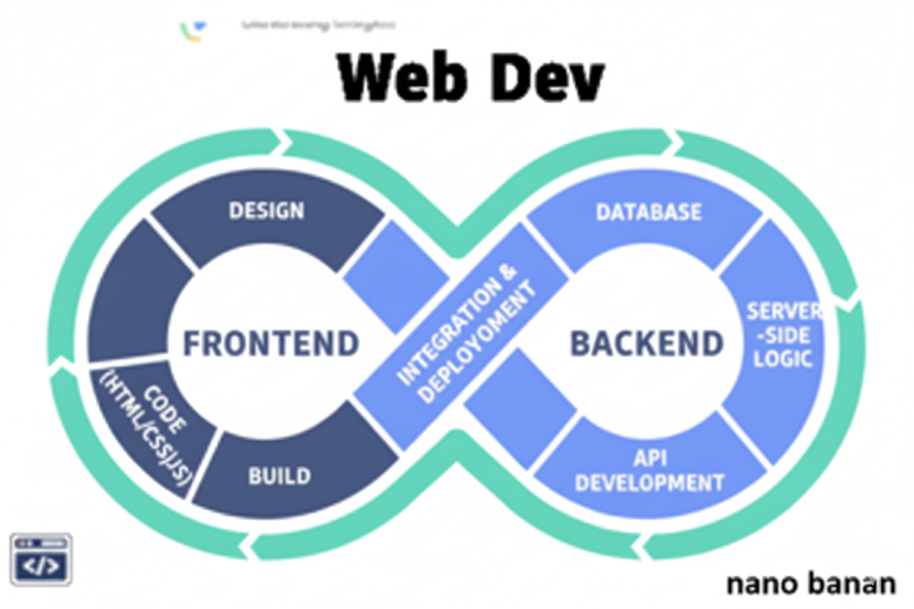

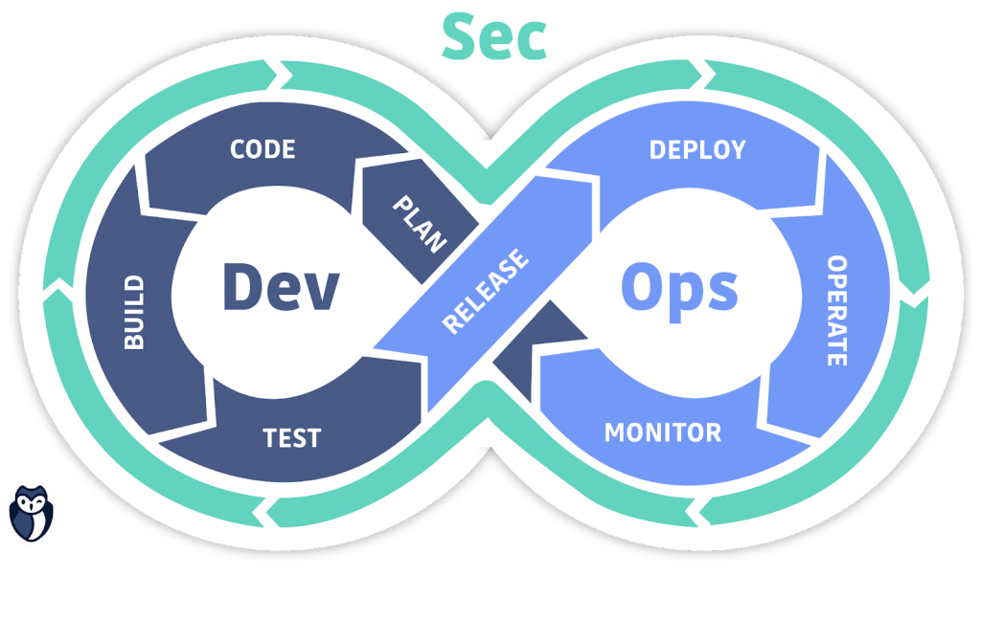

**“Web Development + Security”**

**JavaScript Conditionals:**

**What Are Conditionals?**

Conditionals let your program make decisions — they allow your code to run different blocks based on whether something is true or false.

**Basic Conditional Types in JavaScript**

1. If statement
2. If..else statement
3. If..else if..else statement
4. Temporary operator (short if..else)
5. Switch statement

Example:if..else: Used when you want either one block or another to run.

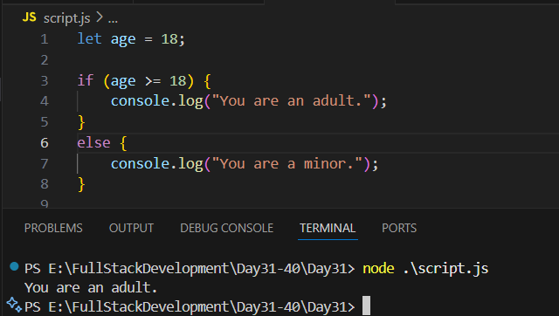

Example: if..else if..else

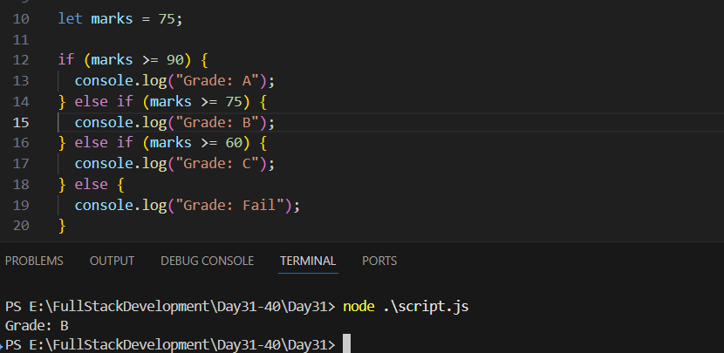

Example: shortcut way

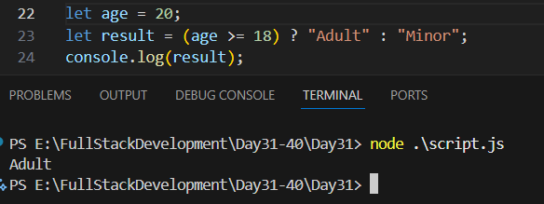

Example: switch statements

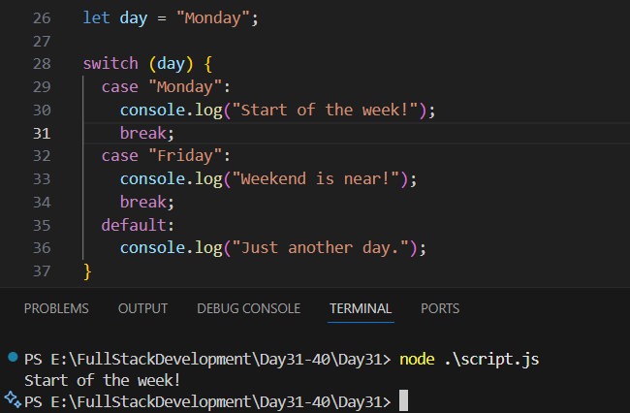

**JavaScript Comments:**

**What Are Comments in JavaScript?**

Comments are pieces of text in your code that the JavaScript engine completely ignores when running.  
They are used to:

* Explain code logic
* Make notes for future reference
* Temporarily disable parts of code (for debugging)
* Help others understand your code

--The End--