**Day 32**

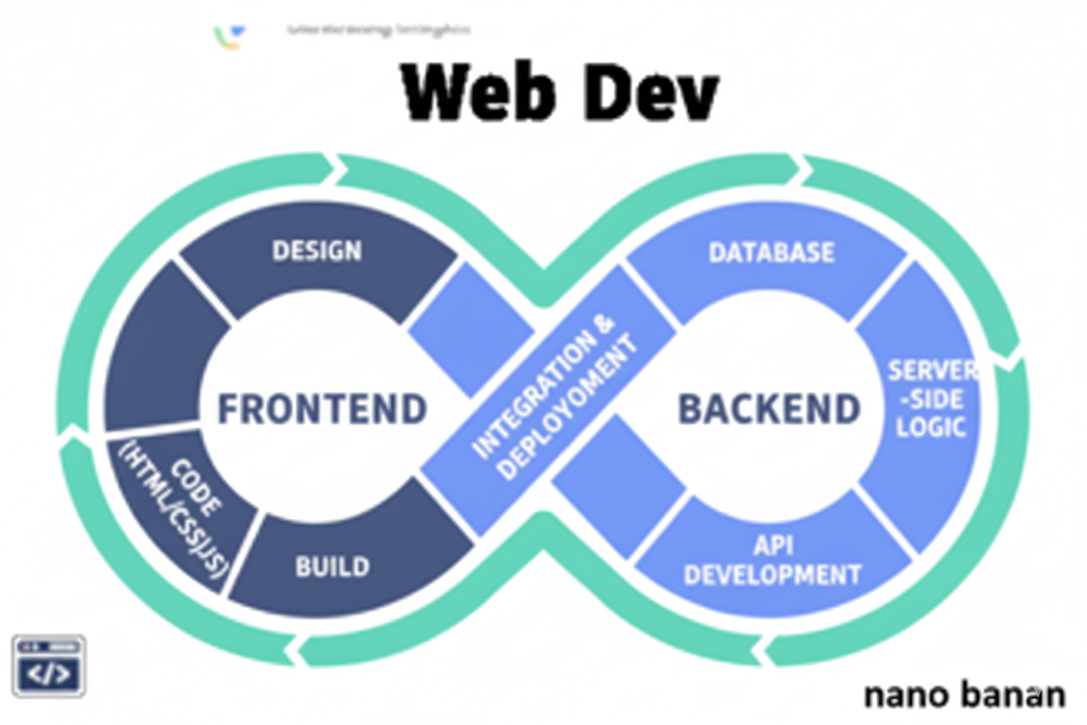

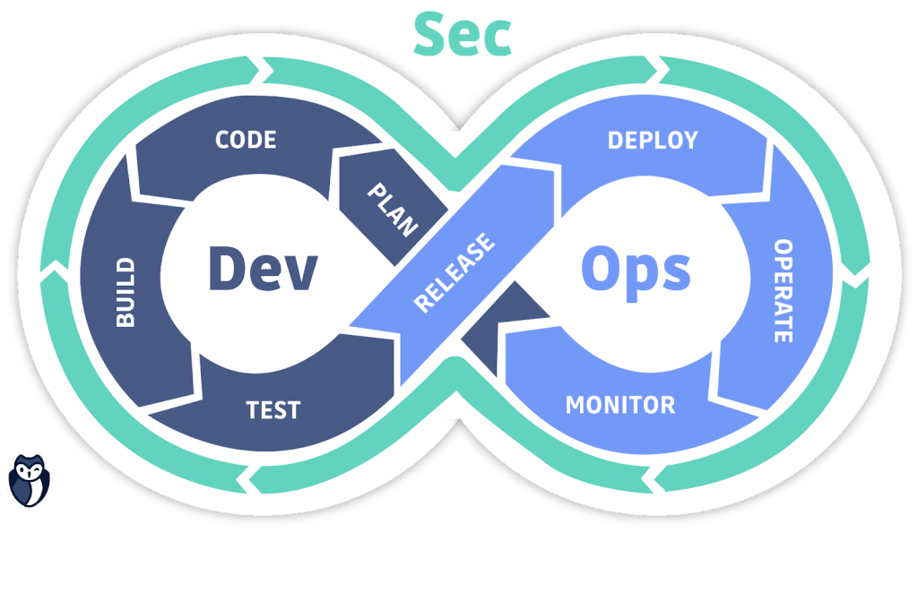

**“Web Development + Security”**

**JavaScript Functions:**

**What Is a Function in JavaScript?**

A function is a block of code designed to perform a specific task. You can define it once and reuse it as many times as you want.

Basic syntax:

function functionName(parameter1, parameter2, ...) {

// code to execute

return result; // optional

}

A very basic function:

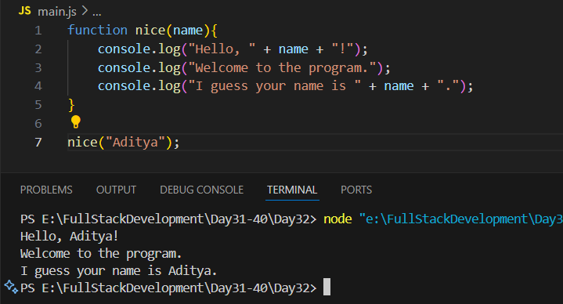

Another basic sum function:

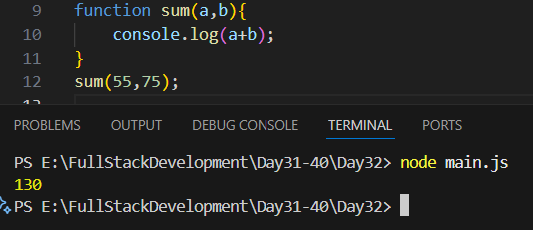

Another way to write the sum function: using the return keyword

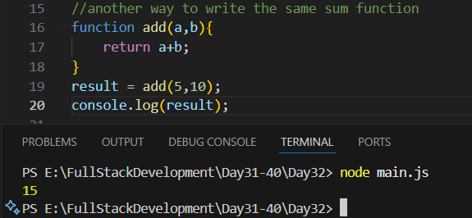

Adding more than one set of numbers:  
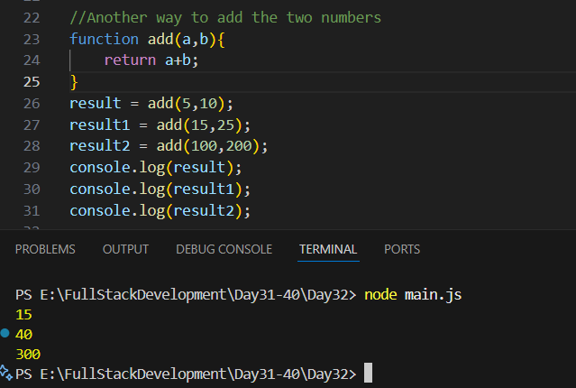

Example: three parameters in the function

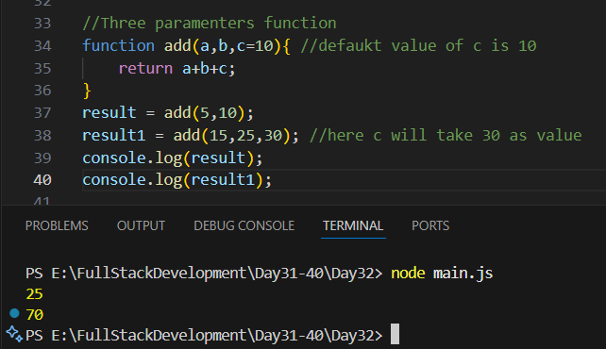

Example: arrow functions

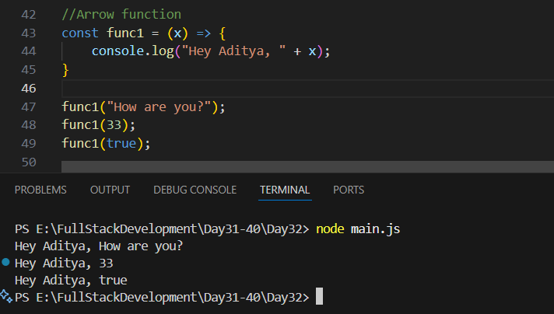

**JavaScript Strings:**

**What Is a String in JavaScript?**

A string is a sequence of characters enclosed in quotes — used to represent text.

**Ways to declare strings:**

| **Type** | **Example** | **Description** |
| --- | --- | --- |
| Single quotes | 'Hello' | Common and simple |
| Double quotes | "Hello" | Common and flexible |
| Template literals (backticks) | `Hello` | Introduced in ES6, allows expressions & multiline strings |

A very basic example using the index:

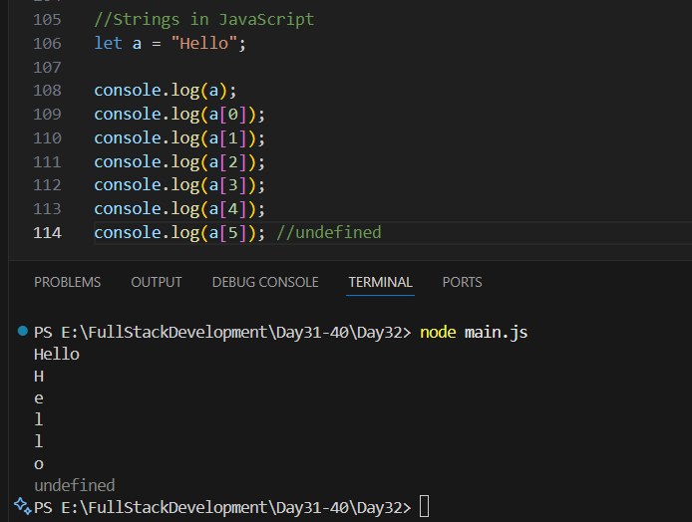

Example: to get the string length

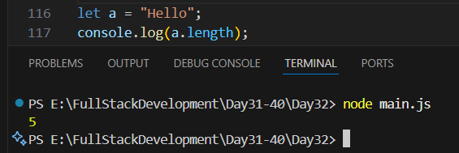

Example: template literals

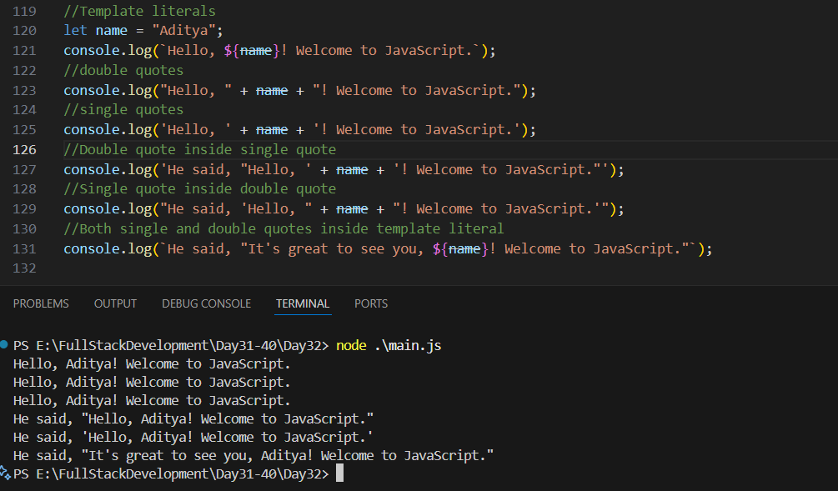

Example: escape sequences

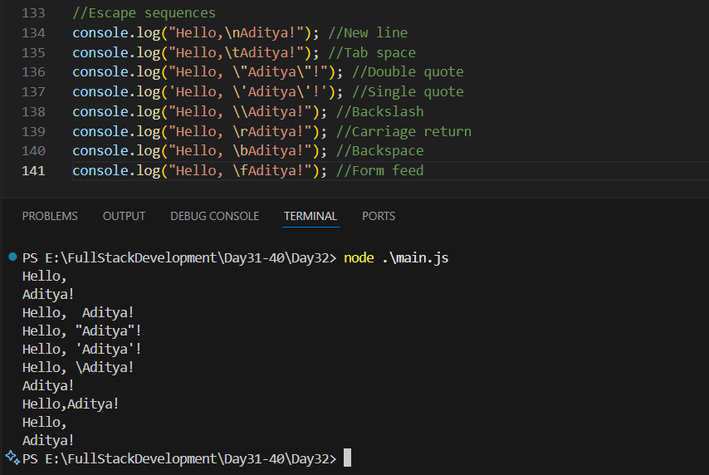

Example: strings are immutable

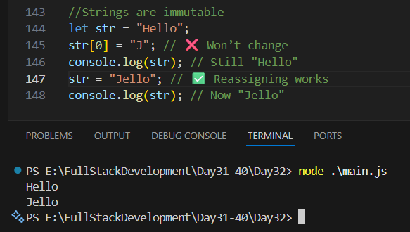

--The End--