**Day 33**

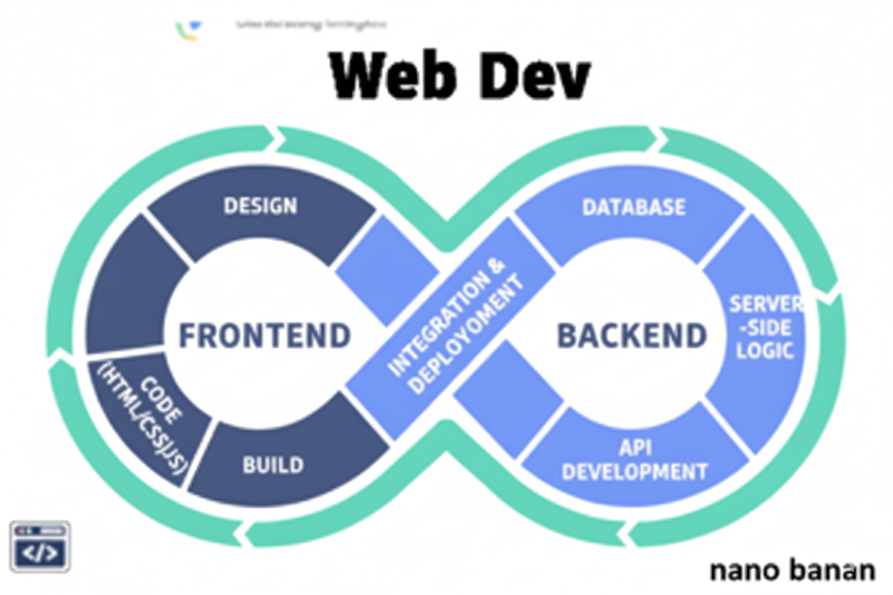

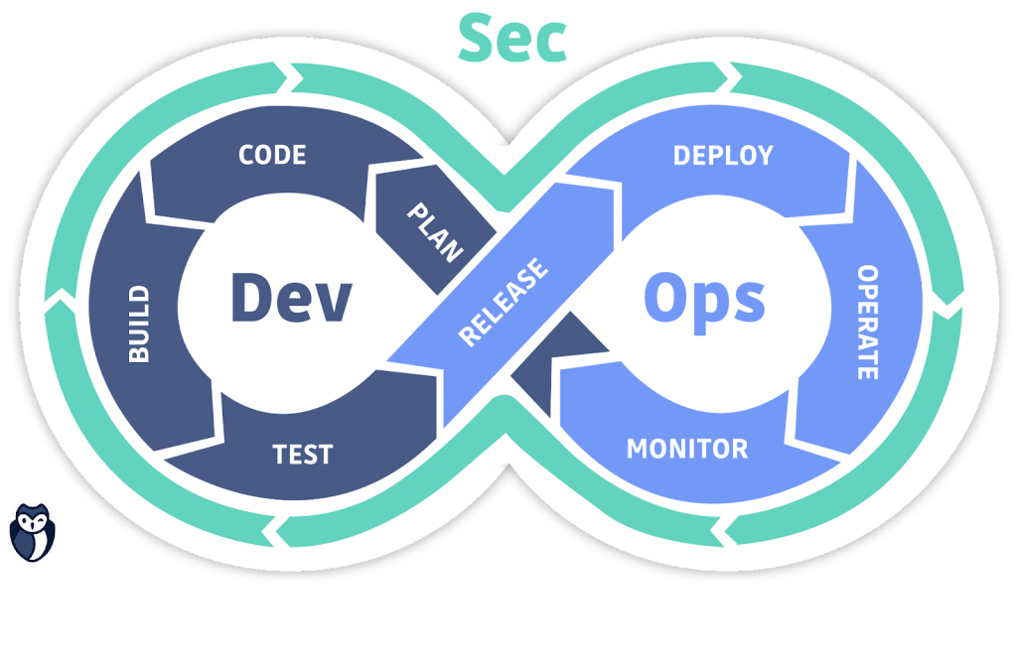

**“Web Development + Security”**

**JavaScript Arrays:**

**What Is an Array?**

An array is a list-like object used to store multiple values in a single variable.

Example:

let fruits = ["Apple", "Banana", "Mango"];

console.log(fruits); // ["Apple", "Banana", "Mango"]

* Arrays can hold any data type: numbers, strings, objects, other arrays, even functions.

**Declaring arrays:**

1. // Using literal syntax (recommended)

let numbers = [1, 2, 3, 4, 5];

1. // Using Array constructor

let colors = new Array("Red", "Green", "Blue");

1. // Empty array

let emptyArr = [];

A very basic array:

Code:

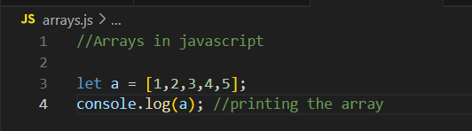

Output:

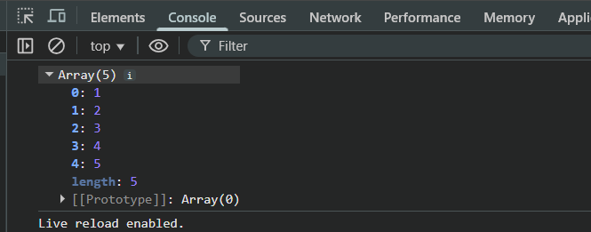

Now, to print the length of the array:

Code:

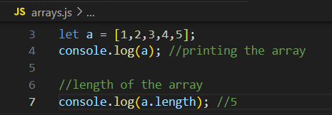

Output:

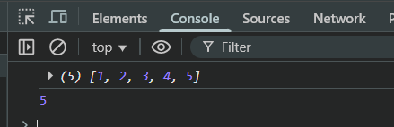

Example: arrays are mutable

Code:

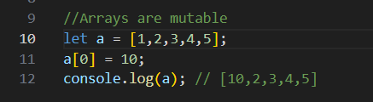

Output:

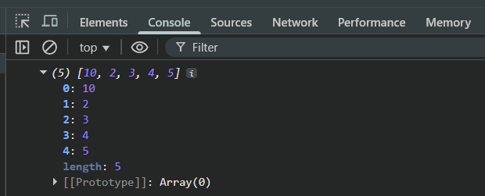

Example: printing the specific element of array using its index

Code:

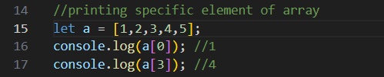

Output:

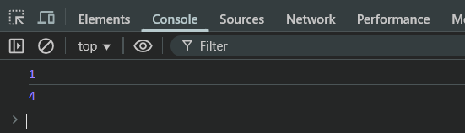

Example: type of array is object

Code:

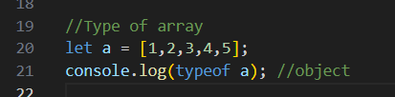

Output:

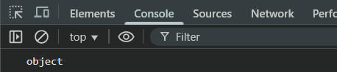

Example: changing array to string

Code:

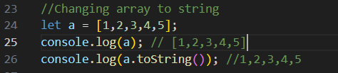

Output:

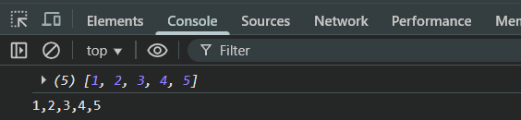

Example: use of join() to join all the arrays elements using a separator

Code:

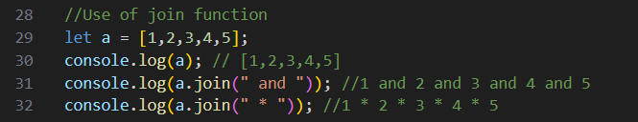

Output:

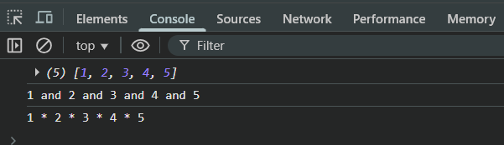

Example: of pop(), it removes the last element of the array

Code:

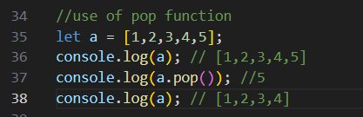

Output:

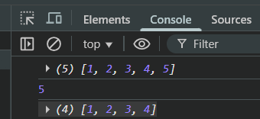

Example: use of push(), it will push the element as the last element of the array

Code:

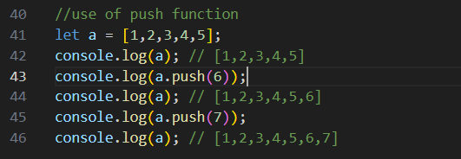

Output:

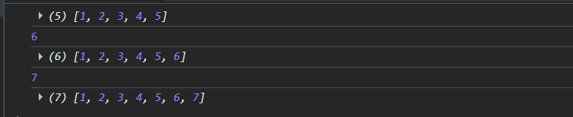

Example: shift() it removes the first element and return it

Code:

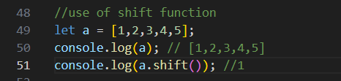

Output:

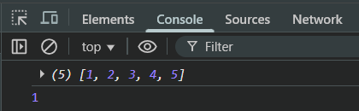

Example: use of unshift() to push the element from the front

Code:

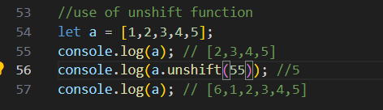

Output:

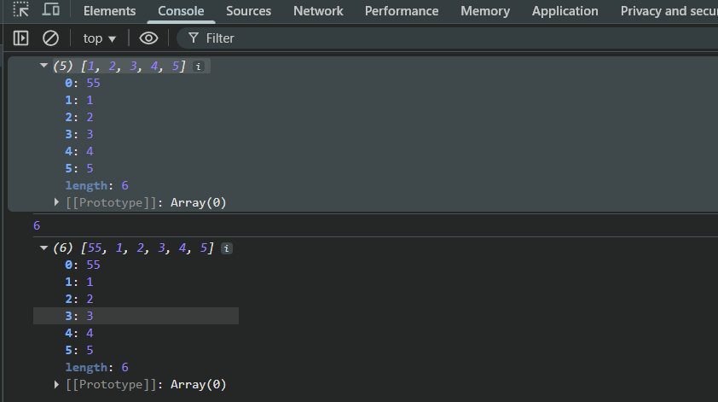

Example: use of delete, when we do so the memory of the deleted value of array be present but the value be absent.

Code:

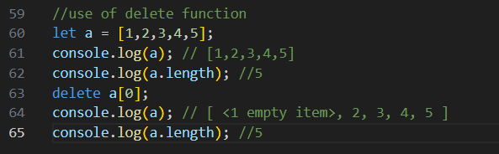

Output:

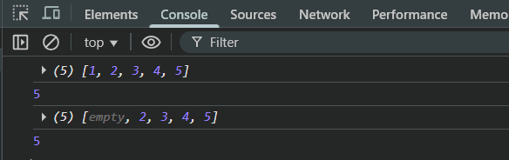

Example: use of concat operator in order to join two arrays

Code:

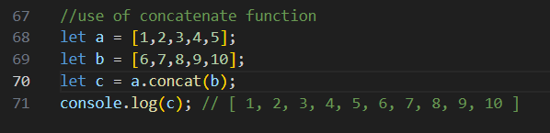

Output:

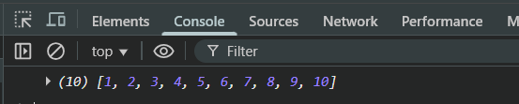

Also,

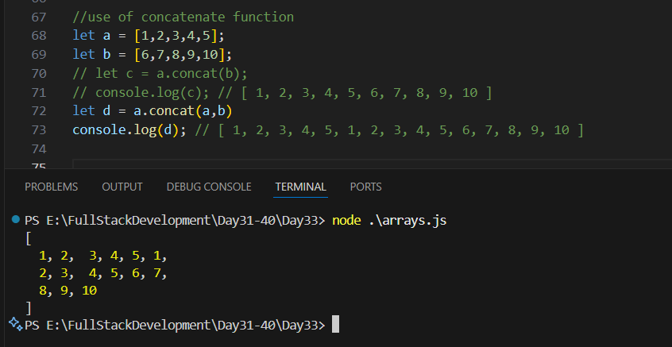

Example: use of sort()

Code:

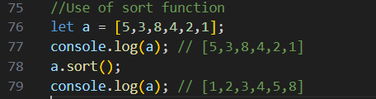

Output:

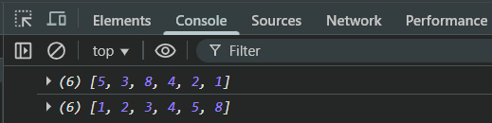

Example: use of reverse()

Code:

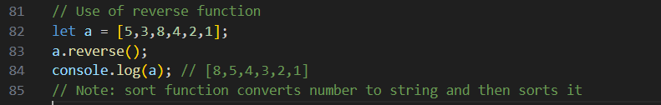

Output:

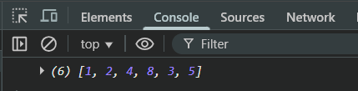

Example: use of splice()

Code:

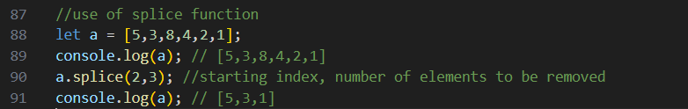

Output:

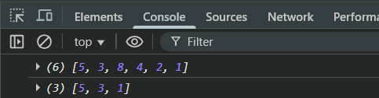

Example: inserting the elements using the splice()

Code:  
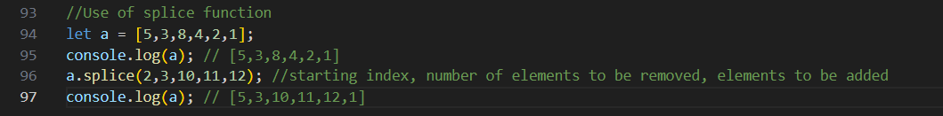

Output:

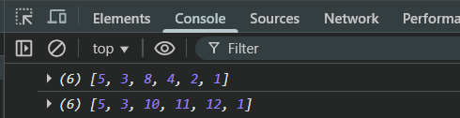

Example: use of slice()

Code:

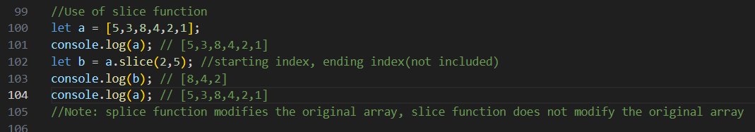

Output:

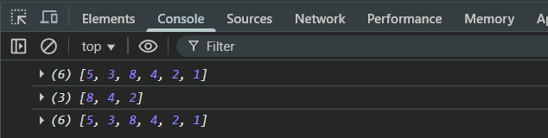

Example: printing the element of array

Code:

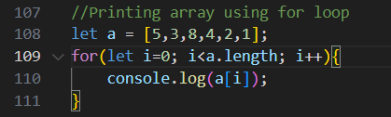

Output:

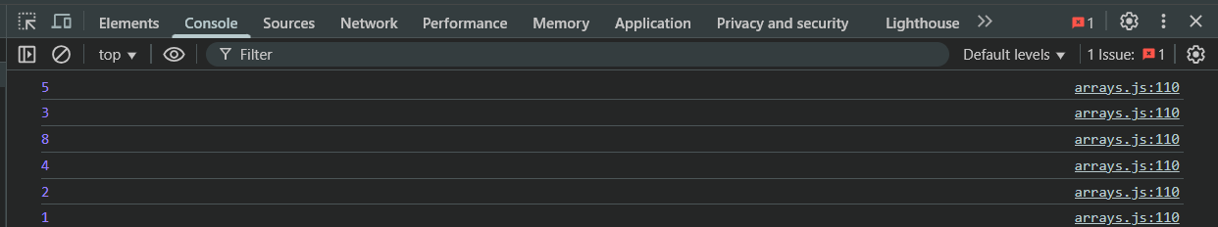

Example: printing the element of array using the for each and arrow

Code:

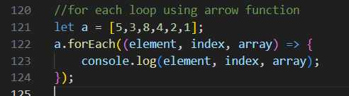

Output:

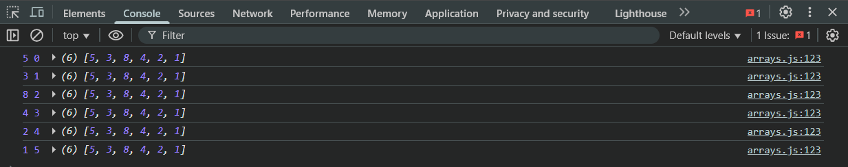

Example: printing the element of array using the for of loop

Code:

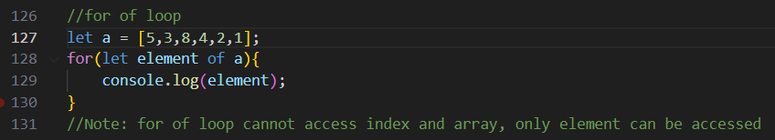

Output:

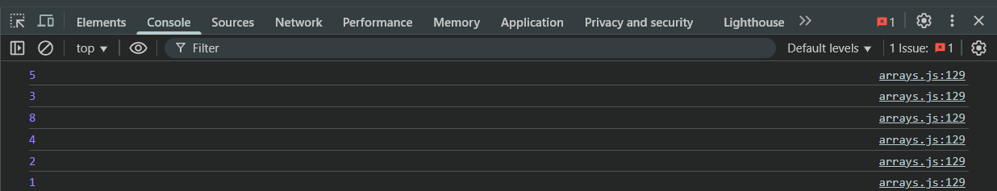

Example: use of for in loop

Code:

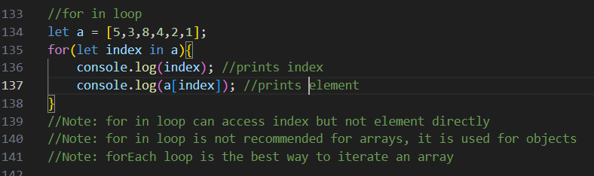

Output:

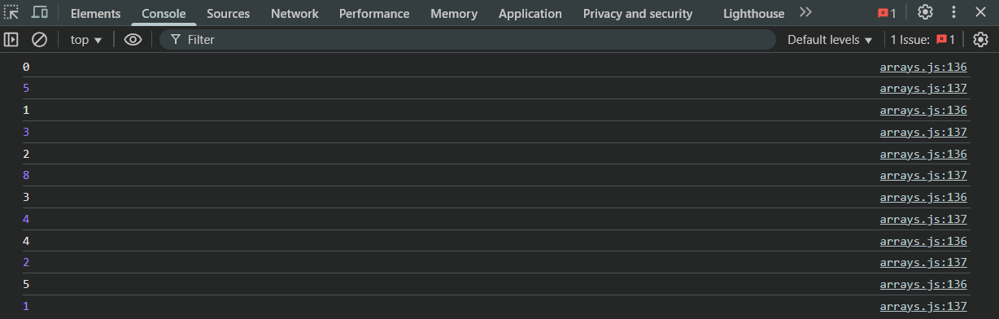

--The End--