**Day 34**

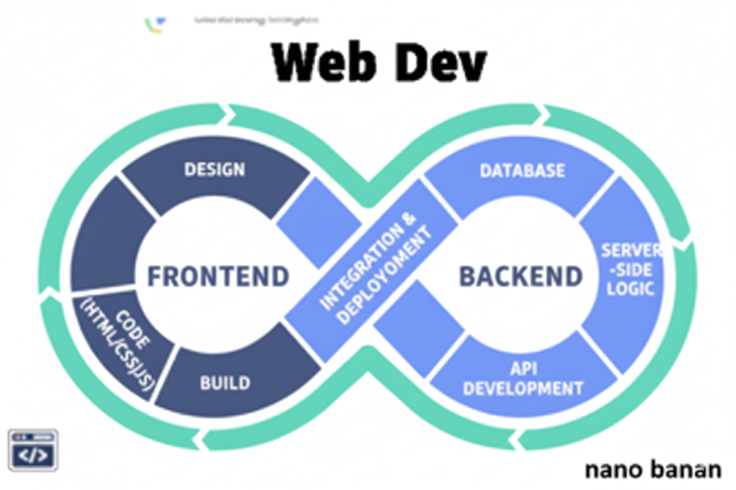

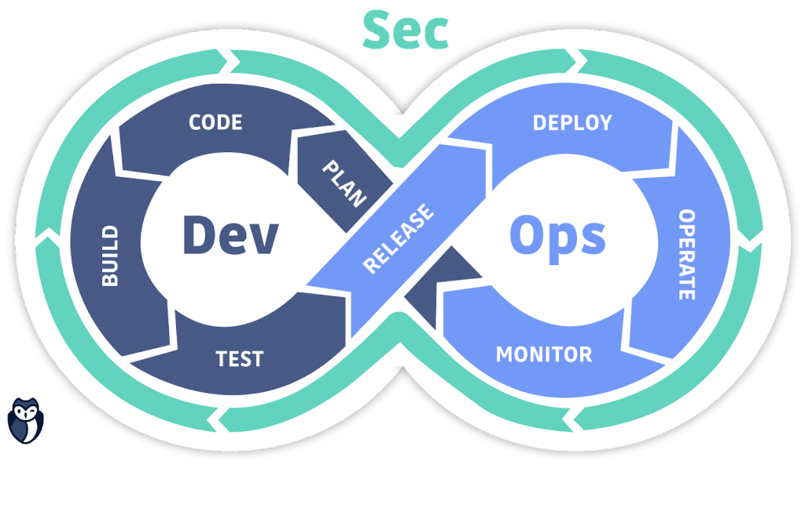

**“Web Development + Security”**

**JavaScript DOM:**

**What Is the DOM?**

The DOM (Document Object Model) is a tree-like structure representing all the elements of an HTML page.

When a browser loads a webpage:

1. It parses the HTML.
2. Creates a DOM tree (each HTML tag becomes a node).
3. JavaScript can then access and manipulate these nodes.

A very basic example without DOM:

Code:  
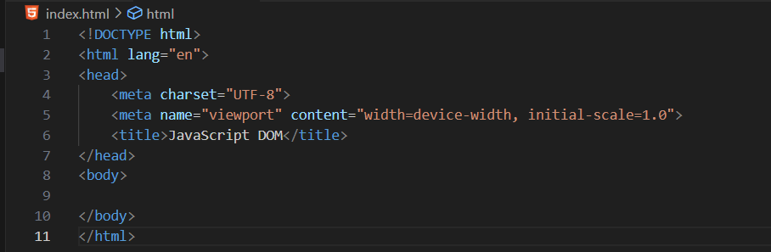

Output:

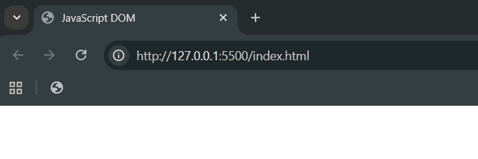

Now, we will change the title of the page using the <script>:

Code:

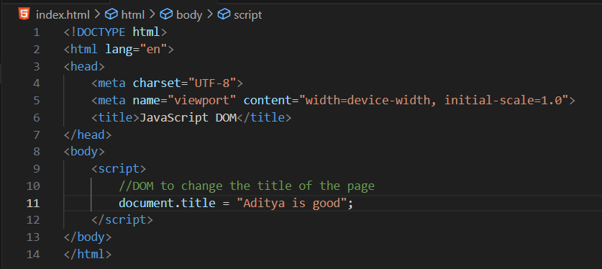

Output:

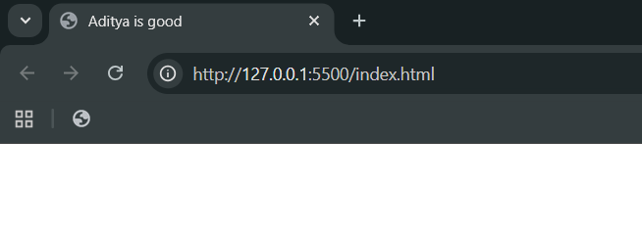

We can also, print the title of the page in the console, using the console.log():  
Code:

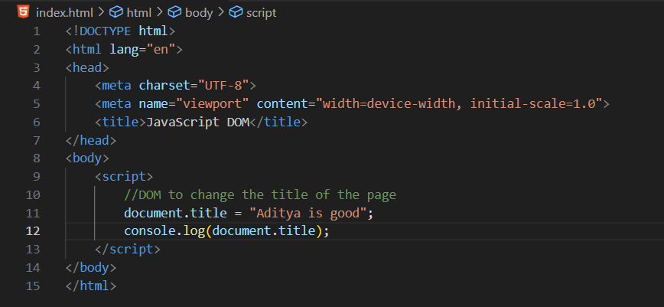

Output:

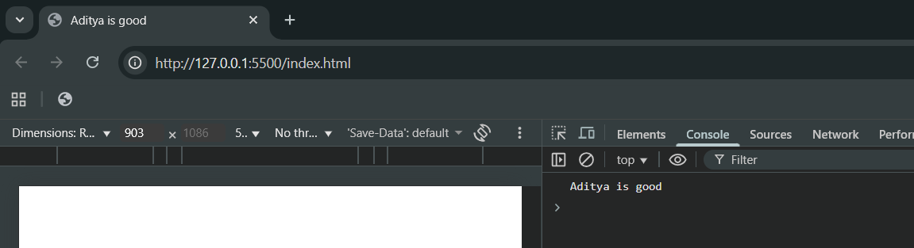

We can also, print the content of the <body>:

Code:

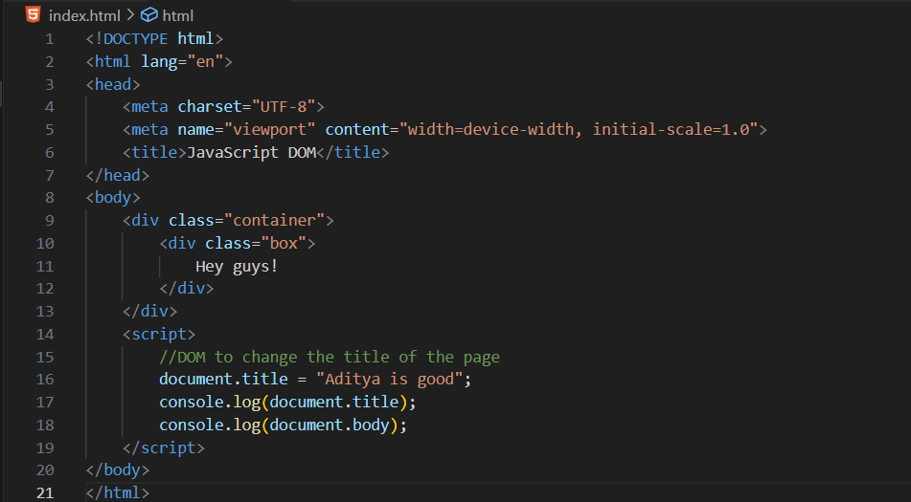  
Output:

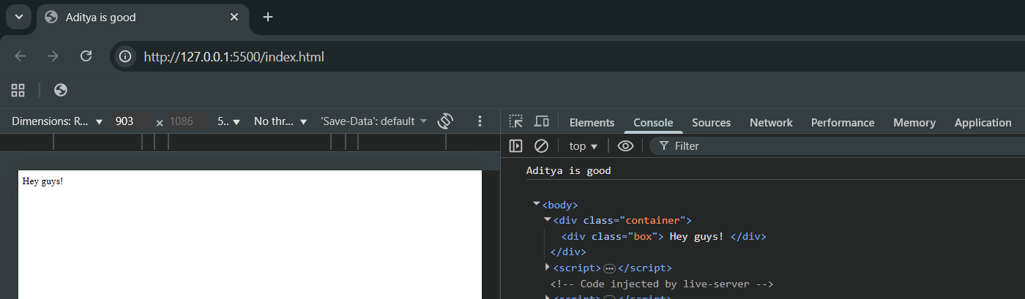

We can also assign properties of CSS through it:  
Code: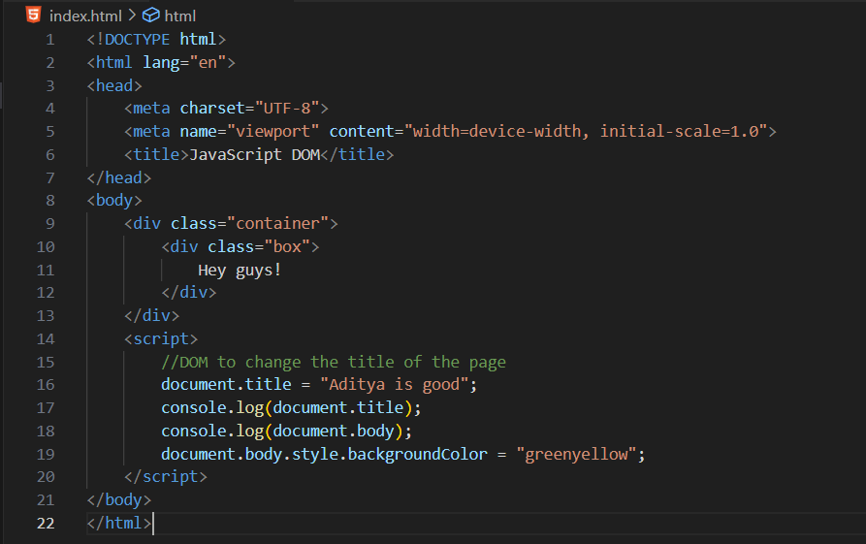

Output:

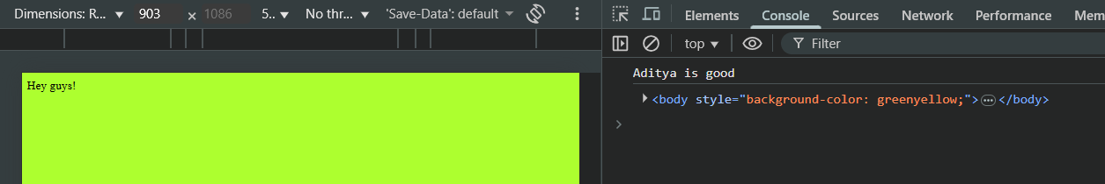

Also, keep in mind that the selected element get the $0, so it be easy for us to target it in the browser:

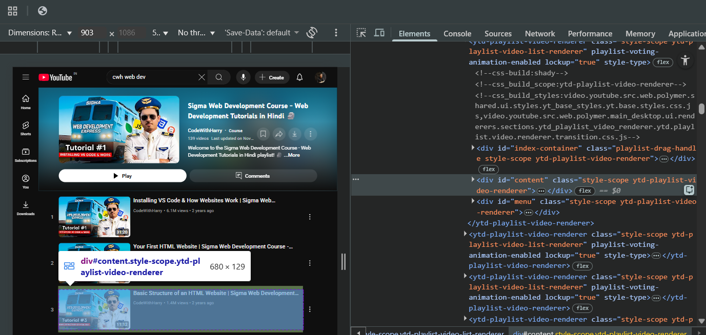

We can even target it: clearly it shows the targeted element

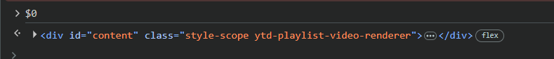

Manipulating using $0:

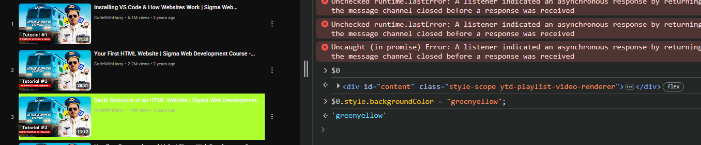

DOM:

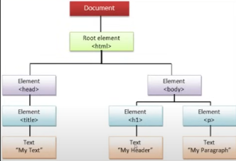

**JavaScript DOM - Children, Parent & Sibling Nodes:**

Creating a basic page with 5 <div>s:

Code:

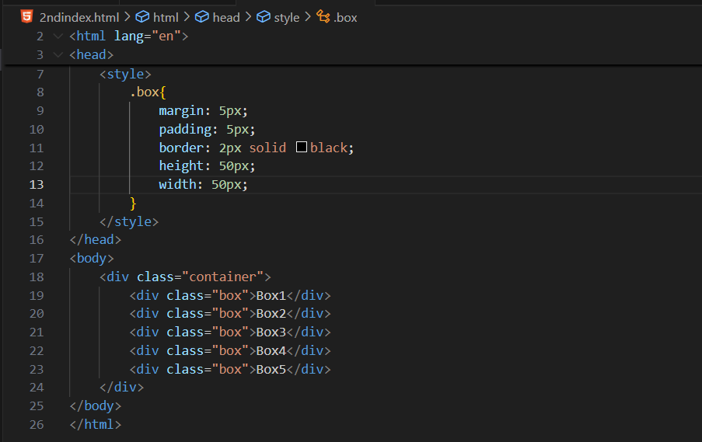

Output:

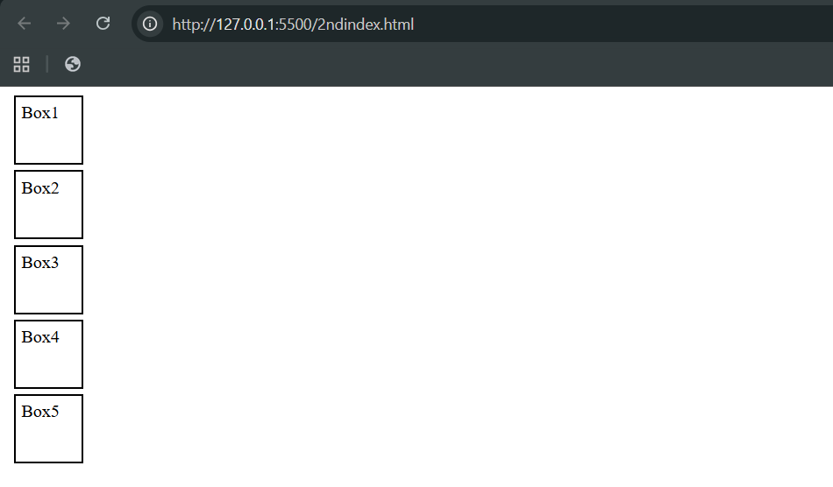

Now, we will be targeting the properties using the JavaScript: just add the reference link of .js

Suppose we want to know the number of child nodes in the container class: just write it as document.body.childNodes[1] as shown below

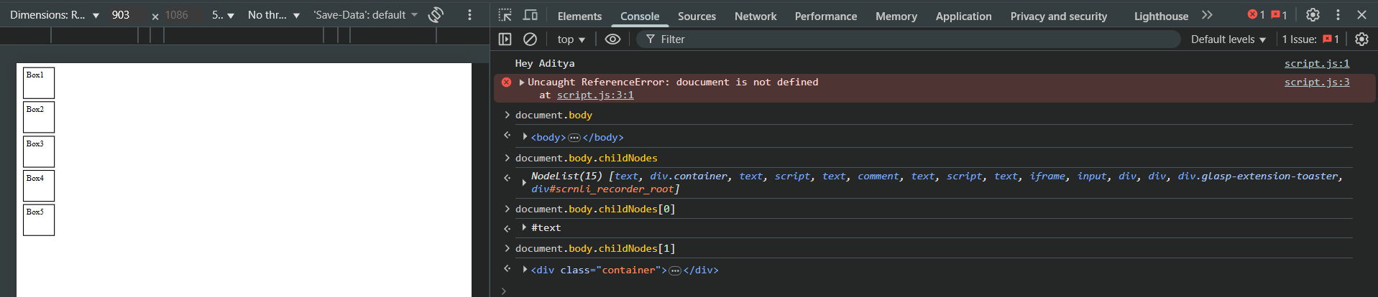

Now, suppose we want the child nodes of the container: document.body.childNodes[1].childNodes



Now, accessing the first child and last child of any node:

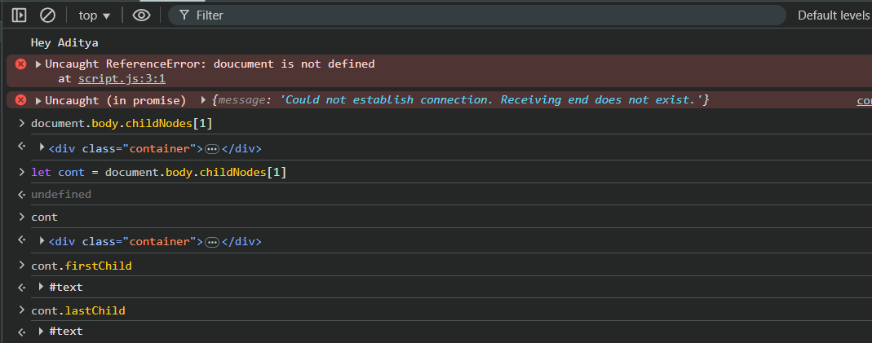

Now, accessing the first element child of a node:

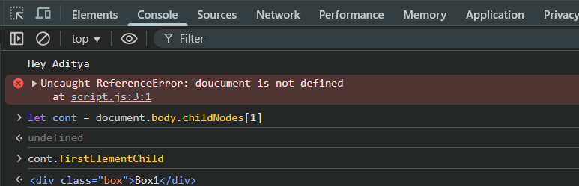

Similarly,

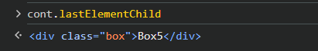

Now, targeting the property of last element child:  
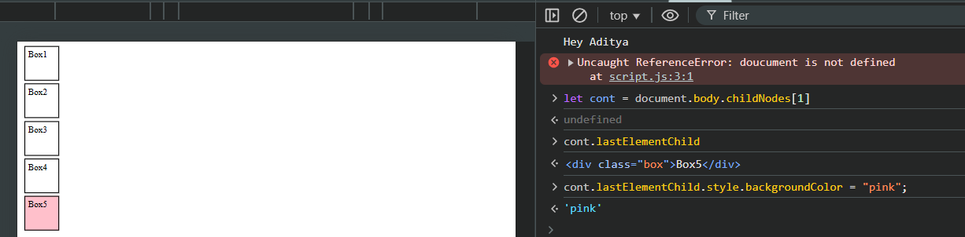

Now, to get the parent node of an element:

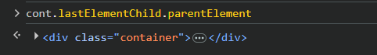

Now, to get all the childnodes of an element child:

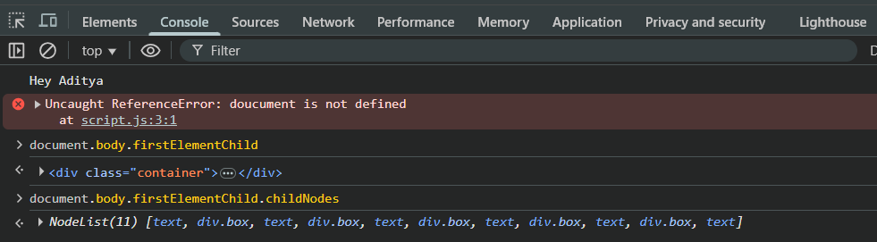

In case we just want elements of an element:

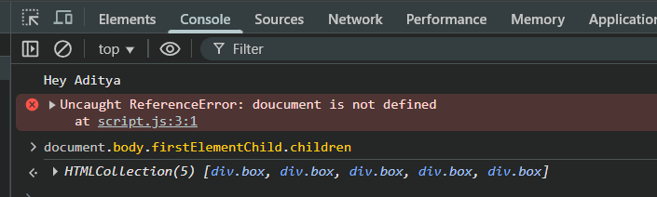

Now, getting the next element sibling as well as just sibling:

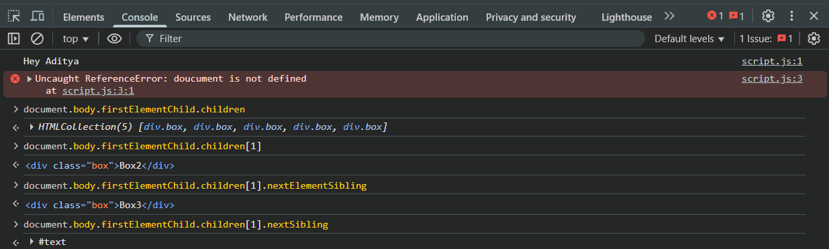

We can also get the previous element sibling:

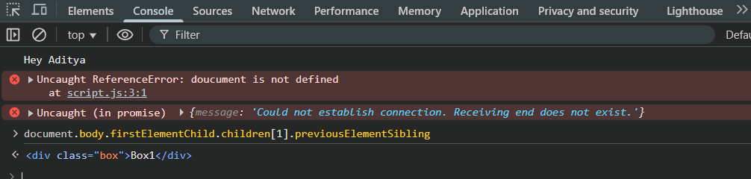

--The End--