**Day 36**

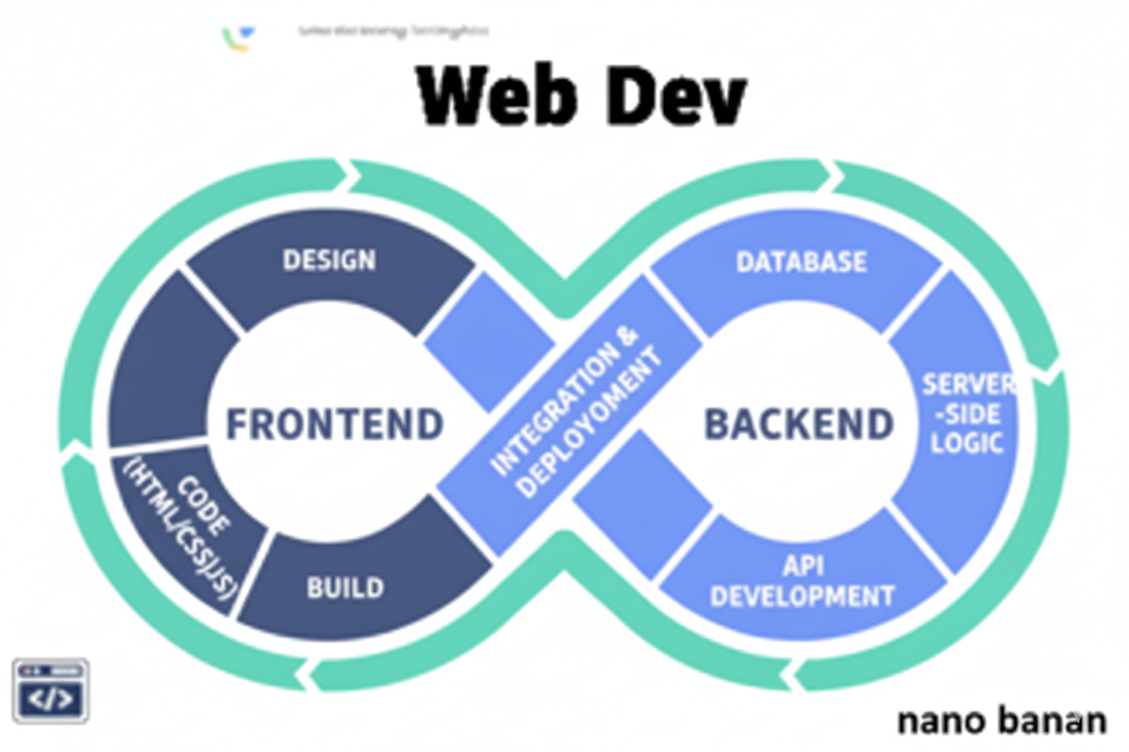

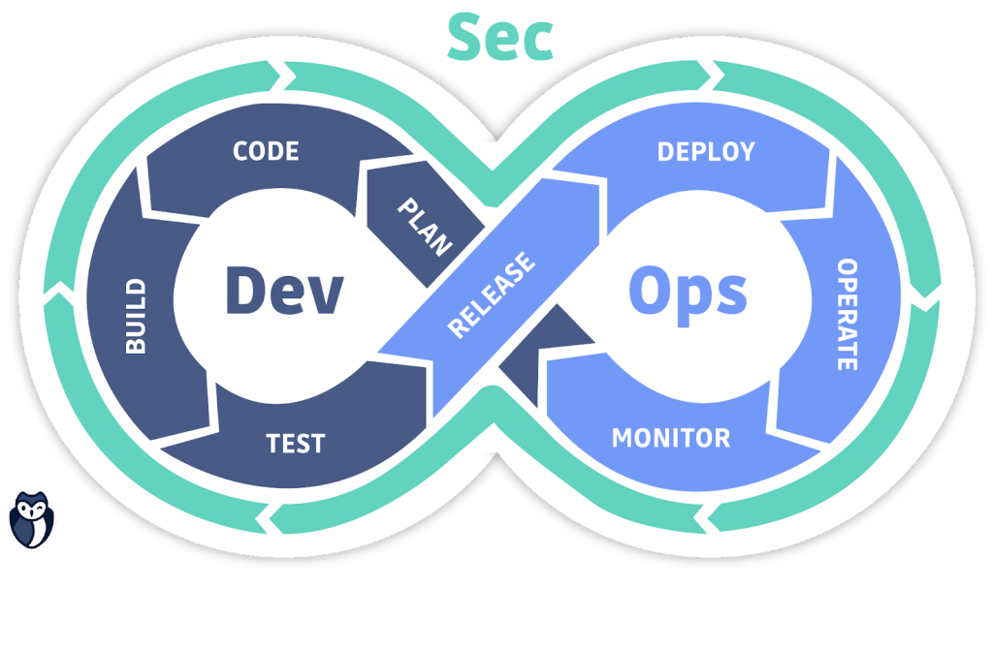

**“Web Development + Security”**

**Events, Event Bubbling, setInterval & setTimeout in JavaScript:**

**What Are Events in JavaScript?**

An event is an action that happens in the browser — e.g., user clicks a button, moves the mouse, presses a key, submits a form, or loads the page.

JavaScript can listen for and respond to these events using event listeners.

**Common Event Types**

| **Category** | **Examples** |
| --- | --- |
| Mouse | click, dblclick, mouseover, mouseout, mousedown, mouseup |
| Keyboard | keydown, keyup, keypress |
| Form | submit, change, focus, blur |
| Window | load, resize, scroll, DOMContentLoaded |
| Touch | touchstart, touchend, touchmove |

Example: a basic <div> and button:

Code: without any JS  
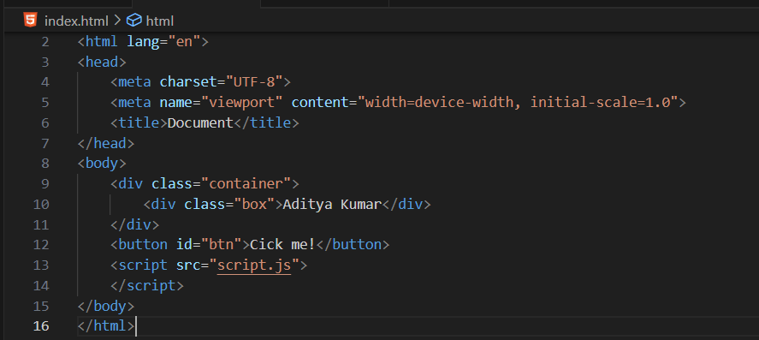

Output:

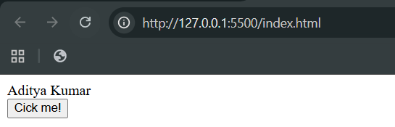

Example:

Adding a very basic event listener, where the alert box will come when we click the button:

Code:

Index.html: as shown above

Script.js:

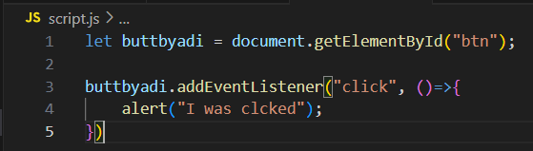

Output:

Before any click:

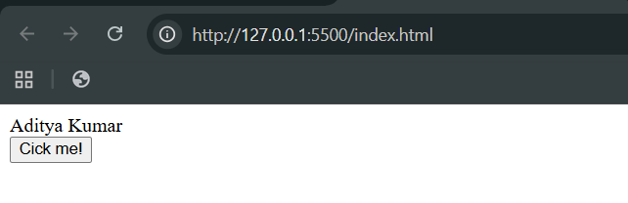

After the click: the alert came

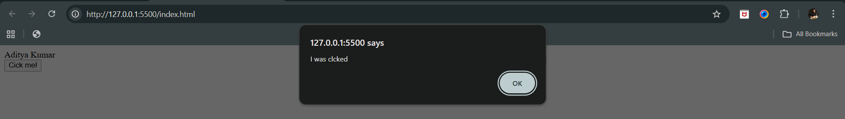

Example:

When we click the button, the text above the button will change:

Index.html: as shown above

Script.js: here we said that we want to target that element whose class be .box, which obviously be the first of its kind, as querySelector will target the first one

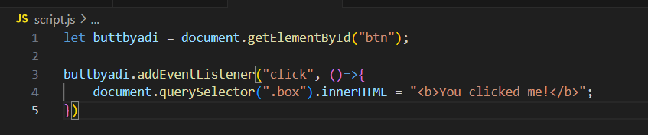

Output:

Before click:

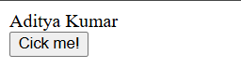

After click:

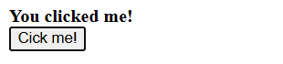

Example:

When we double click the button, the text above the button will change:

Index.html: as shown above

Script.js: here we said that we want to target that element whose class be .box, which obviously be the first of its kind, as querySelector will target the first one

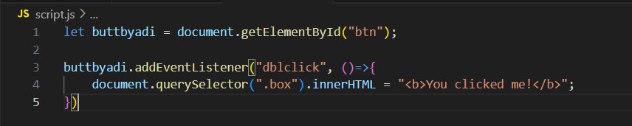

Output:

Before click:



After double click:



**What is eventBubbling?**

When an event occurs on an element:

1. It first triggers on that element,
2. Then bubbles up to its parents.  
   This is called Event Bubbling.

The opposite (from top to bottom) is Event Capturing.

Example:

First a basic <div>s: without any JS

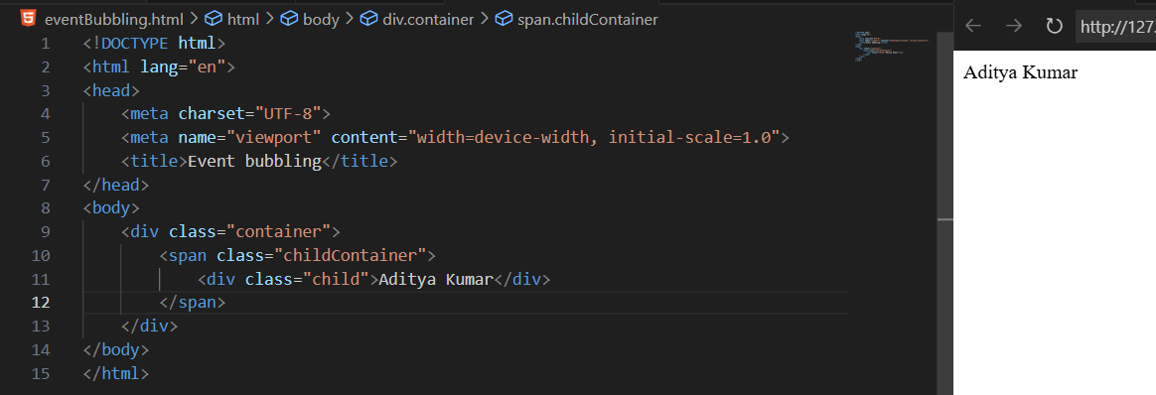

Now, adding the JS: we are doing double click, such that it should show the alert box. It is an example of event bubbling.

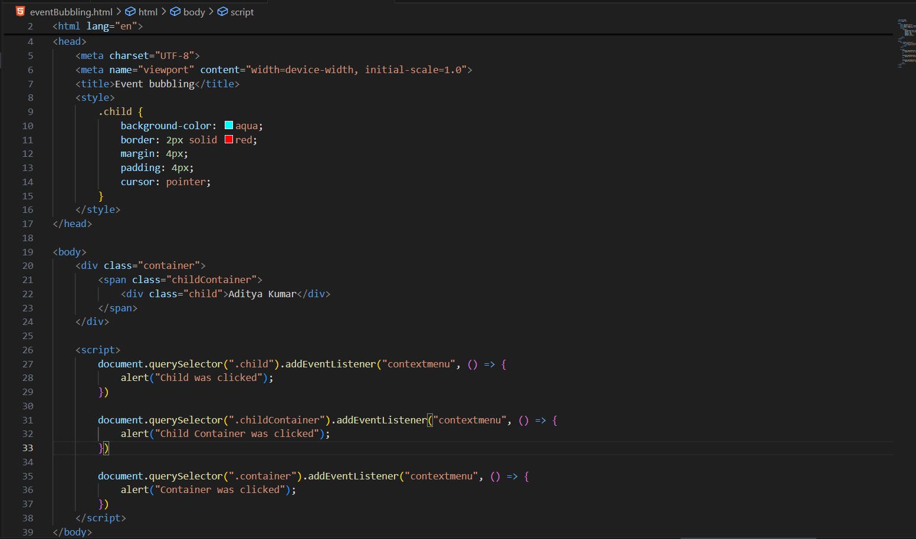

Output:

When we right clicked:  
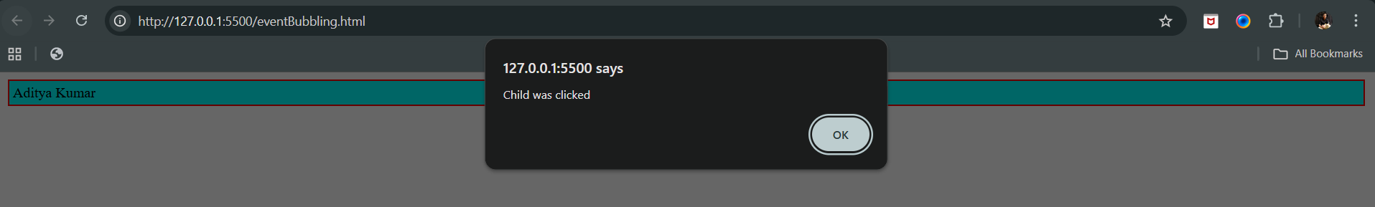

When we clicked ok:

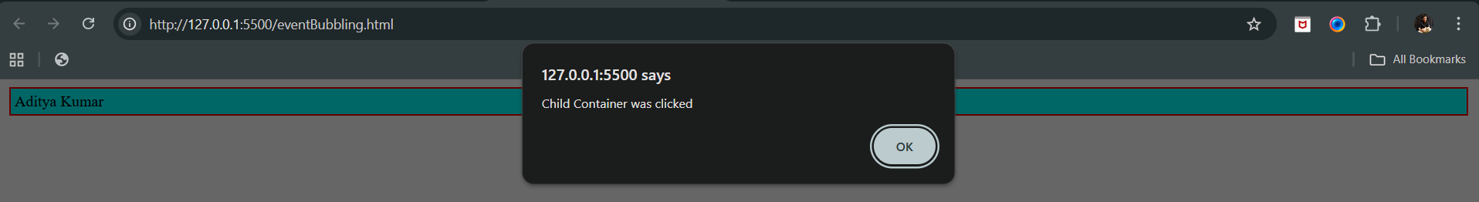

When we again clicked ok:

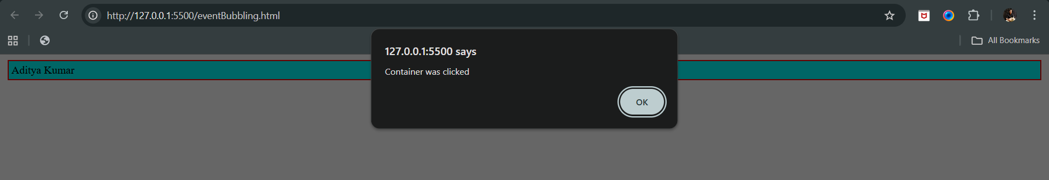

Now, suppose we don’t want something like this, then we can stop the propagation: using the .stopPropagation

Code:

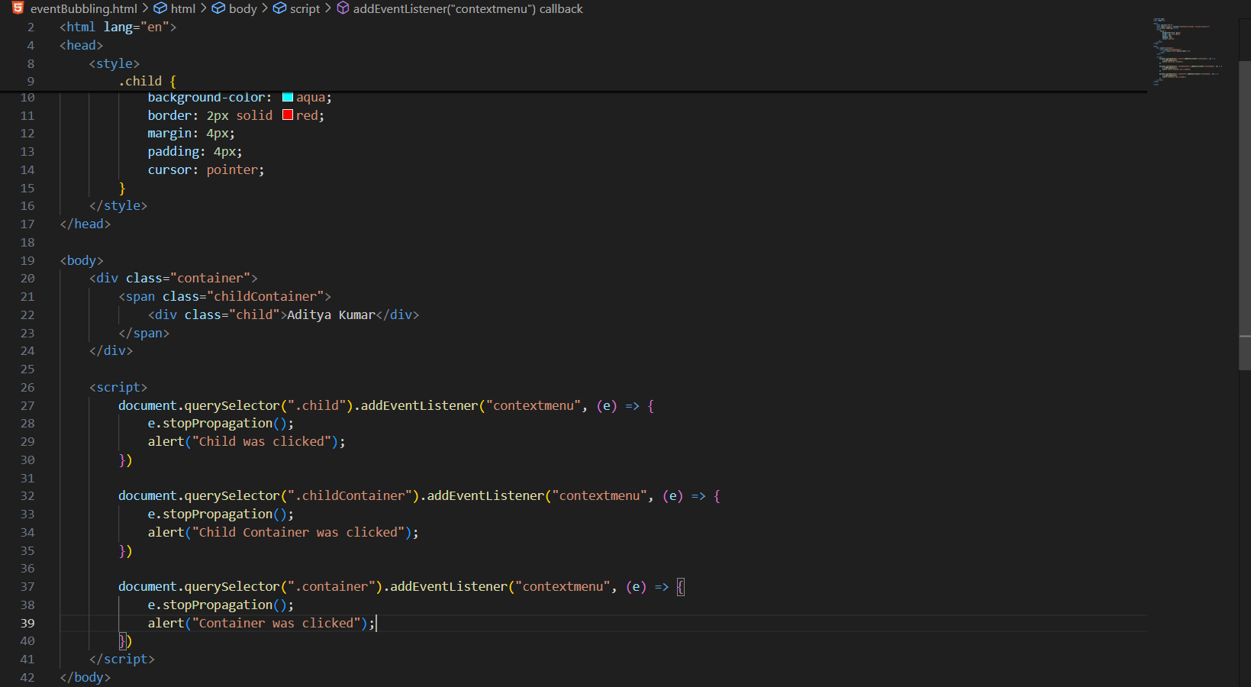

Output:

Only one alert will come when we right click on the output.

Now, we will be understanding, setinterval:

Example: changing the color of the child after every 3s:

Code:

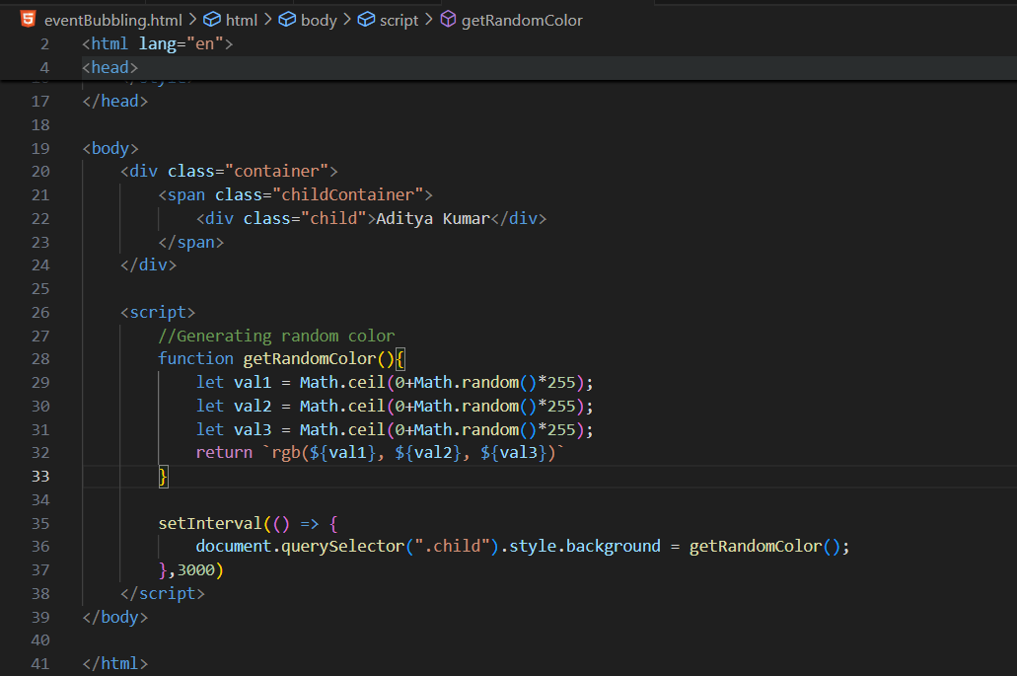

Output:

At start:



After 3 sec:



Example: changing the color of the child after first 3s:

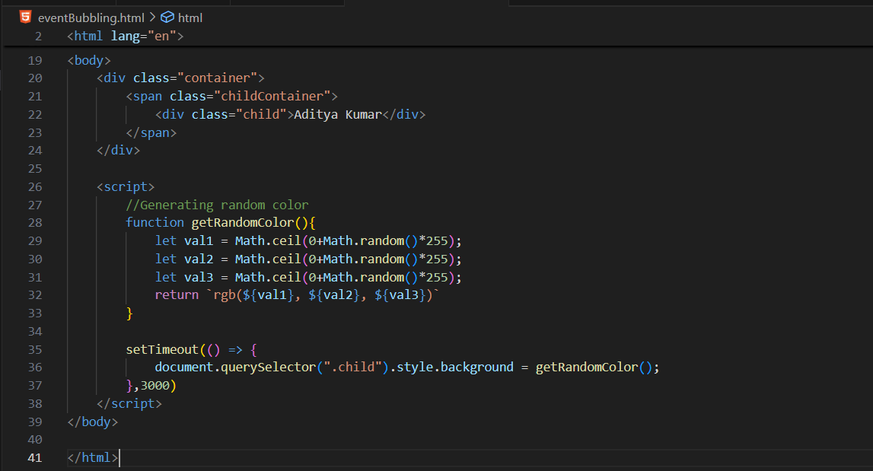

--The End--