**Day 43**





**“Web Development + Security”**

**Working with Files: fs and path Modules:**

**What is the fs Module?**

* The fs (File System) module in Node.js lets you work with files — read, write, update, delete, and manage them.
* It’s a built-in module, so no need to install anything.
* Works only in Node.js, not in the browser.

**Types of File Operations:**

fs supports both:

* Synchronous (blocking) – code waits until the file task finishes
* Asynchronous (non-blocking) – code continues running without waiting

Basic code to import and print the functions in the fs module:

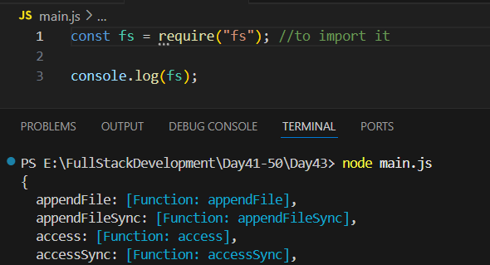

Now, in order that we shall create a file (say .txt) then write in it we will use the “.writeFileSync”.

Example:

Main.js:

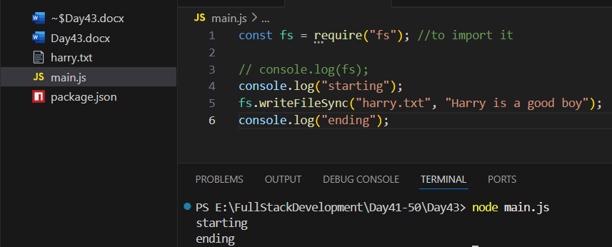

Since, JS is the asynchronous language, we want that it should work synchronously then we will do like this: we used “.writeFile”

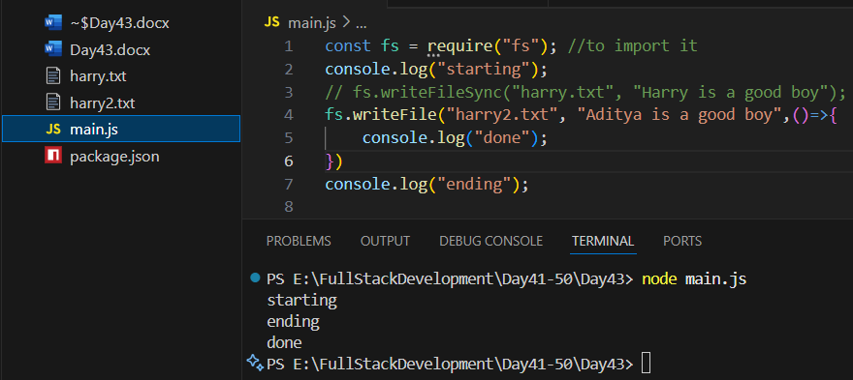

Now, suppose we want to read the file as well after writing: then we will use .readFile:

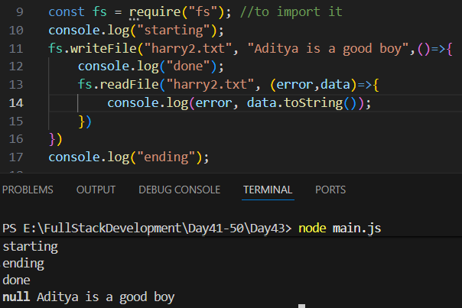

Now, using append: “.appendFile”

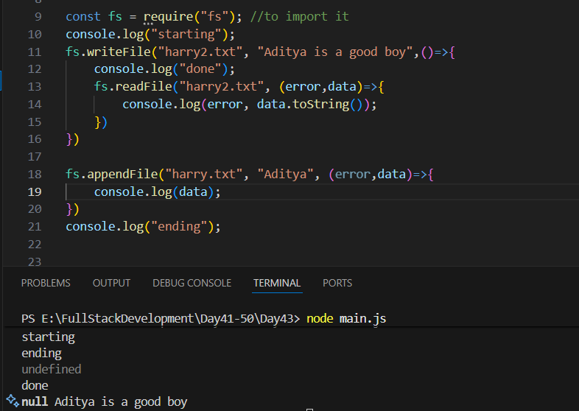

Now, using the promises in the fs modules: we are reading the file

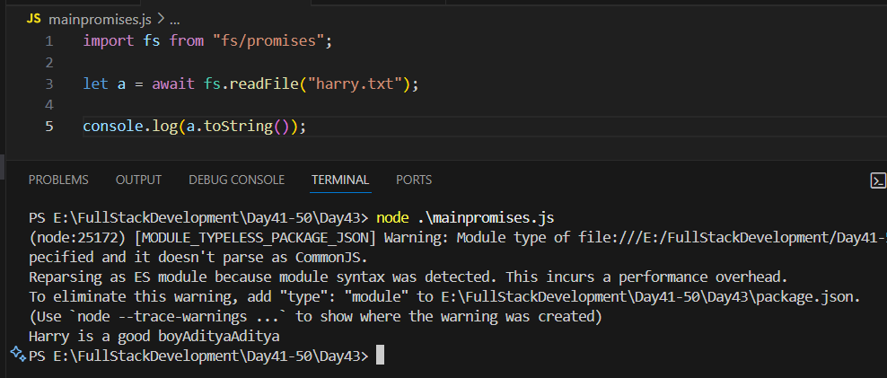

Now, in case we want to write in the file:

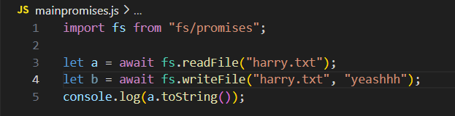

Now, in case we want to append in the file:

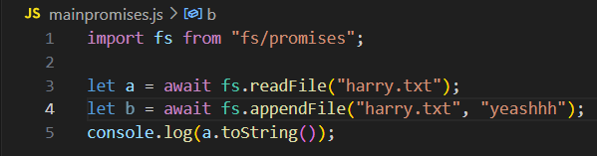

| **Operation** | **Method** | **Description** |
| --- | --- | --- |
| Read File | fs.readFile() | Read file content |
| Write File | fs.writeFile() | Create or replace a file |
| Append Data | fs.appendFile() | Add data to end of file |
| Delete File | fs.unlink() | Delete a file |
| Rename File | fs.rename() | Change file name |
| Check Existence | fs.existsSync() | Check if file exists |

**What is the path Module in Node.js?**

* The path module helps you work with file and directory paths easily and safely.
* It is a core (built-in) module — you don’t need to install it.
* It works on all operating systems (Windows, macOS, Linux) — automatically adjusts path separators (\ or /).

Example: importing path module

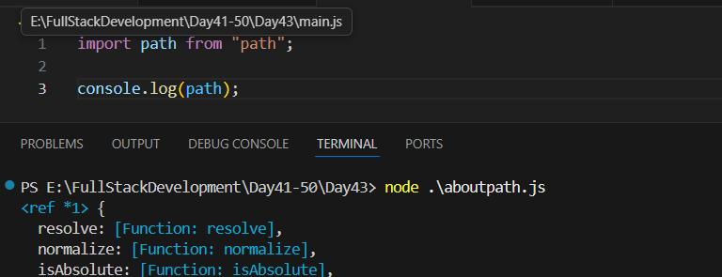

--The End--