**Day 47**

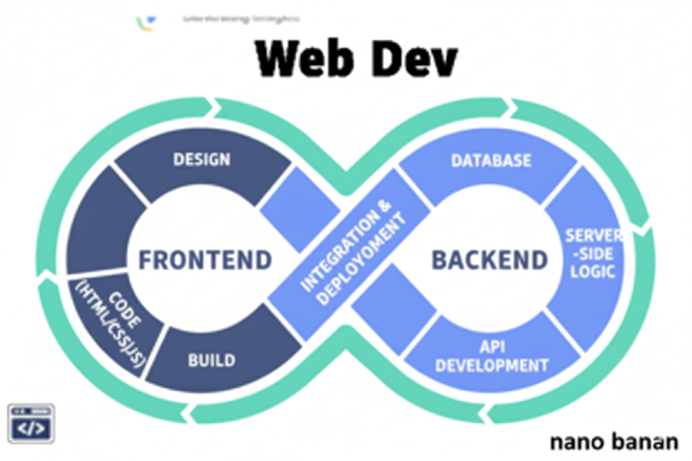

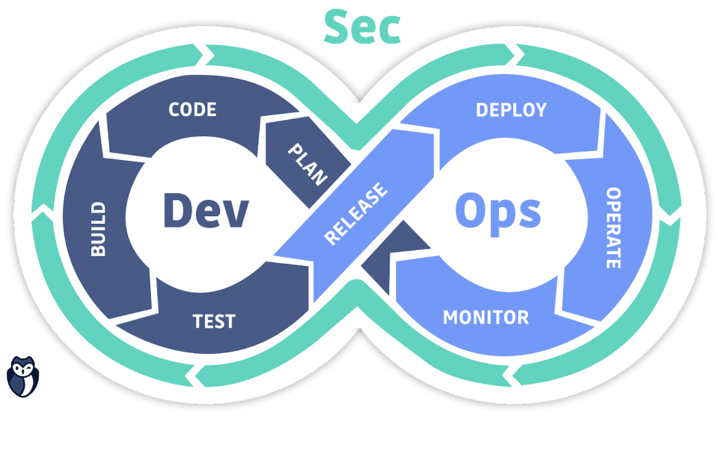

**“Web Development + Security”**

**Installing MongoDB & MongoDB Compass:**

**What is MongoDB?**

MongoDB is a NoSQL database (Not Only SQL). Instead of storing data in rows and tables like traditional databases, it stores it in collections made of JSON-like documents.

**Why MongoDB?**

* Schema-less → You can store flexible data structures.
* JSON-friendly → Works perfectly with JavaScript & Node.js.
* Scalable & fast → Handles big data efficiently.
* Integrated with Express easily via libraries like Mongoose.

**Basic MongoDB Terminology**

| **SQL Term** | **MongoDB Equivalent** | **Example** |
| --- | --- | --- |
| Database | Database | myDatabase |
| Table | Collection | users |
| Row | Document | { name: "Aditya", age: 21 } |
| Column | Field | name, age |
| Primary Key | _id (auto-generated) | _id: ObjectId("...") |

First, we will install MongoDB:

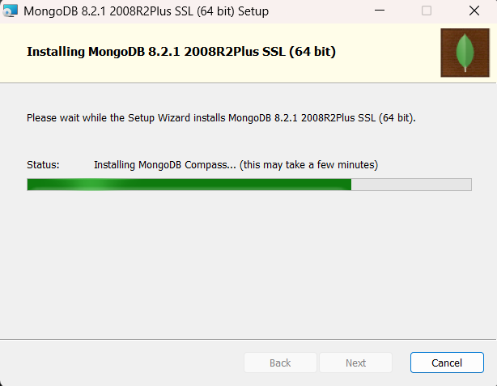

Once it gets installed, following screen will appear:

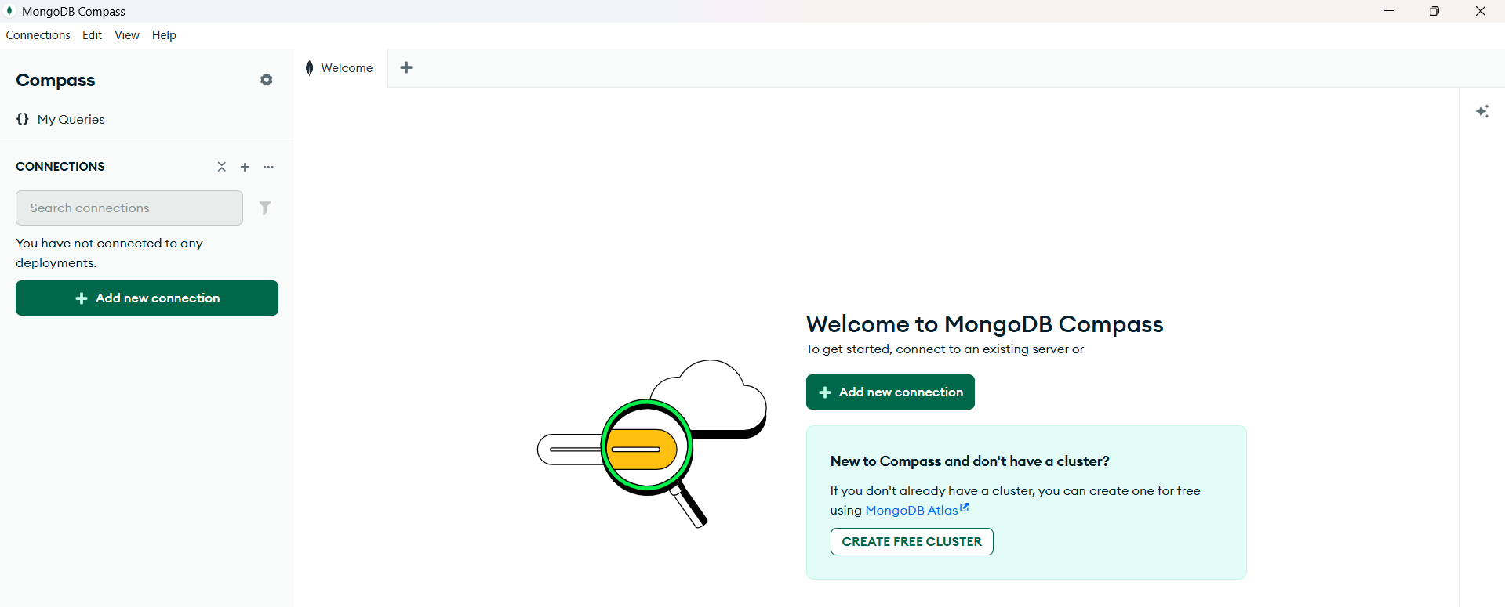

To connect it with the database instance we had installed in the laptop, we will use the MongoDB compass, for which we will use the “add new connection”, following screen will appear:

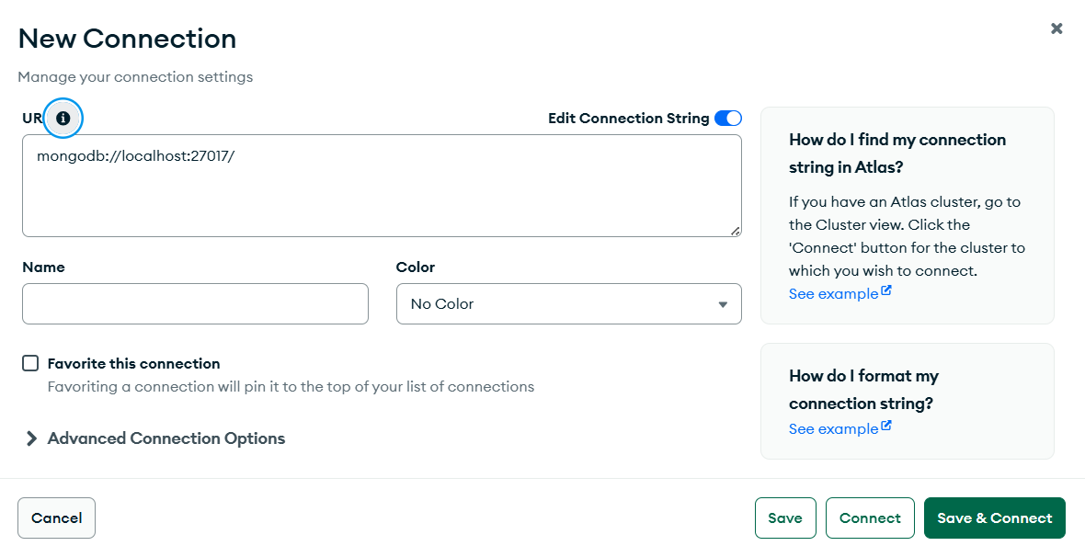

When we click on “Save and connect” following screen will appear: we are basically connected to the instance of the MongoDB present in the laptop.

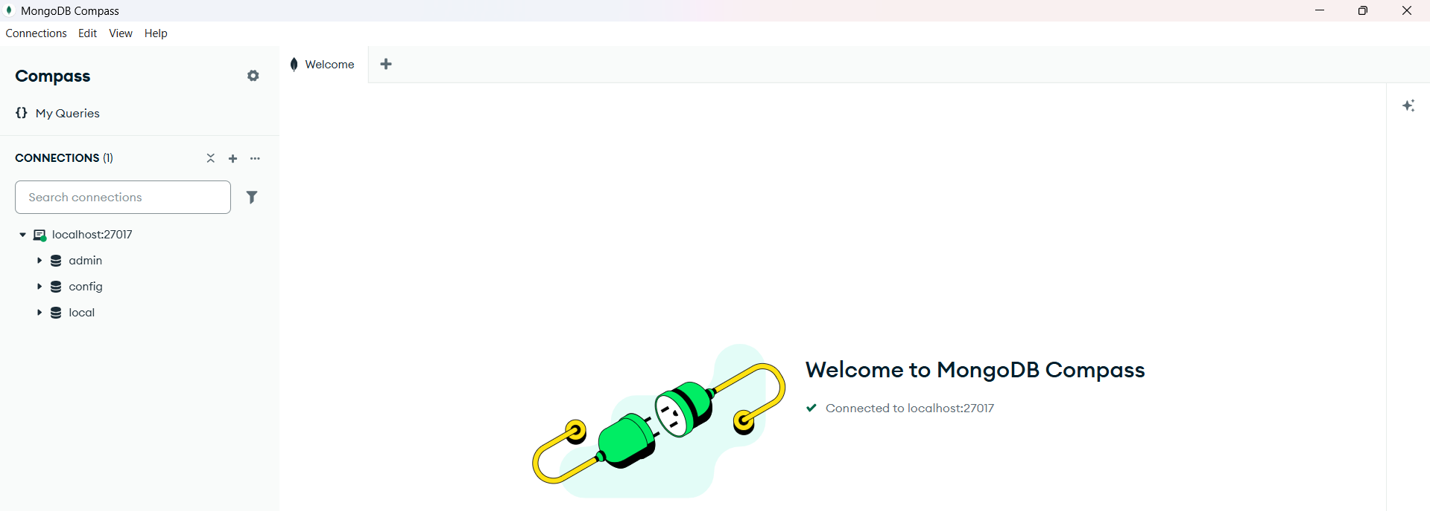

Click on “Create Database” to make a new database:

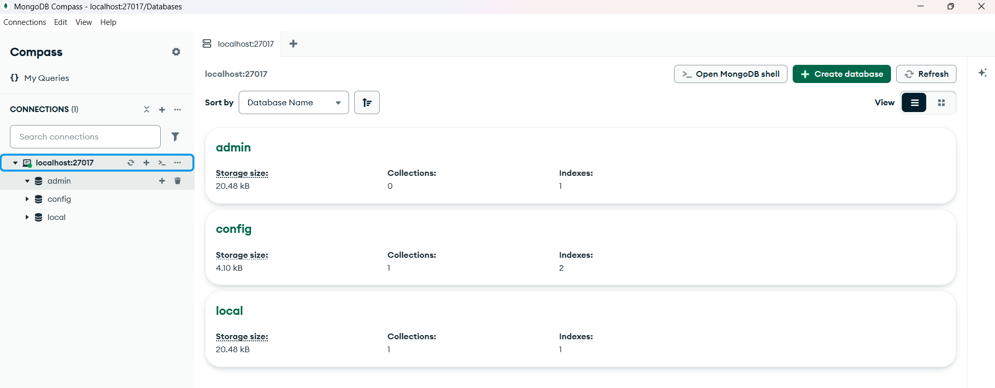

Following data need to be entered:

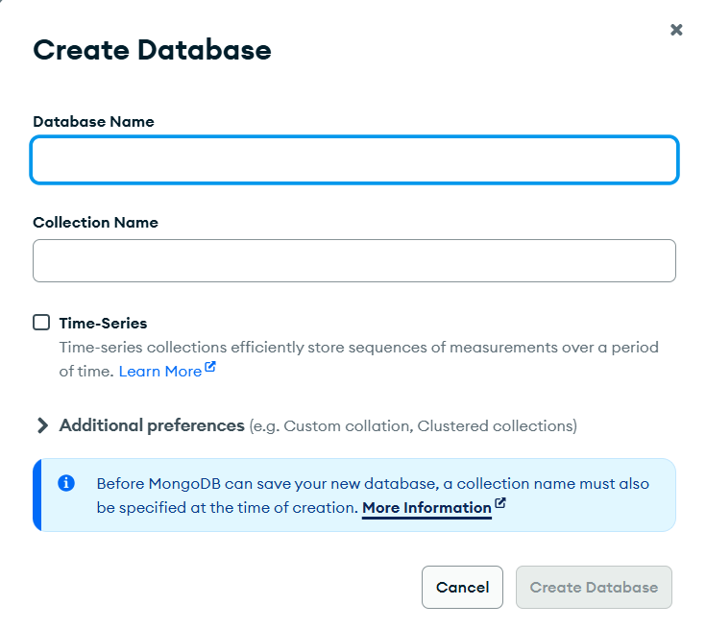

Following screen will appear:

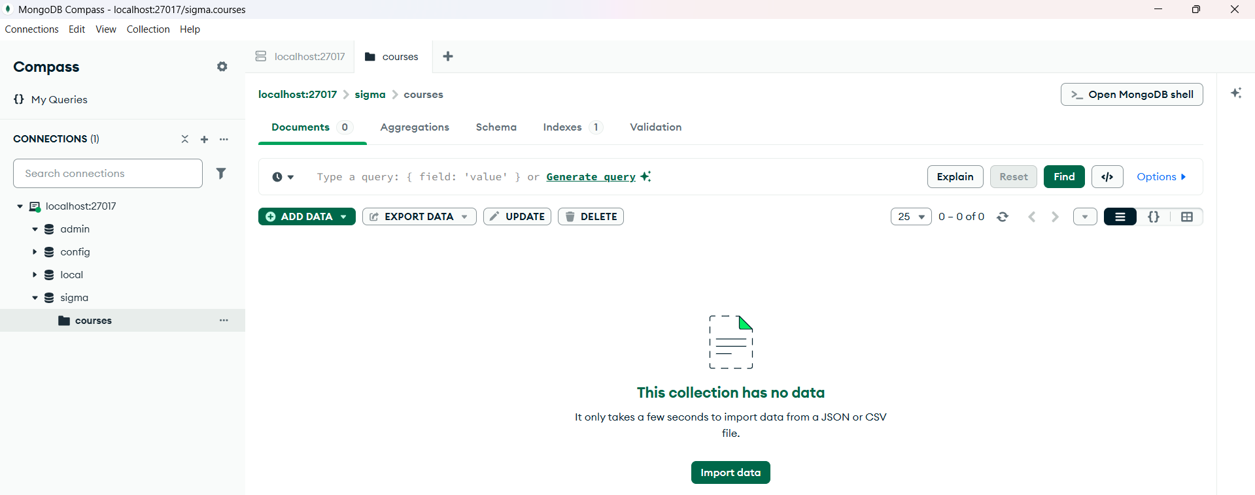

Now, we are adding the data to the collection:

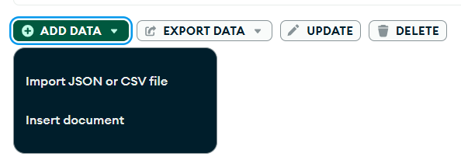

When clicked on “insert document”: following pop up will appear

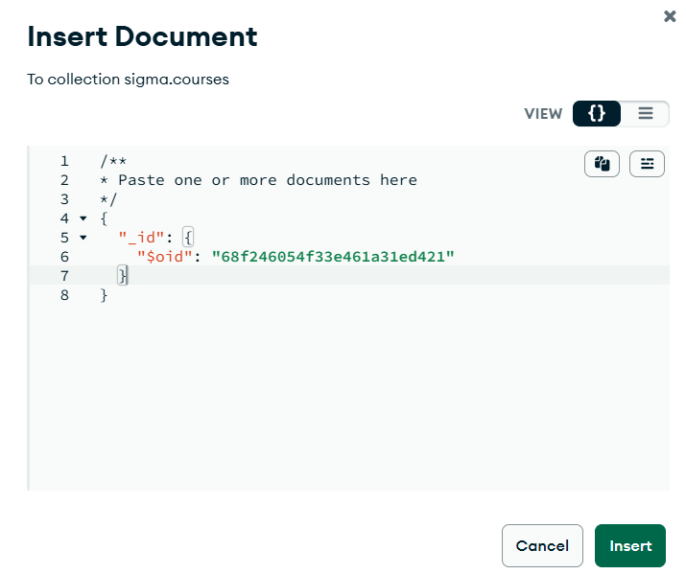

Write the following data:

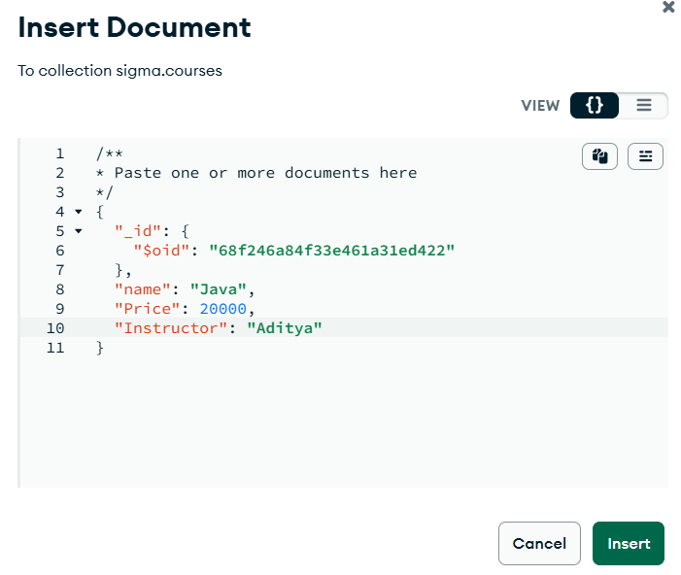

Following confirmation will come: this data is actually persisted.

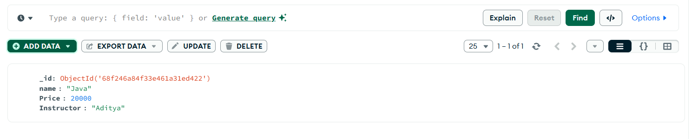

Now, we will look at the MongoDB shell:

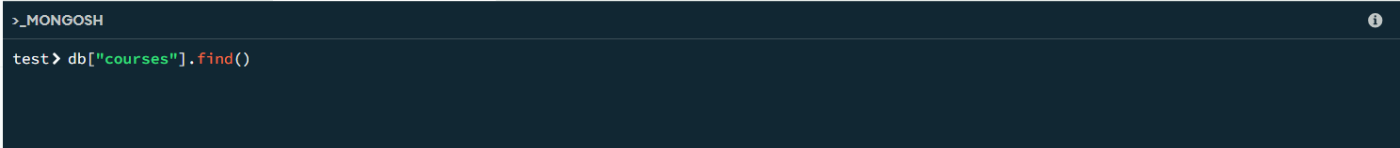

To see the name of databases: we uses “show databases”

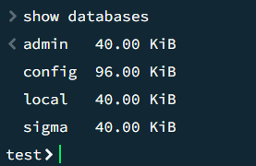

Now, we want to use the sigma database, then we write: use sigma

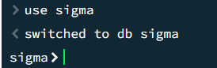

Now, to see the documents of the courses: we will use db.courses.find()

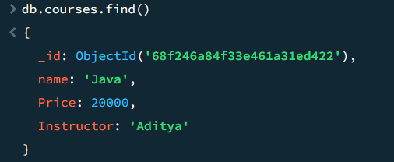

Now, we will add some data via command shell: use db.course.insertOne

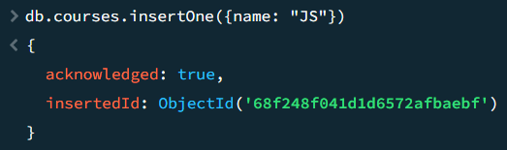

We can cross verify from the MongoDB: clearly, what we added via shell reflects here.

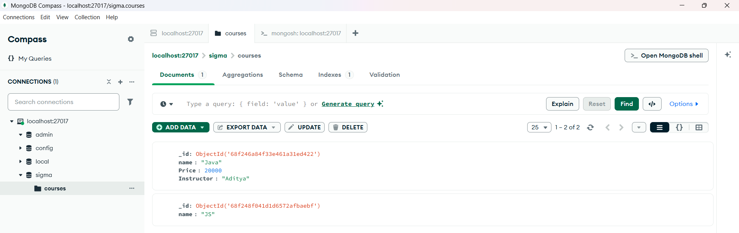

Also, we can install MongoDB on the VS code too:

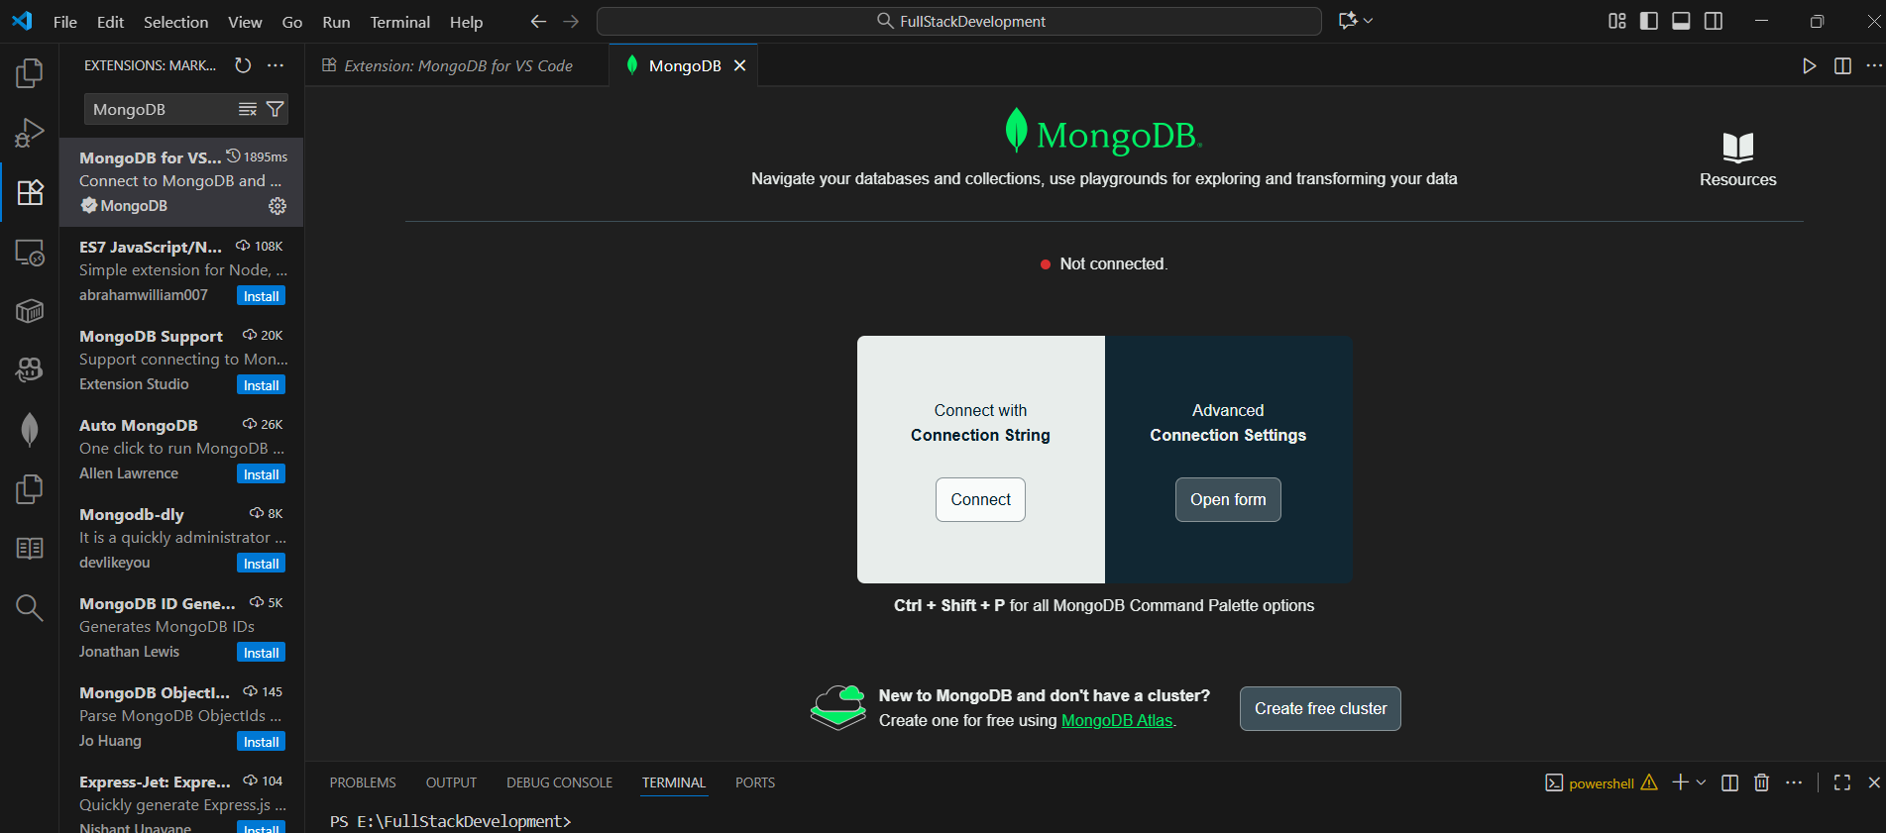

To connect: click on “advanced connection settings”

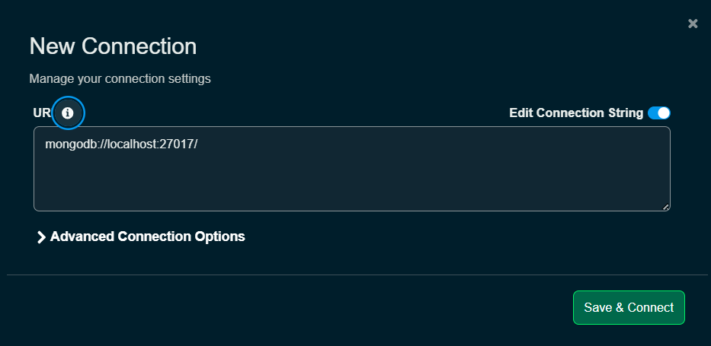

Clearly, it is connected now, we can see the same DB as we had seen in MongoDB:

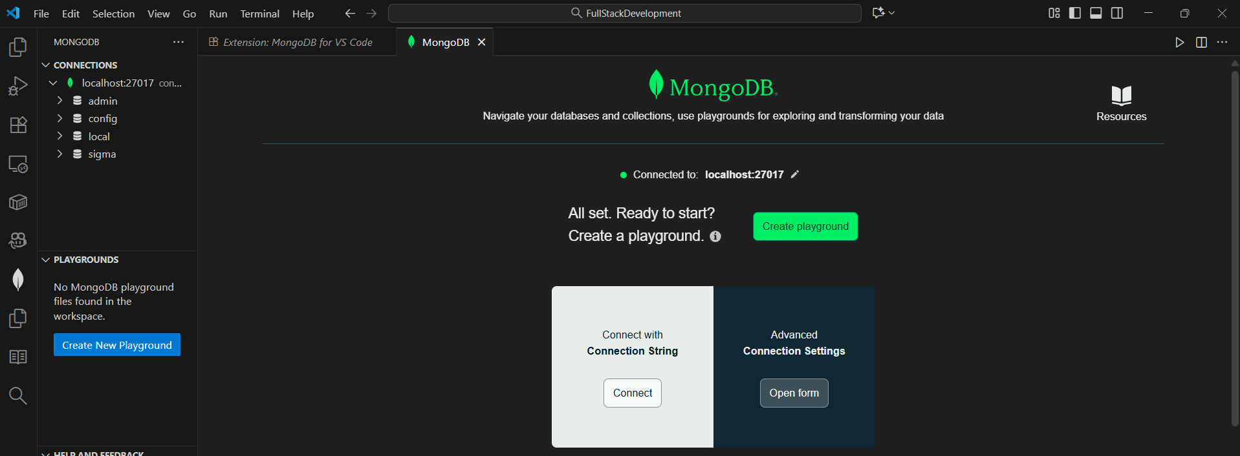

--The End--