**Day 49**

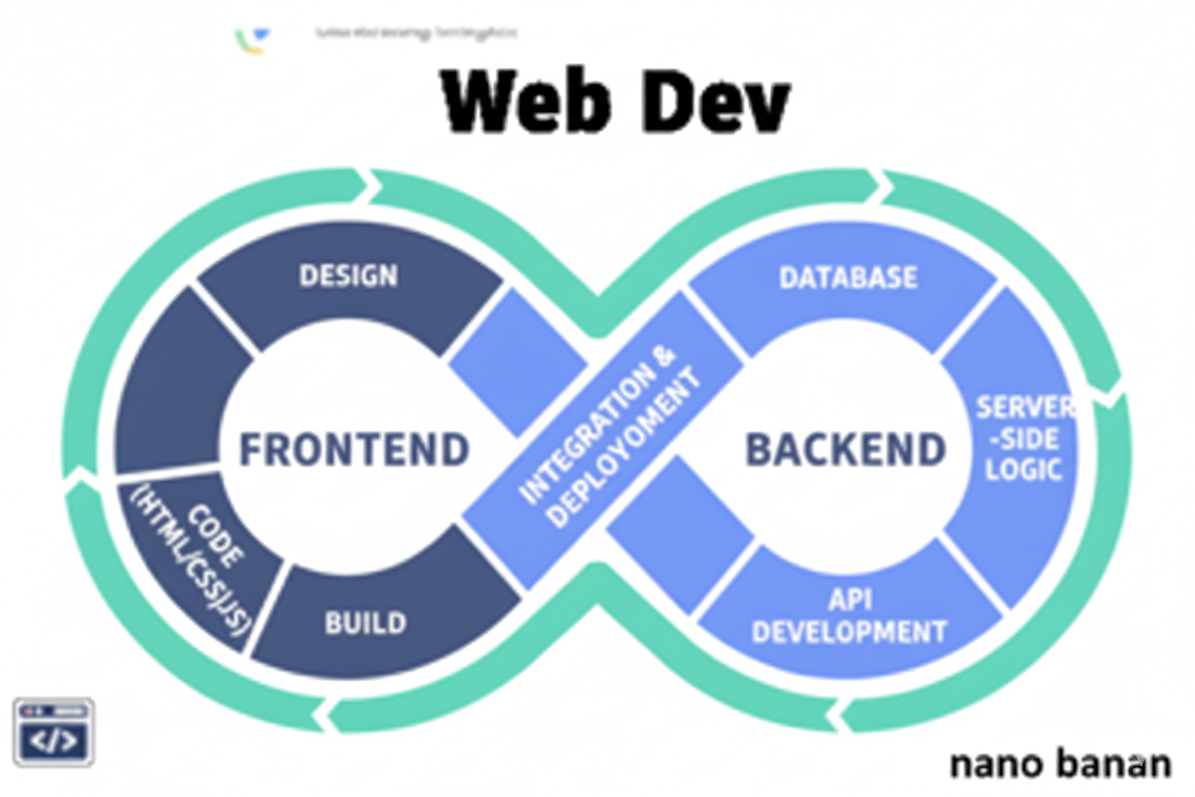

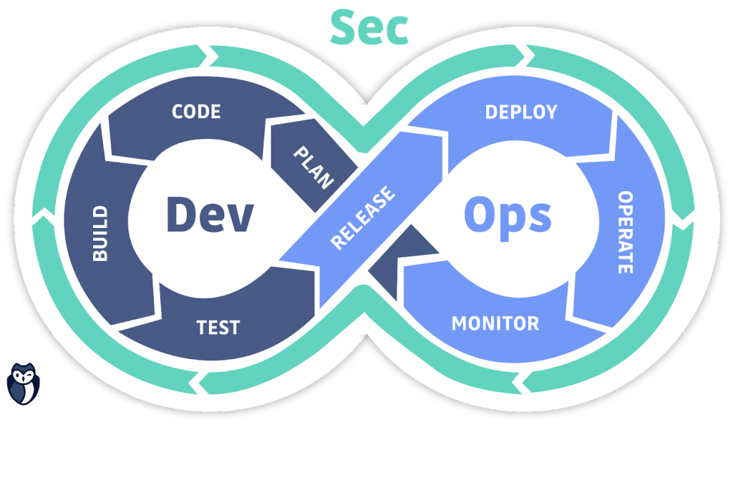

**“Web Development + Security”**

**CRUD operations in MongoDB:**

CRUD operations (Create, Read, Update, Delete).

First connect the MongoDb to the VScode:

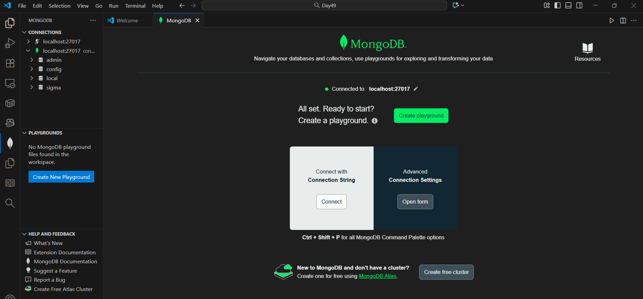

Now, we are creating our own playground: file name be crud.mongodb.js



Now, suppose we want to use the Db named “CrudDb” (it may not exists), then we will use the following code: clearly, it switched to CrudDb Db.

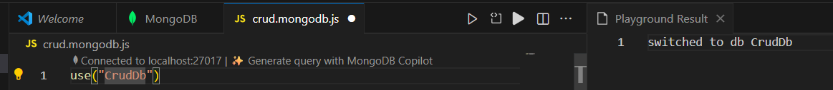

Now, to see which Db we are using, we can use console.log(db), as shown below: clearly it says CrudDb is used.

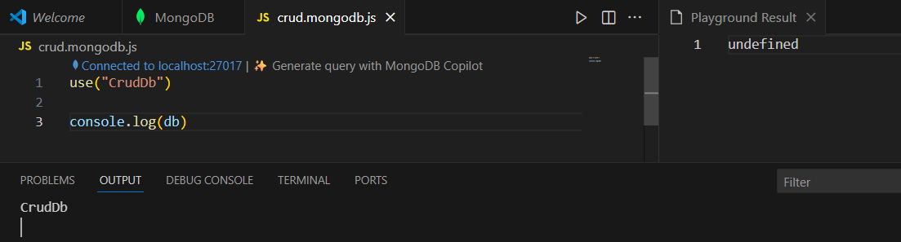

Now, in order to create a new collection in the CrudDb, we will use createCollection, as shown below: clearly it worked as expected.

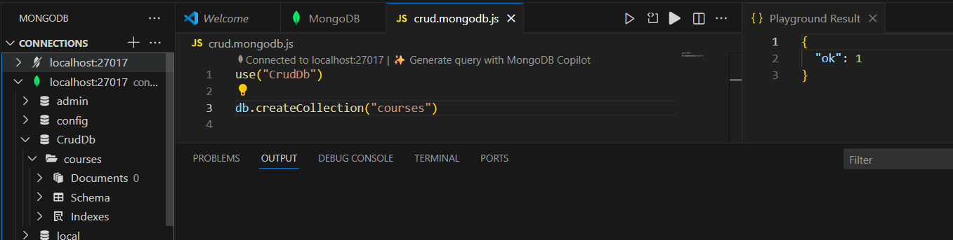

Now, in order to insert a document in the collection we will use the .insertOne, as shown below:

Code:

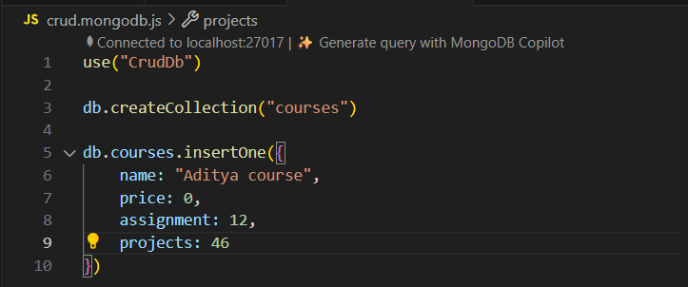

Playground result:

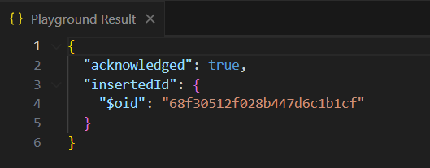

DB json:

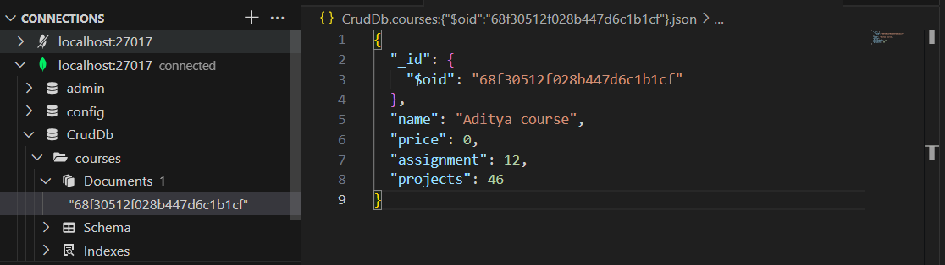

Now, similarly, insert the next document: make sure to comment out earlier one otherwise it will get repeated.

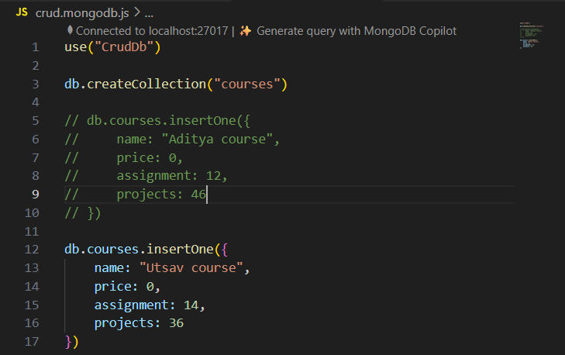

Now, suppose we want to find those courses where the price is 0, then we will use .find() as shown below:

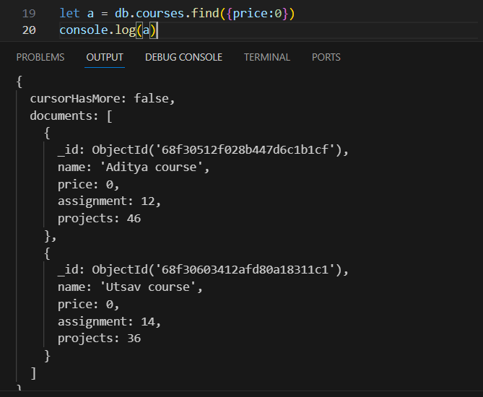

Now, suppose we want to count the number of results returned by above “a”, since it is a cursor, we can count using .count(), as shown below: so basically in the Db we have 2 documents whose price is 0.

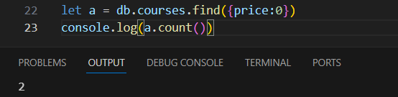

Now, in order to get all the Documents in the form of array we will use: .toArray()

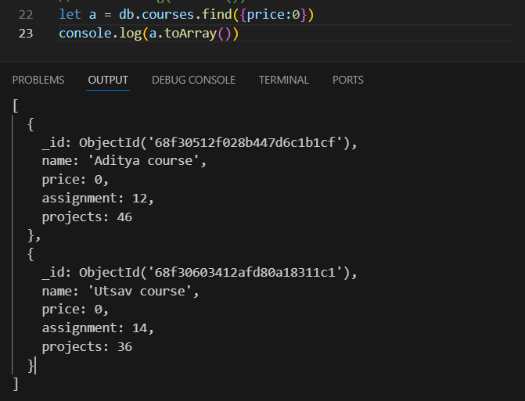

Now, in case we want to get the first result whose price is 0, we will use .findOne() as shown below:  
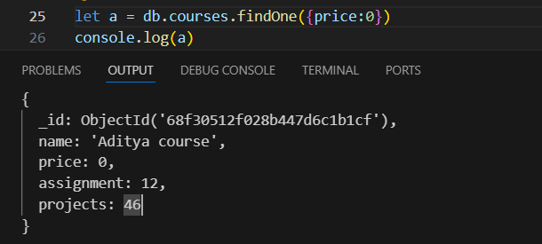

Now, in case we want to update the value we will use .updateOne, as shown below:

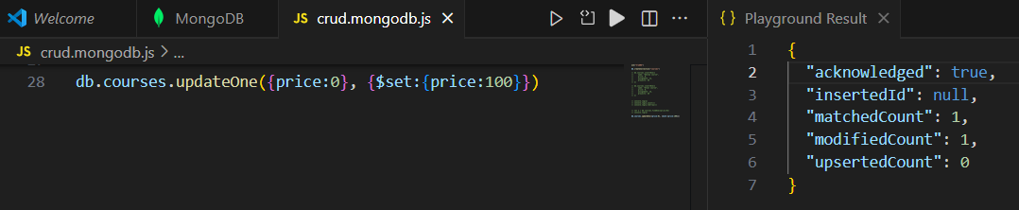

Now, in case we want to update all documents matching the condition, we will use .udpateMany() as shown below:

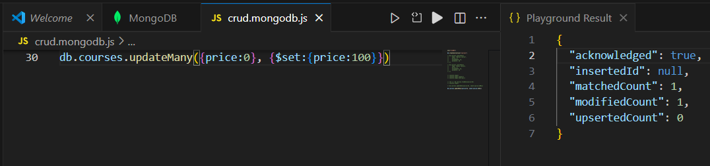

Now, in case we want to delete the documents matching a certain condition we will use .deleteOne(), as shown below:

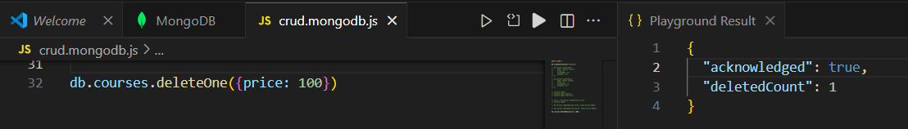

--The End--