**Day 50**

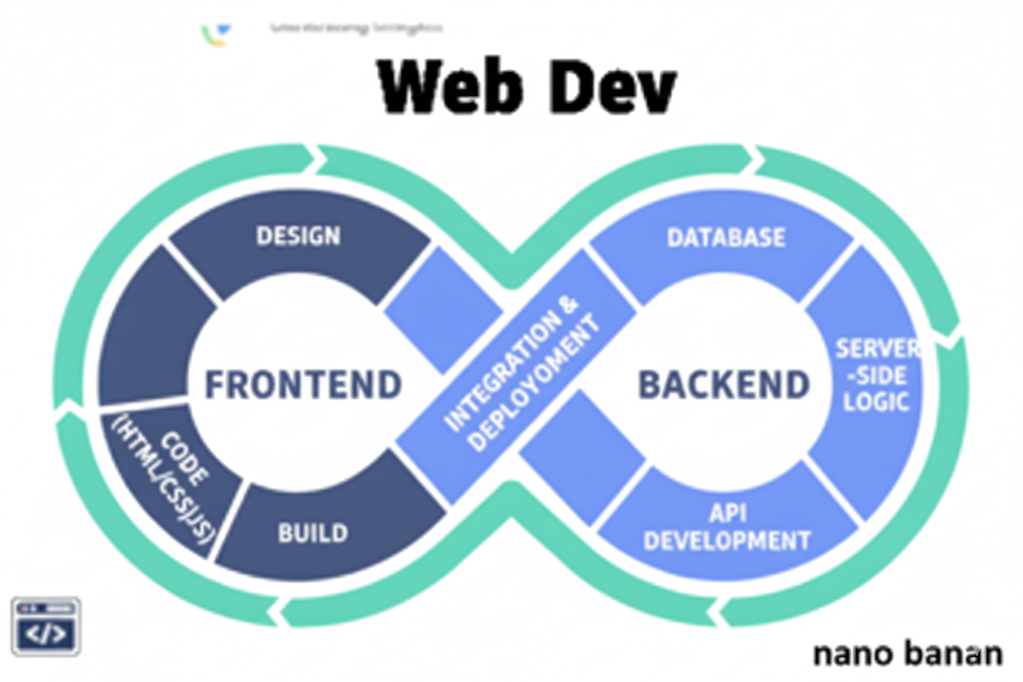

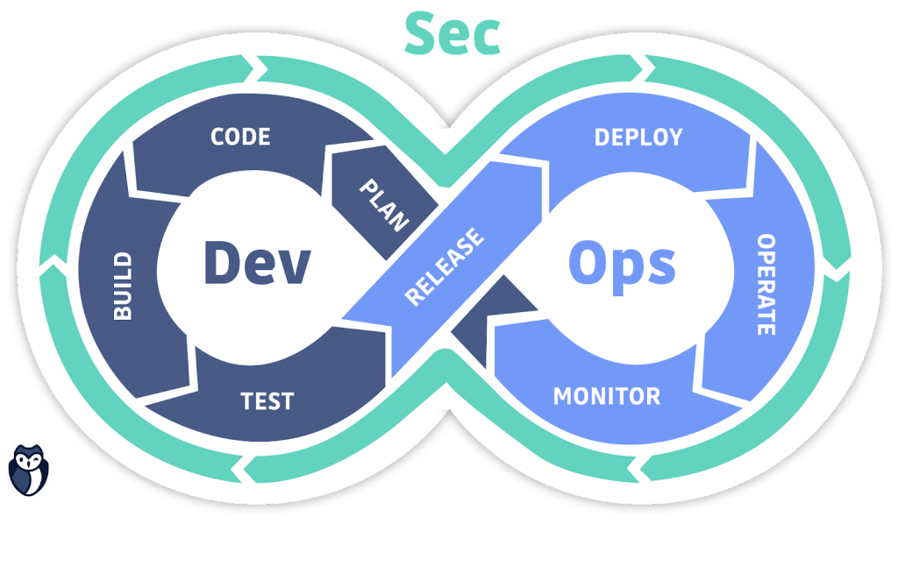

**“Web Development + Security”**

**Mongoose:**

**What is Mongoose?**

Mongoose is an ODM (Object Data Modeling) library for MongoDB and Node.js. It helps you define the structure (schema) of your data and gives you powerful tools to interact with MongoDB easily.

**Why Use Mongoose Instead of Raw MongoDB?**

| **Feature** | **Raw MongoDB** | **Mongoose** |
| --- | --- | --- |
| Schema validation | No schema | Schema-based |
| Relationships | Manual | Built-in population |
| Validation | Manual | Built-in validators |
| Middleware (hooks) | No | Yes (pre/post save, update, etc.) |
| Query helpers | Limited | Advanced chainable methods |

Now, in order to bring it to the code we will write the following code:

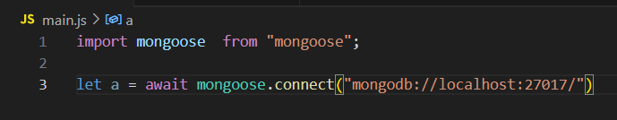

Now, importing express and connecting it with mongoose:

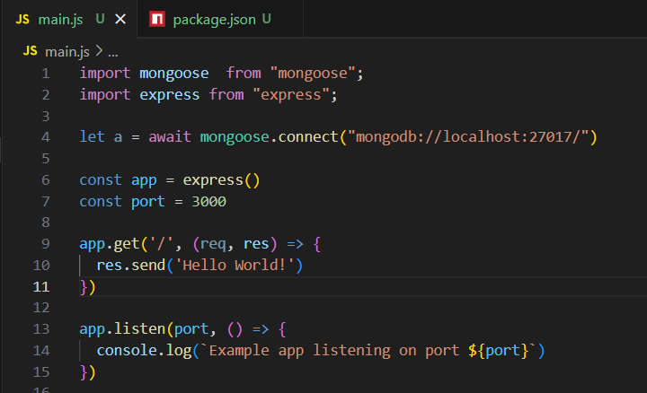

Now, creating a schema under the model folder:

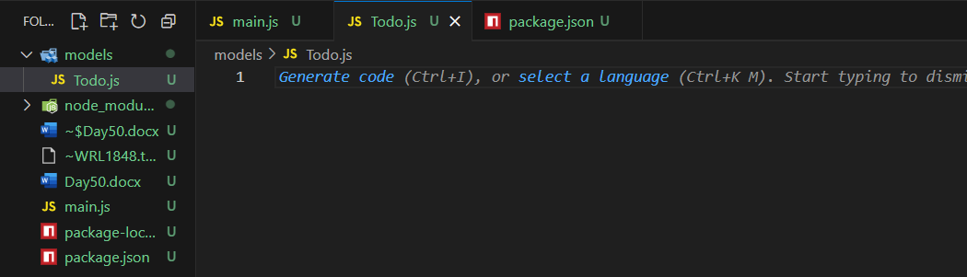

Now, we will create the schema, using the following code:

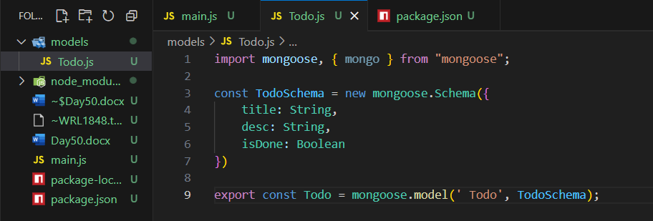

Now, we will import this to the main.js using the following code:

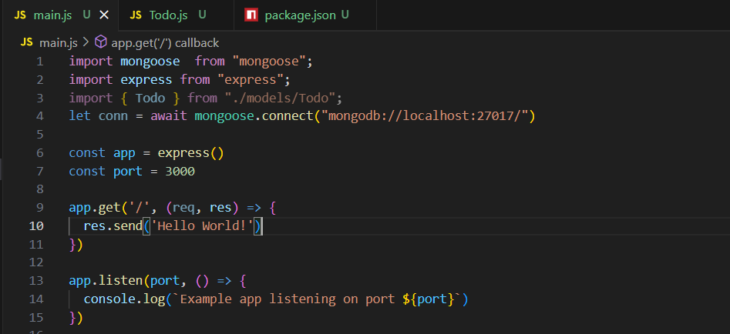

Now, import is modified and added the content: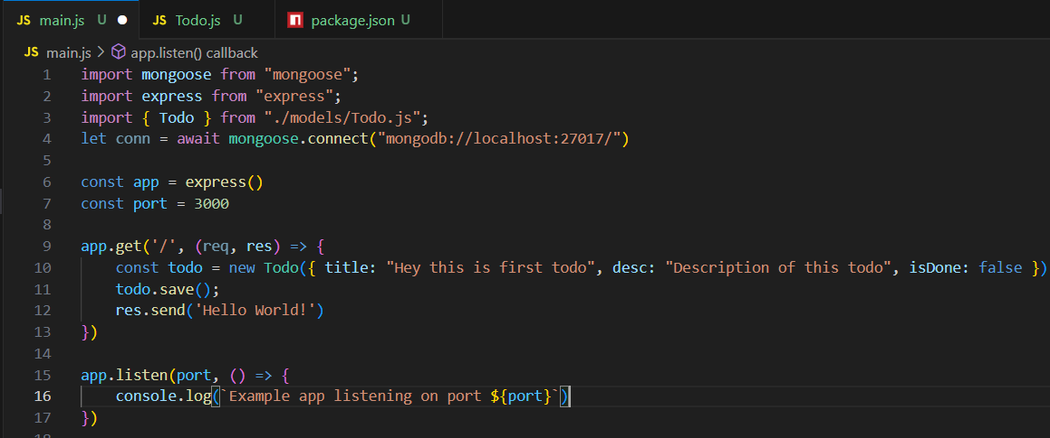

Now, start the server:

Terminal:

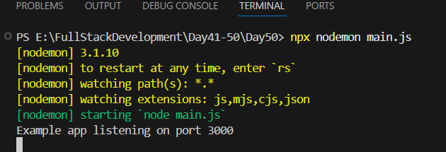

Browser:

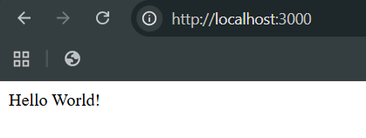

Now, check if the Db is created or not: clearly it is created and inserted the data we had wished.

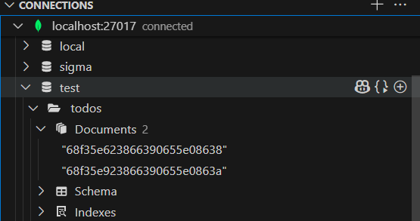

As we had refreshed the page 2 times, so it inserted that data two time.

Now, in case we changed the value to be inserted from string to the number, then it will change it from number to string and then only insert:

Main.js:  
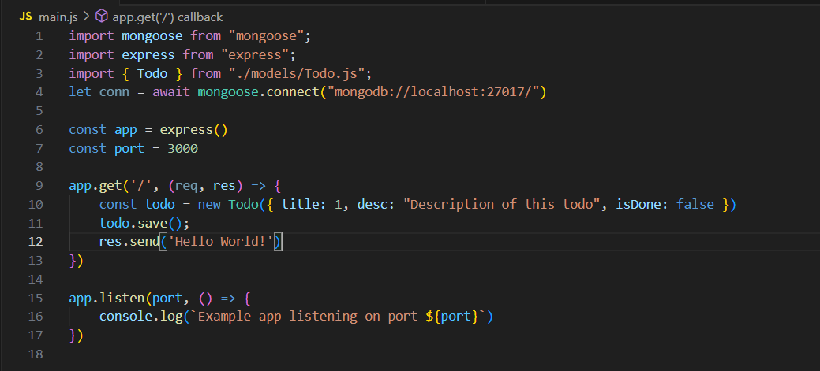

Browser:

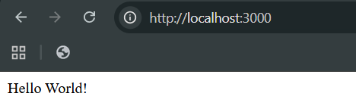

DB: clearly it inserted but converted that to string.

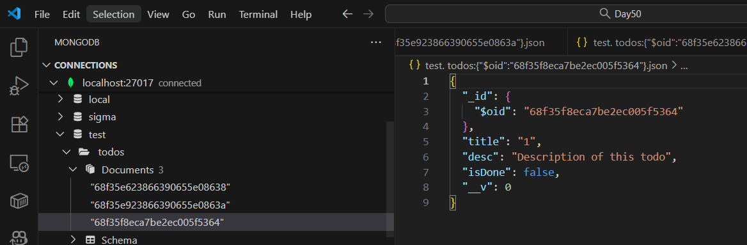

--The End--