**Day 51**

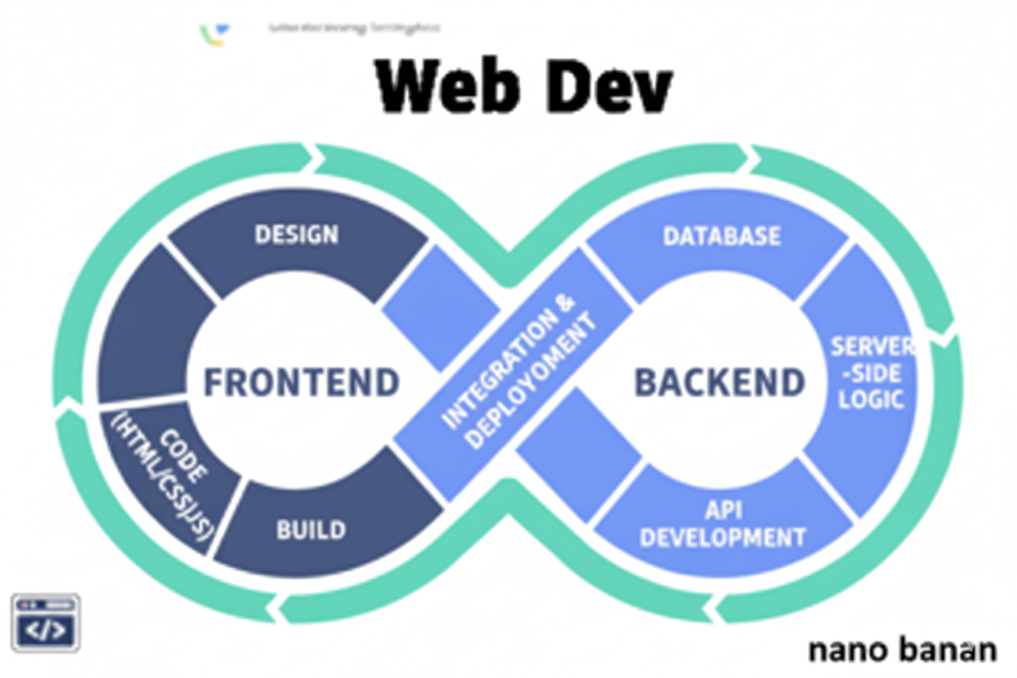

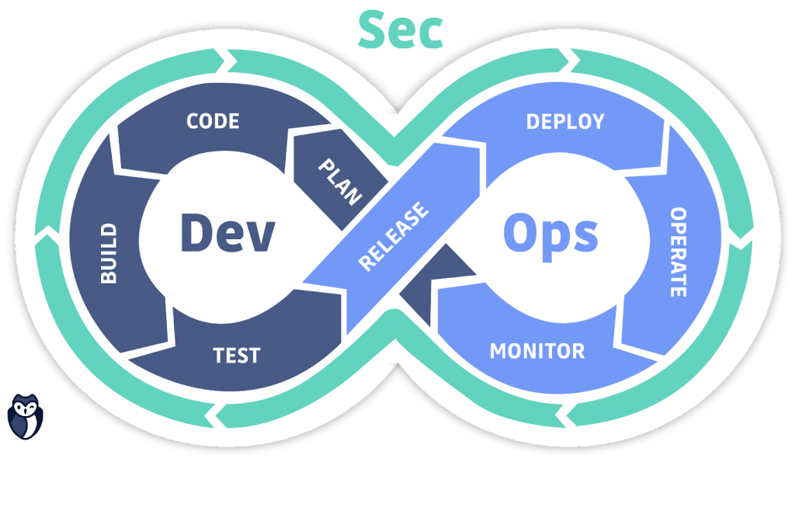

**“Web Development + Security”**

**Tailwind CSS:**

**What is Tailwind CSS?**

Tailwind CSS is a utility-first CSS framework that lets you build modern, responsive UIs directly in your HTML using pre-defined utility classes.

**Why Use Tailwind CSS?**

| **Feature** | **Traditional CSS** | **Tailwind CSS** |
| --- | --- | --- |
| Writing style | Separate .css files | Inline utility classes |
| Speed | Slower | Much faster |
| Customization | Manual | Highly configurable |
| Responsive design | Manual media queries | Built-in responsive classes |
| Framework support | Any | Works with React, Vue, Next.js, etc. |

For now, let’s use tailwind using CDN:  
Code:

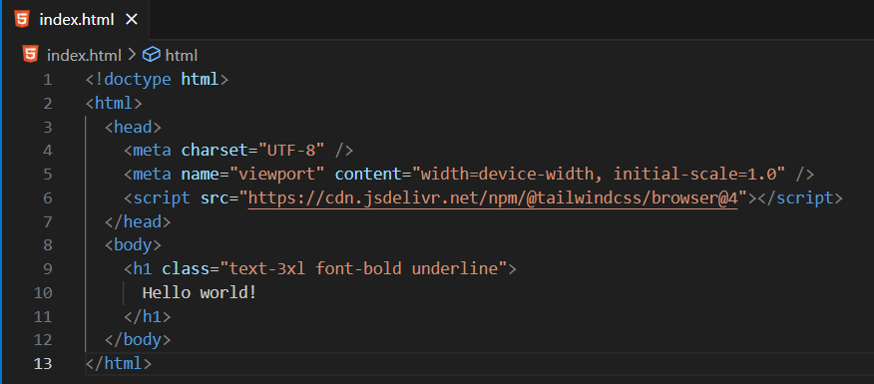

Output:

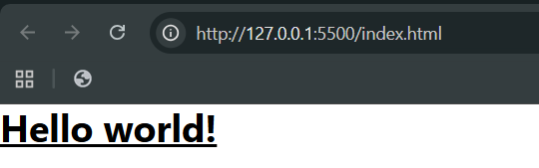

Now, using Tailwind from terminal using npm/npx: -D indicates dev dependency  
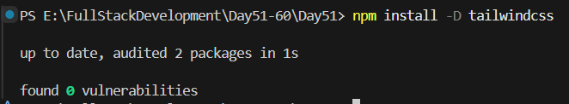

Now, index.html:

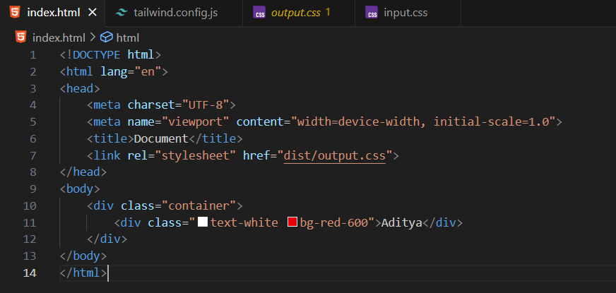

Tailwind.config.js:  
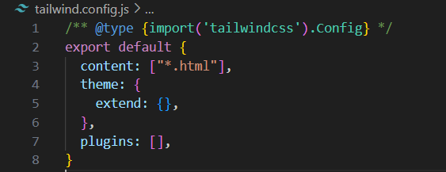

Src/input.css:

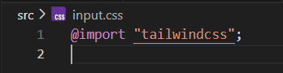

Terminal:

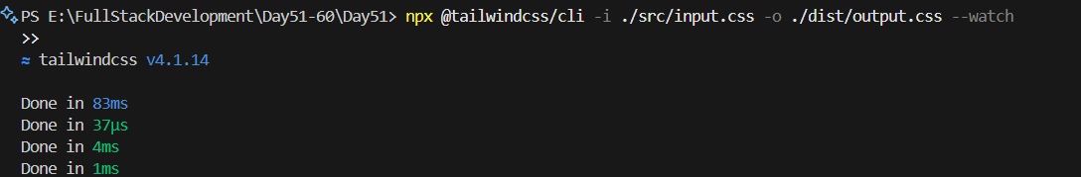

Output:

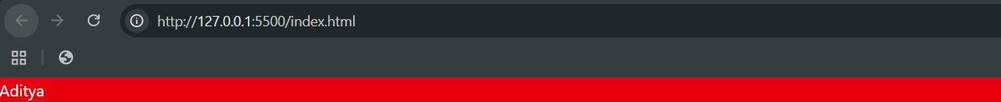

**What Are Breakpoints?**

Breakpoints are specific screen widths at which your website layout changes to fit the device — like phone, tablet, or laptop. In Tailwind, you use breakpoints to make your design responsive — meaning it looks good on all devices.

**Default Breakpoints in Tailwind**

| **Prefix** | **Screen Size** | **Device Type Example** |
| --- | --- | --- |
| sm | ≥ 640px | Small devices (large phones) |
| md | ≥ 768px | Tablets |
| lg | ≥ 1024px | Laptops |
| xl | ≥ 1280px | Desktops |
| 2xl | ≥ 1536px | Large screens |

These breakpoints use the “min-width” approach, meaning the style applies from that width and up.