**Day 52**

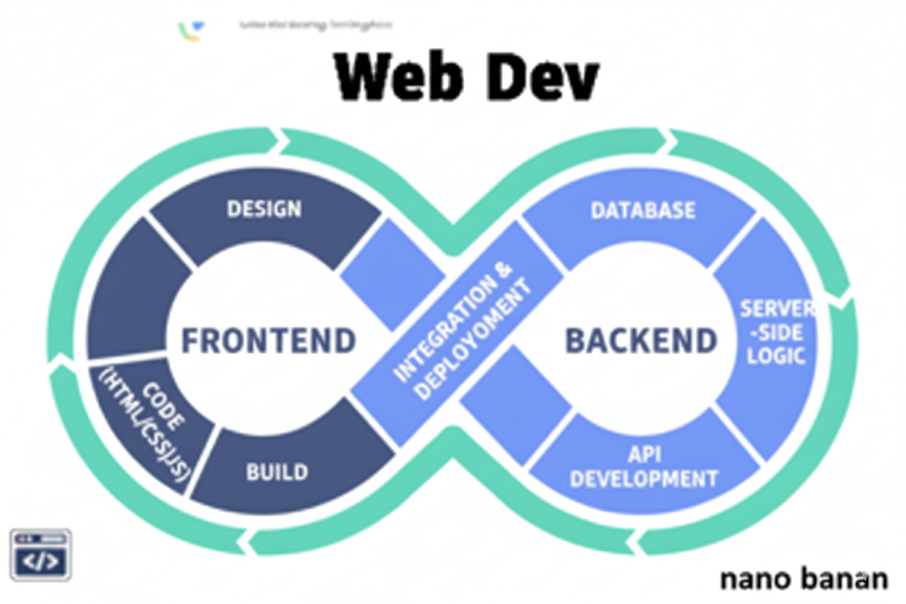

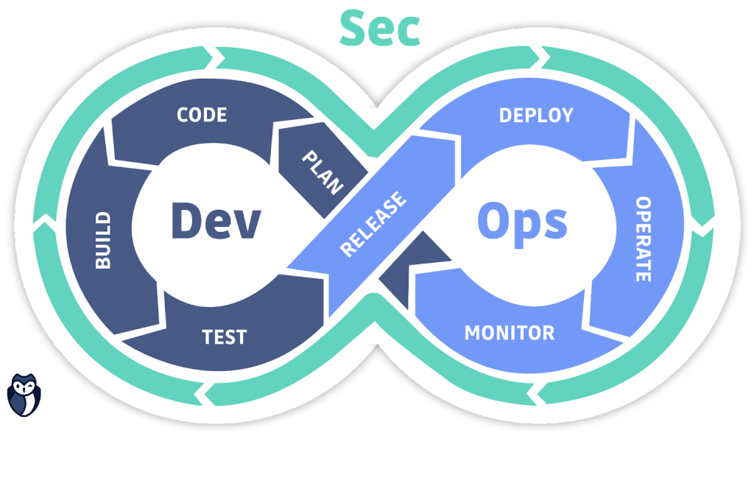

**“Web Development + Security”**

**What is Hosting? Where to Host? Which Hosting?:**

**What Is Hosting?**

Hosting means putting your website or web application on a server so that people can access it on the internet using a web address (like www.example.com).

It’s like renting a space on the internet to store your website’s files (HTML, CSS, JS, images, database, etc.) and make them available 24/7.

**How Hosting Works (Simple Flow)**

1. You build a website (HTML, CSS, JS, etc.).
2. You upload your files to a web server (via a hosting provider).
3. That server has a public IP address.
4. Your domain name (like myportfolio.com) points to that IP.
5. When someone types your domain in a browser → browser connects to the server → your site loads!

**Types of Hosting**

| **Type** | **Description** | **Example Use** |
| --- | --- | --- |
| **Shared Hosting** | Many websites share the same server. | Small sites or portfolios. |
| **VPS (Virtual Private Server)** | Shared hardware, but isolated environment. | Medium-sized projects. |
| **Dedicated Hosting** | One server for one client. | High-traffic sites. |
| **Cloud Hosting** | Uses cloud resources (AWS, Google Cloud, etc.). | Scalable web apps. |
| **Static Hosting** | For static files (HTML, CSS, JS). | Frontend projects or portfolios. |
| **Managed Hosting** | Hosting + server management done for you. | WordPress or app hosting. |

**Popular Hosting Services**

| **Type** | **Example Providers** |
| --- | --- |
| Static Hosting | GitHub Pages, Netlify, Vercel |
| Cloud Hosting | AWS, Google Cloud, Azure |
| Web Hosting | Hostinger, GoDaddy, Bluehost |
| Backend Hosting | Render, Railway, Heroku, Cyclic |

--The End--