**Day 53**

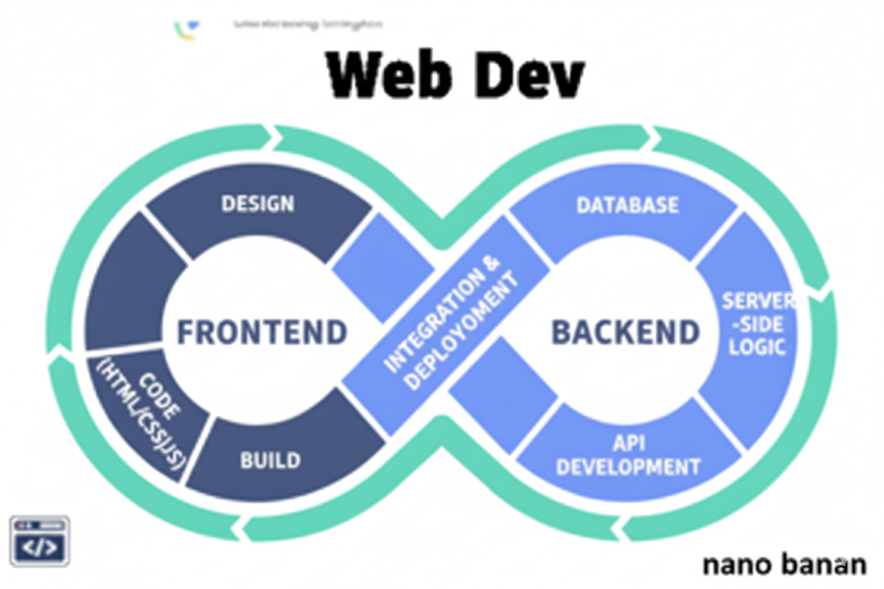

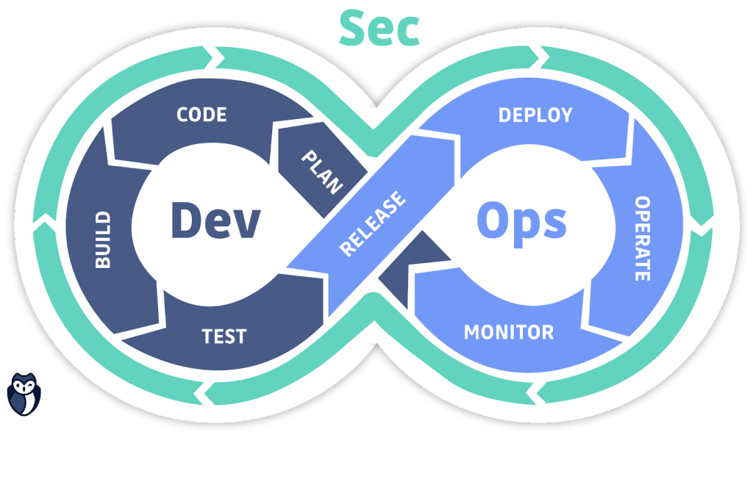

**“Web Development + Security”**

**Introduction to React:**

**What Is React?**

React is a JavaScript library (not a full framework) used to build interactive user interfaces (UIs) — especially single-page applications (SPAs).

It was developed by Facebook (Meta) and is now open source.

**React makes your web app:**

* Faster (by using a Virtual DOM)
* Reusable (components)
* Dynamic (state-based UI updates)
* Easier to maintain (modular code)

**Why Use React?**

| **Feature** | **Description** |
| --- | --- |
| Component-Based | Build UI in small, reusable pieces. |
| Virtual DOM | Efficiently updates only the parts that change. |
| Reactive UI | Automatically updates the view when data changes. |
| SPA Ready | Create single-page apps with smooth navigation. |
| Ecosystem | Works with tools like Redux, Tailwind, Router, etc. |

**Core Concepts in React**

| **Concept** | **Description** | **Example** |
| --- | --- | --- |
| **Component** | Reusable block of UI | function Navbar() { return <nav>...</nav>; } |
| **Props** | Data passed *to* components | <Card title="Hello" /> |
| **State** | Data managed *inside* a component | const [count, setCount] = useState(0) |
| **Event Handling** | Handle user actions | onClick={() => setCount(count + 1)} |
| **JSX** | JavaScript + HTML syntax | <h1>{name}</h1> |

Let’s start from the basics, let’s create three boxes using <div> and add some text inside it as its content:

Index.html:

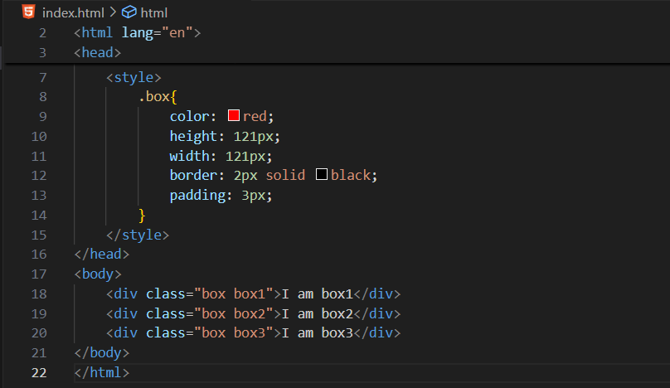

Output:

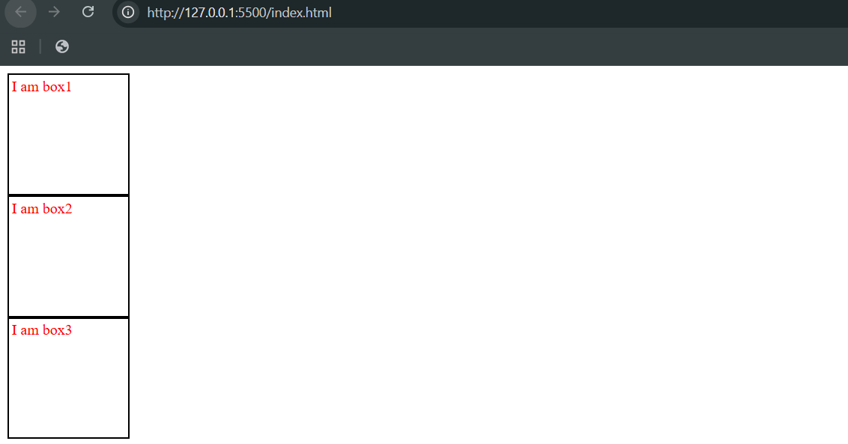

Now, suppose we want that text of these boxes should change with 1s, 2s and 3s respectively, then for that we will add <script> as shown below:

Code snippet:

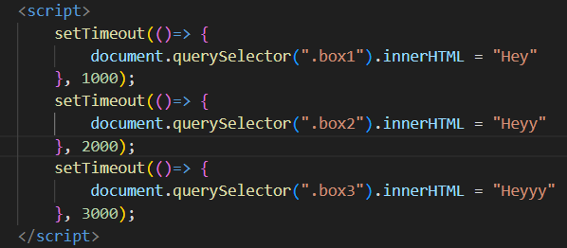

Whole code:

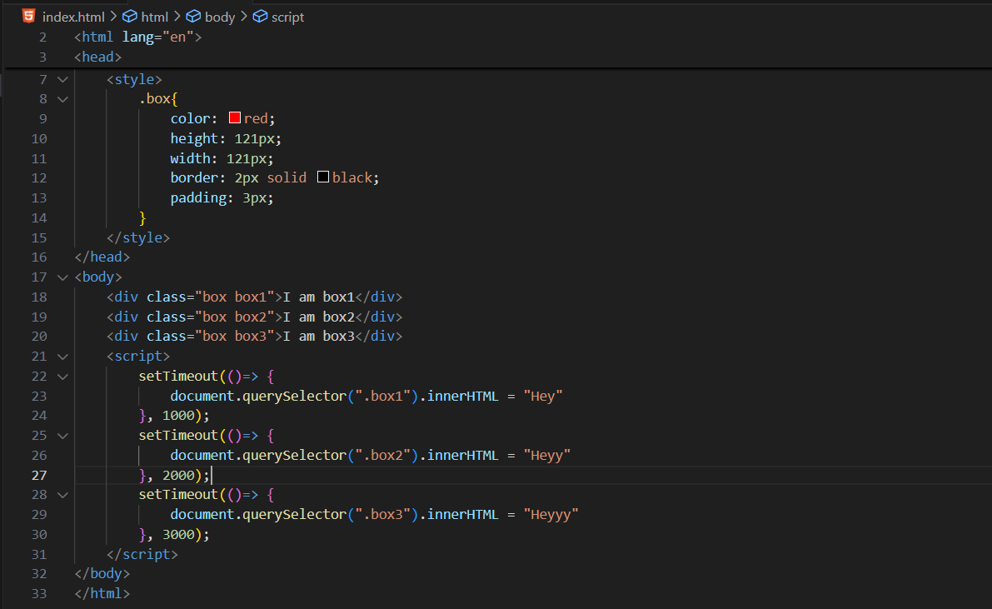

Output: at 0s

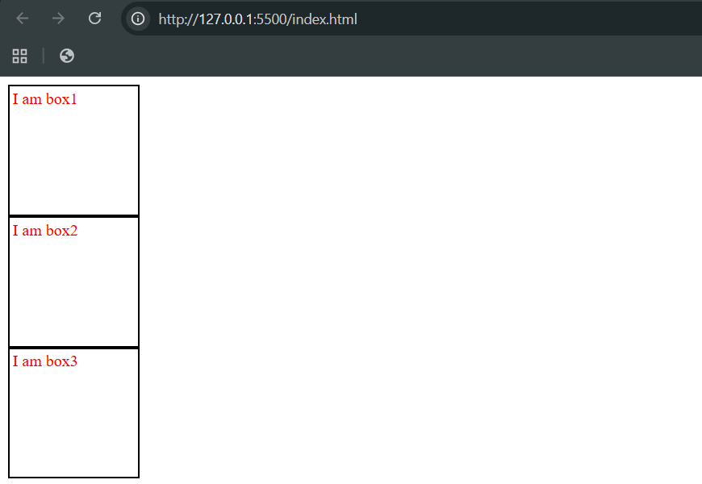

Output: after 3s, clearly one by one there, text changed after 1s, 2s and 3s respectively.

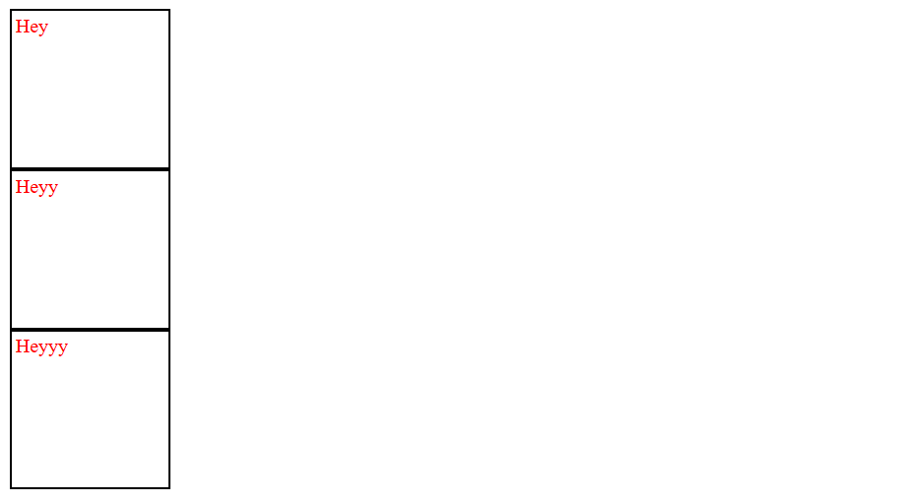

Now, let’s create a program where when we click the button the counter will change(increase), without using React:

Code:

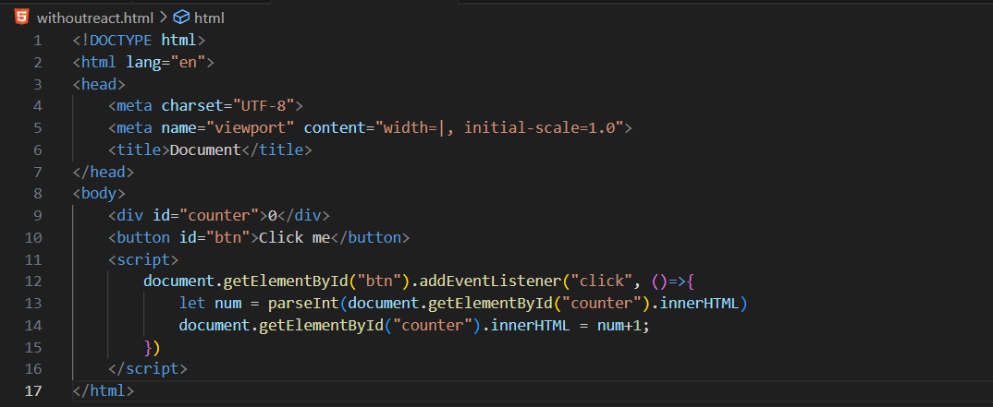

Output: at start

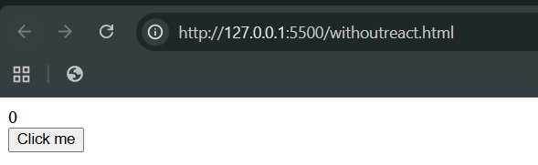

Output: after 7 click

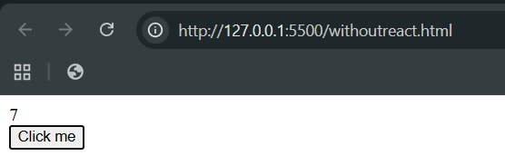

Now, we will create the same using the react:

For this we will first install the react: it will automatically create the folder

Use following code to do so:

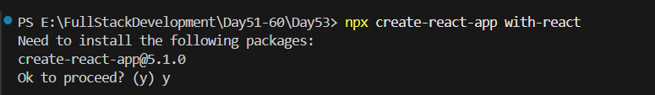

It will create the following folder:

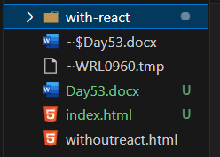

This is the content of this folder:

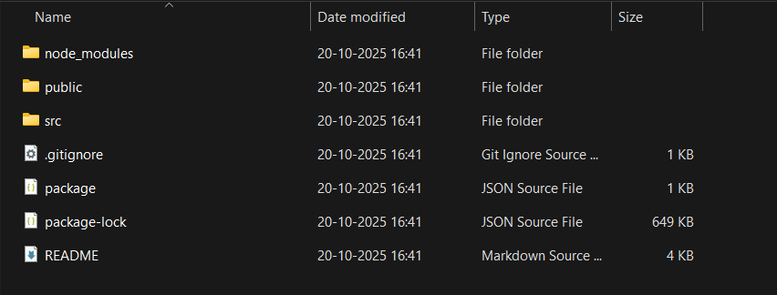

Now, switch to this new folder:

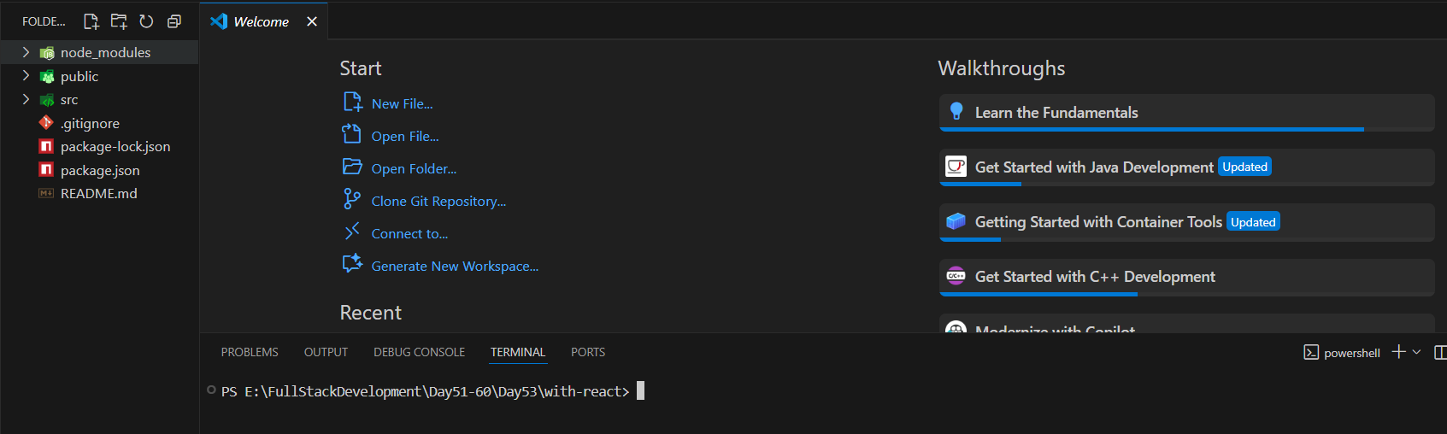

Now, we will use npm start to start the react app:

Terminal:

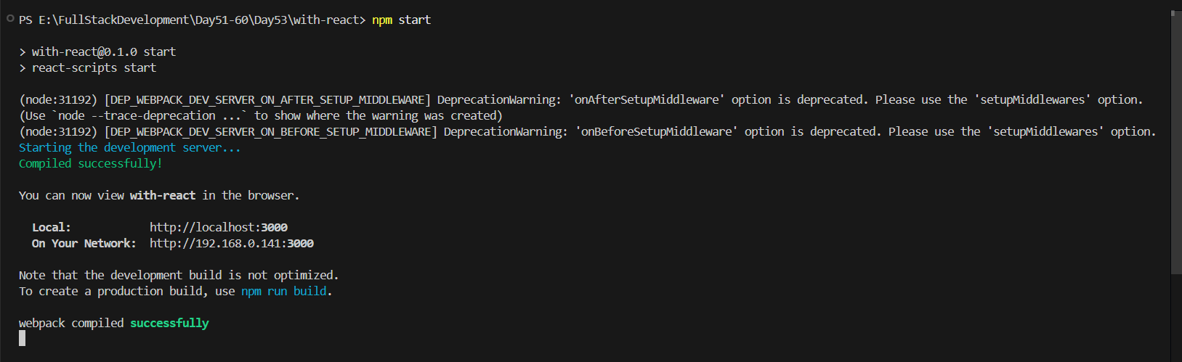

Output:

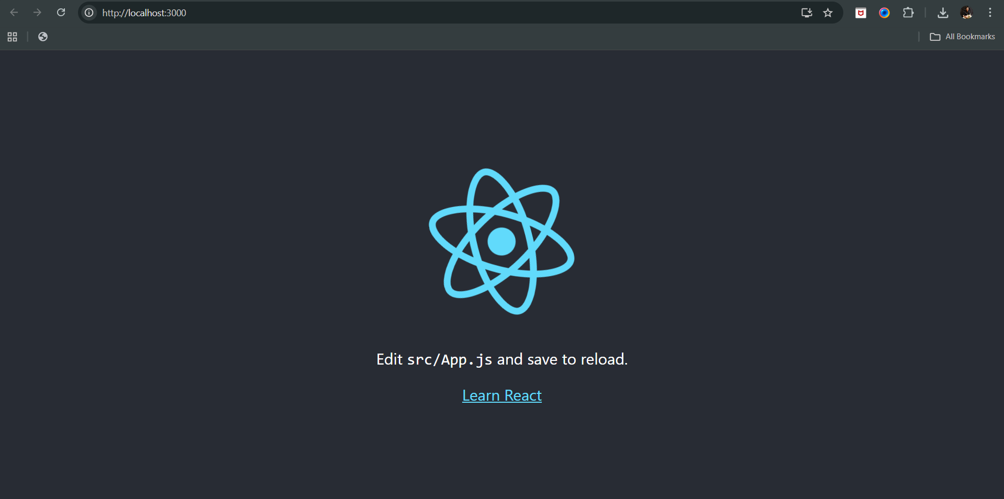

Now, in order to make a counter, we will use the App.js of the “src” folder:

Original:

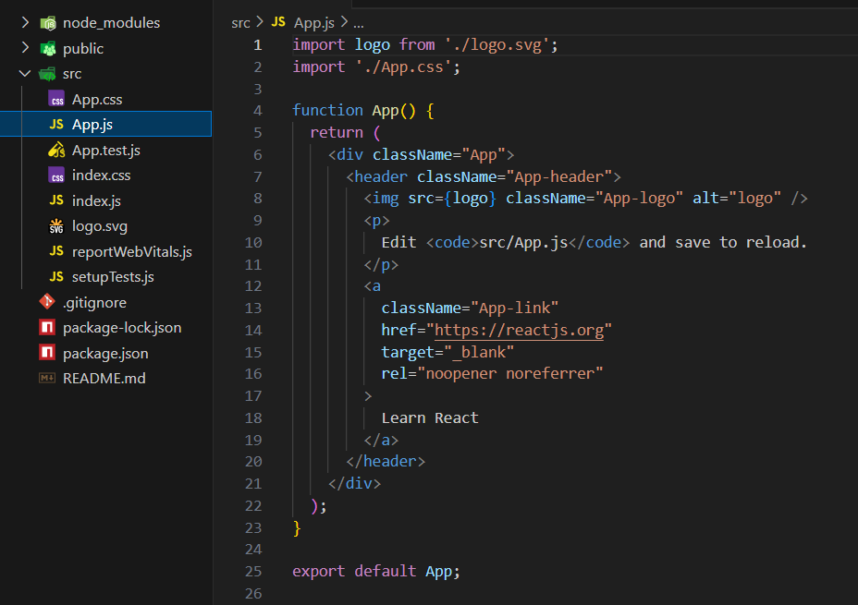

Let’s change the content of it from basics:

Updated src/App.js:

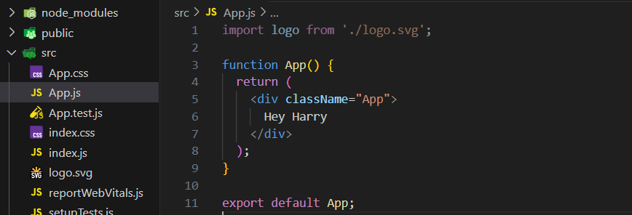

Output:

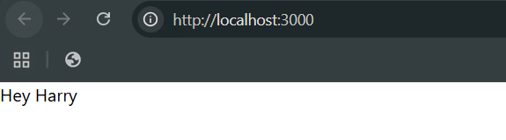

Now, we will add this in the centre, and add the button as well:

App.js:

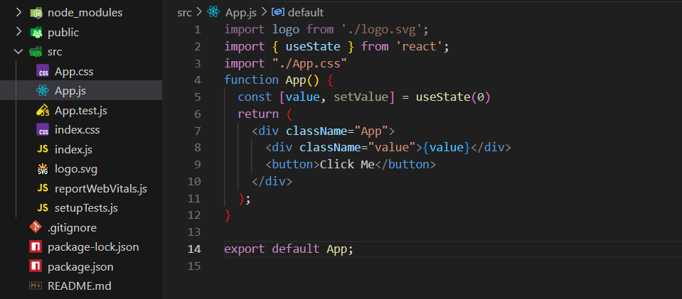

Output:



Now, we will add the logic where the value will increase by 1 with every click:

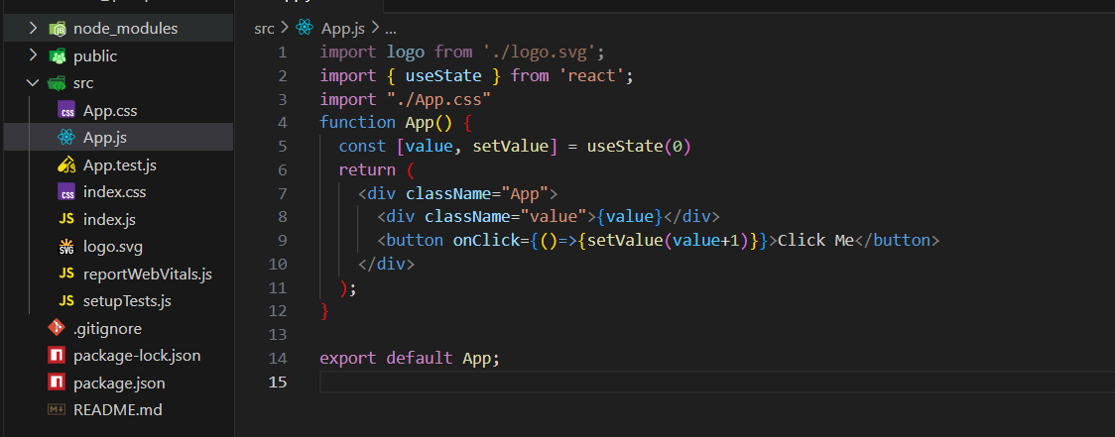

Output: at start

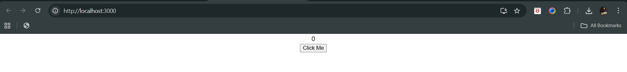

Output: after 1st click

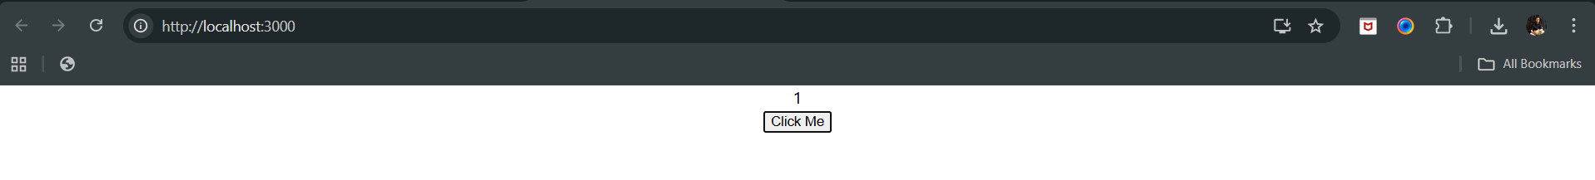

Output: after 2nd click

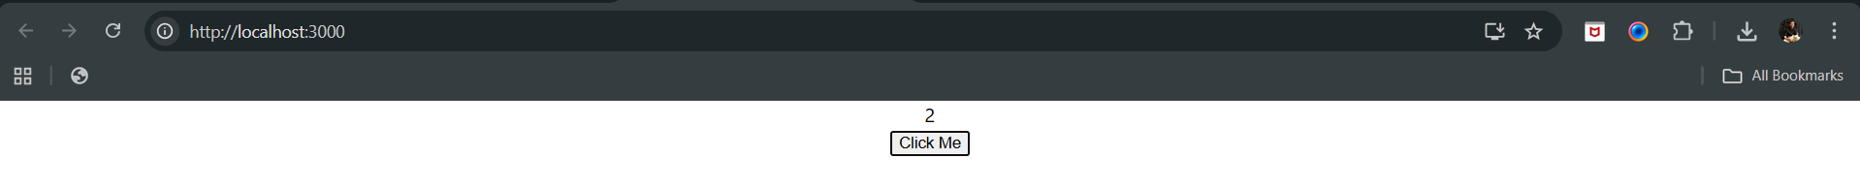

--The End--